Week 2 Task — Exploratory Data Analysis and Visualization Framework Design
Reusable EDA Framework for a Hypothetical Customer Churn Dataset
Prepared for: YuvaIntern | Virtual Data Science Explorer Intern

1. Introduction to EDA
Exploratory Data Analysis (EDA) is the structured process of inspecting, summarizing, visualizing, and questioning data before formal modeling. For the hypothetical churn project, EDA will establish data quality, reveal customer behavior patterns, identify relationships with churn, and surface issues that could affect model validity.

2. Potential Data Types
Type | Examples | EDA focus
Numeric | Tenure, monthly spend, usage | Distribution, scale, outliers, correlations
Categorical | Contract type, payment method | Frequency, proportions, churn rate by category
Binary | Churn flag, autopay indicator | Class balance, group comparisons
Datetime | Signup date, last activity | Trends, recency, seasonality
Text (optional) | Support notes | Length, keyword themes, privacy review

3. EDA Workflow
- Load the dataset and inspect shape, columns, data types, and sample records.
- Create a data dictionary and verify expected ranges and category definitions.
- Measure missing values, duplicates, unique values, and potential identifiers.
- Assess the target variable and class balance.
- Perform univariate analysis for numeric and categorical variables.
- Perform bivariate analysis against churn and between important predictors.
- Use multivariate analysis to examine interactions and correlated features.
- Investigate outliers using statistical rules and business context.
- Document findings, assumptions, exclusions, and data-quality decisions.

4. Missing Data Strategy
- Quantify missingness by column and by important customer segments.
- Distinguish structural missingness from accidental missingness.
- Use business rules before statistical imputation.
- For numeric variables, consider median imputation or model-based approaches when justified.
- For categorical variables, use an explicit 'Unknown' category when appropriate.
- Never impute using information from the test set; fit preprocessing only on training data during modeling.

5. Outlier Strategy
Outliers will be detected using boxplots, interquartile range rules, robust statistics, and domain thresholds. A value will not be removed merely because it is statistically unusual. Each treatment will be documented as retain, cap, transform, correct, or exclude, with a reason.

6. Visualization Strategy
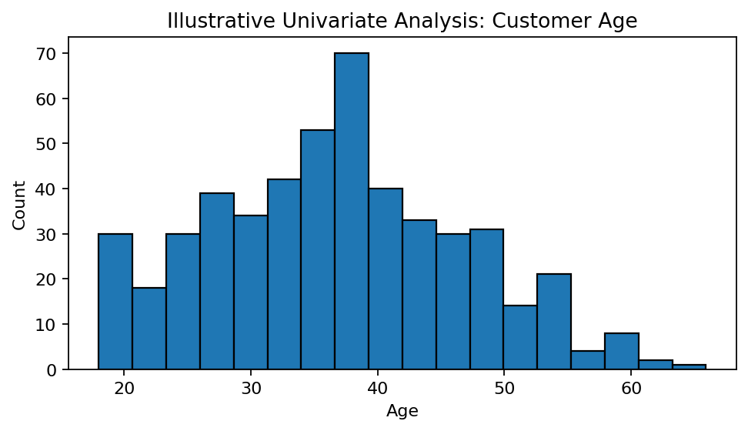
Figure 1. Illustrative histogram for a numeric variable. The figure is a mock example, not a result from a real dataset.
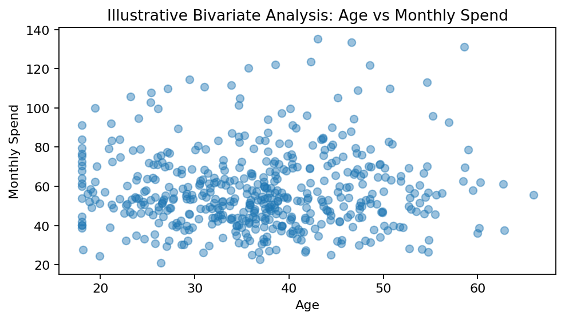
Figure 2. Illustrative scatter plot for relationship exploration. The figure is a mock example.
Question | Recommended visual | Purpose
What is the distribution? | Histogram / boxplot | Shape, spread and outliers
How do categories differ? | Bar chart | Compare counts or rates
How does a numeric variable relate to churn? | Boxplot / violin plot | Compare distributions
Are two numeric variables related? | Scatter plot | Direction and strength
Which variables are correlated? | Correlation heatmap | Detect redundancy and relationships
How does churn vary over time? | Line chart | Trend and seasonality
Which segments have higher risk? | Grouped bar / heatmap | Segment comparison

7. Python Tools and Libraries
Tool | Contribution
pandas | Data loading, cleaning, grouping, summaries
NumPy | Numerical calculations
Matplotlib | Custom, publication-ready plots
Seaborn | Statistical visualizations and heatmaps
Plotly | Interactive exploratory charts
Jupyter Notebook | Narrative analysis and reproducibility
scikit-learn | Preprocessing utilities and modeling-ready transformations

8. Reporting and Documentation Plan
- Executive overview: dataset size, target, major quality concerns.
- Data profile: variables, data types, missingness and class balance.
- Univariate findings: key distributions and anomalies.
- Bivariate and multivariate findings: relationships and segment differences.
- Data-quality decisions: cleaning, imputation, outlier treatment and exclusions.
- Modeling implications: candidate predictors, leakage concerns and transformations.
- Visual appendix: plots with titles, units, captions and interpretation.

9. Quality and Reproducibility Standards
- Every chart must have a meaningful title, labeled axes and a short interpretation.
- Use consistent definitions for churn and customer segments.
- Keep analysis code modular and rerunnable.
- Record package versions and analysis dates.
- Separate exploratory observations from confirmed business conclusions.
- Protect customer-level information and avoid exposing personally identifiable data.

