**Gamefish Locations in Relation to Depth, Bottom Hardness, and Macrophyte Biovolume in Sanford Lake, Wisconsin**

**Abstract**

Walleye (*Sander vitreus)*, Smallmouth Bass (*Micropterus dolomieu)*, and Muskellunge (*Esox masquinongy)* are popular game fish species found across the Midwest. Sanford Lake, in Northern Wisconsin provides a unique opportunity to study habitat use of these species as there is nearly no development on the lake and the lake is considered virtually unexploited. Seven walleyes, seven smallmouth bass, and three muskellunge were implanted with radio transmitters in Sanford Lake, Wisconsin during the summer of 2017. The objectives were to (1) identify habitat use of gamefish in Sanford Lake and (2) collect preliminary data for future habitat studies on Sanford Lake. Fish with radio transmitters were found a total of 408 times from July to October 2017. Walleyes and smallmouth bass utilized the same type of habitat during the study period, which differed significantly from the habitat that was being utilized by muskellunge. As discussed in many publications, habitat use of fish should be taken into consideration when considering the management objective for a species in a body of water. Our results provide a baseline of simple habitat use parameters in an undeveloped and unexploited lake for Walleye, Smallmouth bass, and Muskellunge.

**Introduction**

Walleye (*Sander vitreus),* Smallmouth Bass (*Micropterus dolomieu)*, and Muskellunge (*Esox masquinongy)* are species that are commonly found in many northern Wisconsin Lakes. These species are a favorite target for anglers across Wisconsin and the rest of the Midwest (Lathrop *et al.* 1991; McMahon and Bennet 1996; Newman and Hoff 2000; Simonson and Hewett 1999; VanDeValk *et al.* 2005). Given their importance to anglers, proper management of these species is important. In recent years, it has become apparent that fisheries managers need to focus on ecosystem management rather than individual fish species. In order to manage a lake ecosystem it is vital that managers have an understanding of the habitats that are being utilized by important fish species in the lake. Understanding habitat usage of healthy naturally reproducing fish populations in an undeveloped and unexploited lake provides a unique opportunity to examine fish populations where biotic and abiotic disturbances from humans are minimal. Information from these systems can provide important insight to future legislation and habitat rehabilitation projects. Many lakes in Wisconsin have some shoreline development, which often has some influence on usage and movement of fish within the area (Helmus and Sass 2008; Jennings *et al.* 1999; Scheuerell and Schindler 2004). Sanford Lake, in Northern Wisconsin, provides a unique opportunity to study habitat use of these species as there is nearly no development on the lake and the lake is considered virtually unexploited.

Radiotelemetry is a viable way to collect location data of fish in order to understand movement and habitat use. Radiotelemetry has been used in fisheries research since the 1960’s, but has recently become more popular due to gains in. Historically, fisheries researchers used radiotelemetry locations to provide insights on migrations, habitat use, fish behavior, productivity, and survival of fish. Radiotelemetry is such an effective method of obtaining information for fish because there is no need to recapture or directly observe the fish (Hokersmith and Beeman 2012). Many studies have been done using radio telemetry to assess the use of spawning habitat as well as movements within river systems; however, the technology has not been used as much to assess summer habitat use in a lake (Paragamian 2011). Summer habitat is important, as this time period is when many fish species are most active (Dombeck 1986).

We used radiotelemetry to (1) identify habitats commonly used by Walleye, Smallmouth Bass, and Muskellunge in Sanford Lake and (2) collect preliminary data for future habitat use studies on Sanford Lake.

**Methods**

*Study Area*

Sanford Lake is located on property near Boulder Junction, Wisconsin that is owned by Dairymen's, Inc. Sanford Lake is located on the northern end of the property and has an area of 35.6 ha, with 3.86 km of shoreline and a maximum depth of 15.5 m. Sanford Lake is a mesotrophic seepage lake stained with tannic acid (Bozek *et al.* 2002). The shoreline is undeveloped except for one boat landing and a small picnic area. Trees fall into the lake providing abundant large woody structure throughout the littoral zone; rocks and boulders are uncommon.

Harvest is prohibited for Smallmouth Bass (i.e., catch-and-release angling only) and restricted to three Walleye, only one of which may be over 356 mm, and one Muskellunge over 1016 mm. Very few Walleye and Muskellunge are harvested from Sanford Lake due to limited access. The other main fish species in Sanford Lake are Yellow Perch (*Perca flavescens)*, Rock Bass (*Ambloplites rupestris*), White Suckers (*Catostomus commersoni*), Bluegill (*Lepomis macrochirus)*, Pumpkinseed (*Lepomis gibbosus*), and Golden Shiner (*Notropis crysoleucas*).

*Fish Sampling*

Radiotelemetry was used to monitor habitat use and movement patterns of Walleye, Smallmouth Bass, and Muskellunge in summer 2017. Two-stage radiotelemetry transmitters from Advanced Telemetry SystemsTM (Model F1840) were used in this study. These transmitters weigh 20 g and have a battery life of 666-1191 days. Transmitters were implanted only in fish large enough to not be negatively affected by the transmitter (Jepsen *et al.* 2005; Smircich and Kelly 2014). Thus, transmitters were implanted in seven adult Walleye between 401 and 508 mm, seven adult Smallmouth Bass between 419 and 526 mm, and three adult Muskellunge between 538 and 744 mm total length captured between June 29 and July 20, 2017. Fish were held in holding tanks at the boat landing of Sanford Lake until surgical implantation of the radio tags. The fish were then placed dorsal side down in soft foam, which exposed the ventral side of the fish for surgery. An electric muscle stimulation unit, commonly used for muscle therapy in humans, was used to immobilize the fish during surgery. The voltage was set at the lowest level and gradually increased until the fish was immobilized. A submersible pump was used to pump lake water across the fish’s gills. Transmitters were surgically implanted in the gut cavity just posterior to the pelvic girdle as described by Hart and Summerfelt (1975) and Ahrenstorff *et al.* (2008). All fish were also given a serially numbered PIT tag and all Walleye and Smallmouth Bass were also given a serially numbered FloyTM tag. Upon completion of the surgery and tagging, fish were returned to the holding tanks and monitored until a full recovery was made, usually around 10 minutes, and then released.

Tagged fish were tracked during the day (between 9 AM and 12 PM) twice weekly and at sunset once a week through October 2017. Fish were tracked from a motorboat using an Advanced Telemetry Systems programmable receiver (Model R2000) and a three-element YagiTM antenna. Coordinates for located fish were recorded using a handheld global positioning system (GPS).

*Habitat Sampling*

A Lowrance XDSTM sonar was used to collect depth, bottom hardness, and aquatic plant biovolume for Sanford Lake. The sonar survey followed 100 meter transects at 3-5 miles per hour, which resulted in data from 15,349 points throughout the entire lake. Data collected on the sonar were uploaded into the BioBaseTM mapping software, which generated bottom hardness data on a relative but continuous scale from soft (0–0.25: muck, loose silt, or sand), to moderate (0.25 –0.4), to hard (0.4 –0.5: compacted sand, gravel, or rock) and aquatic plant biovolume data that represents the percent of the water column occupied by plant matter (i.e., plant canopy height divided by water depth multiplied by 100). BioBaseTM mapping software bottom hardness will not be estimated when the aquatic plant biovolume exceeds 60%.

Text files generated from the survey were uploaded to ArcGISTM to create interpolated kringed rasters with 5 m x 5 m cells as suggested in the BioBase manual. These results were then used to generate bathymetry, bottom hardness, and aquatic plant biovolume maps. GPS location points of each fish were overlaid on each raster cell to obtain depth, bottom hardness, and aquatic plant biovolume values for each fish’s observed location. Using this method the depth of the water at the fish’s location, but not the depth within the water column of the fish, was recorded. The depth, hardness, and biovolume data at each location where a fish was recorded were exported from ArcGIS to Microsoft ExcelTM and ultimately R version 3.3.2 (R Core Team 2016) for statistical analyses.

*Data Analysis*

A series of one-way ANOVAs were completed using each species as the explanatory variable and depth, biovolume, and bottom hardness as response variables. A fourth root (0.25) transformation was used to normalize and equalize variances for depth, bottom hardness, and aquatic plant biovolume data. Tukey’s HSD was used following a significant ANOVA to identify which species differed. Upon a series of significant ANOVAs, a one-way ANOVA based on individual fish of each species was completed to identify which fish may have driven some results.

To compliment the results of the one-way ANOVAs, a series of bootstrapped Kolmogorov-Smirnov tests were used to determine if there was a significant difference in the distributions of depth, biovolume, and bottom hardness use among each species. To address differences in depth, biovolume, and bottom hardness use among fish within each species a series of Kolmorgorov-Smirnov tests was completed. For all analysis a significance level of 0.05 was used. In an effort to examine differences among each fish of each species for each habitat variable a kernel density plot was created. For all analysis a significance level of 0.05 was used.

**Results**

Fish equipped with radio transmitters were located 408 times during the study period. One Smallmouth Bass, tag number 413, was assumed to be dead and left out of further analysis after no movement was detected for an extended period of time. Every other fish implanted with a radio transmitter was assumed to be alive and was located on every tracking event from July to October (Table 1).

**Table 1**. Summary of physical characteristics and radiotelemetry data for Muskellunge (MUE), Smallmouth Bass (SMB), and Walleye (WAE) implanted with radiotelemetry transmitters in Sanford Lake. Location events are the number of times a fish was found during the study. M=Male; F=Female; U=Unknown.

|  |  |  |  |  |  |  |
| --- | --- | --- | --- | --- | --- | --- |
| **Implant Date** | **Tag** | **Species** | **Length (mm)** | **Weight (g)** | **Sex** | **Location Events** |
| 7/20/17 | 184 | MUE | 538 | -- | U | 21 |
| 6/29/17 | 353 | MUE | 686 | 1361 | U | 26 |
| 6/29/17 | 423 | MUE | 744 | 1905 | U | 26 |
| 6/29/17 | 23 | SMB | 432 | 998 | U | 26 |
| 7/20/17 | 93 | SMB | 521 | -- | U | 21 |
| 6/29/17 | 333 | SMB | 526 | 2250 | U | 26 |
| 7/20/17 | 343 | SMB | 419 | -- | U | 21 |
| 6/29/17 | 384 | SMB | 462 | 1347 | U | 26 |
| 6/29/17 | 433 | SMB | 516 | 1266 | U | 26 |
| 7/20/17 | 203 | WAE | 432 | -- | U | 21 |
| 6/29/17 | 244 | WAE | 439 | 785 | U | 25 |
| 7/20/17 | 264 | WAE | 452 | -- | F | 21 |
| 7/20/17 | 283 | WAE | 401 | -- | M | 21 |
| 6/29/17 | 441 | WAE | 427 | 612 | U | 25 |
| 6/29/17 | 453 | WAE | 427 | 653 | U | 25 |
| 6/29/17 | 462 | WAE | 508 | 1157 | F | 26 |

The mean depth of Sanford Lake is 4.76 m. Walleye were found at a mean depth of 2.38 m (SE=0.13), Smallmouth Bass at a mean depth of 2.34 m (SE= 0.14), and Muskellunge at a mean depth of 1.53 m (SE= 0.11) (Figures 1 and 2). The mean distribution of depth used by Walleye and Smallmouth Bass did not differ (ANOVA: p=0.74; KS: p=0.06), but was significantly greater (ANOVA: p=0.00001; KS: p<0.00005) than the mean and distribution of depth used by Muskellunge.

The mean biovolume of Sanford Lake is 3.47%. Walleye were found at a mean biovolume of 5.68% (SE= 1.65), Smallmouth Bass at a mean biovolume of 6.84% (SE= 1.69), and Muskellunge were found at a mean biovolume of 17.34% (SE= 1.37) (Figures 1 and 2). The mean and distribution of biovolume used by Walleye and Smallmouth Bass did not differ (ANOVA: p=0.85; KS: p=0.24), but was significantly greater (ANOVA: p=0.00001; KS: p<0.00005) than the mean and distribution of biovolume used by Muskellunge.

The mean bottom hardness of Sanford Lake is 0.29. Walleye were found at a mean bottom hardness of 0.31(SE=0.0063), Smallmouth Bass at a mean bottom hardness of 0.31 (SE=0.0064), and Muskellunge at a mean bottom hardness of 0.34 (SE=0.0052) (Figures 1 and 2). The mean and distribution of bottom hardness used by Walleye and Smallmouth Bass did not differ (ANOVA: 0.854; KS:p=0.13), but was significantly greater (ANOVA: 0.00001; KS: p<0.00005; p=0.003 respectively) than the mean and distribution of bottom hardness used by Muskellunge.

A significant difference in transformed mean depth, biovolume, and bottom hardness was found between some of the Walleye. Tags 203, 244, and 283 utilized similar transformed depths (All p-values >0.99), while tag 264 utilized significantly different transformed depths than the three fish listed prior (All p-values <0.02). The other 4 fish utilized transformed depths that were similar to tags 203, 244, and 283 as well as tag 264. As for biovolume and bottom hardness, Walleyes utilized varying habitats (Figure 3).

A significant difference in transformed mean depth and biovolume was observerved for Muskellunge; bottom hardness did not differ significantly between Muskellunge (All p-values >0.08) (Figure 3). Tags 184 and 353 utilized similar transformed depths (p=0.31), while tag 423 utilized significantly different transformed depth (p<0.0005). As for biovolume, tags 423 and 353 utilized similar transformed biovolume (p=0.77), while tag 184 utilized significantly different transformed biovolume (All p-values <0.005).

Statistically, no significant difference in mean depth, biovolume, or bottom hardness was found among individual Smallmouth Bass (All p-values>0.132). All of the Smallmouth Bass that were implanted with radio telemetry tags utilized variety of habitats in Sanford Lake during the study (Figure 3).

**Hardness**

**Biovolume**

**Depth**

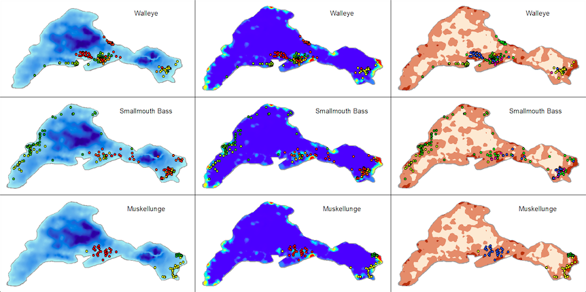

**Figure 1**. Maps of depth (darker is deeper), biovolume (blue is lowest, red is highest), and hardness (darker is harder). Superimposed points of different colors represent telemetry locations of individual fish.

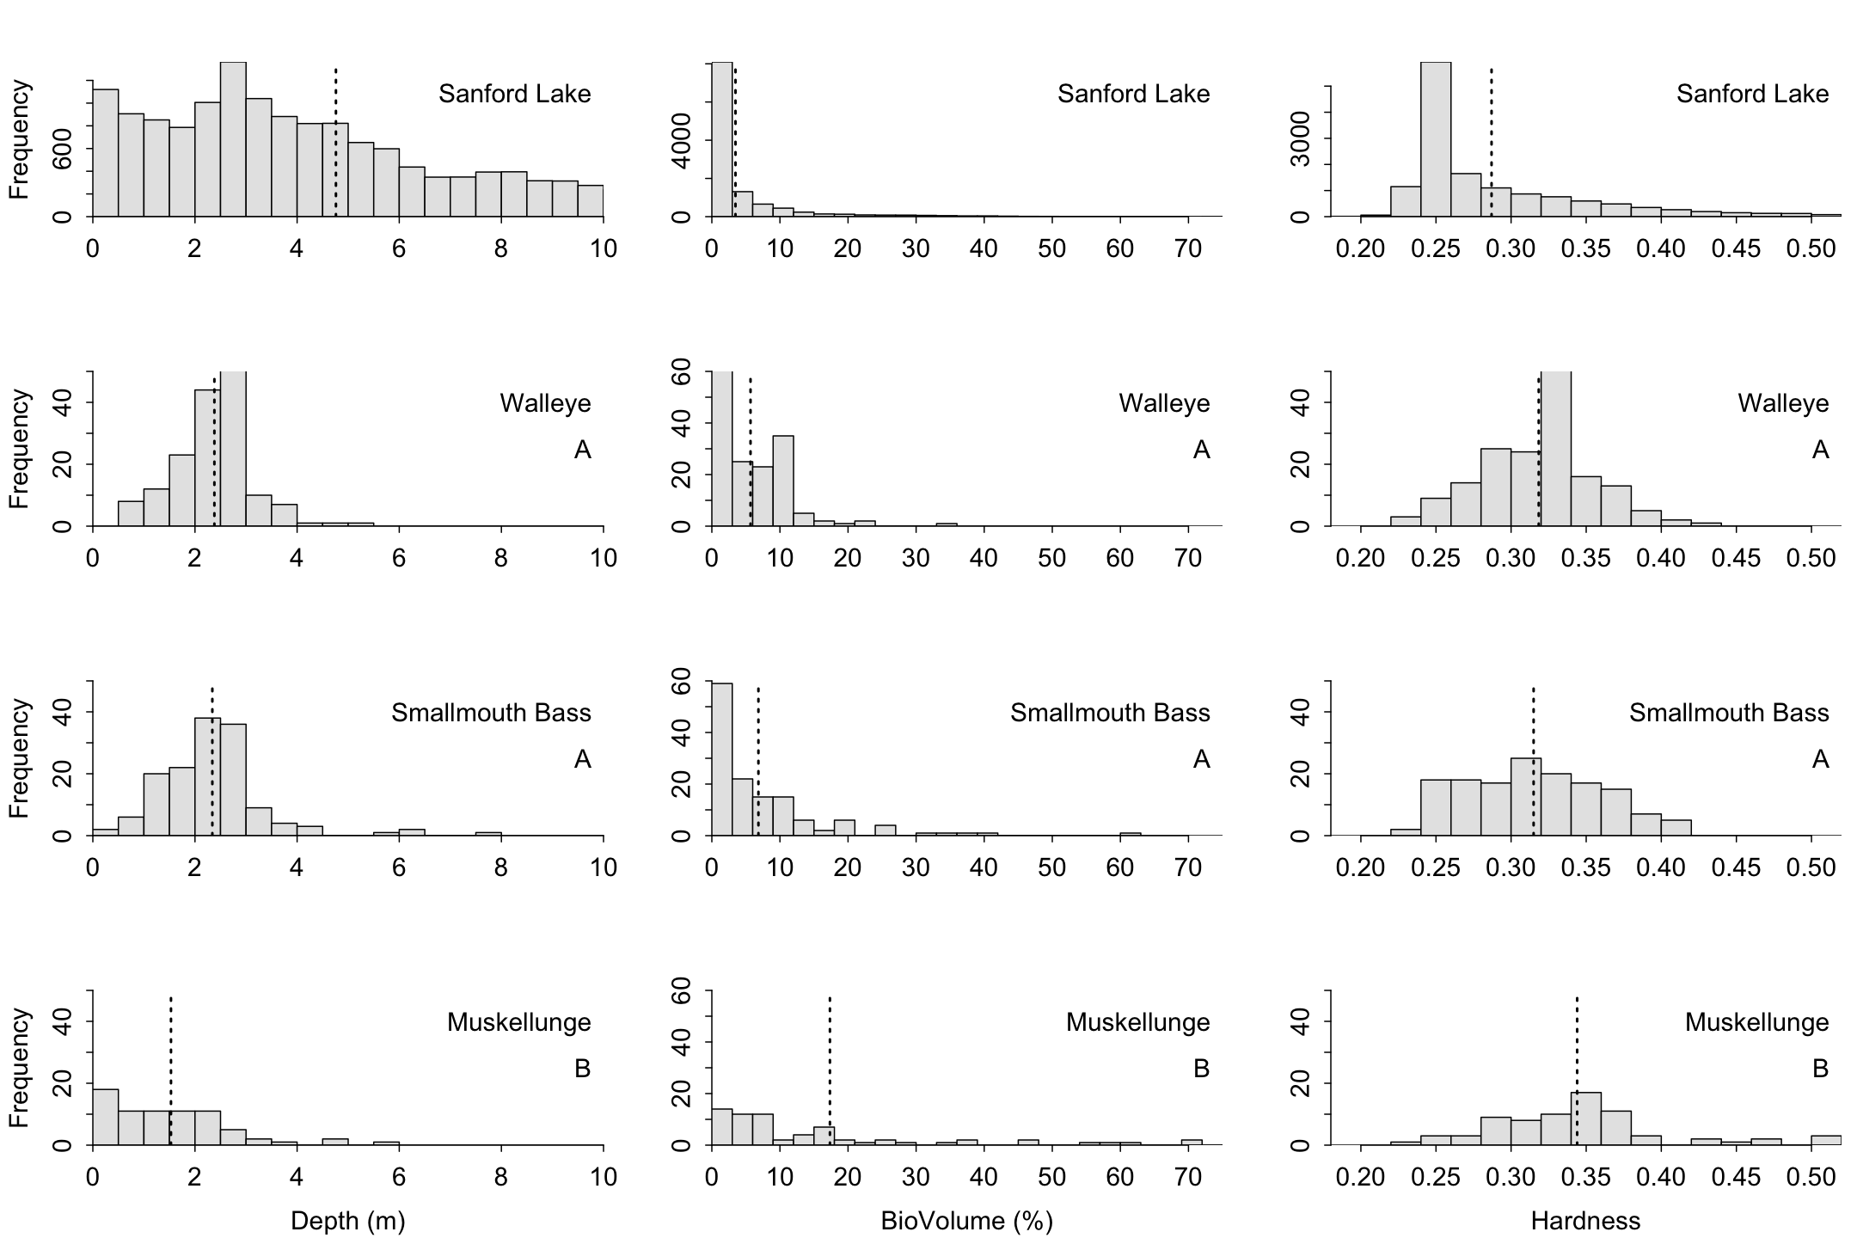

**Hardness**

**Biovolume**

**Depth**

**Figure 2**. Histograms of depth, biovolume, and bottom hardness for all fish locations on Sanford Lake. The vertical dashed line is the mean on each plot. Species with the same letter within a habitat variable did not have a significiantly different distributions or transformed means for that variable.

**Hardness**

**Depth**

**Biovolume**

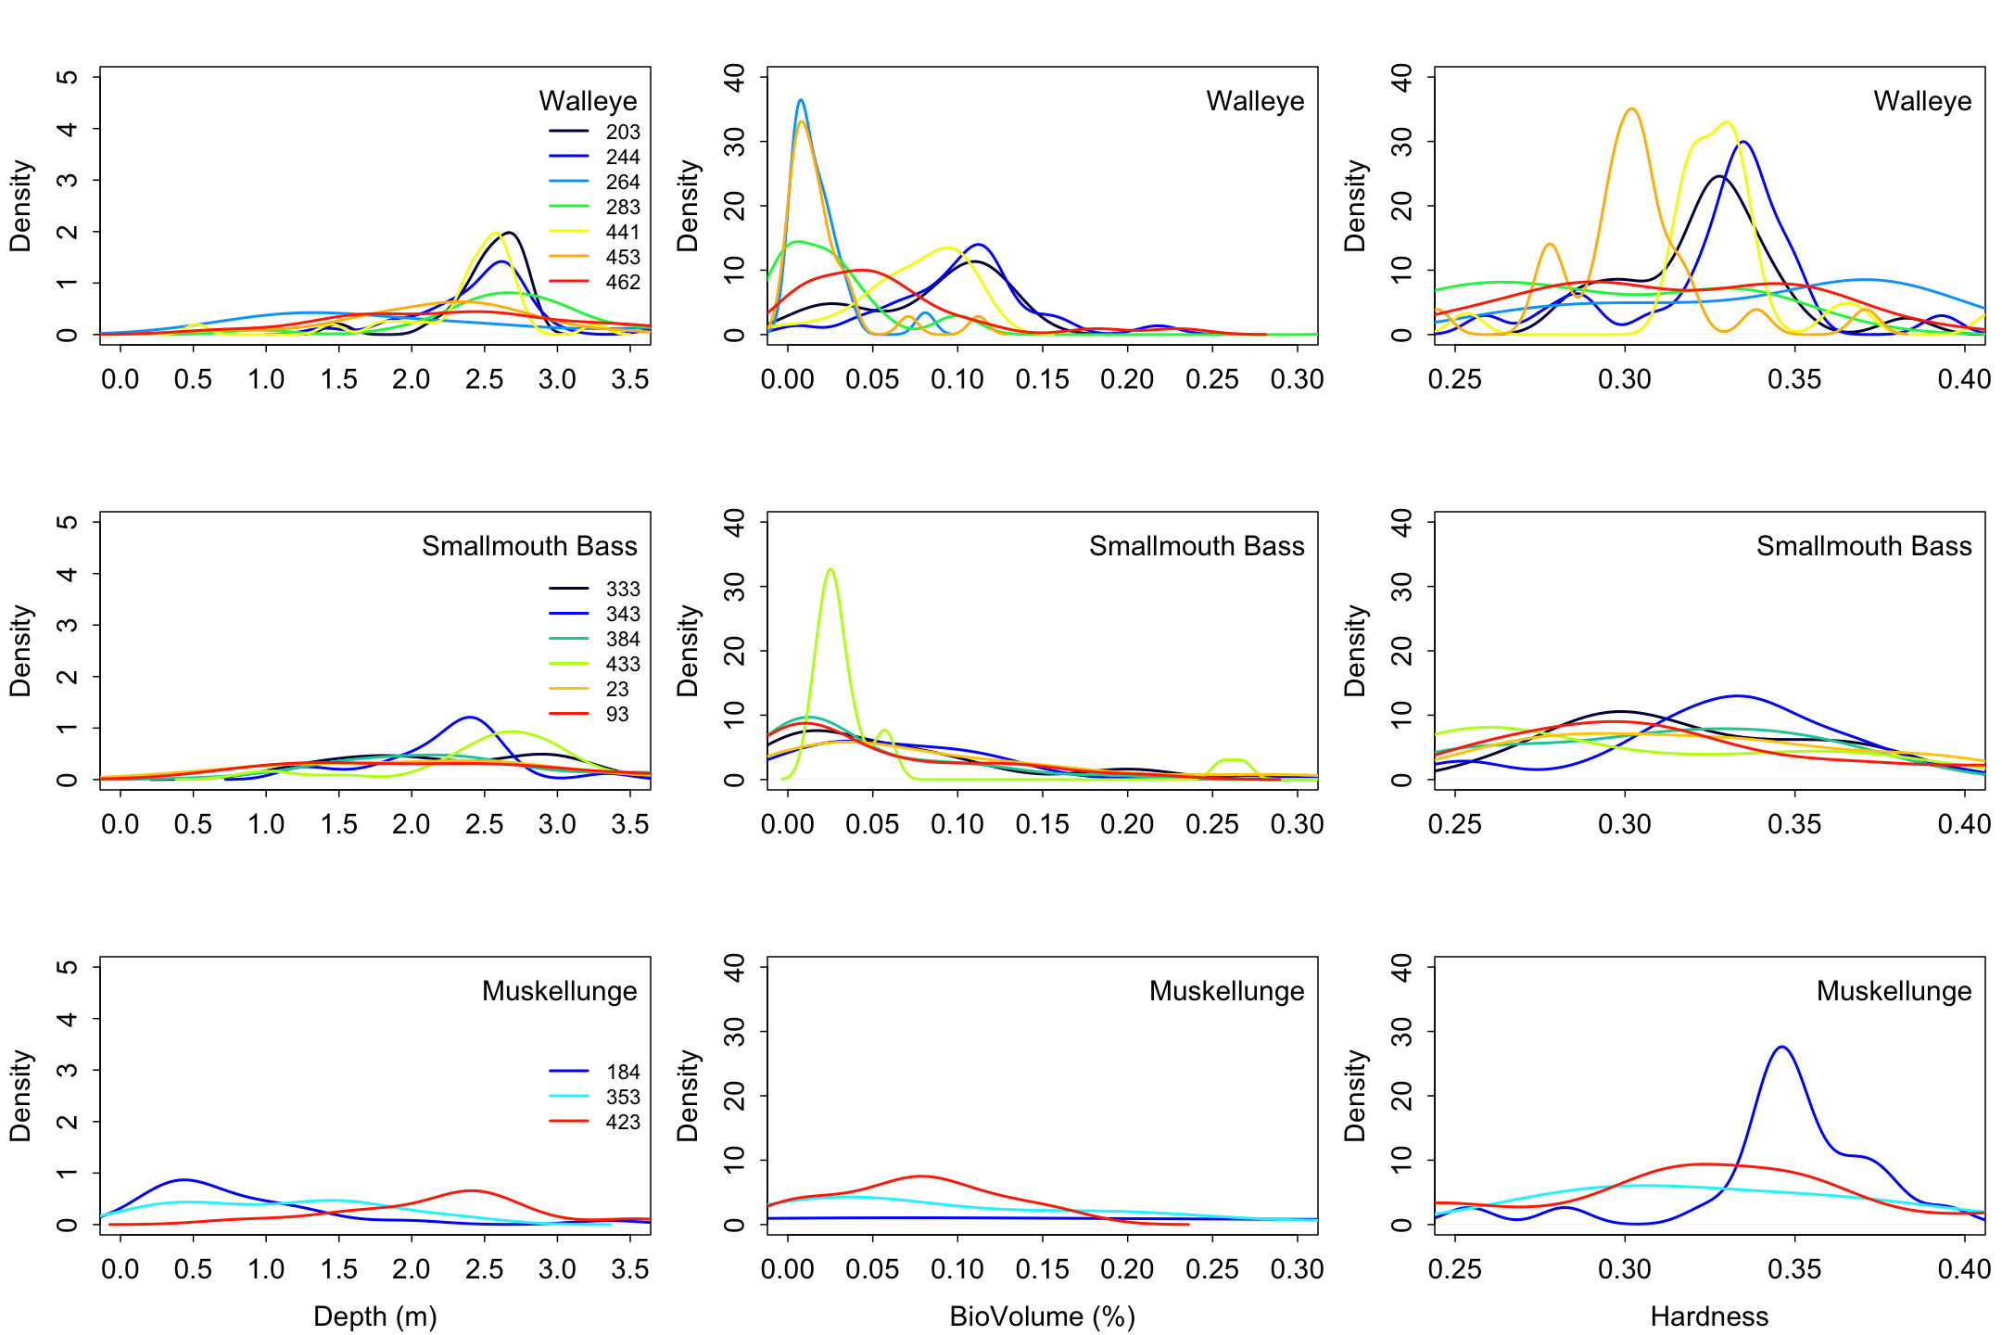

**Figure 3**. Kernel density plot of depth, biovolume, and hardness for all fish locations on Sanford Lake. Each color and corresponding tag number symbolizes an individual fish for that species.

**Discussion**

Walleye utilized a variety of habitats during this study. One group of Walleye related to high macrophyte biovolume, whereas another group related to soft-bottomed areas of the lake. The reason for this difference in habitat use could potentially be explained by the available food during the months that the tracking took place. However, it has been shown in many publications that walleyes utilize a variety of different habitats (McMahon and Bennet 1996; Paragamian 2011).

Smallmouth Bass in Sanford Lake all related to the same habitat of a moderately hard bottom with very little macrophyte growth at an average depth of approximately 2.34 m. Smallmouth Bass were dispersed all around Sanford Lake, making it very interesting that each tagged fish was found in statistically similar habitat. However, the variability of use within each habitat was greater than that of Walleyes and Muskellunge. Many researchers have written that Smallmouth relate to large rock and boulders; however, these areas are not overly abundant in Sanford Lake as the lake is thought to be approximately 80% sand, 10% gravel, and 10% muck. Thus, Smallmouth Bass may be utilizing a variety of habitats that they may not use in a lake where rocks and boulders are common (Bozek *et al.* 2002; Hafs *et al.* 2010; VanDeValk *et al.* 2005).

Muskellunge related to shallower areas than Walleyes and Smallmouth Bass and did not utilize as much of the whole lake as the other two species. Our results show that even though Muskellunge may not be using the whole lake, they utilize a variety of habitats in the area, which is similar to previous findings (Dombeck 1986; MacGregor *et al.* 1960*;* Minor and Crossman 1978; Younk *et al.* 2012). A greater sample size, especially for Muskellunge is needed to obtain more accurate assessments of habitat use in Sanford Lake.

**Management Implications**

Habitat preferences of fish should be considered in the management objectives for a species in a body of water. Over the coming years, Sanford Lake will be the subject of a whole-lake tree-drop study to assess the influence on coarse woody habitat use on the lake. The results from this study may be used to determine whether the habitat use of these fish changes with the increase of littoral coarse woody habitat. More fish need to be fitted with radio transmitters to gain more information on species habitat preference in Sanford Lake. Additionally, over the coming years, it is vital thatspawning habitat be assessed using radiotelemetry to assess the habitat in which each species is using.

**References**

Ahrenstorff, T.D., Sass, G.G., and Helmus, M.R. 2009. The influence of littoral zone coarse woody habitat on home range size, spatial distribution, and feeding ecology of Largemouth Bass (*Micropterus salmoides*). Hydrobiologia. 623:223-233.

`

Bozek, M.A., Edwards, C.J., Jennings, M.J., and Newman, S.P. 2002. Habitat selection of nesting Smallmouth Bass *Micropterus dolomieu* in two north temperate lakes. American Fisheries Society Symposium. 31:135-148.

Dombeck, M.P. 1986. Muskellunge habitat with guidelines for habitat management. American Fisheries Society Special Publication. 208-215.

Hafs, A.W., Gagen, C.J. and Whalen, J.K. 2010. Smallmouth Bass summer habitat use, movement, and survival in response to low flow in the Illinois Bayou, Arkansas. North American Journal of Fisheries Management. 30:604-612.

Hart, L.G. and Summerfelt R.C. 2011. Surgical procedures for implanting ultrasonic transmitters into Flathead Catfish (*Pylodictis olivaris*). Transactions of the American Fisheries Society. 104:56-59.

Helmus, M.R. and Sass, G.G. 2008. The rapid effects of a whole-lake reduction of coarse woody debris on fish and benthic macroinvertebrates. Freshwater Biology. 53:1423–1433.

Hockersmith, E.E., and Beeman, J.W. 2012. A history of telemetry in fishery research. *In* Telemetry techniques: a user guide for fisheries research. *Edited by* N.S. Adams, J.W. Beeman, and J.H. Eiler. American Fisheries Society. 7–19.

Jennings, M.J., Bozek, M.A., Hatzenbeler, G.R., Emmons, E.E., and Staggs, M.D. 1999. Cumulative effects of incremental shoreline habitat modification on fish assemblages in north temperate lakes. North American Journal of Fisheries Management. 19:18-27.

Jepsen, N., Schreck, C., Clements, S., and Thorstad, E.B. 2005. A brief discussion on the 2% tag/bodymass rule of thumb. Aquatic telemetry: advances and applications. Proceedings of the Fifth Conference on Fish Telemetry heldin Europe. 255-260.

Lathrop, R.C., Rasmussen, P.W., and Knauer, D.R. 1991. Mercury concentrations in Walleyes from Wisconsin (USA) Lakes. Water, Air, and Soil Pollution. 56:295-307.

MacGregor, J., Scott, J. and Dean, B. 1960. A review of the life history and proposed management of the northern Muskellunge (*Esox immaculatus*), Michigan Department of Conservation, Fish Division, Lake and Stream Improvement Report.

McMahon, T.E. and Bennett, D.H. 1996. Walleye and Northern Pike: boost or bane to Northweset fisheries?. Fisheries. 21: 6-13.

Minor, J.D., and Crossman, E.J. 1978. Home range and seasonal movements of Muskellunge as determined my radiotelemetry. American Fisheries Society Special Publication. 11:146-153.

Newman, S.P. and Hoff, M.H. 2000. Evaluation of a 16‐Inch minimum length limit for Smallmouth Bass in Pallette Lake, Wisconsin. North American Journal of Fisheries Management. 20:90-99.

Paragamian, V.L. 2011. Seasonal habitat use by Walleye in a warmwater river system, as determined by radiotelemetry. North American Journal of Fisheries Management. 9:392-401.

R Development Core Team. 2016. R: a language and environment for statistical computing. R Foundation for Statistical Computing, Vienna. Available: www. R-project.org.

Sass, G.G., Hewett, S.W., Beard, T.D., Fayram, A.H. and Kitchell, J.F. 2004. The role of density dependence in growth patterns of ceded territory Walleye populations of Northern Wisconsin: effects of changing management regimes. North American Journal of Fisheries Management. 24:1262-1278.

Scheuerell, M.D. and Schindler, D.E., 2004. Changes in the spatial distribution of fishes in lakes along a residential development gradient. Ecosystems. 7:98–106.

Simonson, T.D. and Hewett, S.W. 1999. Trends in Wisconsin's Muskellunge fishery. North American Journal of Fisheries Management. 19:291-299.

Smircich, M.G. and Kelly, J.T. 2014. Extending the 2% rule: the effects of heavy internal tags on stress physiology, swimming performance, and growth in Brook Trout. Animal Biotelemetry. 2:1-7.

VanDeValk, A.J., Forney, J.L., Jackson, J.R., Rudstam, L.G., Brooking, T.E. and Krueger, S.D. 2005. Angler catch rates and catchability of Walleyes in Oneida Lake, New York. North American Journal of Fisheries Management. 25:1441-1447.

Younk, J.A., Cook, M.F., Goeman, T.J., and Spencer, P.D. 2012. Seasonal habitat use and movements of Muskellunge in the Mississippi River. Minnesota Department of Natural Resources Investigational Report. 449:1-20.