

AHM Exception Framework 3.0
Sample Application
Quick Start Guide

Prepared By

AHM eBusiness B2C

Project Management Office

Revised: 02/05/2010
Version: 1.00
Document History

Date | Description Of Changes | Version | Author
02/05/2010 | Initial release | 1.00 | Pankil Patel

Table of contents
Overview 4
Pre-requisite 4
Application Location 4
Instructions 4

Overview
The Exception Framework 3.0 Sample Application contains various scenarios in which exception framework can and should be used. It also shows the flow of exceptions through different layers and based on the flow, how the exceptions should be handled.

Pre-requisite
Ahm Exception Framework 3.0 | Install the framework before using the sample application

Application Location
The sample application is located in the Ahm Exception Framework 3.0 package. It is also located at \\ahm\web\FTP\B2C_Apps\Exception Framework\Release\01192010\ folder.

Instructions
After unzipping or copying the Sample Application folder to a specified location, the following steps need to be followed to set up the application.

Step 1. Open IIS and create a website “AEF30Sample” and point to the AEF30Sample folder located in Sample Application folder. So if the Sample Application folder is located at D:\ then the path you will point to is D:\Sample Application\AEF30Sample.
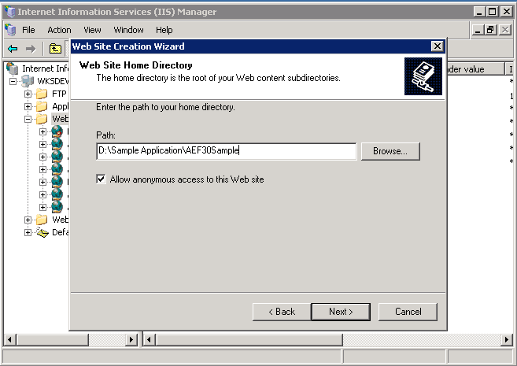

Step 2. In the “Website Access Permissions” step, select “Run Scripts (such as ASP)”, click
Next and Finish.

Step 3. In the custom errors tab for the website, set 403, 404 and 500 URL to point to
“/error/GeneralError.aspx”.

Step 4. Based on the C: or D: drive installation, make sure the C:\app_logs\ or
D:\app_logs folder is present and the App Pool user for the “AEF30Sample” website has read/write access to that folder.

Step 5. Browse to the Default.aspx of the configured application and test that all scenarios
properly logs the errors.

