1. **Handling Requests from WebBrowser:**
2. **Web Browser:**

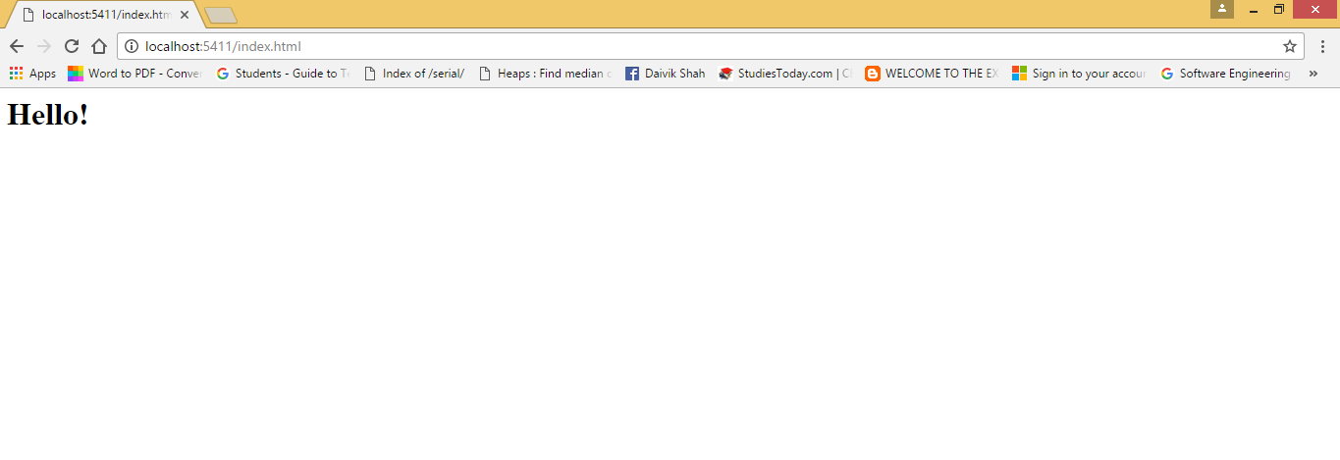

1. **Server:**

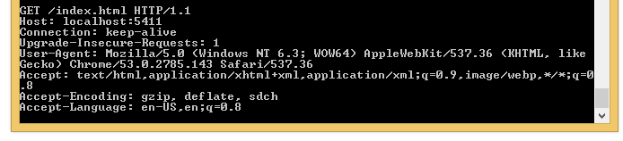

1. **Handling requests from WebClient:**
2. **WebClient:**

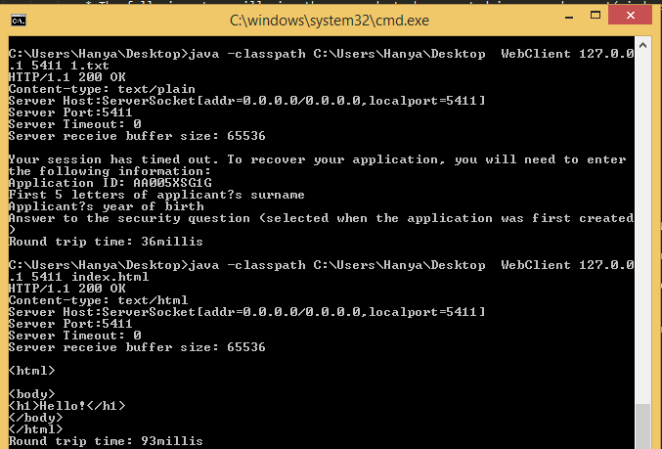

1. **WebServer:**

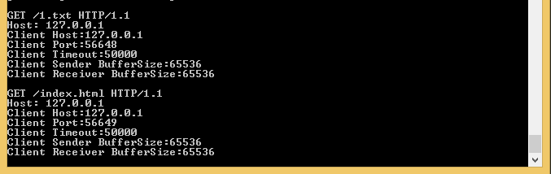

1. **Handling requests when file is not found:**
2. **WebClient:**

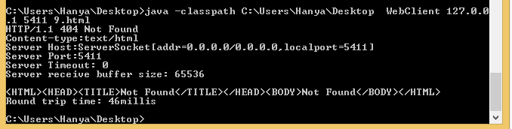

1. **WebServer:**

