Project Report Template

1. **INTRODUCTION** 1.1 Overview

*To Create a CRM Application to help the applicant to track various Job Applications posted by the Recruiters.*

1.2 Purpose

*The Purpose of this Project is to Gain Knowledge*

*About creating a Job Application Tracking Application.*

1. **Problem Definition & Design Thinking**

2.1 Empathy Map

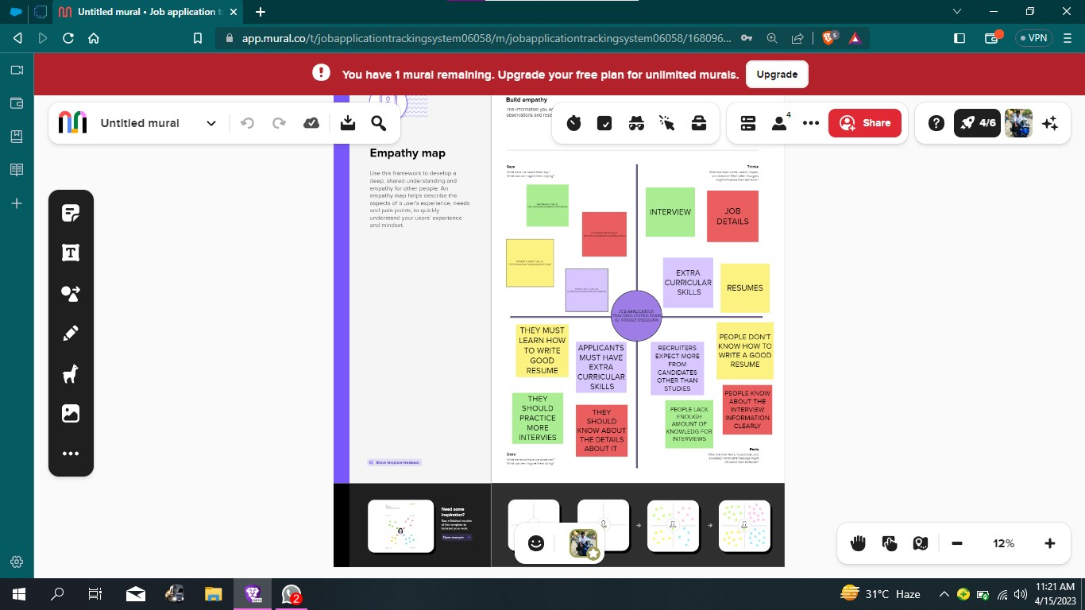

2.2 Ideation & Brainstorming Map

1. **RESULT**

**3.1** Data Model:

|  |  |  |  |  |
| --- | --- | --- | --- | --- |
| **Object name** | **Fields in the Object** | |  |  |
|  |  |  |  |  |
| JOBS |  |  |  |  |
|  |  |  |  |  |
|  |  | Field label | Data type |  |
|  |  |  |  |  |
|  |  | Description | Text Area (255) |  |
|  |  | Job Number | Auto Number |  |
|  |  |  |  |  |
| CANDIDATE |  |  |  |  |
|  |  |  |  |  |
|  |  | Field label | Data type |  |
|  |  |  |  |  |
|  |  | Candidate Number | Auto Number |  |
|  |  | Owner | Lookup (User,Group) |  |
|  |  |  |  |  |

**3.2 Activity & Screenshot**

MILESTONE:02 -OBJECT

Activity-01:Create a custom object for Recruiters

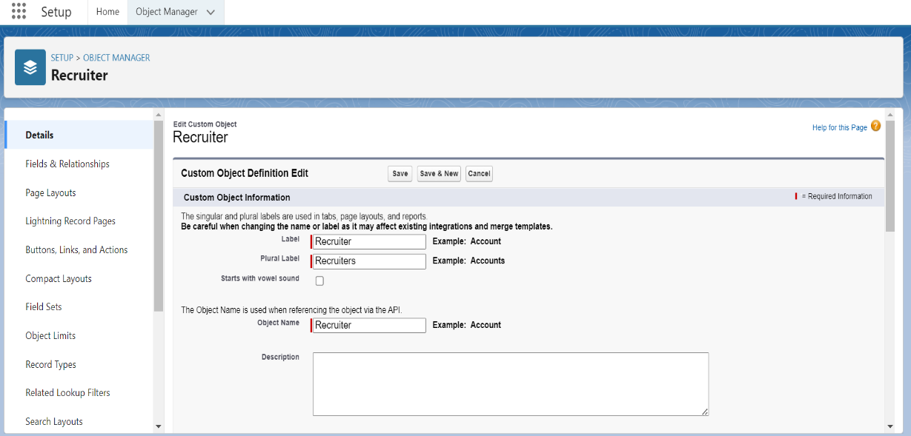

ACTIVITY-02:Create a jobs,Candidate,Job Application Objects

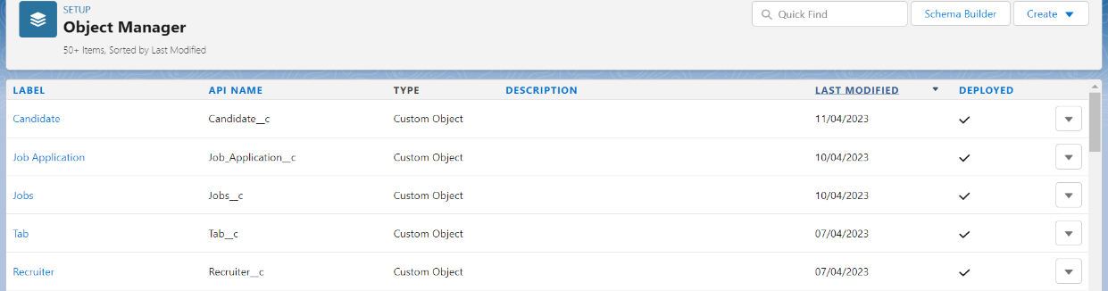

MILESTONE-03:FIELDS

Activity-01:Create the Custom Field

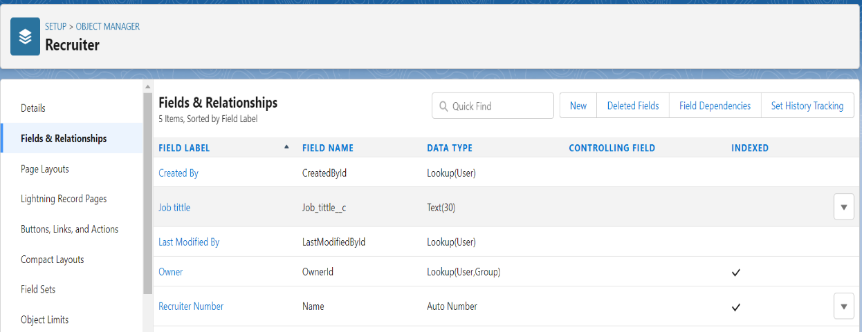

Activity-02: Creation of Master Detail Relationship:

ACTIVITY-03 & ACTIVITY -04

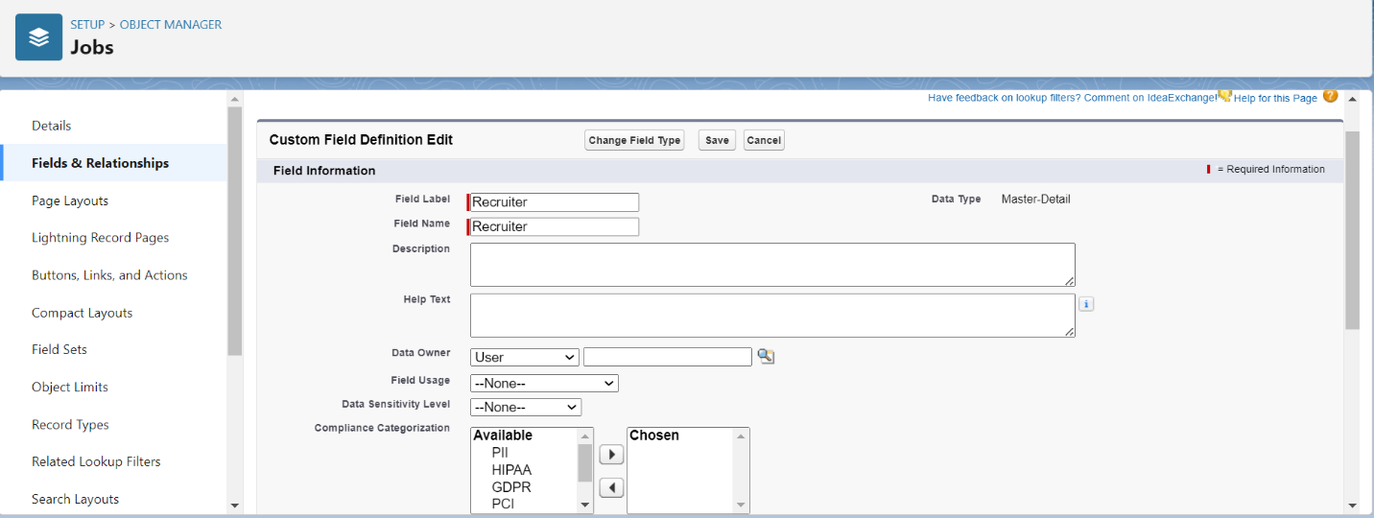

MILESTONE -04:TAB

ACTIVITY-01: Create a Tab

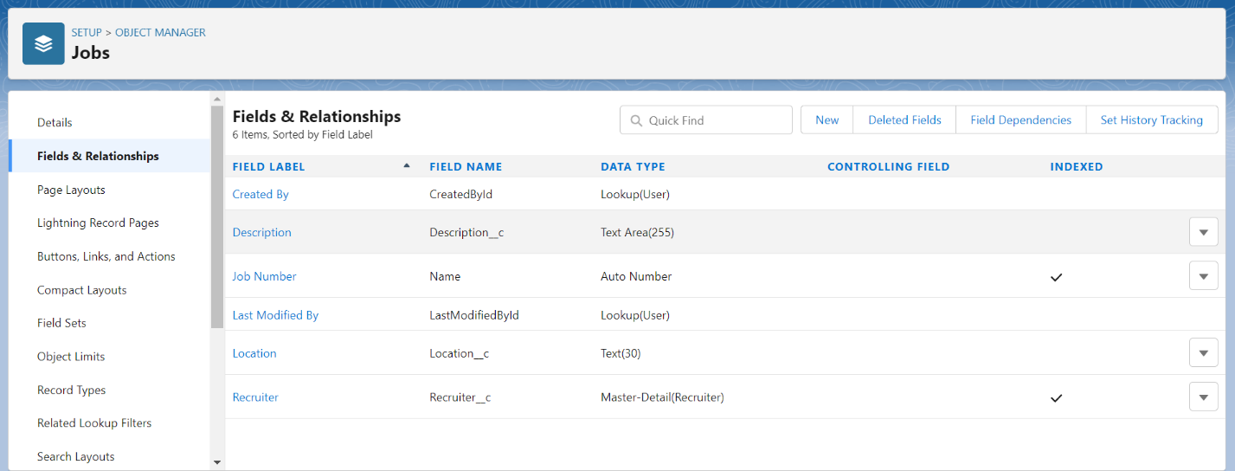

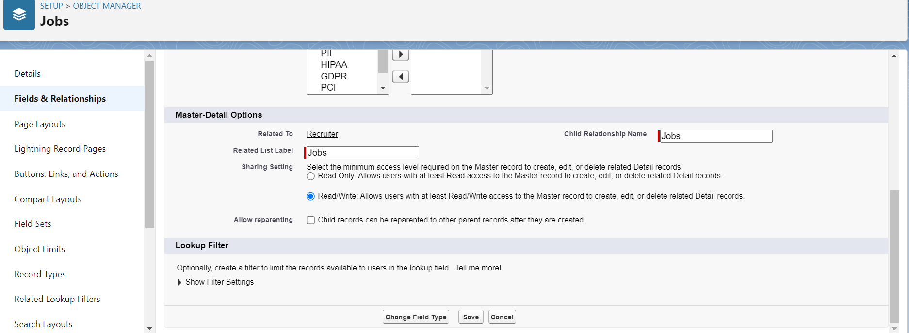

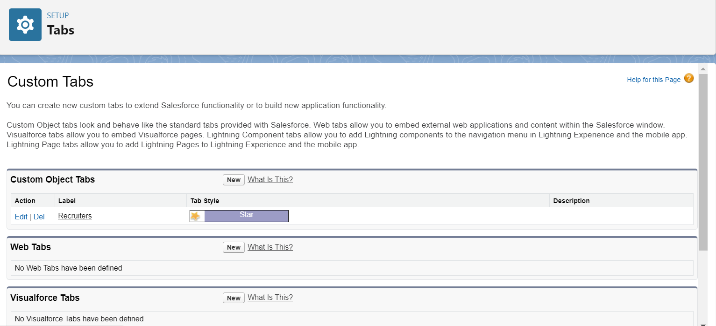

MILESTONE-05:PROFILE

ACTIVITY-01:Create a custom Profile

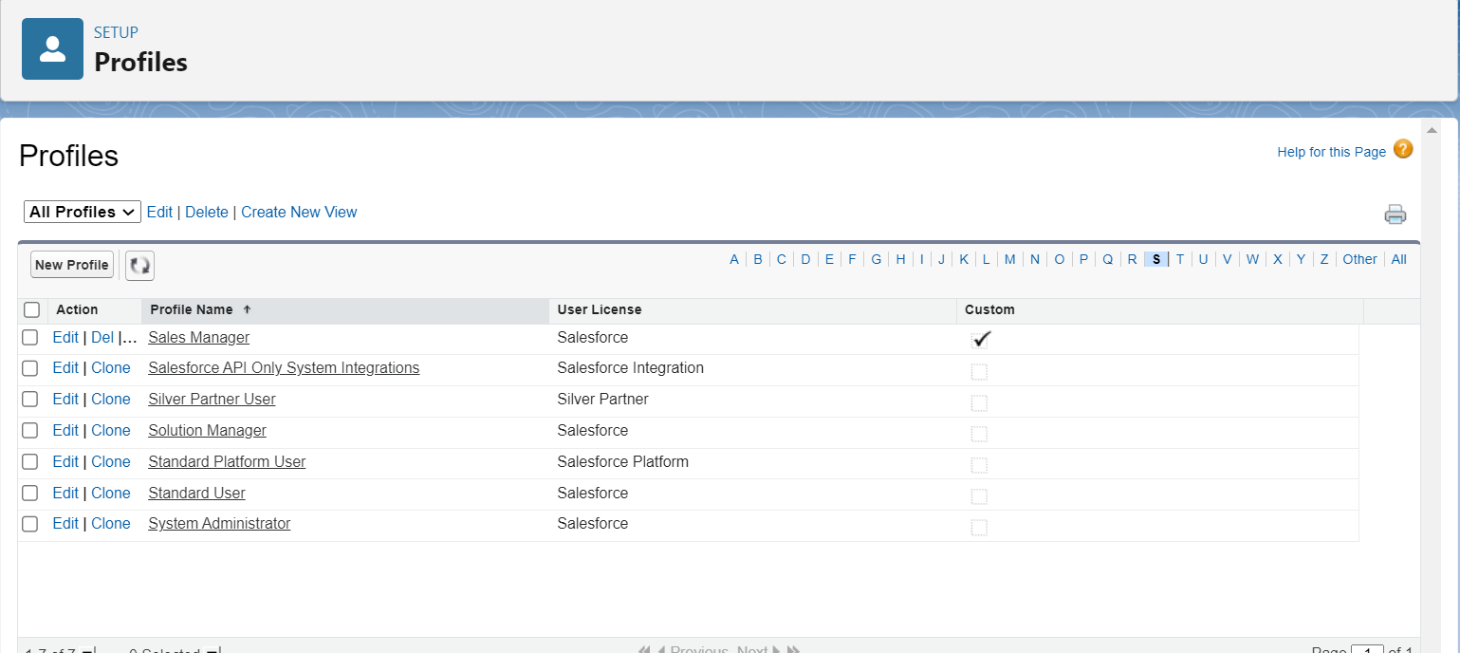

MILESTONE-06:USER

ACTIVITY-01:

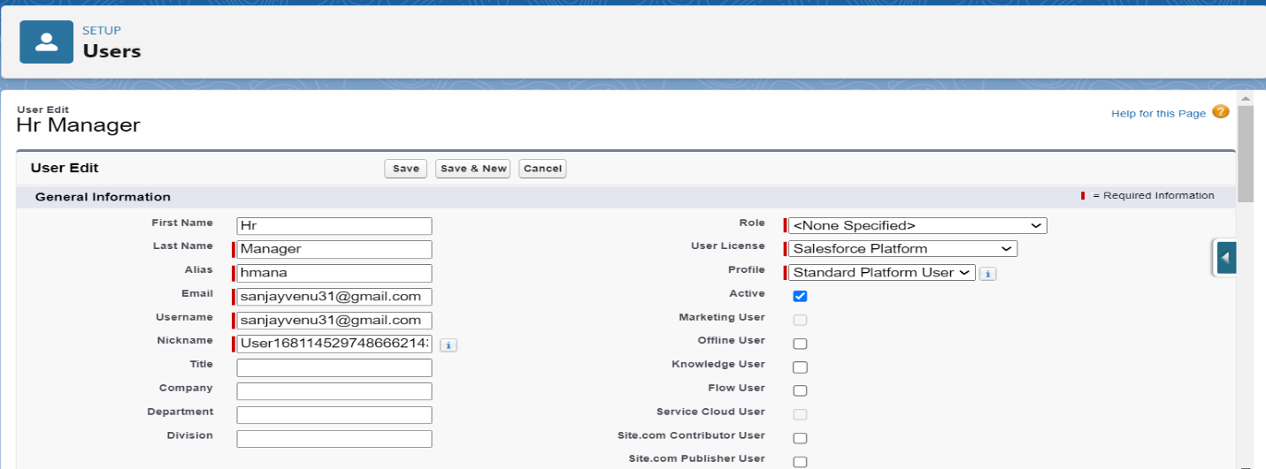

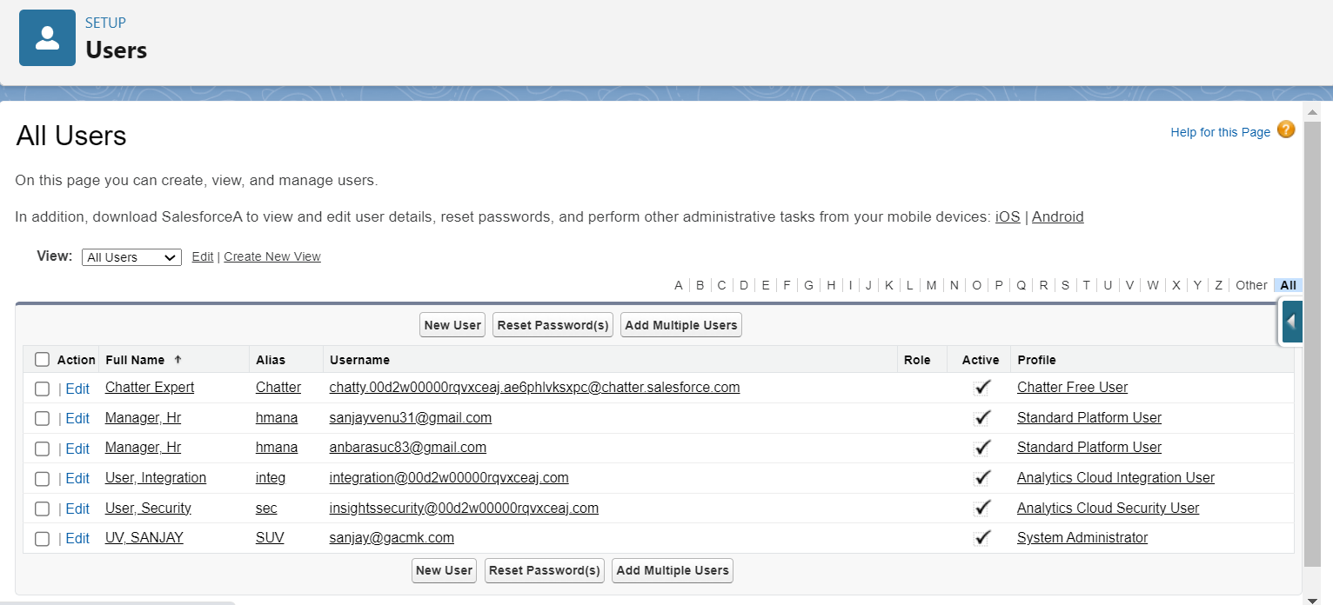

MILESTONE-07:SHARING RULES

ACTIVITY-01: Creating a Sharing Rule

ACTIVITY-02: Create a Sharing Rule to share the records of Job Application to Hr Manager

with the access of read /write

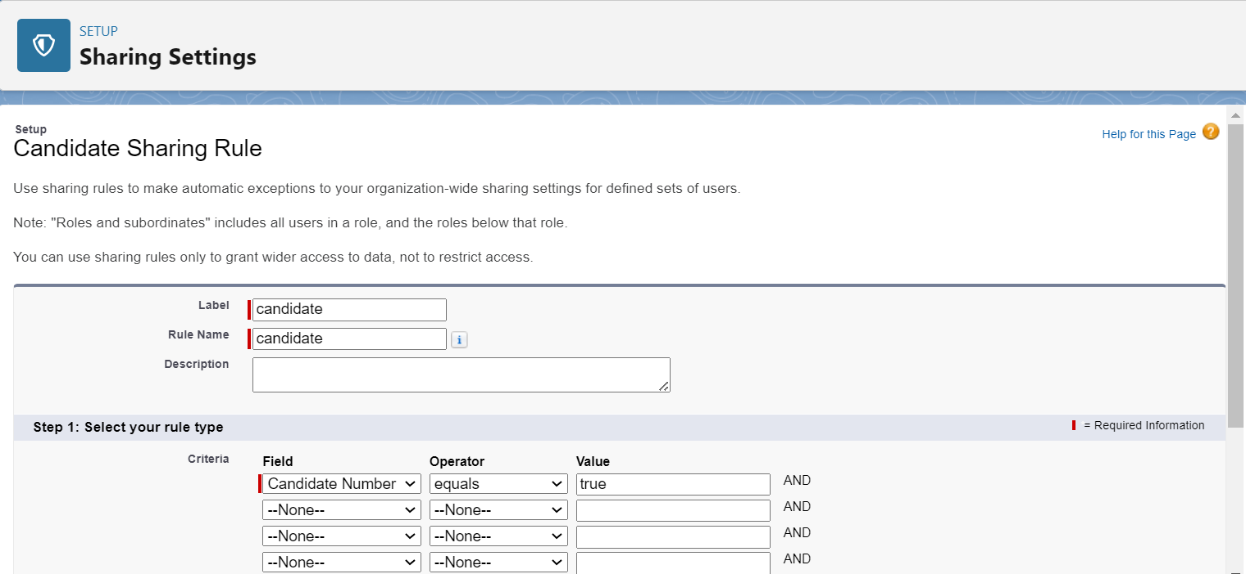

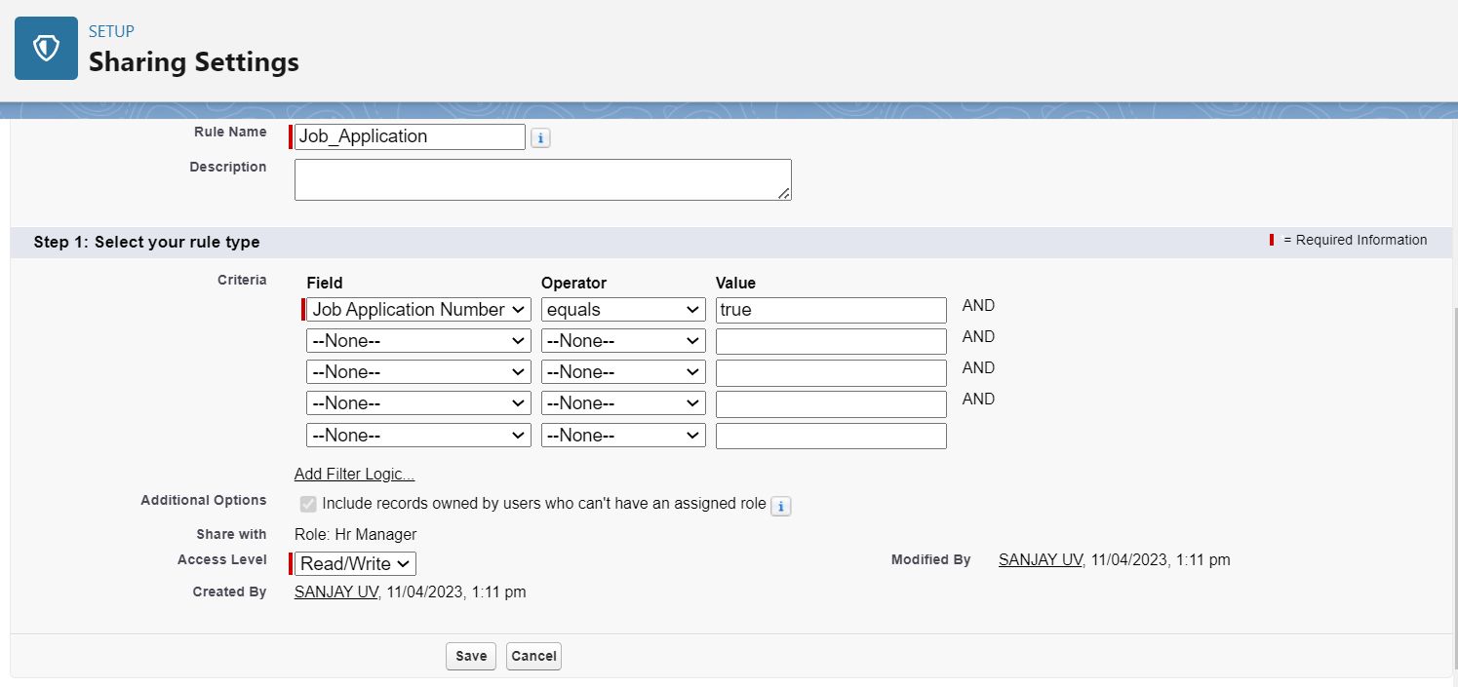

MILESTONE-08:

ACTIVITY-01: Create a Report:

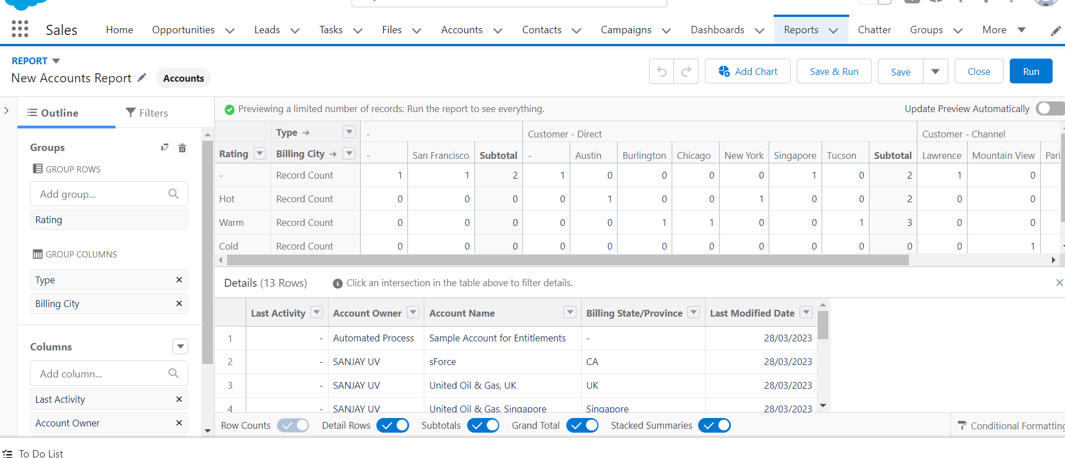

ACTIVITY-02: Creating a Report using Jobs,Candidates,and Job Application

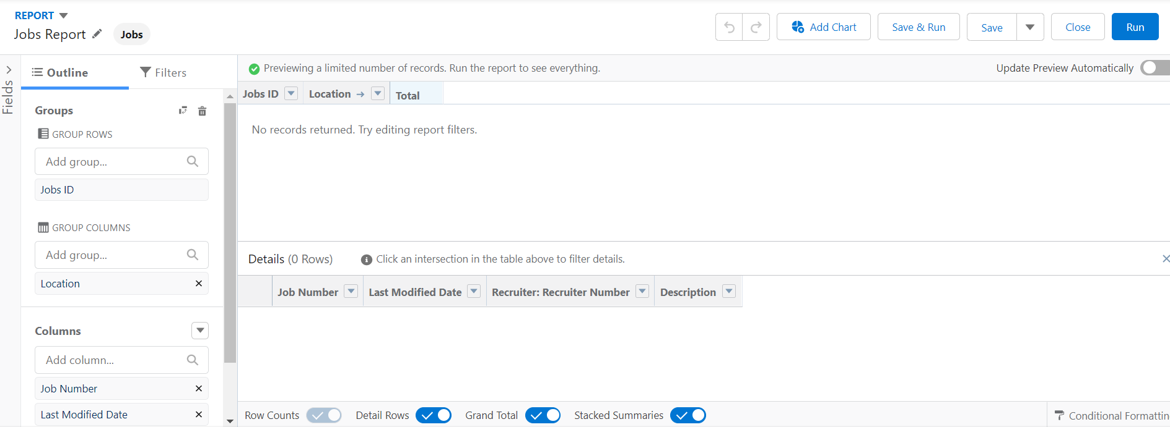

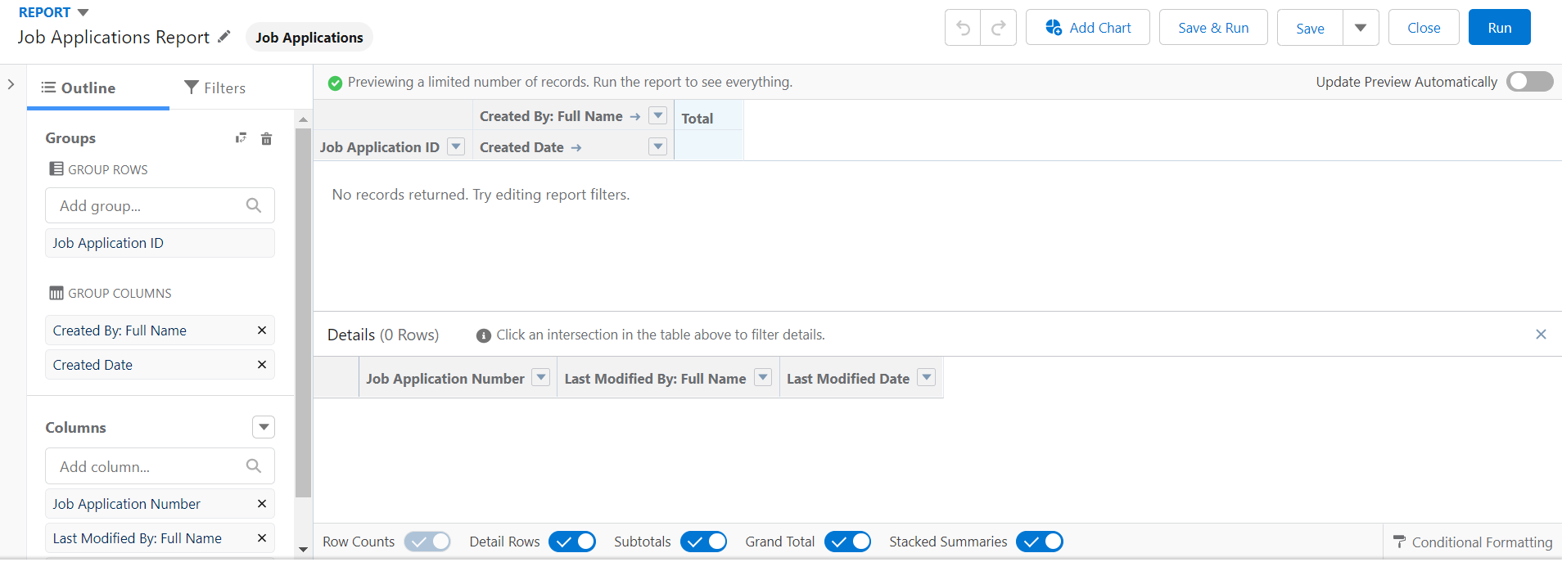

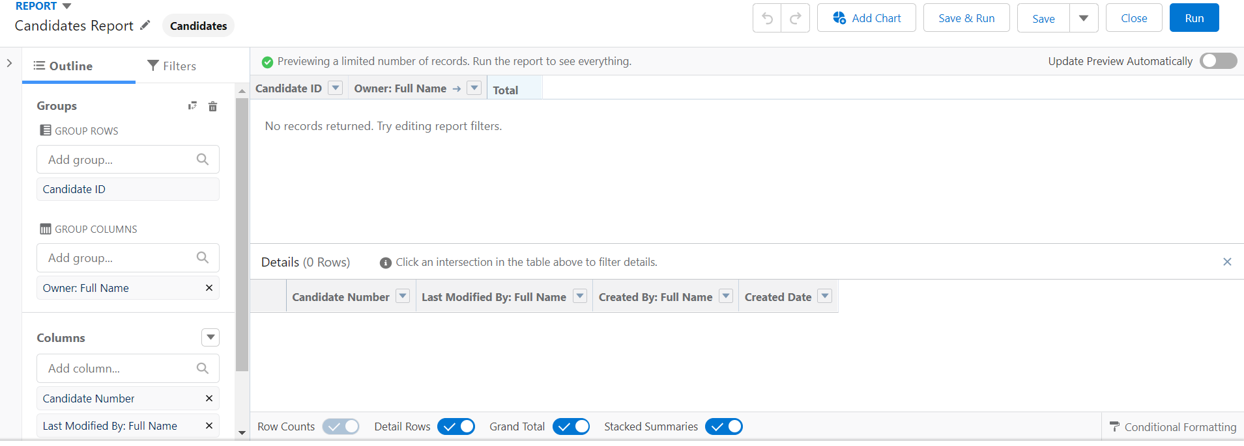

1. **Trailhead Profile Public URL**

**Team Lead -** [**https://trailblazer.me/id/nirmalraj05**](https://trailblazer.me/id/nirmalraj05)

**Team Member 1 -** [**https://trailblazer.me/id/mchitham**](https://trailblazer.me/id/mchitham)

**Team Member 2 –**

[**https://trailblazer.me/id/maiyan3**](https://trailblazer.me/id/maiyan3)

**Team Member 3 –**

[**https://trailblazer.me/id/csathis**](https://trailblazer.me/id/csathis)

****Project Report Template

1. **ADVANTAGES & DISADVANTAGE**

ADVANTAGES

1.REDUCES TIME SPENT ON ADMIN TASKS

2.SPEEDS UP RECRUITMENT CYCLE

3.IMPROVES THE QUALITY OF HIRE

DISADVANTAGES

1.AUTOMATIC ELIMINATION

2.SYSTEM CAN’T READ AND INTERPRET

3.MISREAD RESUMES IN PDF FORMAT

1. **APPLICATIONS**

* JOB APPLICATION TRACKING SYSTEM CAN BE USED BY ANY APPLICANTS WHO ARE LOOKING FOR JOBS
* HELPS TO TRACK JOBS POSTED BY RECRUITERS
* RESUMES CAN BE SUBMITTED EASILY

1. **CONCLUSION**

WE MUST CONCLUDE THAT THE ENTIRE WORK WAS FANTASTIC

AND IT ENABLED US TO GAIN SOME KNOWLEDGE ABOUT THE JOB APPLICATION TRACKING SYSTEM

THANK YOU SALESFORCE AND SMART INTERNZ

1. **FUTURE SCOPE**

WITH THE HELP OF AI , THERE WILL BE A MORE EFFICIENT WAY TO ACCESS JOB APPLICATION TRACKING SYSTEM