**INSTRUCTIONS:**

**#loading the arules package**

install.packages("arulesViz")

**#loading the arulesviz package**

library("arulesViz")

**#loading the dataset**

data("Income")

**#To show transactions(rows) and items(columns)**

head(Income)

**#summarizing the rules**

summary(Income)

**#defining the rules**

rules <- apriori(Income, parameter=list(support=0.5, confidence=0.5, target = "rules"))

rules

**#inspecting the top 10 rules**

inspect(rules[1:10])

head(quality(rules))

subrules <- rules[quality(rules)$confidence > 0.8]

subrules

**#summarizing the rules**

summary(subrules)

plot(subrules, method="matrix3D", measure="lift")

**#graph visualization for top 20 rules**

plot(rules[1:20],method ="graph",control = list(type = "items"))

plot(rules[1:20], measure=c("support","lift"), shading="confidence");

plot(rules[1:20], shading="order", control=list(main ="Two-key plot"));

**#defining the subrule**

subrule <- head(sort(rules, by="lift"), 10)

**#parallel coordinate for subrule**

plot(subrule, method="paracoord", control=list(reorder=TRUE))

**#grouped visualization for subrule**

plot(rules, method="grouped", control=list(k=50))

**OUTPUT:**

**#To show transactions(rows) and items(columns)**

transactions in sparse format with

6 transactions (rows) and

50 items (columns)

**#summarizing the rules**

transactions as itemMatrix in sparse format with

6876 rows (elements/itemsets/transactions) and

50 columns (items) and a density of 0.28

most frequent items:

language in home=english education=no college graduate

6277 4849

number in household=1 ethnic classification=white

4757 4605

years in bay area=10+ (Other)

4446 71330

element (itemset/transaction) length distribution:

sizes

14

6876

Min. 1st Qu. Median Mean 3rd Qu. Max.

14 14 14 14 14 14

includes extended item information - examples:

labels variables levels

1 income=$0-$40,000 income $0-$40,000

2 income=$40,000+ income $40,000+

3 sex=male sex male

includes extended transaction information - examples:

transactionID

1 2

2 3

3 4

**#defining the rules**

Apriori

Parameter specification:

confidence minval smax arem aval originalSupport maxtime support minlen maxlen target

0.5 0.1 1 none FALSE TRUE 5 0.5 1 10 rules

ext

FALSE

Algorithmic control:

filter tree heap memopt load sort verbose

0.1 TRUE TRUE FALSE TRUE 2 TRUE

Absolute minimum support count: 3438

set item appearances ...[0 item(s)] done [0.00s].

set transactions ...[50 item(s), 6876 transaction(s)] done [0.01s].

sorting and recoding items ... [11 item(s)] done [0.00s].

creating transaction tree ... done [0.00s].

checking subsets of size 1 2 3 done [0.00s].

writing ... [40 rule(s)] done [0.00s].

creating S4 object ... done [0.00s].

**#inspecting the top 10 rules**

lhs rhs support confidence lift count

[1] {} => {sex=female} 0.5539558 0.5539558 1 3809

[2] {} => {age=14-34} 0.5853694 0.5853694 1 4025

[3] {} => {type of home=house} 0.5965678 0.5965678 1 4102

[4] {} => {dual incomes=not married} 0.5983130 0.5983130 1 4114

[5] {} => {number of children=0} 0.6218732 0.6218732 1 4276

[6] {} => {income=$0-$40,000} 0.6224549 0.6224549 1 4280

[7] {} => {years in bay area=10+} 0.6465969 0.6465969 1 4446

[8] {} => {ethnic classification=white} 0.6697208 0.6697208 1 4605

[9] {} => {number in household=1} 0.6918266 0.6918266 1 4757

[10] {} => {education=no college graduate} 0.7052065 0.7052065 1 4849

**#summarizing the rules**

support confidence lift count

1 0.5539558 0.5539558 1 3809

2 0.5853694 0.5853694 1 4025

3 0.5965678 0.5965678 1 4102

4 0.5983130 0.5983130 1 4114

5 0.6218732 0.6218732 1 4276

6 0.6224549 0.6224549 1 4280

**MATRIX 3D**

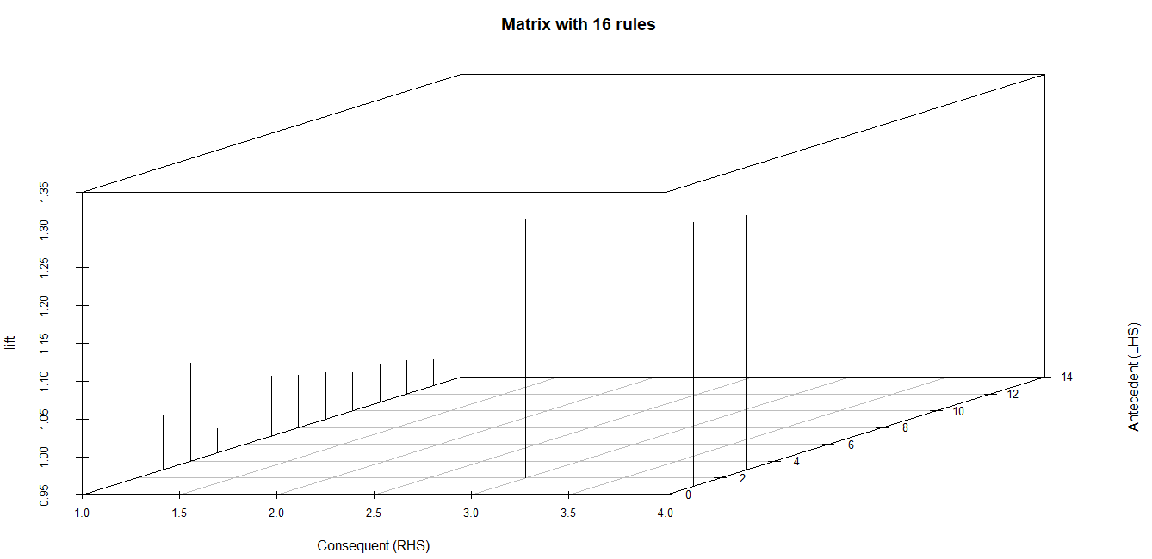

**#graph visualization for top 20 rules**

**Plot:**

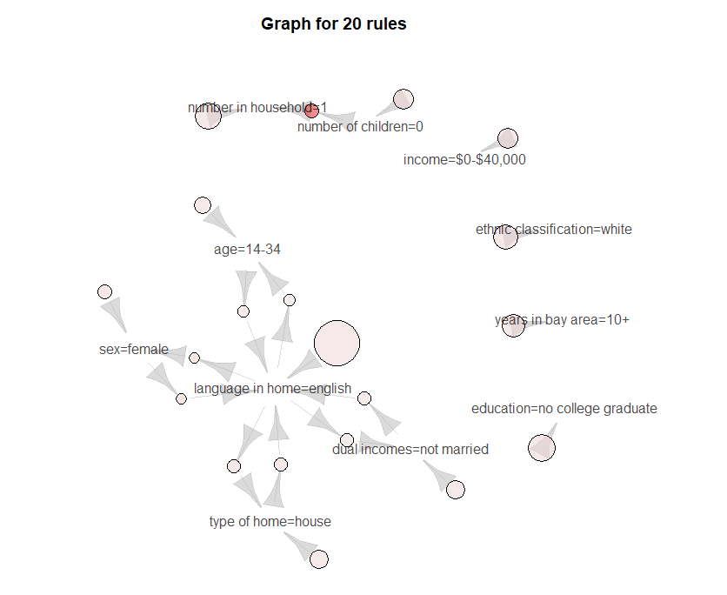

**Plot:**

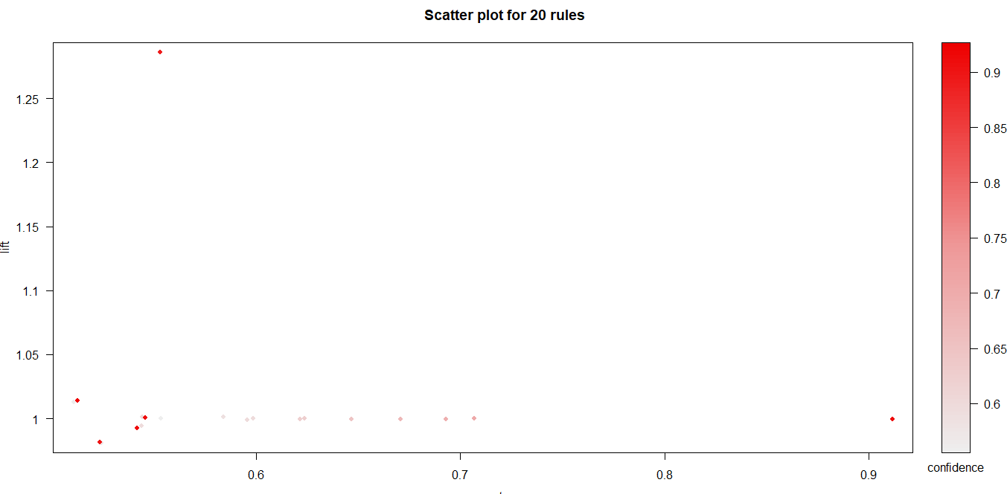

**Plot:**

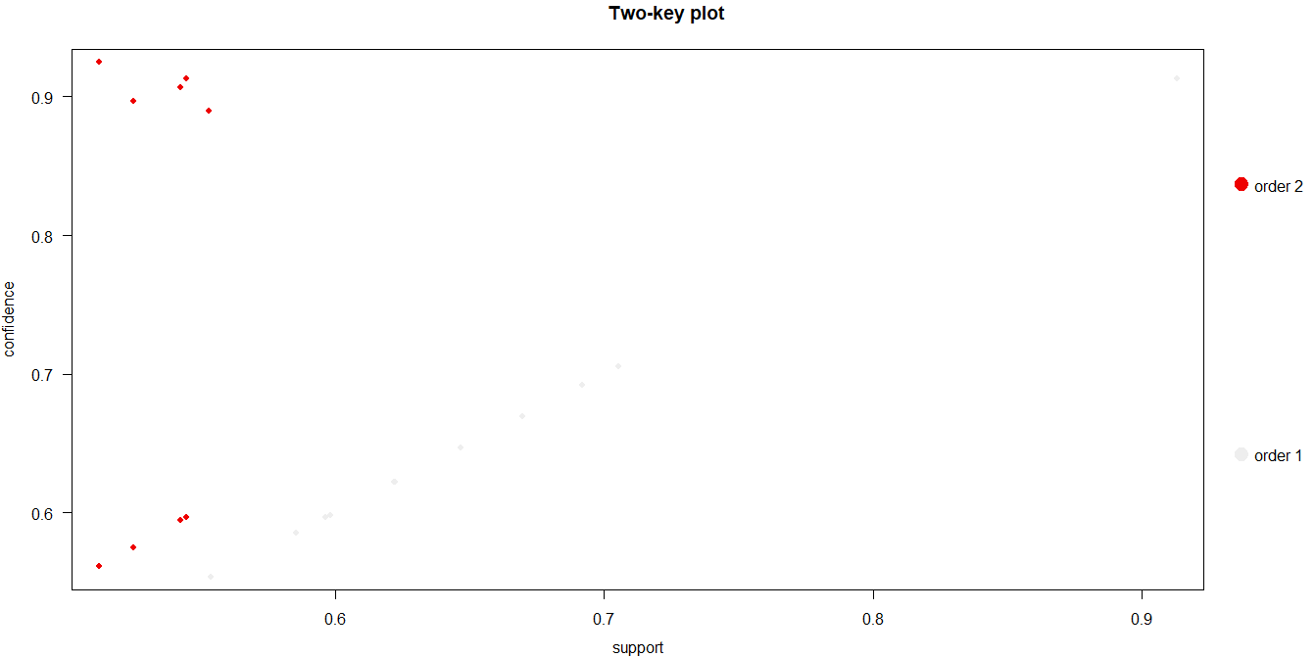

**#parallel coordinate for subrule**

**Plot:**

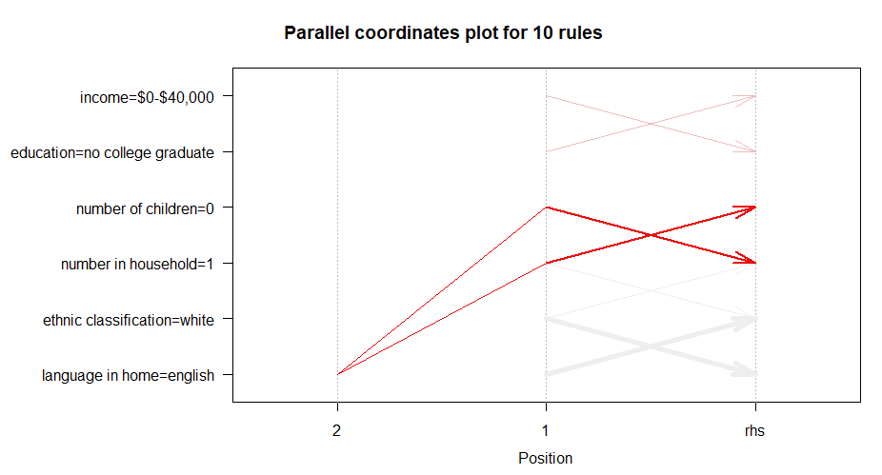

**#grouped visualization for subrule**

**Plot:**

