**INSTRUCTIONS:**

**# Set the Working Directory**

setwd("D:/Studies/VIII Semester/R/Programs/Ex 3")

**#Get the Working Directory**

getwd()

**#Read the Dataset of CSV Format**

data_cleaning <- read.csv("D:/Studies/VIII Semester/R/Programs/Ex 3/data_cleaning.csv", header=TRUE)

**#View the Minimum Value in the Column**

min(data_cleaning$Budget_2018_2019_Total)

**#View the Maximum Value in the Column**

max(data_cleaning$Budget_2018_2019_Total)

**#View the Mean Value of a Column**

mean(data_cleaning$Budget_2018_2019_Total)

**#View the Standard Deviation of a Column**

sd(data_cleaning$Budget_2018_2019_Total)

**#View the Dataset**

View(data_cleaning)

**#View the Dataset Class**

class(data_cleaning)

**#View the Dimention of Dataset**

dim(data_cleaning)

**#View the Number of Columns**

length(data_cleaning)

**#View the Names of Columns**

names(data_cleaning)

**#View the Number of Rows**

nrow(data_cleaning)

**#View the Structure of Dataset**

str(data_cleaning)

**#View the Summary of Dataset**

summary(data_cleaning)

**#View the First N Rows**

head(data_cleaning, n=10)

**#View the Last N Rows**

tail(data_cleaning,n=10)

**#View the Dataset in Data Editor**

fix(data_cleaning)

**#View the Glimpse of Data in a Column**

glimpse(data_cleaning$Budget_2018_2019_Total)

**#NOISY DATA**

**#binning**

bins<-5

minimumVal<-min(data_cleaning$Budget_2018_2019_Total)

maximumVal<-max(data_cleaning$Budget_2018_2019_Total)

width=(maximumVal-minimumVal)/bins;

x<-cut(data_cleaning$Budget_2018_2019_Total, breaks=seq(minimumVal, maximumVal, width))

x

barplot(data_cleaning$Budget_2018_2019_Total)

barplot(table(cut(data_cleaning$Budget_2018_2019_Total, breaks=seq(minimumVal, maximumVal, width))))

**#regression**

scatter.smooth(x=data_cleaning$Revised_2017_2018_Revenue, y=data_cleaning$Budget_2018_2019_Revenue, main="Revised_2018_2019_Revenue ~ Budget_2018_2019_Revenue")

boxplot(data_cleaning$Budget_2018_2019_Total, main="Budget_2017_2018_Revenue", sub=paste("Outlier rows: ", boxplot.stats(data_cleaning$Budget_2017_2018_Revenue)$out)) # box plot for 'Budget_2017_2018_Revenue'

**#Outlier Analysis**

data_cleaning$Budget_2018_2019_Total[data_cleaning$Budget_2018_2019_Total<0]<-NA

**#MISSING VALUES**

**#To replace the data with mean value**

for (i in which(sapply(data_cleaning, is.numeric)))

{

data_cleaning[is.na(data_cleaning[, i]), i] <- mean(data_cleaning[, i], na.rm = TRUE)

}

**#Ignoring the tuples**

data_new<-na.omit(data_cleaning)

data_new

fix(data_new)

**#Pictorial representation**

**#histogram**

hist(data_cleaning$Budget_2018_2019_Total)

**#plot**

plot(data_cleaning$Budget_2017_2018_Total,data_cleaning$Budget_2018_2019_Total)

**#boxplot**

boxplot(data_cleaning)

boxplot(data_cleaning, las = 2,col = c("red","sienna","red","sienna","royalblue2","red","sienna","royalblue2","red","sienna","royalblue2","red","sienna","royalblue2"),at = c(1,2, 4,5,6, 8,9,10, 12,13,14, 16,17,18),par(mar = c(14, 5, 4, 2)- 1),names = c("Index","Partriculars","Actual_2016_2017_Revenue","Actual_2016_2017_Capital","Actual_2016_2017_Total","Budget_2017_2018_Revenue","Budget_2017_2018_Capital","Budget_2017_2018_Total","Revised_2017_2018_Revenue","Revised_2017_2018_Capital","Revised_2017_2018_Total","Budget_2018_2019_Revenue","Budget_2018_2019_Capital","Budget_2018_2019_Total "))

**OUTPUT:**

**#Get the Working Directory**

[1] "D:/Studies/VIII Semester/R/Programs/Ex 3"

**#View the Minimum Value in the Column**

[1] -2100.00

**#View the Maximum Value in the Column**

[1] 982.72

**#View the Mean Value of a Column**

[1] 185.11

**#View the Dataset Class**

[1] "data.frame"

**#View the Dimention of Dataset**

[1] 77 14

**#View the Number of Columns**

[1] 14

**#View the Names of Columns**

[1] "Index" "Particulars"

[3] "Actual_2016_2017_Revenue" "Actual_2016_2017_Capital"

[5] "Actual_2016_2017._Total" "Budget_2017_2018_Revenue"

[7] "Budget_2017_2018_Capital" "Budget_2017_2018_Total"

[9] "Revised_2017_2018_Revenue" "Revised_2017_2018_Capital"

[11] "Revised_2017_2018_Total" "Budget_2018_2019_Revenue"

[13] "Budget_2018_2019_Capital" "Budget_2018_2019_Total"

**#View the Number of Rows**

[1] 77

**#View the Glimpse of Data in a Column**

num [1:77] 752 193 -2100 170 ...

**#NOISY DATA**

**#binning**

**#before:**

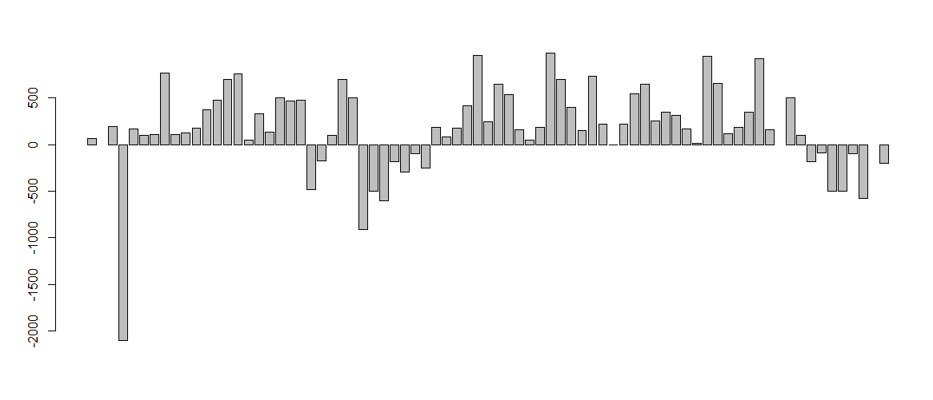

**After:**

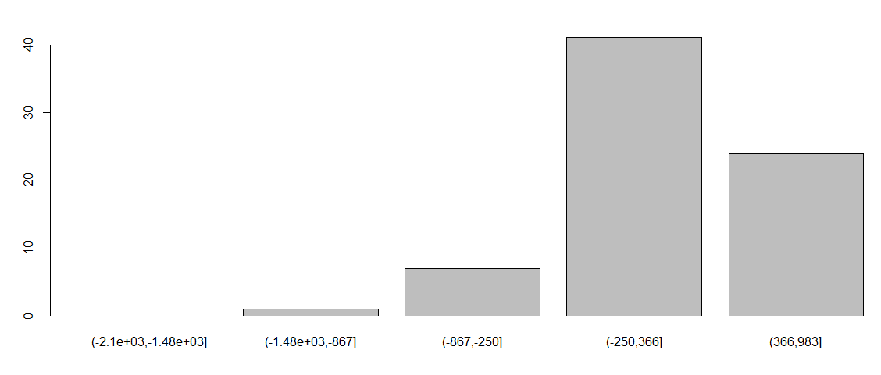

**#regression**

**scatter plot:**

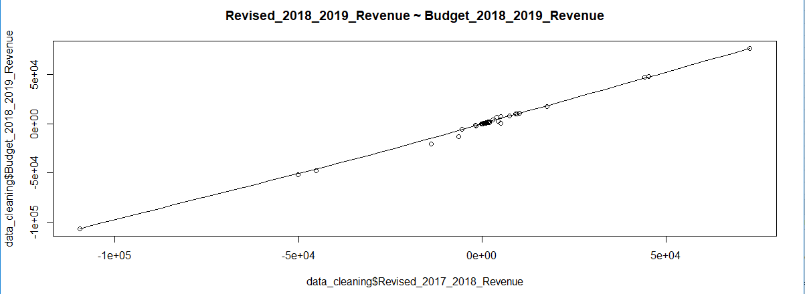

**BOX PLOT:**

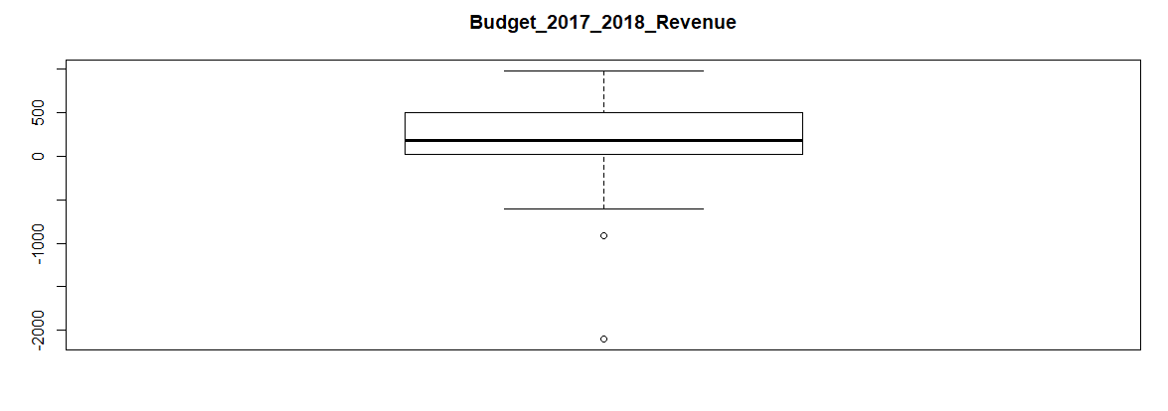

**#Outlier Analysis**

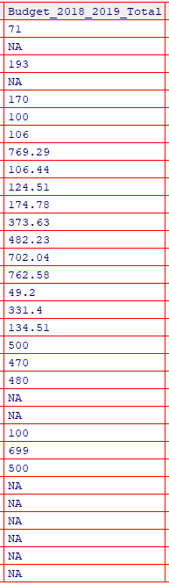

**#MISSING VALUES**

**#To replace the data with mean value**

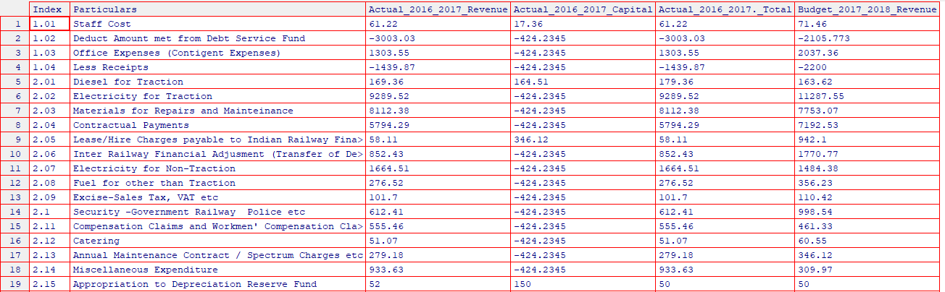

**#Ignoring the tuples**

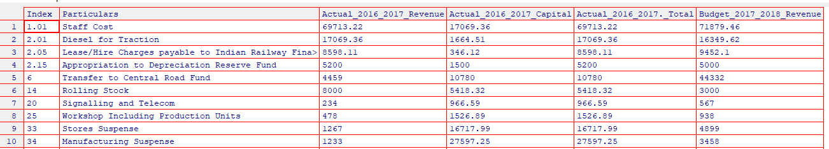

**#PICTORIAL REPRESENTATION**

**#HISTOGRAM**

**Before:**

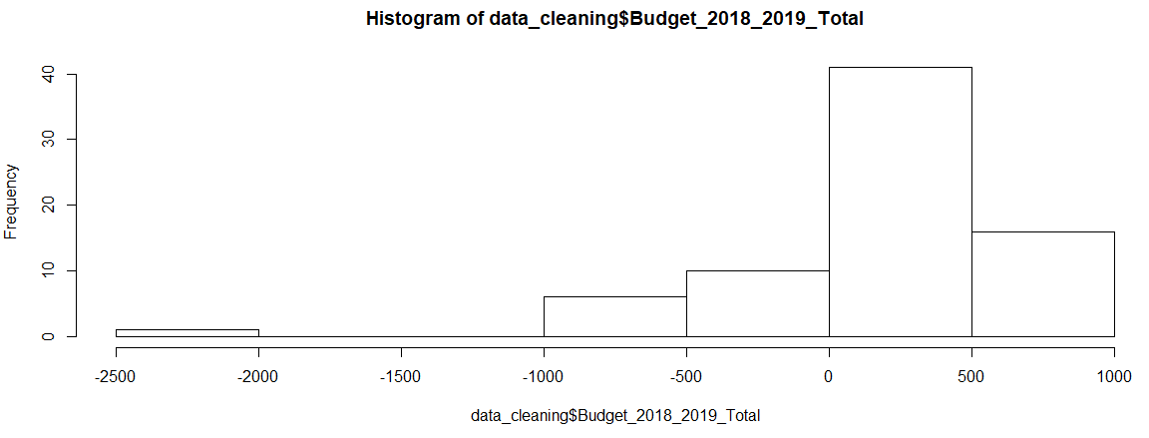

**After:**

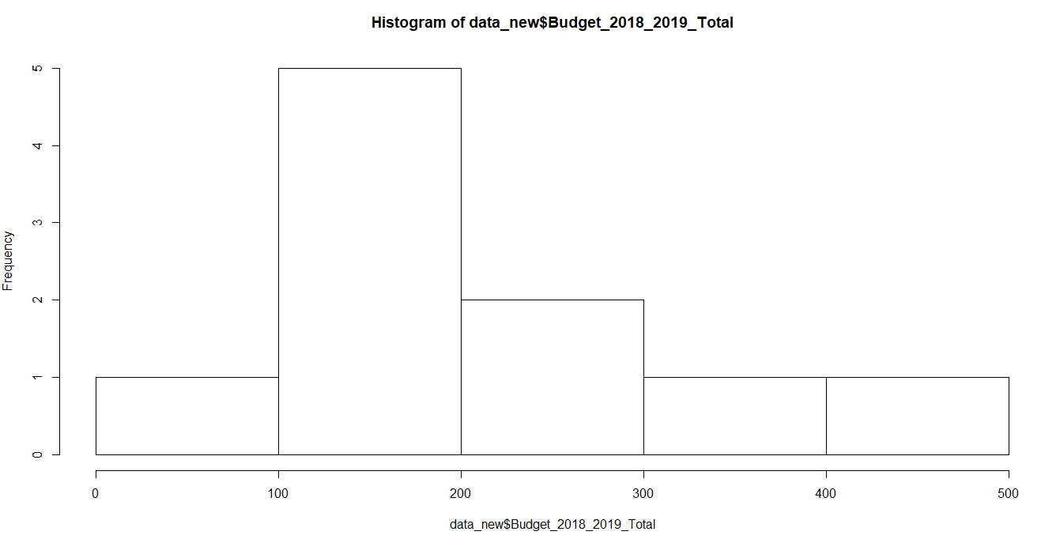

**PLOT:**

**Before:**

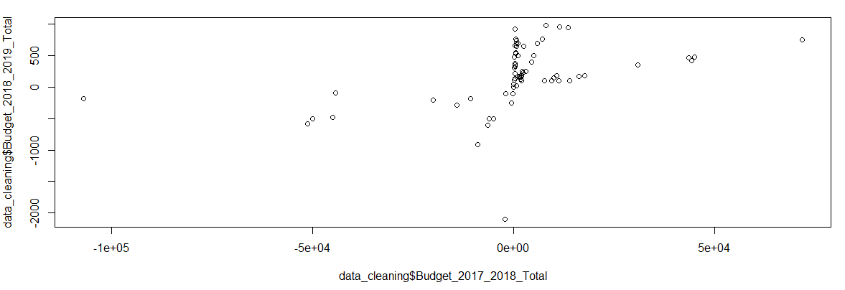

**After:**

