Document to Run and test INGParent Enterprise Application :

1. Run below command and clone the project from git

Git clone <https://github.com/nirmalshah1989/INGParent/>

1. Run **mvn clean install** command to build the project.(If error occurs check the Java version)

If doing checkout direct from eclipse then convert application into maven application and then do clean install.

1. Create database with schema **sys**. If schema and Database is different than change the values in **config.properties**.

Add the dependent jar as well if DB is not MySql.

1. Import the project in eclipse and run the INGEar module with Jboss.
2. Screenshots of different endpoint and its response.

[**http://localhost:8080/WebModule/rest/statuscheck/db**](http://localhost:8080/WebModule/rest/statuscheck/db)

Response :

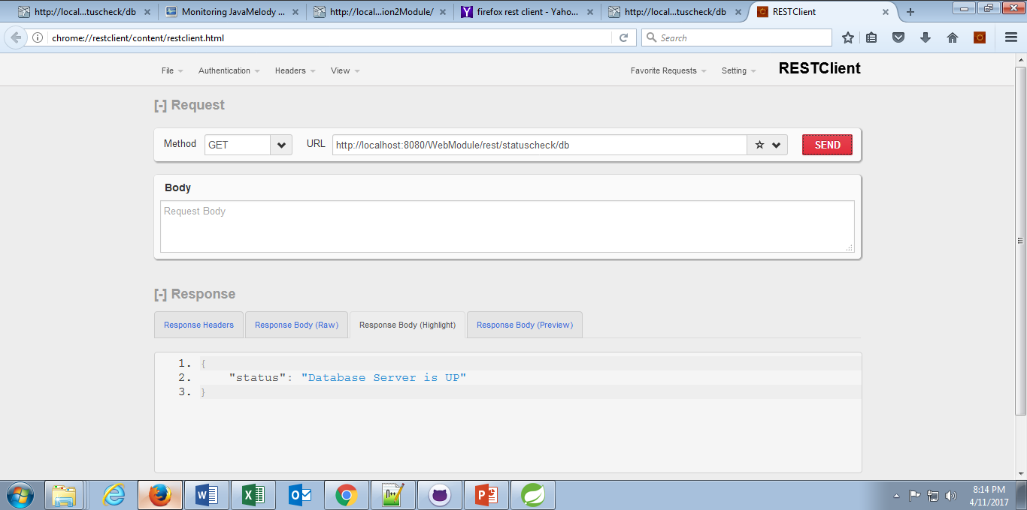

[**http://localhost:8080/WebModule/rest/statuscheck/app1**](http://localhost:8080/WebModule/rest/statuscheck/app1)

Response :

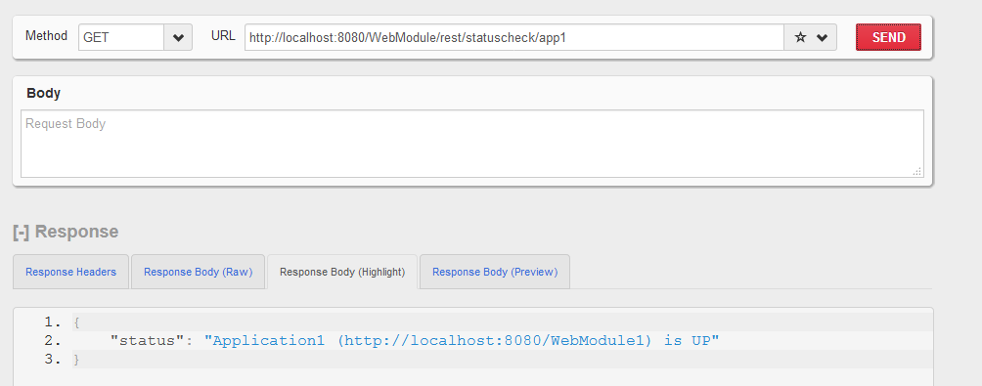

[**http://localhost:8080/WebModule/rest/statuscheck/app2**](http://localhost:8080/WebModule/rest/statuscheck/app2)

Response :

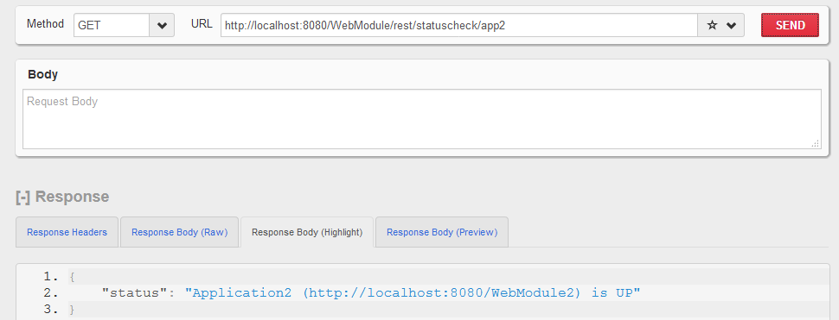

[**http://localhost:8080/WebModule/rest/statuscheck/app**](http://localhost:8080/WebModule/rest/statuscheck/app)

Response :

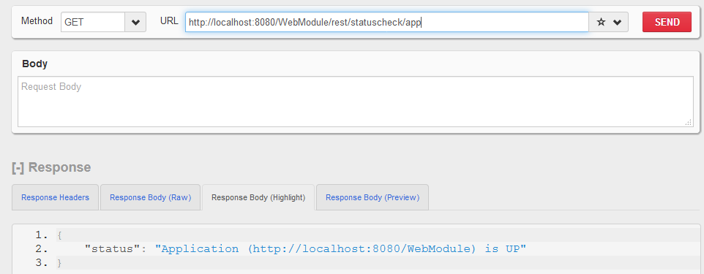

**<http://localhost:8080/WebModule/rest/statuscheck/dependency>**

Response :

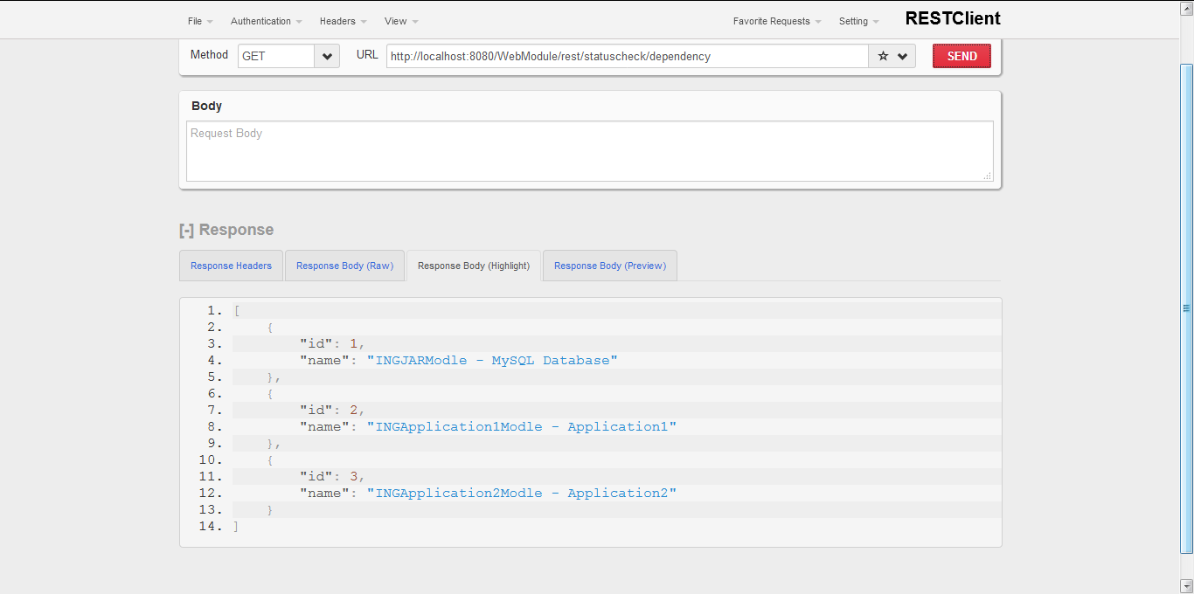

Monitoring Page

[**http://localhost:8080/WebModule/monitoring**](http://localhost:8080/WebModule/monitoring)

