Name Taterh, Nirman___ Date: Wednesday 10/5/23 (last name, first name)

NYU ID: N14422340

Course Section: 001

Lab #2 – Application Layer

**Total in points** (100 points total):

Professor’s Comments:

Affirmation of my Independent Effort: NIRMAN TATERH

(Sign here)

1. **Problem 1 – Protocols Analysis:**
2. **Use a packet sniffer (e.g., Wireshark) to capture the sequence of ASCII characters that are sent and received by a web browser as a result of a request of your choice to a web server. Provide a screen capture of these sequences and add carriage return and line feed characters as needed to improve readability.**

**Ans:** I used Wireshark to capture the sequence of ASCII characters that are sent and received using Google Chrome for amazon.com.

Request:

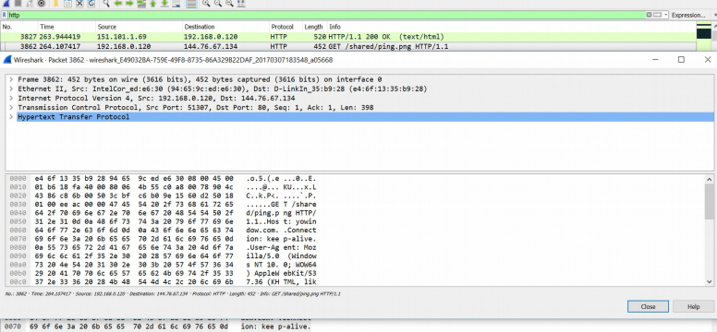

Response:

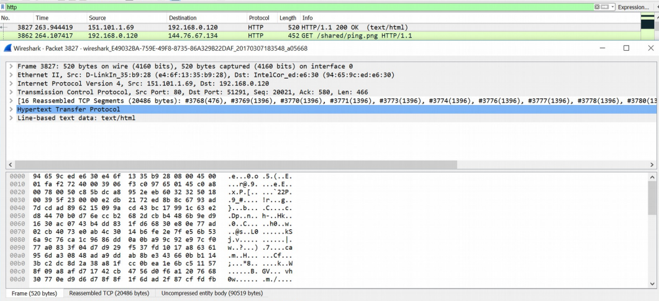

1. **Identify the complete URL of the document requested, the HTTP protocol version for both the request and response, the operating system that the web browser is running on, and the kind of web server that answered the request**

**Ans:** Complete URL of the document requested: <https://www.amazon.com/>

HTTP protocol version for both the request and response: 1.1

Operating System that the web browser is running on: Windows 10

1. **Is the HTTP connection persistent?**

**Ans:** The browser has indicated a desire for a continuous or persistent connection, which can be recognized by the presence of the "Connection: keep-alive" header in the request.

1. **Which web browser sent the request and why is it important for the server to know this information?**

**Ans:** Google Chrome is the web browser that includes this data in its request. This detail is crucial for the server because it determines which version of the content to send, tailored to the specific browser type. Depending on the browser, the web server will then send the suitable response to the computer's IP address through a designated port number.

1. **Was the request successful and, if so, what type of document was received by the server?**

**Ans:** Yes, the request was successful and the document type received is text/html (which can be seen in the screenshot above).

1. **Problem 2 – Network Application Deployment**

**Deploy a simple application to K8s that returns the current time when visited using the path “/time”.**

**Ans:** Deployed on Github (Link: <https://github.com/nirmantaterh/time_app>)