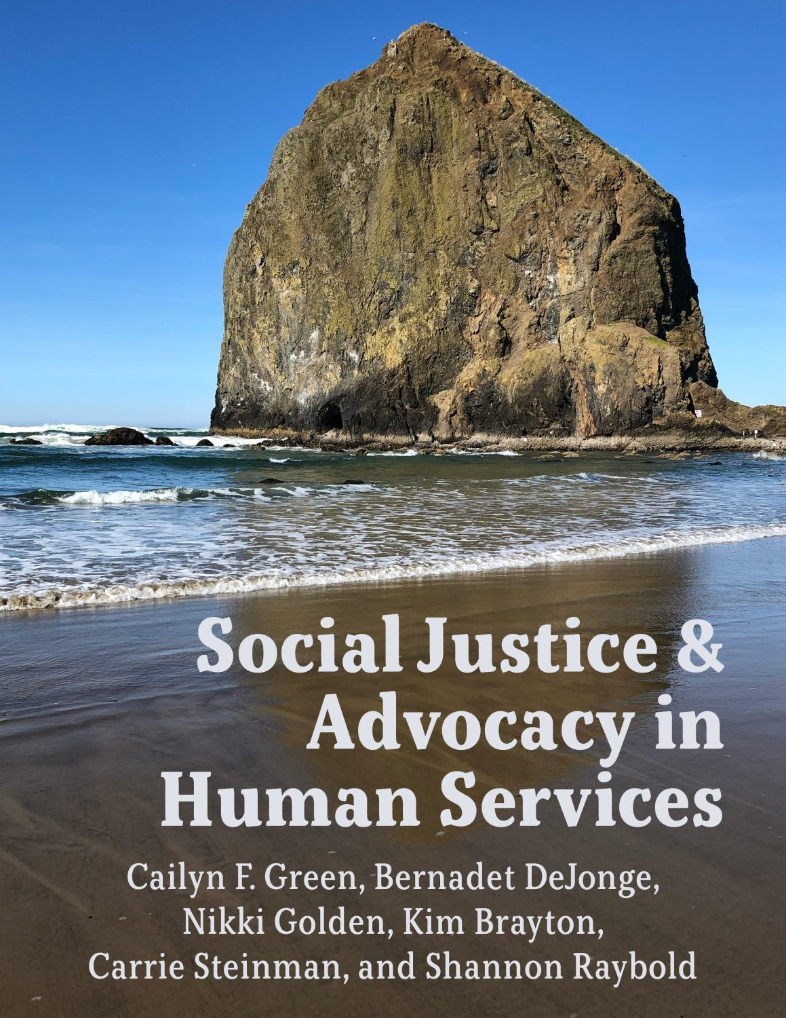

SOCIAL JUSTICE & ADVOCACY IN HUMAN SERVICES

Cailyn F. Green; Bernadet DeJonge; Nikki Golden; Kim Brayton; Carrie Steinman; and Shannon Raybold

Milne Open Textbooks

Geneseo

*Social Justice & Advocacy in Human Services Copyright © 2025 by Cailyn F. Green, Bernadet DeJonge, Nikki Golden, Kim Brayton, Carrie Steinman and Shannon Raybold is licensed under a* [*Creative Commons Attribution 4.0 International License*](https://creativecommons.org/licenses/by/4.0/)*, except where otherwise noted.*

ISBN: 978-1-956862-15-7

Published by Milne Open Textbooks, Milne Library

State University of New York at Geneseo,

Geneseo, NY 14454

AI Usage Disclosure: Portions of this text were created or edited with assistance from ChatGPT and Grammarly. The content has been reviewed and edited by multiple authors and reviewers. For more information on the extent and nature of AI usage, please contact the authors.

CONTENTS

Preface vii

Cailyn F. Green

Overview, Framing, and Definitions ix

Bernadet DeJonge and Cailyn F. Green

1. Historical Concepts of Social Justice 1

Cailyn F. Green; Kim Brayton; and Bernadet DeJonge

1. Theories of Social Justice 14

Cailyn F. Green; Kim Brayton; and Bernadet DeJonge

1. Human Rights and the Equitable Distribution of Resources 31

Cailyn F. Green; Kim Brayton; and Bernadet DeJonge

1. Power, Privilege, Oppression, and Bias 43

Cailyn F. Green; Kim Brayton; and Bernadet DeJonge

1. Legislation and Policy 59

Bernadet DeJonge; Nikki Golden; and Cailyn F. Green

1. Race, Racism, and Being Black in the United States 84

Nikki Golden and Bernadet DeJonge

1. Race: Being Asian, Indigenous, and Latinx in the United States 143

Bernadet DeJonge and Nikki Golden

1. Being a Woman in the United States 231

Nikki Golden and Bernadet DeJonge

1. Gender and Sexuality in the United States 274

Nikki Golden and Bernadet DeJonge

1. Poverty in the United States 322

Bernadet DeJonge

1. Religion in the United States 340

Bernadet DeJonge; Nikki Golden; and Cailyn F. Green

|  |  |
| --- | --- |
| 12. Ability in the United States  Bernadet DeJonge and Shannon Raybold | 374 |
| 13. Community Action and Activism  Bernadet DeJonge; Nikki Golden; and Cailyn F. Green | 427 |
| 14. Social Justice Practice in Human Services: An Individual Approach  Cailyn F. Green; Kim Brayton; Carrie Steinman; and Bernadet DeJonge | 438 |
| 15. Social Justice Practice in Human Services: A Systems Approach  Cailyn F. Green; Kim Brayton; Carrie Steinman; and Bernadet DeJonge | 462 |
| Peer Reviewer Statement | 478 |
| Acknowledgements | 480 |
| About the Authors | 481 |

PREFACE | VII

# Preface

## Cailyn F. Green

There is a noticeable disparity in the educational field when it comes to affordable resources on topics associated with social justice. Creating this open educational resource (OER) allowed us to “practice what we preach” when teaching a class about social justice and diversity. By offering a free, peer-reviewed resource for instructors, we can offer inclusivity and equity for students. Our goal is to disrupt the high cost of textbooks and to create space for students in the social justice movement.

Throughout the writing process of this OER, our team traveled and presented at national conferences all over the country. By presenting at different venues, we were able not only to share the idea of OER and how they benefit students, but also to share the specific content of this textbook. During our presentation at the National Conference on Race and Ethnicity (NCORE) in 2023, we asked the audience to share words or concepts that come to mind when they think about “social justice.” The words they shared are listed below:

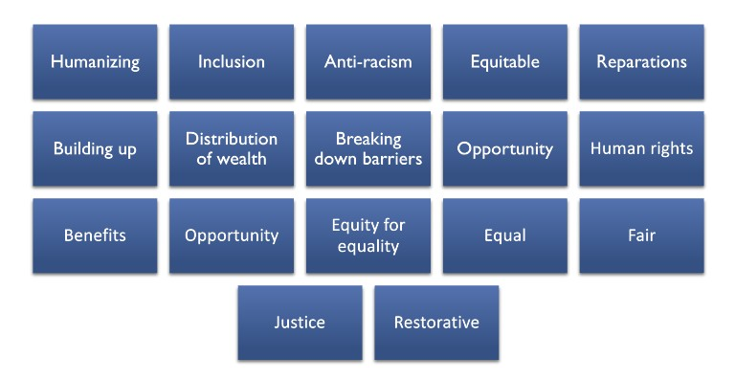

This collection of words was an inspirational message. It showed us that the work we are doing is necessary, important, and desired. The long-term plan for this OER is to update it on a yearly basis. We aim to maintain a current and up-to-date resource for instructors teaching social justice. If, after reading this OER, you have feedback to share regarding concepts, theories, facts, or ideas that you would like to see in the next updated version, please let us know.

### VIII | PREFACE

Just as social justice will only grow if society remains vigilant, this OER will only remain strong if our community engages and supports this project.

Contact information for this project: Cailyn Green

Cailyn.green@sunyempire.edu

518-581-5353

Bernadet DeJonge bernadet.dejonge@yu.edu

315-460-3166

OVERVIEW, FRAMING, AND DEFINITIONS | IX

# Overview, Framing, and Definitions

Bernadet DeJonge and Cailyn F. Green

|  |
| --- |
| Learning Objectives |
| 1. The reader will identify the framing used in this text. 2. The reader will define key terms used throughout this text. |

Writing about social justice is a daunting task. Social justice cannot, by definition, be neutral. As writers on this project, we did not aim for neutrality. Our goal in writing this text is to advocate to change the systems of oppression that divide us. We believe social justice is important and salient in today’s world and acknowledge the systems of power that permeate the content of this book. We also acknowledge that not every experience of injustice is the same and recognize that intersectionality is important in discussing social justice issues. And yet, we also had to organize this text to make it useful in the classroom setting and beyond. Thus, we have woven intersectionality in where we can while acknowledging the inherent difficulties in choosing to address populations individually. In addition, the authors acknowledge that this text is written by mostly White-identifying women who, while impassioned by the topic, also have not experienced all the marginalization discussed.

This text is written from the perspective that many marginalized identities are social constructs. As people, we sort ourselves into categories of race, ethnicity, gender, sexual orientation, and ability. However, these categories are constructed and maintained by the status quo and thus change and shift over time. Race is not a biological construct but a social one. Our chapters address race, gender, and ability from this perspective.

This text is also framed through a lens of social constructivism, which means that we learn from each other. In this vein, we have intentionally branched out from peer-reviewed sources to add real-world stories to supplement our research and work. This includes personal stories, voices found online, interviews, and the generation of real-world examples for the reader to learn from.

### X | OVERVIEW, FRAMING, AND DEFINITIONS



### Overview of Chapters

This text is intentionally organized to be used in full in a human services context, or in pieces for any other subject. It is meant to be a broad overview with cues to encourage student exploration and depth. Our intent is to provide students and instructors the opportunity to use content that is useful for teaching social justice in any context.

This overview reviews the general themes and topics of the text, the framing of the text, and the definitions used throughout. Chapter 1 provides historical foundations for social justice concepts and explores how people have historically viewed and regulated morality and justice. Chapter 2 examines theories of social justice from ancient to modern times. Chapter 3 starts to frame social justice issues in the language of human rights and equitable distribution of resources. Chapter 4 examines and defines power, privilege, bias, and oppression. Chapter 5 examines the impact of law and policy on social justice issues.

Chapters 6 and 7 starts the discussion of racism, and examines the history and experience of specific populations. Chapter 8 examines women in the United States. Chapter 9 reviews sexuality and gender issues in the United States. Chapter 10 discusses the experience of poverty in the United States. Chapter 11 examines religion. Chapter 12 discusses disability.