Output

df.head()

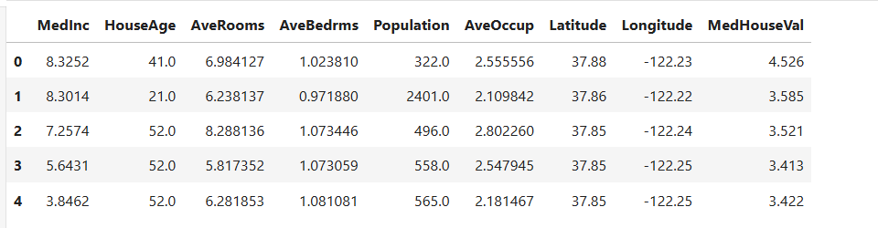

Rmse

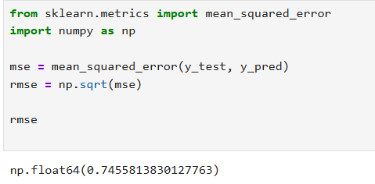

predicted_price_dollars

