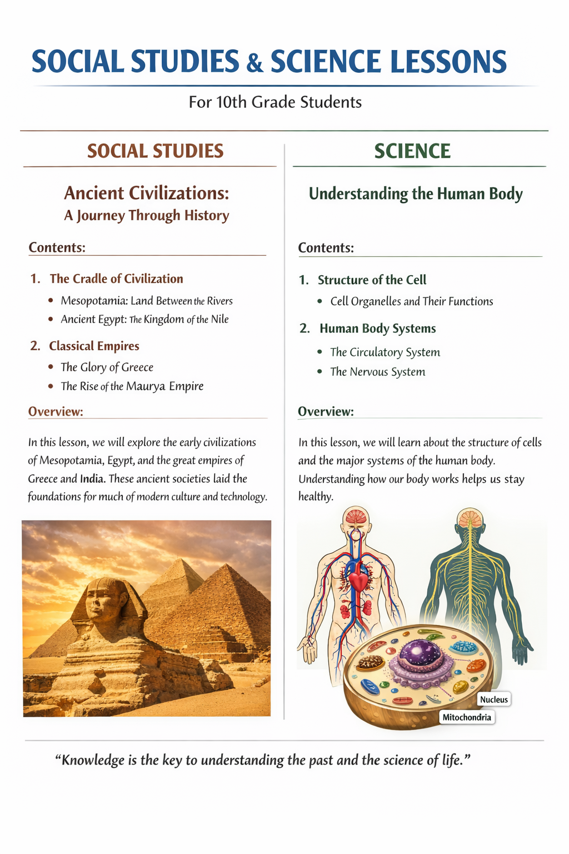
Lesson: Introduction to Democracy
Definition:
Democracy is a form of government in which the supreme power is vested in the hands of the people. Citizens have the right to elect their representatives and participate in decision-making processes.
Key Features of Democracy:
- Free and Fair Elections: Citizens can choose their leaders through periodic, transparent, and impartial elections.
- Fundamental Rights: Every individual has the right to freedom of speech, religion, and equality before the law.
- Equality and Justice: All citizens are treated equally regardless of caste, religion, gender, or social status.
- Rule of Law: No one is above the law; laws apply equally to all.
- Accountability of Government: Elected representatives are accountable to the people and can be removed if they fail to perform.
Importance of Democracy:
- Protects individual rights and freedoms.
- Ensures participation of citizens in governance.
- Promotes equality and reduces misuse of power.
- Encourages transparency and accountability in government.
Example:
India is the world’s largest democracy where citizens above 18 years of age can vote to elect representatives at local, state, and national levels.
Summary:
Democracy is not only a system of government but a way of life. It ensures justice, freedom, and equality, allowing citizens to actively shape the future of their nation.

Science – 10th Standard
Lesson: The Human Digestive System
Definition:
The digestive system is a group of organs that work together to convert food into energy and essential nutrients required by the body, and to remove waste products.
Major Organs and Functions:
- Mouth:
  - Food is chewed and mixed with saliva containing enzymes.
  - Mechanical and chemical digestion begins here.
- Esophagus:
  - A muscular tube that carries food from the mouth to the stomach.
  - Food is pushed by a process called peristalsis.
- Stomach:
  - Food is mixed with gastric juice containing hydrochloric acid and enzymes.
  - Proteins are broken down into simpler forms.
- Small Intestine:
  - Major site for digestion and absorption of nutrients.
  - Enzymes from the pancreas and bile from the liver aid in digestion.
- Large Intestine:
  - Absorbs water and salts.
  - Converts undigested food into feces.
- Anus:
  - Feces are expelled from the body through this opening.
Importance of the Digestive System:
- Provides nutrients and energy for growth and repair.
- Removes harmful waste from the body.
- Maintains overall health and immunity.
Summary:
The human digestive system is essential for survival. Proper functioning ensures that the body gets the necessary nutrients while eliminating waste effectively.

