|  |  |
| --- | --- |
| **RURAL HEALTH STATISTICS**  ***A DATA ANALYTICS PROJECT*** | **Abstract**  *The analytics behind the working of various aspects in the health sector, across different states of India, is explained. Various Parameters indicating health and sanitation infrastructure facilities, along with the possible health-status indicators are studied, compared, analysed, and interpreted with the help of various statistical tools for better perseverance.*  Nirmit Shetty, Pradyumna S, Vaishak G D |

**CONTENTS**

ABSTRACT................................................................................................................................1

ACKNOWLEDGEMENTS............................................................................................................3

SHORT FORMS…………………………………………………………………………………………………………………….4

INTRODUCTION........................................................................................................................5

EXPERIMENTS WITH HEALTH AND ITS INTERPRETATIONS……………………………………………………6-13

CALCULATION OF THE PARAMETERS REQUIRED TO FIND HDI…………………………………………….13-15

REFERENCES………………………………………………………………………………………………………………………….16

**ACKNOWLEDGEMENT**

The team would like to acknowledge Data.gov.in, an Indian governmental website for all the data provided to us on rural health in India. Furthermore, we would like to extend our gratitude to Dr. Kavi Mahesh, and his team under KANoE, PES University for extending the necessary cooperation, in all possible ways that includes helping in procuring data, valuable reviews and suggestions from time to time, just to name a handful.

**SHORT FORMS**

CHC-COMMUNITY HEALTH CENTRE

PHC-PRIMARY HEALTH CENTRE

IMR-INFANT MORTALITY RATE

MMR-MATERNAL MORTALITY RATE

**INTRODUCTION**

Health in the second most populated country of the world is clearly in many ways forms a major consequence, for health in the world. So performing, analytics on available rural health data in India through various representations is definitely of concern to all of us. The testimony is explained using the below example.

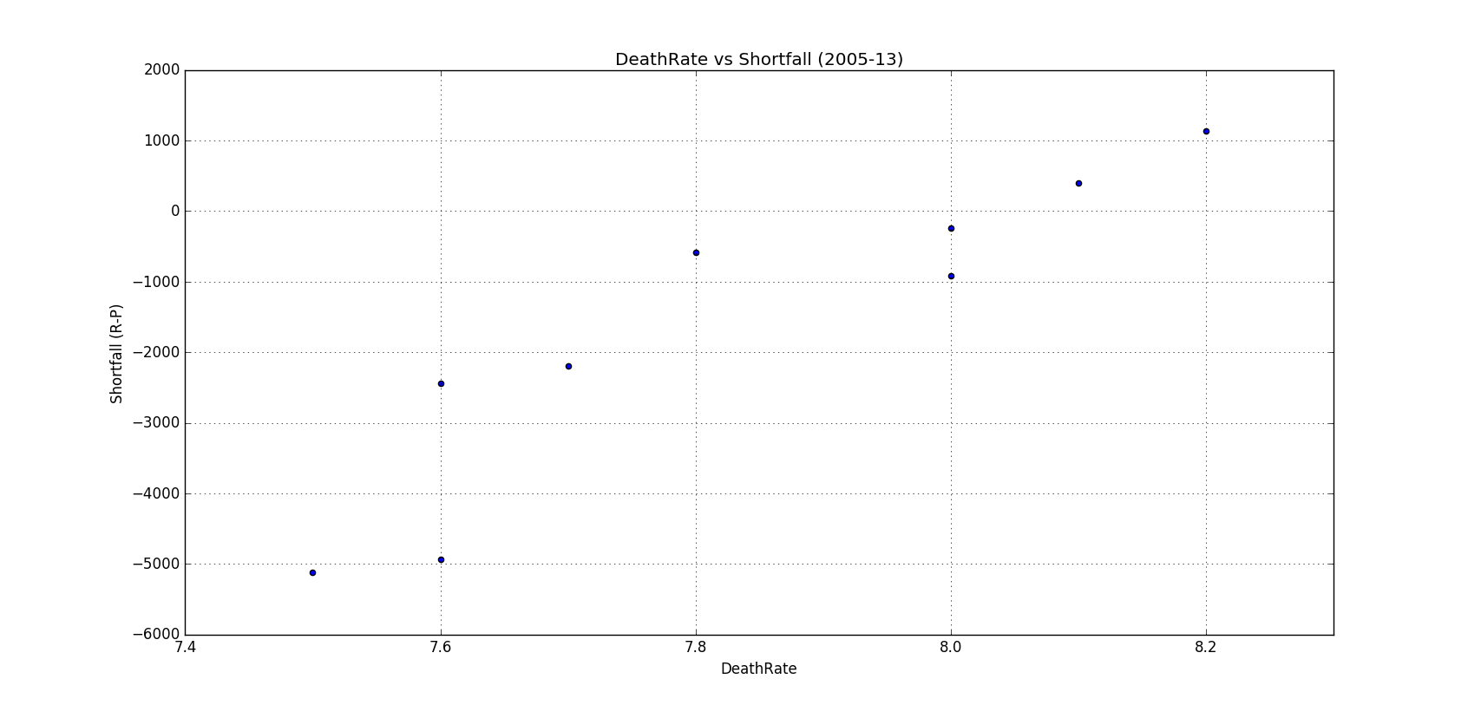

The following scatterplot indicates the Shortfall in the number of doctors at primary health centres vs The Average Death Rate of India from 2005-13. There is clearly a linear relationship between the rise in shortfall and the Death Rate per 1000 members in the country per year.

So the given project is in many ways a rough head start towards analytics in comparing and understanding health in India.

Python is the language used throughout the project to code and obtain results. Bar Graphs, scatter-plots, PI-charts, histograms and Regression arithmetic are some of the representations used to better interpret health data.

**EXPERIMENTS WITH HEALTH AND ITS INTERPRETATIONS**

1. Rural population of India covered under one of each kind. Ex: In the year 2005, for every 230444 Indians, one CHC is available. As the trend shows, number of Indians being covered under one CHC is declining with time which is a positive indication.

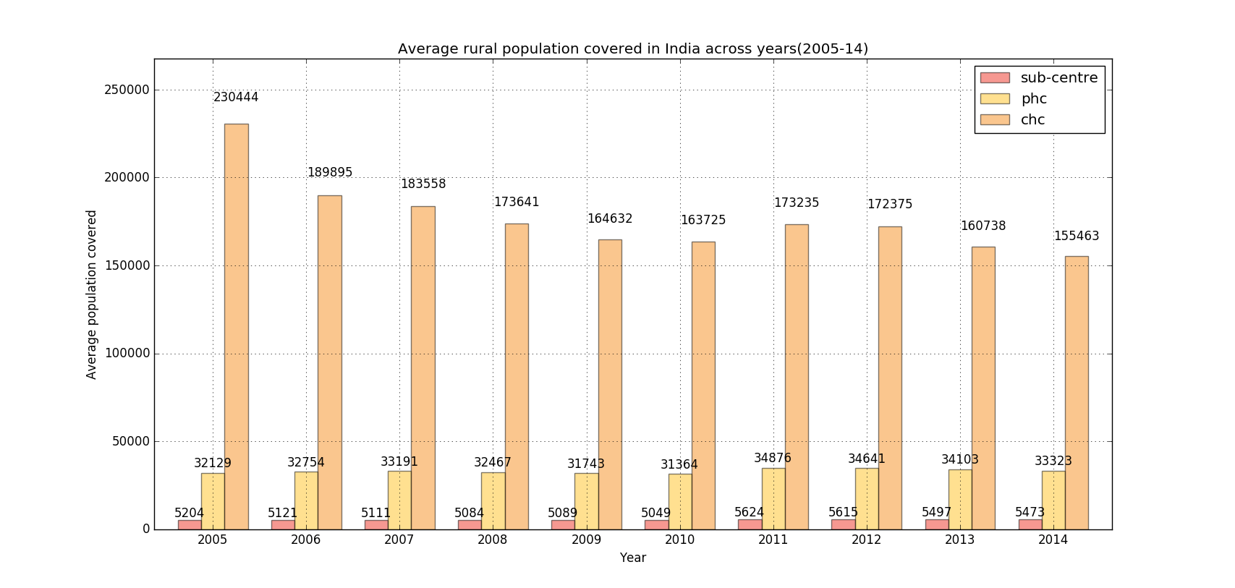

2.Trends in the decline of death rate per 1000 individuals in the country for the years 2005-13.

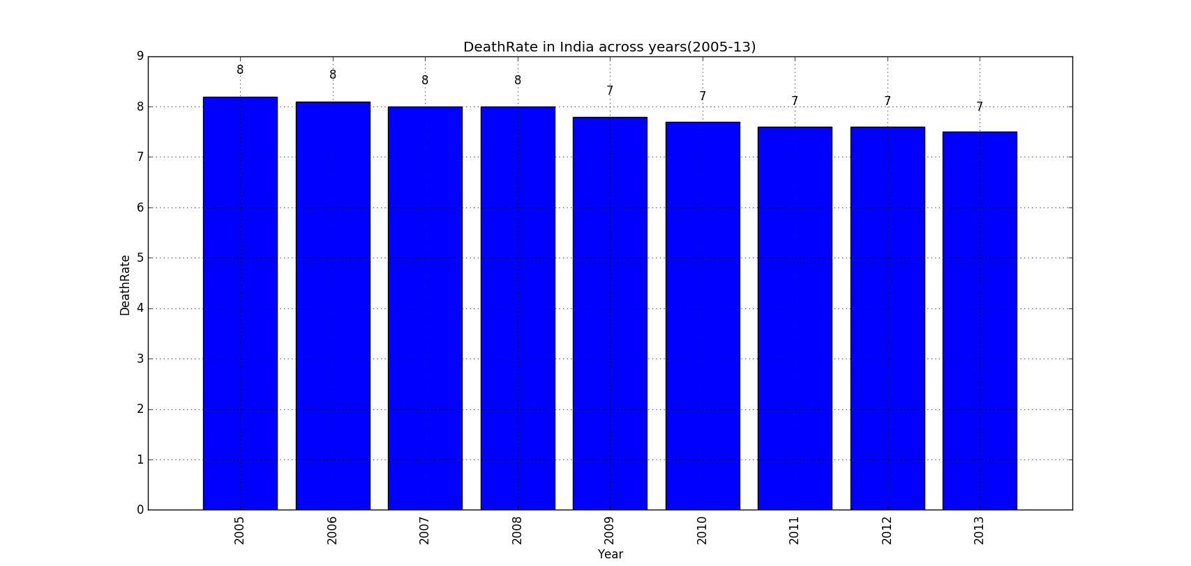

3. A comparison of the number of doctors required, sanctioned and in position at PHCs for years 2005-14. Number of doctors in position has gone up and the shortfall in doctors has decreased. There is a strong correlation between decrease in death rate and decrease in shortfall.

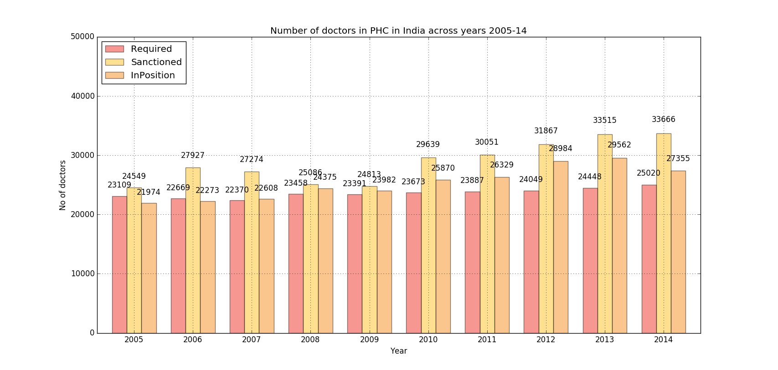

4. IMR in India across various years. (IMR measures number of infant (< 1 year) deaths per 1000 live births)

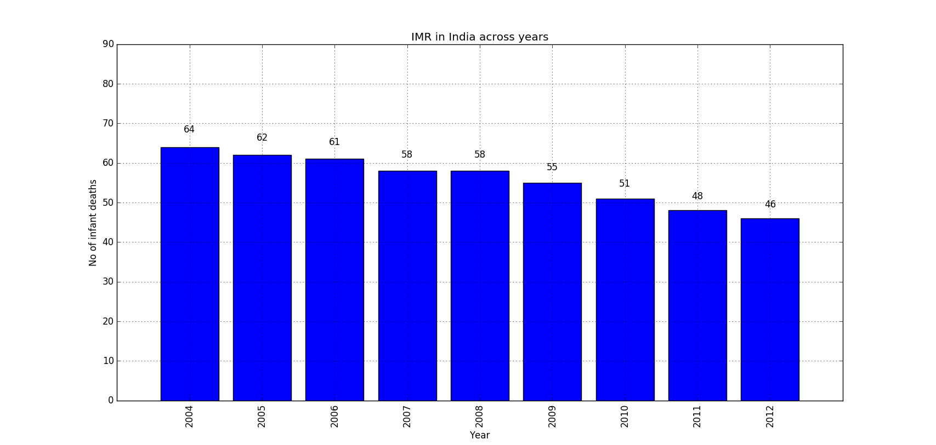

5. Required, sanctioned and in position for number of Paediatricians at CHCs. There is an increase in the number of paediatricians and also a decrease in IMR.

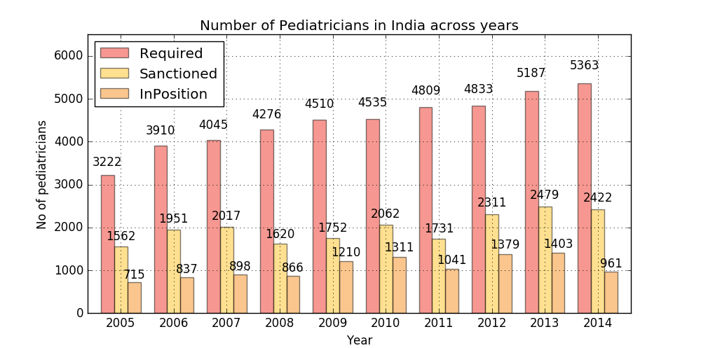

6. There is a good correlation between improvement of facilities and decrease in IMR.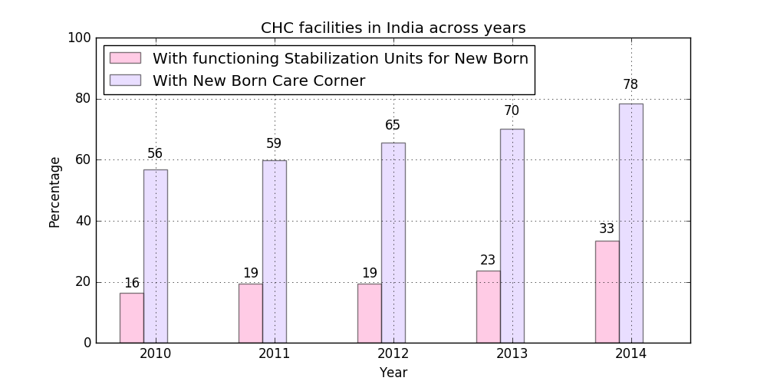

Self-explanatory. (CHC)

7. MMR measures number of women aged 15-49 years dying due to maternal causes per 1,00,000 live births. As clearly observed by the bar graph, MMR has reduced by 50% from 1997 to 2011.

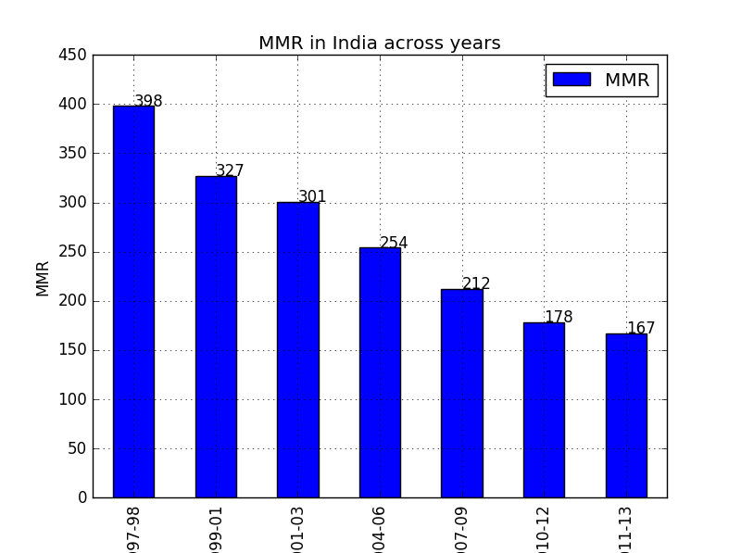

8. 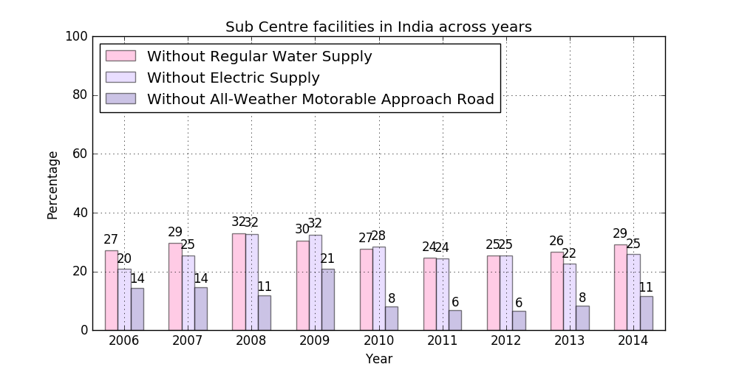

9. 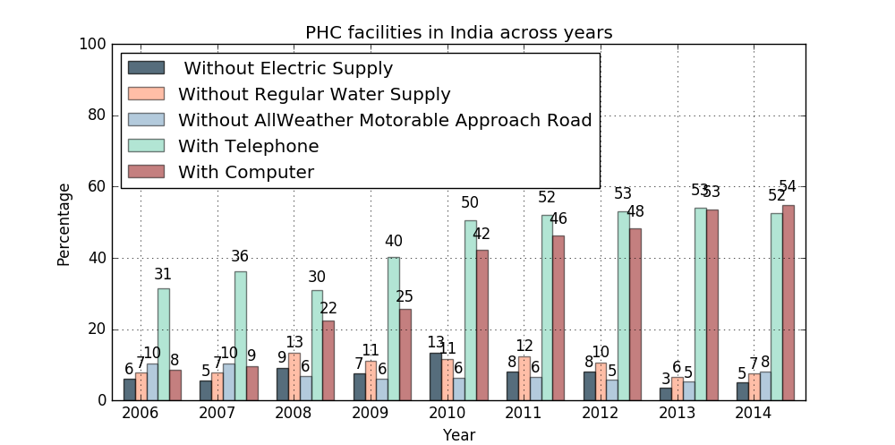

10. The requirement in the number of doctors at CHC is increasing over the years,but the no of doctors in Position has remained constant,which is a clear indication of the increase in Shortfall of the Doctors at Community Health Centres.

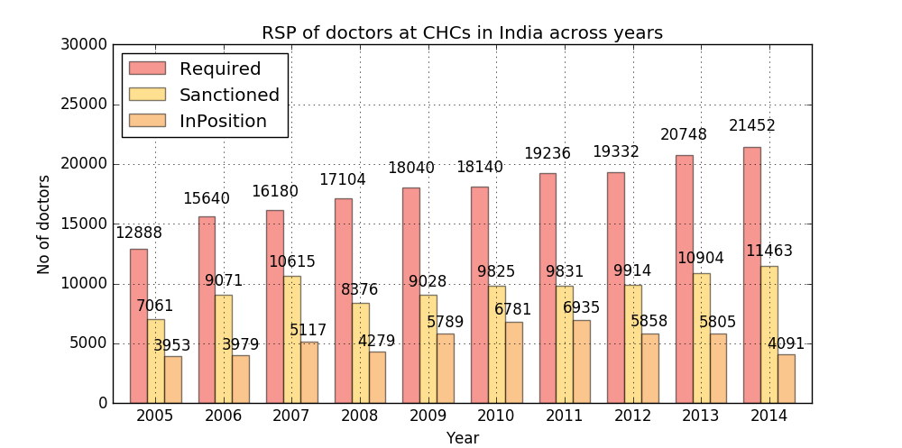

**HDI**

Human Development Index of a country is a measure of the overall well being of an individual in the country in terms of three parameters,

1>Educational Developmental Index (EDI)

2>Avg Life Expectancy at birth

3>Net income of the state/Country.

While most projects deal with predicting Hdi over the years, this exercise is aimed at calculating the coefficients of the relative importance of each of them, based on a data Set comprising of 15 States in the country. (For the year 2010-11)

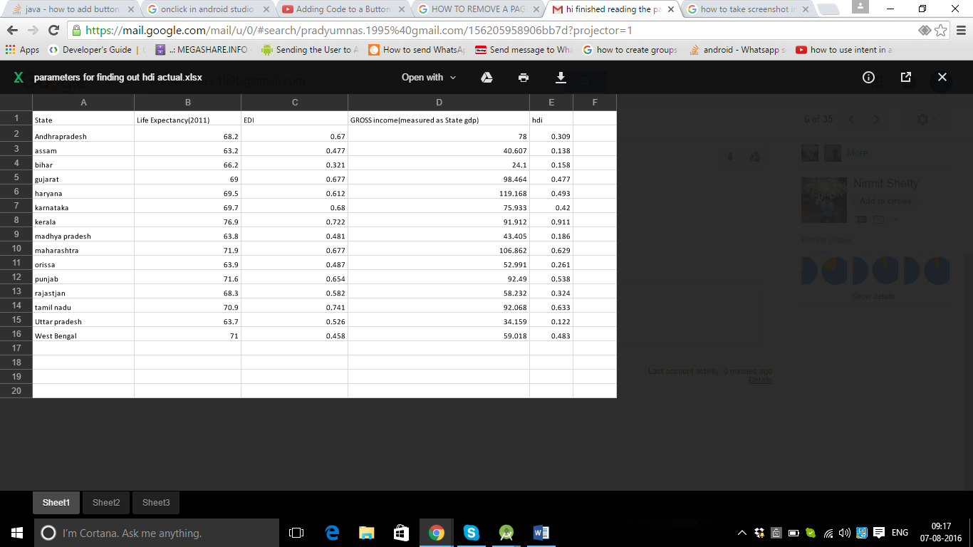

THE Following Code Snippet was used to run this available data OF HDI.

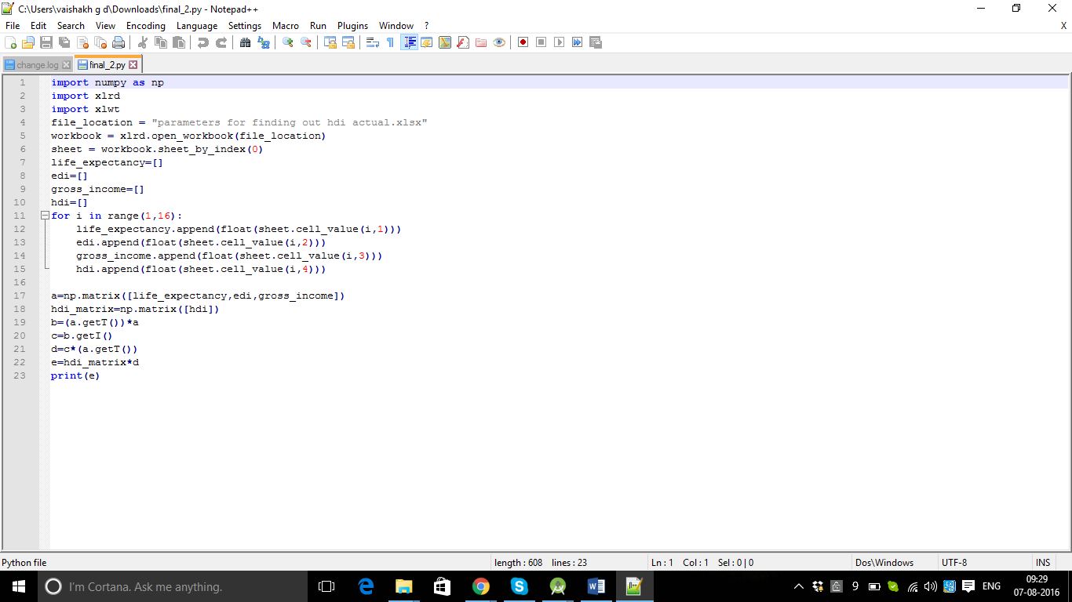

Ax=b

In a matrix manner was Solved where

A= the three Para metered matrices

b=hdi

x=the coefficient matrix.

The results of the following exercise were quite Surprising.

**RESULTS AND PREDICTIONS**

Interestingly the coefficient of life expectancy at birth turned out to be negative and the gross Income of the country exceeded 100%. So in a way

The Results measured in % contributions of each of them turned out to be the following.

Educational Development Index - (100+x-y) % (this value exceeded 100%)

Life Expectancy at birth – (-x) %

Net Income (measured as State GDP)- y %

CONCLUSION-1

So this was an indication of the fact that because life expectancy acted negative, because the net Income of the country, and the EDI in contrast to the life expectancy at birth (However this doesn’t mean the overall population) Has to increase so much that it more than compensates the increase in life expectancy. So more people in India, more income has to move in to increase a greater human development index per person on an average. (The increase in Educational Developmental Index is not growing to meet the requirements of the increased population.)

CONCLUSION-2

This could also mean that between the Net-income of the country in terms of percentages, and its immediate effect, i.e. GDP translation, enough isn’t being translated.

CONCLUSION-3

This also emphasizes the need for improvement in the Educational Sector to achieve higher HDI’s.

CONCLUSION-4

It obviously also implies that more income doesn’t essentially translate into higher growth in Educational Sectors, (like any other sector for that matter.)

**REFERENCES**

* Ministry of health and family welfare <http://www.mohfw.nic.in>
* Open Government Data Platform India <https://data.gov.in>
* Wikipedia
* Indian Public Health Standards <http://nrhm.gov.in/nhm/nrhm/guidelines/indian-public-health-standards.html>