TRAVELEASE

A course project report submitted in partial fulfilment of the requirement
of
DEVOPS AND FULLSTACK
by

M. Hindu (2303A51296)
M. Nirnaya (2303A51060)
Y. Sai Prasanna (2303A51355)

Under the guidance of
Dr. N.VENKATESH
Asst. Professor, Department of CS & AI



SR University, Warangal
APRIL-2026
ABSTRACT
The TravelEase project is developed to provide a smart, efficient, and user-friendly travel planning and booking platform that simplifies the complete travel management process. In today’s fast-growing digital environment, people prefer online solutions that save time, reduce manual effort, and provide instant access to services. Traditional travel planning methods often require visiting multiple websites, comparing packages manually, and spending significant time on decision-making. To overcome these challenges, TravelEase offers an integrated web-based solution where users can easily explore destinations, compare packages, and complete bookings through a single platform.
The primary objective of this project is to enhance user convenience by designing a responsive and interactive system that supports travel planning in a structured manner. The platform provides detailed information about destinations, package costs, travel duration, available services, and booking options. With a clean and intuitive user interface, users can navigate the application easily, even with minimal technical knowledge. The system focuses on simplicity, faster response times, and a seamless user experience.
TravelEase is developed using full-stack technologies where the frontend is built using HTML, CSS, and JavaScript to create an attractive and responsive interface, while the backend is implemented using Python to handle server-side logic, user requests, and data processing. The integration between frontend and backend ensures smooth communication, reliable performance, and accurate handling of user inputs. A lightweight database such as SQLite or structured JSON storage is used for managing travel-related data efficiently.
The project also demonstrates the implementation of DevOps practices such as version control, deployment automation, and continuous integration. These practices help improve software quality, reduce deployment errors, and ensure faster updates. The application is deployed on a cloud platform, which improves accessibility, scalability, and system availability. Users can access the system anytime and from anywhere without depending on local installation.

CONTENTS

ABSTRACT ii

Chapter No. Title Page No.

1 INTRODUCTION 01
1.1 About the project 01
1.2 Objectives 02

2 LITERATURE REVIEW
2.1 Overview 03
2.2 Related Studies and Existing Solutions 05
2.3 Tools and Technologies Used 07

3. METHODOLOGY
3.1 Data Collection and Description 08
3.2 Data Preprocessing and Cleaning 10
3.3 Analytical and Visualization Techniques 12

4 RESULTS AND DISCUSSION
4.1 Data Analysis and Key Findings 14
4.2 Visualization and Interpretation of Results 16
4.3 Insights and Discussion 18

5 CONCLUSION AND FUTURE WORK
5.1 Summary of Findings 19
5.2 Conclusions Drawn 20
5.3 Recommendations and Future Scope 20

1. INTRODUCTION
1.1 About the Project
In the modern digital era, technology has significantly transformed the way people plan and manage their daily activities, including travel. With the increasing demand for efficient and convenient solutions, online travel platforms have become essential tools for users worldwide. However, many existing systems are often complex, time-consuming, or lack user-friendly interfaces, making travel planning a challenging task for many individuals.
The TravelEase project is designed to overcome these limitations by providing a simple, efficient, and user-centric travel planning and booking system. It is a web-based application that enables users to explore various travel destinations, view available travel packages, and make bookings through a structured and intuitive interface. The system aims to reduce manual effort and provide a seamless experience for users who wish to plan their trips quickly and effectively.
TravelEase integrates both frontend and backend technologies, making it a complete full-stack application. The frontend is developed using HTML, CSS, and JavaScript to ensure a responsive and visually appealing user interface, while the backend is implemented using Python to handle data processing, request management, and application logic efficiently. This integration ensures smooth communication between different components of the system.
The system is deployed on a cloud platform, allowing users to access it from anywhere at any time, thereby improving accessibility and scalability. This cloud-based approach ensures better performance, reliability, and the ability to handle multiple users simultaneously without affecting system efficiency.
In addition to its core functionality, the project incorporates DevOps practices such as version control, deployment automation, and continuous updates. These practices enhance the reliability and maintainability of the system while reducing development time and ensuring faster delivery of updates and improvements.
Furthermore, the TravelEase system is designed with a modular architecture, allowing easy integration of new features and future enhancements. The system also focuses on improving user experience by providing clear navigation, smooth workflows, and responsive feedback, making it accessible even to users with minimal technical knowledge.
Performance optimization is also considered in the system design to ensure faster loading times and efficient use of resources. Overall, the project demonstrates the practical implementation of full-stack development and DevOps concepts while providing a smart, efficient, and reliable solution for modern travel planning.

1.2 Objectives
The main objective of the TravelEase project is to design and develop a comprehensive, user-friendly, and efficient travel planning and booking system that simplifies the overall travel management process. The system is intended to provide users with a seamless digital platform where they can explore travel options, compare packages, and make bookings with ease and convenience.
In addition to the primary goal, the project focuses on achieving the following specific objectives:
To design and implement a web-based platform that allows users to easily access travel-related information such as destinations, packages, and pricing details.
To develop a responsive and visually appealing user interface that ensures smooth navigation across different devices including desktops, tablets, and mobile phones.
To provide a structured and organized system for displaying travel packages in a clear and understandable format, enabling users to compare options effectively.
To implement a simplified booking mechanism that reduces complexity and allows users to confirm travel plans with minimal steps.
To ensure efficient handling of user inputs and backend processing for accurate and reliable system performance.
To integrate frontend and backend technologies seamlessly, ensuring proper communication between user interface and server-side logic.
To deploy the application on a cloud-based platform, enabling global accessibility, better performance, and scalability.
To adopt DevOps practices such as version control and deployment to improve development workflow and system reliability.
To reduce the time and effort required for travel planning by automating key processes and minimizing manual intervention.
To enhance user experience by providing faster response times and intuitive design elements.
To ensure the system is modular and scalable so that new features can be easily added in the future.
To provide a foundation for integrating advanced features such as online payment systems and AI-based travel recommendations in future versions.
To demonstrate the practical implementation of full-stack development and DevOps concepts in solving real-world problems.

2. LITERATURE REVIEW
2.1 Overview
The rapid advancement of technology has significantly influenced the development of modern web-based applications, including travel planning and booking systems. With the increasing reliance on digital platforms, users expect fast, efficient, and user-friendly solutions for managing their travel activities. As a result, travel applications have evolved from simple information portals to comprehensive systems that integrate multiple functionalities such as destination browsing, package comparison, and online booking.
In recent years, full-stack development has played a crucial role in building such applications by combining frontend and backend technologies into a unified system. Frontend technologies such as HTML, CSS, and JavaScript are used to create interactive and responsive user interfaces, while backend technologies like Python enable efficient data processing and application logic. This integration ensures smooth communication between users and the system, improving overall performance and usability.
DevOps practices have further enhanced the development and deployment of web applications by promoting automation, collaboration, and continuous improvement. Techniques such as version control, continuous integration, and continuous deployment help developers deliver reliable and scalable applications in a shorter time. These practices reduce errors, improve system stability, and ensure consistent performance across different environments.
Cloud computing has also become an essential component in modern application development. By deploying applications on cloud platforms, developers can ensure better accessibility, scalability, and availability. Cloud-based systems allow users to access services from anywhere, making them ideal for travel-related applications that require global reach and real-time interaction.
Additionally, database management plays a vital role in handling large amounts of travel-related data such as destinations, pricing, and booking details. Efficient data storage and retrieval mechanisms ensure that users receive accurate and timely information. Modern systems often use structured and flexible databases to maintain performance and reliability.
Another important aspect in modern web applications is the use of responsive design and cross-platform compatibility. Users access applications through various devices such as smartphones, tablets, and laptops, making it essential for systems to adapt to different screen sizes and operating environments. Technologies such as responsive frameworks and adaptive layouts ensure consistent user experience across devices.
Security and data privacy have also become critical considerations in application development. With the increasing use of online platforms, protecting user data and preventing unauthorized access is essential. Developers implement authentication mechanisms, data encryption, and secure communication protocols to ensure safe interactions within the system.
Furthermore, the integration of analytics and user behavior tracking has improved system performance and personalization. By analyzing user preferences and interactions, modern applications can provide customized recommendations and improve decision-making processes. This feature enhances user satisfaction and engagement.
In addition to these advancements, the adoption of API-based architecture has become common in modern applications. APIs (Application Programming Interfaces) allow different systems and services to communicate with each other, enabling integration with external services such as payment gateways, maps, and notification systems. This enhances the overall functionality and flexibility of applications.
Moreover, the concept of scalability and performance optimization has gained importance in handling large user traffic. Techniques such as load balancing, caching, and efficient resource management help maintain system performance even under heavy usage conditions. These approaches ensure that applications remain stable and responsive.
Another emerging trend is the use of automation tools in testing and deployment. Automated testing ensures that applications function correctly before deployment, while automated deployment reduces manual errors and speeds up the release process. These practices are essential for maintaining high-quality software systems.
Overall, the literature suggests that the integration of full-stack development, DevOps practices, cloud computing, security mechanisms, and modern architectural approaches has significantly improved the efficiency and functionality of travel planning systems. These technologies provide a strong foundation for developing scalable, user-friendly, and high-performance applications like TravelEase, which aim to simplify and enhance the travel planning experience.

2.2 Related Studies and Existing Solutions
The development of travel planning and booking systems has been widely studied and implemented in recent years due to the growing demand for digital solutions in the tourism industry. Several researchers and developers have focused on creating platforms that simplify travel management by integrating various services such as destination exploration, booking, and payment processing into a single system.
Existing travel applications and websites provide users with a range of functionalities, including searching for destinations, comparing travel packages, and making online reservations. Popular systems have successfully implemented user-friendly interfaces and real-time data handling to enhance user experience. These platforms often include features such as filtering options, customer reviews, and dynamic pricing, which help users make informed decisions.
However, despite these advancements, many existing systems still face certain limitations. Some platforms are overly complex, making navigation difficult for users, especially those with limited technical knowledge. Others may suffer from performance issues, slow response times, or lack of proper integration between frontend and backend components. In some cases, the absence of clear structure and organization in presenting travel information leads to confusion and inefficiency.
Research studies have highlighted the importance of simplicity, usability, and performance in designing effective travel systems. A well-designed application should provide a clean and intuitive interface, efficient data processing, and seamless interaction between different components. Additionally, scalability and flexibility are essential factors that determine the long-term success of such systems.
Modern solutions are increasingly adopting full-stack development approaches to ensure better integration of frontend and backend technologies. DevOps practices are also being incorporated to improve development efficiency, automate deployment processes, and maintain system reliability. Furthermore, cloud-based deployment has become a standard practice, allowing applications to handle large numbers of users while maintaining consistent performance.
The TravelEase project builds upon these existing solutions and research findings by focusing on simplicity, efficiency, and user experience. It aims to overcome the limitations of current systems by providing a streamlined interface, faster performance, and a structured approach to travel planning. By integrating modern technologies and development practices, TravelEase offers an improved and practical solution for users seeking a convenient travel planning platform.

2.3 Tools and Technologies Used
The development of the TravelEase system involves the use of various tools and technologies that support both frontend and backend functionalities, as well as deployment and version control. These technologies are carefully selected to ensure efficiency, scalability, and ease of development.
Frontend Technologies:
The frontend of the application is developed using HTML, CSS, and JavaScript. HTML (HyperText Markup Language) is used to structure the content of web pages, while CSS (Cascading Style Sheets) is used for styling and layout design. JavaScript is used to add interactivity and dynamic behavior to the application, such as handling user inputs and updating content without reloading the page. These technologies together provide a responsive and user-friendly interface.
Backend Technology:
The backend of the system is developed using Python, which is known for its simplicity and powerful capabilities. Python is used to handle server-side logic, process user requests, manage data flow, and ensure smooth interaction between the frontend and database. Frameworks such as Flask can be used to simplify backend development and create RESTful APIs.
Database Management:
The application uses a database system to store and manage travel-related data such as destinations, packages, and booking details. Lightweight databases like SQLite or structured data formats such as JSON are used to ensure efficient data storage and retrieval. Proper data management ensures accuracy, consistency, and reliability of information presented to users.
Version Control System:
Git is used as the version control system to manage source code efficiently. It allows developers to track changes, collaborate effectively, and maintain different versions of the project. Platforms like GitHub are used to host the repository and facilitate collaboration and code management.
DevOps Tools and Practices:
DevOps practices are incorporated to improve development and deployment processes. Continuous Integration (CI) and Continuous Deployment (CD) techniques help automate testing and deployment, ensuring faster and more reliable updates. These practices enhance system stability and reduce manual errors.
Cloud Deployment:
The TravelEase application is deployed on a cloud platform such as Render. Cloud deployment ensures that the application is accessible from anywhere and can handle multiple users simultaneously. It also provides scalability, reliability, and better performance compared to local hosting.
Development Environment:
Tools such as Visual Studio Code are used as the development environment for writing and managing code. It provides features like syntax highlighting, debugging tools, and extensions that improve developer productivity and efficiency.
Web Browser and Testing Tools:
Web browsers such as Google Chrome are used for testing and debugging the application. Developer tools available in browsers help identify errors, inspect elements, and analyze performance, ensuring the application functions correctly.
Overall, the combination of these tools and technologies enables the development of a robust, scalable, and efficient travel planning system. The integration of frontend, backend, database, and deployment tools ensures that the TravelEase application meets modern software development standards and provides a reliable user experience.

3. METHODOLOGY
3.1 Data Collection and Description
The data collection process is a crucial step in the development of the TravelEase system, as it ensures that accurate and relevant information is available for users to explore and make travel decisions. The system primarily focuses on collecting and organizing travel-related data such as destination details, travel packages, pricing information, and basic booking inputs provided by users.
The data used in this project is collected from various reliable sources, including publicly available travel information, sample datasets, and manually curated content. These sources provide essential details such as popular destinations, package descriptions, estimated costs, travel duration, and basic itinerary information. The collected data is structured in a way that makes it easy to store, retrieve, and display within the application.
In addition to static travel data, the system also handles dynamic data generated through user interactions. This includes user inputs such as selected destinations, booking preferences, number of travelers, travel dates, and contact details entered through forms on the website. The system processes this data in real time to provide appropriate responses and outputs, ensuring a smooth and interactive user experience.
The collected data is stored using lightweight database solutions such as SQLite or structured formats like JSON files. These storage methods are chosen for their simplicity, flexibility, and efficiency in handling moderate amounts of data. Proper data organization ensures quick retrieval and accurate display of information, which is essential for maintaining system performance.
Furthermore, the data is categorized into different sections such as destinations, packages, and bookings to maintain clarity and structure. Each category contains specific attributes, for example, destination data includes name, location, description, and images, while package data includes price, duration, and included services. This categorization improves data accessibility and enhances the overall usability of the system.
Data validation is also an important aspect of the system. User inputs are validated to ensure correctness, completeness, and consistency. Validation techniques help prevent incorrect data entry, reduce system errors, and improve the reliability of the application.
Another important aspect of data collection is data consistency and standardization. The system ensures that all collected data follows a uniform format, which simplifies processing and avoids inconsistencies. For example, pricing formats, date formats, and naming conventions are standardized to maintain uniformity across the application.
Additionally, the system considers data updating and maintenance processes. Travel-related information such as pricing and availability may change over time, so the system is designed to allow easy updates and modifications. This ensures that users always receive accurate and up-to-date information.
The project also ensures that only necessary data is collected from users to maintain simplicity and avoid unnecessary complexity. This approach improves system performance and enhances user trust by minimizing data collection.
Overall, the data collection and description process in the TravelEase project ensures that the system has access to accurate, organized, and relevant information. This enables the application to function effectively, maintain reliability, and provide users with a smooth and efficient travel planning experience.

3.2 Data Preprocessing and Cleaning
Data preprocessing and cleaning are essential steps in the development of the TravelEase system, as they ensure that the collected data is accurate, consistent, and suitable for further processing. Raw data collected from various sources or user inputs may contain errors, inconsistencies, or incomplete information, which can affect the performance and reliability of the system. Therefore, proper preprocessing techniques are applied to improve data quality.
The first step in data preprocessing involves data validation, where user inputs are checked for correctness and completeness. For example, fields such as destination names, travel dates, and number of travelers are verified to ensure that they follow the required format and constraints. Invalid or missing inputs are either corrected or rejected with appropriate error messages, ensuring that only valid data is processed by the system.
Another important step is data cleaning, which involves removing duplicate entries, correcting inconsistencies, and handling missing values. Duplicate data can lead to incorrect results and confusion, so it is identified and eliminated. Inconsistent data formats, such as different date or currency formats, are standardized to maintain uniformity across the system. Missing values are handled by either assigning default values or prompting users to provide the required information.
Data transformation is also performed to convert raw data into a structured format suitable for processing and storage. For instance, user inputs may be converted into specific data types such as integers, strings, or date formats. This ensures compatibility with the backend system and database operations.
Normalization is another preprocessing technique used to maintain consistency in data representation. For example, text data such as destination names may be converted to a standard format (e.g., lowercase or uppercase) to avoid duplication and improve search efficiency. Similarly, numerical values such as prices are formatted consistently for accurate comparison and display.
The system also performs filtering and sorting operations to organize data effectively. Irrelevant or unnecessary data is removed, while useful data is arranged in a structured manner. This improves system performance and ensures that users receive relevant information quickly.
Error handling mechanisms are implemented to manage unexpected inputs or system issues during data processing. These mechanisms ensure that the system continues to function smoothly even when errors occur, thereby improving reliability.
Additionally, preprocessing includes preparing data for efficient retrieval and display. Data indexing and categorization help in faster access and better organization of information. This is particularly important for applications like TravelEase, where users expect quick responses and smooth interaction.
Overall, data preprocessing and cleaning play a vital role in enhancing the quality and reliability of the TravelEase system. By ensuring that the data is accurate, consistent, and well-structured, these processes contribute to improved system performance and a better user experience.

3.3 Analytical and Visualization Techniques
Analytical and visualization techniques play a crucial role in understanding data and improving decision-making in the TravelEase system. These techniques help in organizing, analyzing, and presenting travel-related data in a meaningful way so that users can easily interpret information and make informed choices.
The analytical process involves examining travel data such as package prices, user preferences, and booking trends. By analyzing this data, the system can identify patterns and provide useful insights. For example, comparing travel package prices helps users select options that best fit their budget, while analyzing booking trends can indicate popular travel periods.
Data visualization techniques are used to represent this information graphically, making it easier to understand complex data. Graphs such as bar charts, pie charts, and line charts are used to display different types of information in a clear and concise manner. These visual representations improve user experience by allowing quick interpretation of data.
A bar chart is used to compare travel package prices across different categories such as beach, hill, city, and adventure trips. This helps users easily identify cost differences between packages.

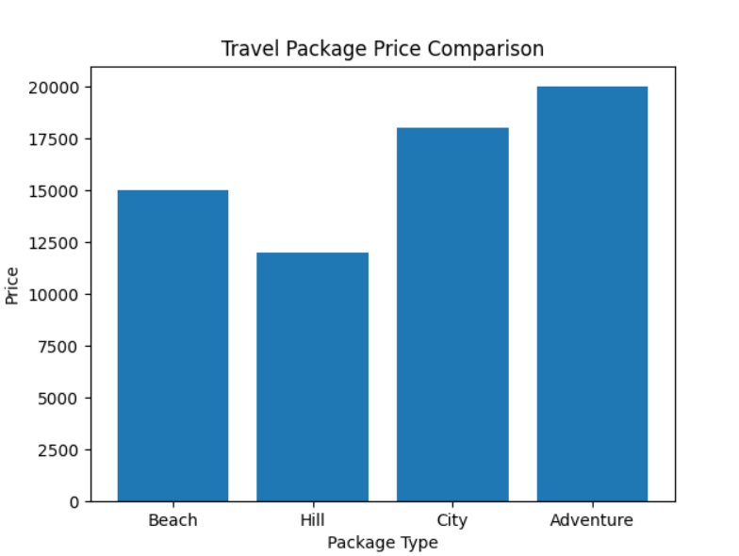
A pie chart is used to represent user travel preferences. It shows the percentage distribution of users interested in different types of destinations, helping in understanding popular choices.
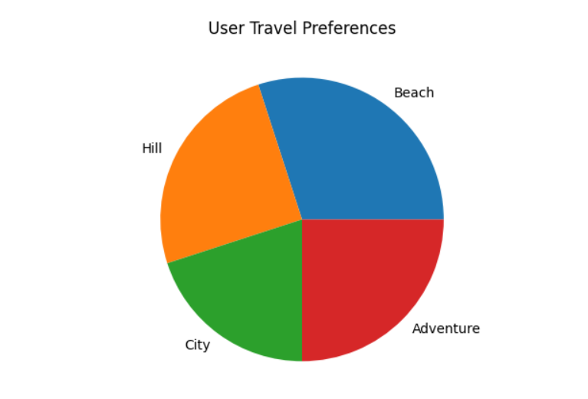

A line chart is used to analyze booking trends over time. It helps in identifying peak booking periods and understanding seasonal demand for travel services.
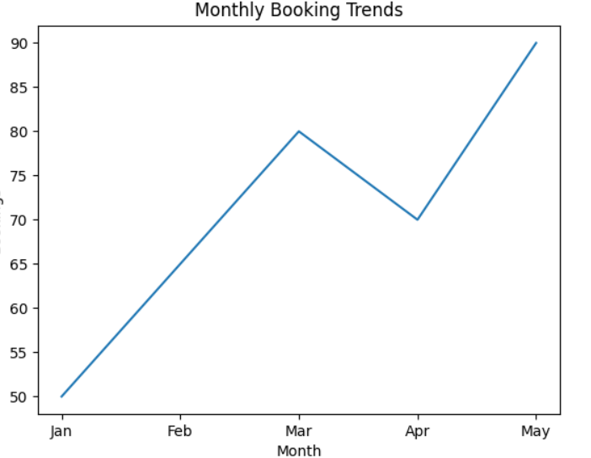
These visualization techniques not only enhance the presentation of data but also improve system usability by providing meaningful insights. Users can make faster and more accurate decisions based on graphical representations rather than raw data.
Furthermore, these techniques can be extended in future versions of the system to include advanced analytics such as predictive analysis and recommendation systems. This will allow the system to provide personalized travel suggestions based on user behavior and preferences.
Overall, analytical and visualization techniques significantly improve the functionality and effectiveness of the TravelEase system by transforming raw data into useful information, thereby enhancing user experience and decision-making.

4: RESULTS AND DISCUSSION
4.1 Data Analysis and Key Findings
The data analysis phase of the TravelEase project focuses on evaluating travel-related data such as package pricing, user preferences, and booking trends. The primary objective of this analysis is to extract meaningful insights that can support user decision-making and enhance the overall efficiency of the system. By analyzing the collected and processed data, the system is able to present useful information in a structured and understandable manner.
The analysis of travel package pricing reveals that different categories of travel, such as beach, hill, city, and adventure trips, vary significantly in cost. Adventure and city packages are generally priced higher due to the inclusion of additional activities, premium services, and extended itineraries. On the other hand, hill and beach packages are relatively more affordable, making them suitable for a wider range of users. This variation in pricing allows users to compare options effectively and choose packages that best match their budget and preferences.
User preference analysis provides valuable insights into the interests and choices of users. The data indicates that certain types of destinations are more popular than others. For instance, beach destinations tend to attract a larger number of users due to their relaxing environment and recreational activities. Hill stations are preferred by users seeking a peaceful and scenic experience, while adventure trips appeal to those interested in thrilling and outdoor activities. Understanding these preferences helps in improving the system’s ability to recommend suitable travel options.
The analysis of booking trends over time highlights patterns in user behavior and travel demand. It is observed that booking activity increases during specific periods, which may correspond to holidays, vacation seasons, or favorable weather conditions. These peak periods indicate high demand, while other periods show relatively lower booking activity. Such insights are useful for optimizing system performance, managing resources, and planning promotional offers.
Another important finding is related to user interaction with the system. Users tend to prefer platforms that provide quick access to information, simple navigation, and minimal steps for completing bookings. The TravelEase system addresses these requirements by offering a streamlined interface and efficient processing, which enhances user satisfaction and engagement.
The analysis also shows that organizing data in a structured format significantly improves usability. When information is presented clearly and supported by visual representations such as charts and graphs, users can easily interpret and compare different options. This reduces confusion and enables faster decision-making.
In addition, the system demonstrates consistent performance in handling user requests and displaying relevant data. The integration of frontend and backend components ensures smooth data flow and accurate results. This reliability is essential for maintaining user trust and ensuring the effectiveness of the application.
Furthermore, the findings emphasize the importance of scalability and adaptability in modern web applications. As user demand increases, the system should be capable of handling larger datasets and more complex operations without compromising performance. The TravelEase system is designed with this consideration, making it suitable for future expansion.
Overall, the data analysis confirms that the TravelEase system effectively processes and presents travel-related information. The key findings highlight the importance of pricing comparison, user preference analysis, and booking trend evaluation in developing a successful travel planning platform. These insights contribute to improving system functionality, enhancing user experience, and supporting informed decision-making.

4.2 Visualization and Interpretation of Results
Visualization plays a crucial role in presenting system outputs in a clear and understandable format. In the TravelEase system, the frontend web pages act as the primary medium for visualization, allowing users to interact with the system and interpret information easily. Instead of using complex graphical charts, the system focuses on displaying information through well-structured and interactive web interfaces, which improves usability and accessibility.
The homepage of the TravelEase system serves as the entry point for users and provides an overview of the platform. It is designed with a clean layout, clear navigation options, and visually appealing elements that guide users through different functionalities of the system. The homepage allows users to explore available travel options and understand the overall workflow of the application. The use of proper spacing, headings, and buttons enhances readability and ensures a smooth user experience.
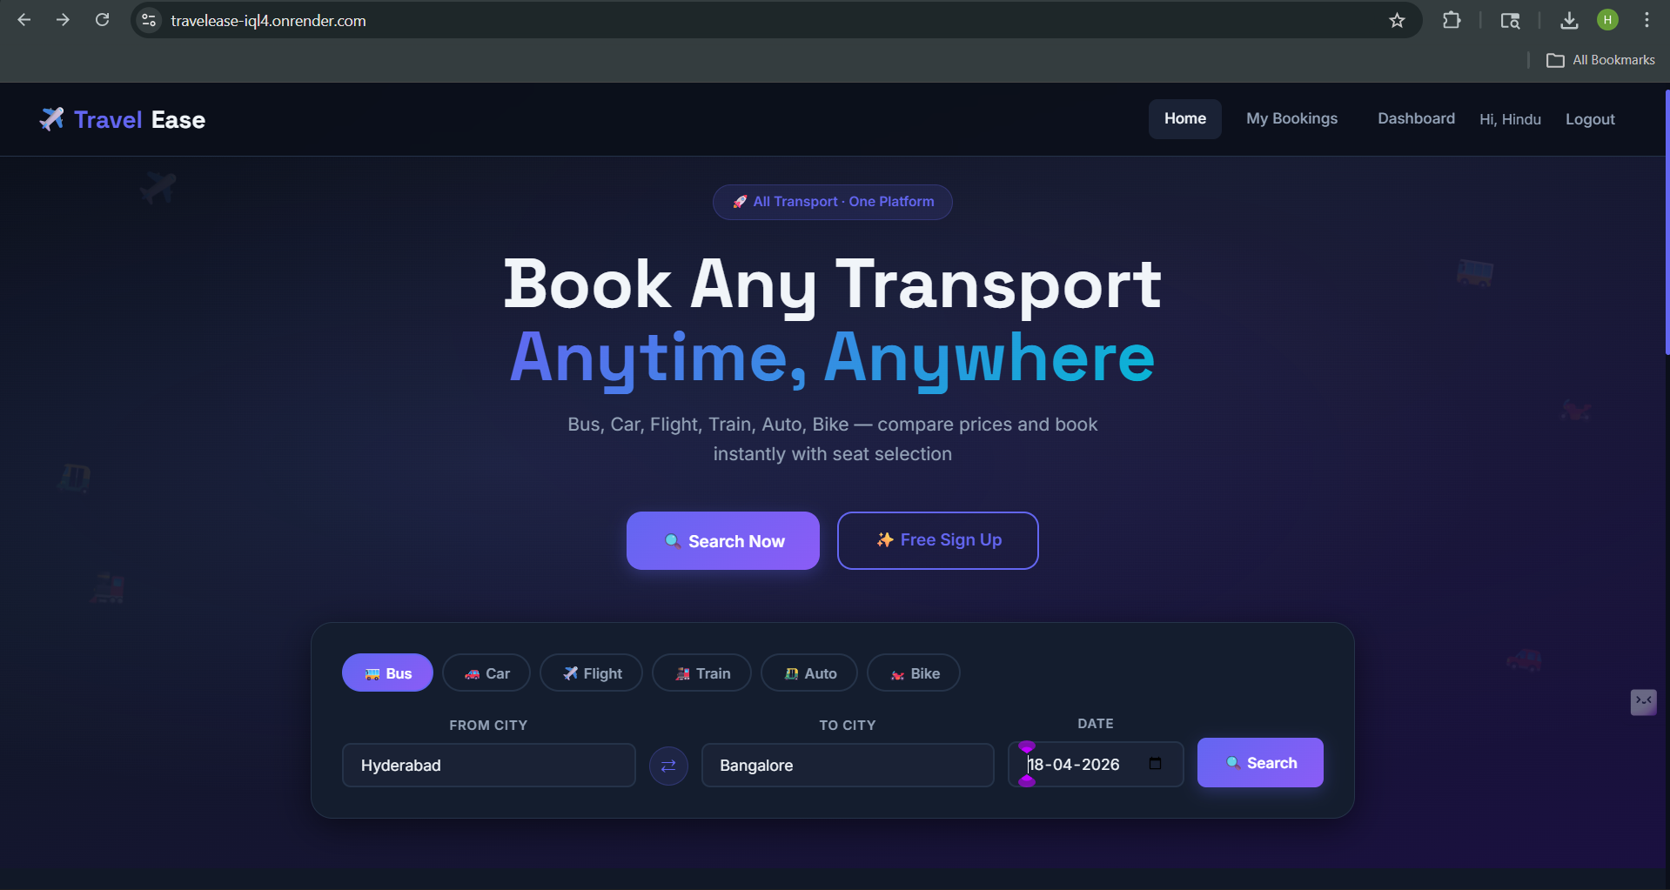
This figure shows the homepage of the TravelEase system where users can browse and explore travel options through a structured and interactive interface.
The homepage design also plays an important role in user engagement. A well-designed interface encourages users to interact with the system and explore available features. The placement of navigation menus and content sections ensures that users can easily access different parts of the application without confusion. This contributes to better usability and improved user satisfaction.
The booking and confirmation interface represents the core functionality of the TravelEase system. It allows users to enter their travel details such as destination, preferences, and other required information through a simple and intuitive form. The design of the form ensures that users can complete the booking process with minimal effort, reducing complexity and saving time.
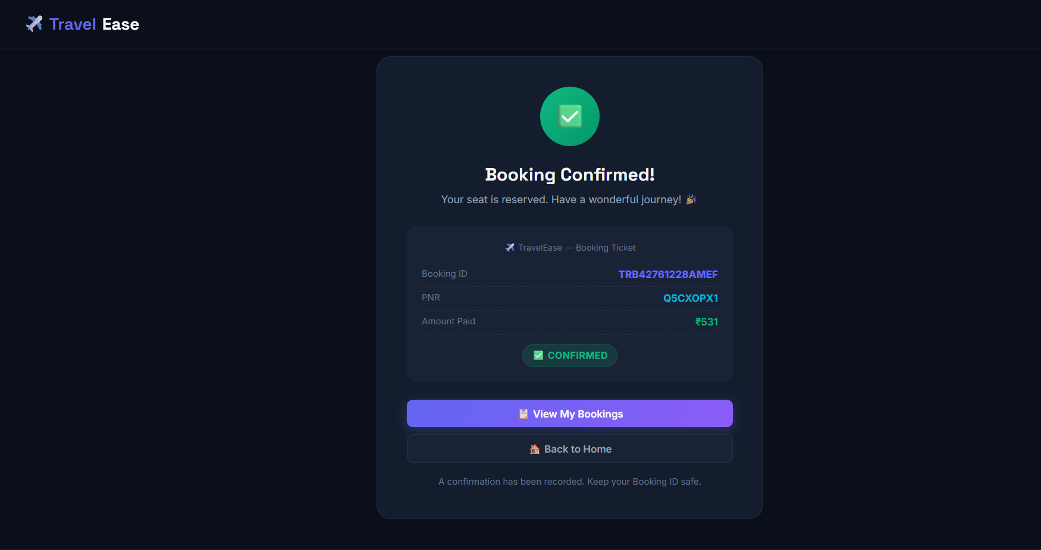
This figure shows the booking process and confirmation output, demonstrating how the system processes user inputs and displays the final result.
The confirmation output provides clear feedback to the user, indicating that the booking process has been successfully completed. This feedback is essential for building user confidence and ensuring reliability. The system presents the output in a structured format, making it easy for users to understand the details of their booking.
Another important aspect of visualization in the TravelEase system is the consistency of design across different web pages. Consistent use of colors, fonts, and layout elements ensures a uniform look and feel throughout the application. This consistency helps users navigate the system more efficiently and reduces confusion.
The system also focuses on responsiveness, ensuring that the web pages adapt to different screen sizes and devices. This allows users to access the application on desktops, tablets, and mobile devices without affecting usability. Responsive design improves accessibility and ensures a seamless experience across platforms.
Furthermore, the use of clear labels, buttons, and feedback messages enhances interaction between the user and the system. These elements guide users through each step of the process, reducing errors and improving overall efficiency. Proper error handling and validation messages also contribute to better user experience.
In addition, the frontend visualization helps in identifying user interaction patterns and system performance. By analyzing how users interact with different web pages, improvements can be made to enhance functionality and usability in future versions.
Overall, the visualization and interpretation of results through frontend outputs in the TravelEase project significantly improve user experience, accessibility, and system effectiveness. The structured design, interactive elements, and clear feedback mechanisms transform system data into meaningful and easily interpretable information. This approach ensures that the application remains efficient, reliable, and user-friendly while meeting modern web application standards.

4.3 Insights and Discussion
The TravelEase project provides several important insights into the design and development of modern web-based travel planning systems. Through the implementation and analysis of the system, it is evident that simplicity, usability, and efficiency are key factors in creating a successful application.
One of the major insights gained from this project is the importance of a user-friendly interface. Users prefer systems that are easy to navigate and require minimal effort to complete tasks. The TravelEase system achieves this by providing a clean layout, clear navigation, and structured presentation of information. This significantly improves user experience and encourages user interaction.
Another key observation is the effectiveness of frontend visualization in enhancing system usability. Instead of relying on complex data representations, the use of well-designed web pages allows users to easily understand and interact with the system. The homepage and booking interface provide clear guidance, enabling users to explore options and complete actions without confusion.
The project also highlights the importance of efficient data handling and processing. The integration of frontend and backend components ensures smooth communication and accurate results. This improves system reliability and ensures that users receive correct and timely information during the booking process.
In addition, the system demonstrates the value of cloud deployment and DevOps practices. By deploying the application on a cloud platform, the system becomes accessible from anywhere, improving usability and scalability. DevOps practices such as version control and continuous updates contribute to better system maintenance and faster development cycles.
Another important insight is the role of structured design and consistency in improving user interaction. Maintaining a consistent layout, color scheme, and navigation style across all web pages helps users become familiar with the system quickly. This reduces confusion and enhances overall efficiency.
The project also reveals that responsiveness is a critical factor in modern web applications. Ensuring that the system works effectively across different devices such as desktops, tablets, and mobile phones increases accessibility and user satisfaction. Responsive design allows the application to adapt to various screen sizes without compromising functionality.
Furthermore, the implementation process highlights the importance of error handling and user feedback. Providing clear messages during form submission and displaying confirmation outputs improves user confidence and ensures smooth interaction with the system.
Despite the successful implementation, certain limitations are identified in the current version of the system. For example, the absence of advanced features such as real-time payment integration, personalized recommendations, and real-time data updates limits the system’s capabilities. These limitations provide opportunities for future improvements.
Overall, the TravelEase project demonstrates how modern web technologies and development practices can be effectively used to build a functional and user-friendly travel planning system. The insights gained from this project emphasize the importance of simplicity, performance, scalability, and user experience in developing successful web applications. These findings can be applied to enhance future versions of the system and develop more advanced and efficient solutions.

5. CONCLUSION AND FUTURE WORK
5.1 Summary of Findings
The TravelEase project successfully demonstrates the development of a web-based travel planning and booking system using full-stack technologies and DevOps practices. The system was designed to simplify the process of exploring travel options and making bookings through a user-friendly interface.
From the implementation and analysis of the system, it is observed that a well-structured and intuitive frontend plays a significant role in enhancing user experience. The use of clear navigation, organized layout, and responsive design ensures that users can interact with the system efficiently. The frontend web pages effectively act as visualization tools, allowing users to understand and interpret information easily.
Another important finding is the effectiveness of integrating frontend and backend components. The smooth communication between these components ensures accurate data processing and reliable system performance. This integration helps in providing real-time responses to user inputs and improves the overall functionality of the system.
The project also highlights the importance of cloud deployment in improving accessibility and scalability. By deploying the application on a cloud platform, the system can be accessed from anywhere, making it more convenient for users. This approach also ensures that the application can handle multiple users efficiently.
In addition, the implementation of DevOps practices such as version control and continuous updates contributes to better system maintenance and development efficiency. These practices reduce errors, improve reliability, and support continuous improvement of the application.
The findings also emphasize the importance of simplicity and usability in application design. Users prefer systems that are easy to use and require minimal effort to complete tasks. The TravelEase system successfully meets these expectations by providing a streamlined booking process and clear feedback mechanisms.
Overall, the project demonstrates that the combination of modern web technologies, structured design, and efficient deployment strategies can result in a reliable and user-friendly travel planning system. The findings provide valuable insights into developing scalable and effective web applications that meet user needs.

5.2 Conclusions Drawn
The TravelEase project successfully achieves its objective of developing a simple, efficient, and user-friendly travel planning and booking system. The application demonstrates how modern web technologies and full-stack development can be effectively used to create a functional and interactive platform.
The system provides an intuitive interface that allows users to explore travel options and complete bookings with ease. The use of structured web pages and responsive design ensures smooth navigation and enhances overall user experience. The frontend plays a key role in presenting information clearly, making the system accessible even to users with minimal technical knowledge.
The integration of frontend and backend components ensures accurate data processing and reliable system performance. The application effectively handles user inputs and provides appropriate outputs, demonstrating the importance of proper system design and implementation.
Furthermore, the deployment of the application on a cloud platform highlights the advantages of accessibility and scalability. Users can access the system from different locations, and the system can support multiple users without performance issues.
The project also reflects the practical application of DevOps practices, including version control and deployment, which contribute to improved development efficiency and system reliability.
In conclusion, the TravelEase system proves to be a practical and effective solution for modern travel planning needs. It successfully combines usability, performance, and scalability, demonstrating the potential of web-based applications in simplifying real-world processes.

5.3 Recommendations and Future Scope
The TravelEase project provides a strong foundation for a web-based travel planning and booking system; however, there are several opportunities for further improvement and enhancement. Future developments can focus on adding advanced features and improving system performance to make the application more efficient and competitive.
One of the key recommendations is the integration of an online payment system. Currently, the system focuses on booking functionality, but adding secure payment options such as digital wallets, UPI, or card payments would make the platform more practical and closer to real-world applications. This enhancement would allow users to complete the entire booking process within the system.
Another important area for improvement is the implementation of personalized recommendations. By using user data and behavior analysis, the system can suggest travel packages based on user preferences. This can be achieved through basic machine learning techniques, which would enhance user engagement and satisfaction.
The system can also be improved by incorporating real-time data updates. Travel-related information such as pricing, availability, and seasonal offers may change frequently. Integrating real-time data sources or APIs would ensure that users receive accurate and up-to-date information, making the system more reliable.
In addition, the application can be extended by adding features such as search filters, sorting options, and user reviews. These features would help users compare different travel packages more effectively and make better decisions. A review and rating system would also increase trust and credibility.
Another recommendation is to enhance security features by implementing user authentication and data protection mechanisms. Features such as login systems, encrypted data handling, and secure communication protocols would improve system safety and protect user information.
The development of a mobile application can also be considered as part of future scope. Since many users prefer mobile devices for accessing online services, creating a mobile-friendly or dedicated mobile application would improve accessibility and reach a wider audience.
Furthermore, the system can be scaled to support larger datasets and a higher number of users. This may involve using advanced databases, optimizing backend performance, and implementing load balancing techniques to maintain system efficiency under heavy usage.
The project can also integrate additional services such as hotel booking, transportation options, and travel guides. This would transform the system into a complete travel management platform, providing users with a comprehensive solution for all their travel needs.
Overall, the TravelEase project has significant potential for future development. By incorporating advanced technologies and additional features, the system can evolve into a fully functional and commercially viable travel platform. These improvements will enhance usability, performance, and user satisfaction, making the system more effective and competitive in the real-world environment.

