Observing energy growth in Pseudo-Integrable Systems using smoothly oscillating dynamical Billiards

### Nirnay Roy, Roll No. 16128 ∗

M.S. Project Supervisor: Dr. Kushal Shah and Dr. Nirmal Ganguli Department of Physics, Indian Institute of Science Education and Research (IISER), Bhopal

Date of submission: 29 November 2020

**Abstract**

The motion of a mass-less particle in two types of Billiard tables was studied numerically. The first table was rectangular with a vertically oscillating bar and the second table was Stadium shaped. An ensemble of 100 systems was considered for each case. The simulations were run for 500,000 collisions, and changes in ensemble average energy with time were observed for both the Billiards tables. The particles in the slitted-rectangle experienced an exponential energy growth, and the particles in the Stadium Billiards experienced a series of energy gains and losses; the gains being higher than the losses, the energy gain is positive.

# Introduction

Dynamical Billiards are simulations of a particle moving inside an enclosure and colliding elastically with its rigid walls. These simulations are used for a variety of sys- tems in Physics in like Classical, Statistical [10] and Quan- tum [30] mechanics. [13]

## Static Billiards

Static Billiards have stationary boundaries. They can be broadly classified according to the shapes of their bound- aries. The boundary of a billiards may consist of Dispers- ing(convex inward), Focusing(convex outward) or Neu- tral(Flat) components.

#### Dispersing Billiards

These systems of billiards have chaotic properties. Dis- persing boundaries cause the divergence of trajectories. Repeated reflections with the boundaries causes the tra- jectories to separate exponentially. The Sinai Billiard has a circular disc inside it, which provides the dispersing surface. The Sinai Billiards is used to model the Boltz- mann gas consisting of elastically colliding hard balls in a box [10]. The Sinai Billiard also shows chaotic properties like ergodicity.

#### Focusing Billiards

Billiards with focusing boundaries can give both regular chaotic dynamics depending on the exact shape of the Billiard table. Elliptical or Circular shaped Billiard ta- bles are examples of focusing Billiards which give rise to integrable billiards. These types of billiard tables may be solved analytically by a coordinate transformation into the action-angle variables to give conserved quantities. in- tegrable systems have an invariant manifold which is dif-

∗email: [nirna](mailto:nirnay16@iiserb.ac.in)[y16@iiserb.ac.in](mailto:y16@iiserb.ac.in)

feomorphic to a torus in their phase space. [6] Stadium shaped Billiard tables are not integrable because the path lengths of trajectories after converging are long enough to diverge after focusing at a point. This is called the mechanism of defocusing. [1]

#### Polygonal Billiards

These type of systems can show a variety of different prop- erties like being integrable(Rectangle and Equilateral Tri- angle), almost integrable [20] and pseudointegrable sys- tems(square torus billiards) [26]. We are particularly in- terested in rational polygons. These types of billiards are particularly interesting because such systems can show chaotic properties which arise from the splitting of trajec- tories at the vertices of the polygon and not from diver- gence of nearby initial conditions. Pseudointegrable sys- tems do not form an invariant torus in their phase space despite the presence of conserved quantities. [26] show that the square torus billiards forms a 5-handled sphere in its phase space.

#### Other types of Billiards

There are several different kinds Billiards like the Mush- room Billiard which has coexistence of regular and chaotic dynamics. This arises due to presence of integrable tra- jectories that never leave the semi-circular part of the ta- ble [2].

## Fermi Acceleration and Fermi-Ulam Model

Our study of Breathing Billiards is centered around Fermi Acceleration. It was first discovered by Enrico Fermi [8] for the acceleration of cosmic wave particle due to mag- netic fields [24]. Ulam was the first to model this phenom- ena with a particle bouncing back and forth two walls, out

of which one is oscillating slowly in comparison to the par- ticle velocity [27]. The Fermi-Ulam model has been stud- ied in detail. However, Fermi acceleration was only ob- served for non-periodic oscillations of the wall which have a stochastic component in its motion [14] [3]. Periodic os- cillations can give energy growth upon in introduction of a potentials [22] [7] or relativistic correction [23].

## Breathing Billiards and LRA conjec- ture

It was then found that 2D breathing Billiards show Fermi Acceleration for slow, periodic oscillations of the bound- ary [28] [11]. Fermi Acceleration was mostly found in Billiarrds which are Chaotic when frozen [18] [19]. No unbounded energy growth was observed in systems which are Integrable when frozen [21] [15]. . Similar results were obtained for the oscillating stadium-like [17] anad annular billiard systems [25].This was hypothesized by Loskutov et al. as ‘A chaotic dynamics for the static billiard is a sufficient condition for the presence of Fermi acceleration in the billiard with time-dependent boundary’. This is also known as the LRA conjecture. This was proven by

V. Gelfreich et al in 2002 [31]. More recently, Fermi Accel- eration was found in breathing elliptically driven billiards by Lenz. et. al., which violates the LRA conjecture [9].

## Energy growth in Breathing Billiards

Given unbounded energy growth, we are also interested in the rate of this growth. Smoothly oscillating chaotic bil- liards have shown quadratic in time energy growth [4] [12]. Exponential energy growth was observed in pseudointe- grable Billiards. It was also proven that pseudointegribil- ity is a sufficient condition for unbounded energy [16] [29]. Even Integrable systems show slow energy growth due to Arnold diffusion [5].

In this work, we compare a pseudointegrable and a chaotic dynamical Billiard. For the pseudointegrable bil- liard, we choose the Slitted rectangle Billiard table and for the chaotic one, we choose the breathing Stadium Billiard table. Our obejective is to replicate the results reported in [16] and [29]

# Methodology

## Slitted rectangle Billiard

This system consists of a particle moving inside a rect- angular enclosure and elastically colliding with its bound- aries. There is a horizontal slit in the center of the rect- angle, which oscillates vertically with a fixed frequency

plotted w.r.t. time. The initial positions of the particles were randomly sampled from the uniform distribution.

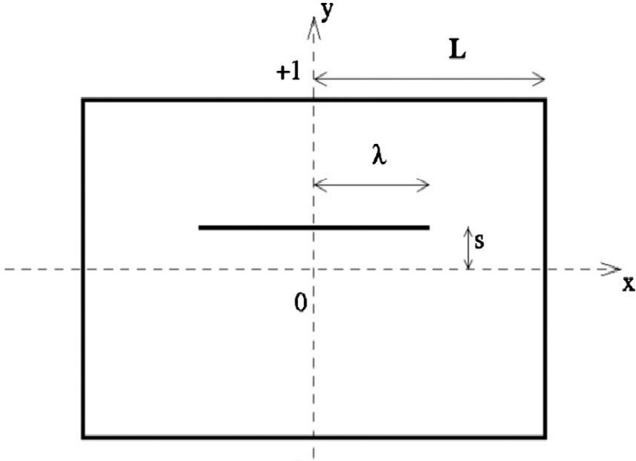

Figure 1: Geometry of the slitted rectangle Billiards

## Stadium Billiards

This system consists of a particle moving inside a stadium shape (Figure 2) enclosure and elastically colliding with its boundaries. The bottom wall oscillates vertically with a fixed frequency *ω*

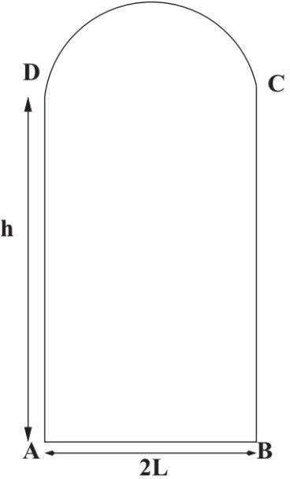

Figure 2: Geometry of the slitted rectangle Billiards

Th*√*e particle starts with an initial velocity *u*0 =

*ω*. 4*λω/* 5 and *v*0 = 41*u*0. Values for the other parame-

70

The particle starts with an initial velocity *u*0 = 4*λω/* 5 and *v*0 = 41*u*0. Values for the other parameters in Figure 1 are *λ* = 1, *L* = 2, *h* = 1 and *s* = 0*.*1. The slit oscillates with *f* (*t*) = cos 2*πt* . The state variables of the system were recorded at every collision. The total energy of an ensemble of 100 systems over 500,000 collisions was

70

*√*

ters in Figure 2 are *L* = 0*.*5, *h* = 4 and *s* = 0*.*1. The slit oscillates with *f* (*t*) = cos 2*πt* . The state variables of the system were recorded at every collision. The total energy of an ensemble of 100 systems over 500,000 collisions was plotted w.r.t. time. The initial positions of the particles were randomly sampled from the uniform distribution.

# Results and Discussions

## Slitted rectangle Billiard

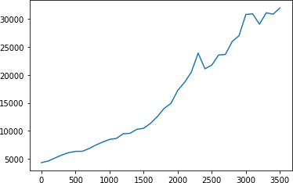

Figure 3: Total Energy of the slitted rectangle ensemble changing with time

Figure 3 shows the energy growth for an ensemble of 100 systems over 500,000 collisions. We can observe an exponential energy growth over time.

## Stadium Billiards

Figure 4 shows the energy growth for an ensemble of 100 systems over 500,000 collisions. We can see growth in en- ergy but cannot find any trend followed by the ensemble energies.

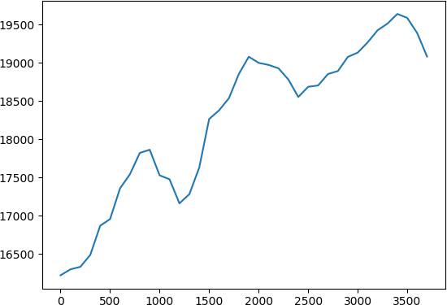

Figure 4: Total Energy of the stadium ensemble changing with time

We observe almost exponential energy growth in the slitted rectangular Billiards. For the Stadium Billiards, we observe a series of energy gains and losses. The net energy gain is positive.

# Future plan

Following is a brief road map for further work in this project.

* Analyze the data obtained to fit a curve and find growth rates for these ensembles.
* Obtain results for the Trapezium Billiards ensemble for comparison with the Stadium Billiards.
* Vary other parameters like the amplitude and fre- quency of the slit oscillations, the shape of the en- closure.
* Introducing a small mass for the particle and mak- ing the collisions more inelastic to make these sim- ulations closer to reality.
* Read the paper ”Robust Exponential Acceleration in Time-Dependent Billiards”

# References

1. Bunimovich L. A. The ergodic properties of certain billiards.

*Funkt. Anal. Prilozh.*, (8:73-74), 1974b.

1. Bunimovich L. A. Mushrooms and other billiards with divided phase space. *Chaos.*, 11(802-808), 2001.
2. Lieberman M A and Lichtenberg A J. *Phys. Rev. A*, 5(1852), 1972.
3. A. B. Ryabov A. Loskutov and L. G. Akinshin. *J. Phys. A*, 33(7973), 2000.
4. V. I. Arnold. *Sov. Math. Dokl.*, 5(581), 1964.
5. V. I. Arnold. *Mathematical Methods of Classical Mechanics, 2nd ed*. Number ISBN 978-0-387-96890-2. Springer., 1997.
6. D. Dolgopyat. *Discrete Contin. Dyn. Syst.*, 22(165), 2008. [8] Fermi E. *Phys. Rev.*, 15(1169), 1949.
7. * F. K. Diakonos 2 F. Lenz, 1 and P. Schmelchers. Tunable fermi acceleration in the driven elliptical billiard. *Phy. Rev. Lett.*, 100(014103), 2008.
8. Sinai Y G. *Russ. Math. Surv.*, 25(137), 1970.
9. V. Gelfreich and D. Turaev. *J. Phys. A: Math. Theor.*, 41(212003), 2008.
10. V. Gelfreich and D. Turaev. *J. Phys. A*, 41(7973), 2008.
11. Eugene Gutkin. Billiard dynamics: An updated survey with the emphasis on open problems. *Chaos.*, 22(0261168), 2012.
12. Diakonos F K Constantoudis V Karlis A K, Papachristou P K and Schmelcher P. *Phys. Rev. Lett.*, 97(194102), 2006.
13. Oliffson Kamphorst S Koiller J, Markarian R and Pinto de Car- valho S. *J. Stat. Phys.*, 83(127), 1996.
14. Dmitry Turaev Kushal Shah and Vered Rom-Kedar. Expo- nential energy growth in a fermi accelerator. *PHYSICAL RE- VIEW*, E(056205), May 2010.
15. A. Yu. Loskutov and A. B. Ryabov. *J. Stat. Phys.*, 108(995), 2002.
16. Ryabov A B Loskutov A and Akinshin L G. *J. Exp. Theor. Phys.*, 89(966), 1999.
17. Ryabov A B Loskutov A and Akinshin L G. *J. Phys. A: Math. Gen.*, 33(7973), 2000.
18. Howard Masur and Serge Tabachnikov. Rational billiards and flat structures.
19. Kamphorst S Oliffson and Pinto de Carvalho S. *Nonlinearity*, 12(1363), 1999.
20. L. D. Pustyl’nikov. *Proc. Moscow Math. Soc.*, 34(3), 1977.
21. L. D. Pustyl’nikov. *Theor. Math. Phys.*, 86(82), 1991.
22. Blandford R and Eichler D. *Phys. Rep.*, 1(154), 1987.
23. F. C. Souza R. E. de Carvalho and E. D. Leonel. *Phys. Rev. E*, 73(066229), 2006.
24. P.J. Richens and M.V. Bery. Pseudointegrable systems in clas- sical and quantum mechanics. *Physica*, D2(495), April 1981.
25. Ulam S. *Proc. 4th Berkeley Symp. on Math. Stat. and Prob.*, 3(315), 1961.
26. E. D. Leonel S. O. Kamphorst and J. K. L. da Silva. *J. Phys. A: Math. Theor.*, 40(F887), 2007.
27. Kushal Shah. Energy growth rate in smoothly oscillating bil- liards. *PHYSICAL REVIEW E*, 83(046215), 2011.
28. Prosen T. and Robnik M. *J. Phys. A: Math. Gen.*, 27(8059), 1994.
29. V. Rom-Kedar2 V. Gelfreich1 and D. Turaev3. Fermi accel- eration and adiabatic invariants for non-autonomous billiards. *Chaos 22, 033116*, 22(033116), 2002.