System Requirement Specification

Student Fee Management System

# Version 1.0

# 

Students who submitted this project :-

Shivam Nirne (B16CS022)

Nikunj Labana (B16CS021)

Team Number -8

**Table of Contents**

1. Introduction

1.1 Purpose

1.2 Scope

1.3 Constraints

1.4 Assumptions and Dependencies

1.5 Definitions, Acronyms and Abbreviations

1.6 References

1.7 Organization of the Document

2. Overall Description

2.1 Product Functions

2.1.1 Functional Requirement

2.1.1.1 Use Case Diagram

2.1.1.2 Class Diagram

2.1.1.3 Sequence Diagram

2.1.1.4 Activity Diagram

2.1.2 Non Functional Requirement

2.2 User Characteristics

3. Specific Requirements

3.1 Use case description

3.1.1 Administration : Register Students

3.1.2 Administration : View Fee Details

3.1.3 Administration :Update Details

3.1.4 Administration : Remove Student

3.2.1 Student : Semester Fee Payment

3.2.2 Student : Mess Fee Payment

3.2.3 Student : See Receipt

3.2.4 Student : Change Password

3.3 Supportability

## 

### 

# **1.0 Introduction**

## **1.1 Purpose**

The main purpose of this document is to briefly describe the development and operation of the Student Fee Management System .It will also give description about the functionality of the system.It will explain the constraints on the system and the assumptions that are made while developing this system. It will describe user interface, software interface and response of the system to any external factors. This document is made so that customer will get to know about the software , but this can also be used by the developer to measure the progress.

## **1.2 Scope of Project**

This software system can be used to digitize the fee payment system in the institute and to efficiently maintain the fee payment record of each student.This software system can be used by both administration as well as students .This system can be used by other institutes or schools as well.

Primarily administration will use this software to maintain fees records of each student. Administration will register the new students to this system at the time of admission. The records will be maintained till the student is part of the institute. It can also check whether a student has paid the fees in ongoing semester or not. It will also make changes in the fee structure if needed.

Student will pay the semester and mess fee at the start of each semester with the help of this software. After the payment the payment receipt will be provided so that further registration process can be done.

## **1.3 Constraints**

1. The fees structure will differ for Open , OBC , SC , ST category students.

2.The fees will be different for Undergraduate and Postgraduate student.

3.Depending upon the family income of the student the fees will differ.

## **1.4 Assumptions And Dependencies**

1. All the student are hostellers.

2.All Postgraduate Students will have same fees .

3. Payment gateway system is not considered.

4. The fees can not be paid in installments.

5. there are no dues for any student at the start of new semester.

6. It is assumed that administration knows for how much duration particular student is part of institute.

7. It is assumed that the fees is same for students of each year if they belong to same program.(fees may differ on the basis of cast,income).

## **1.5Definitions,Acronyms And Abbreviations**

|  |  |
| --- | --- |
| **Term** | **Definition** |
| Student | One who is studying or will study in the Institute or School |
| Administration | A Institute body which helps in proper functioning of the institute. |
| Undergraduate | B.tech students |
| Postgraduate | M.Sc students |

## **1.6References**

[1] IEEE. IEEE Std 830-1998 IEEE Recommended Practice for Software Requirements

Specifications. IEEE Computer Society, 1998

[2] Fees structure of IIT Jodhpur

<http://iitj.ac.in/admission/btech.php?id=fee>

[3]Official Fee payment portal of IIT Jodhpur

<https://oa.iitj.ac.in/FeePayment/>

## **1.7 Overview of Document**

The design of the remaining document is as follows .

# **2.0 Overall Description**

## **2.1 Product Function**

## **2.1.1 Functional Requirement**

## **2.1.1.1 Use Case Diagram**

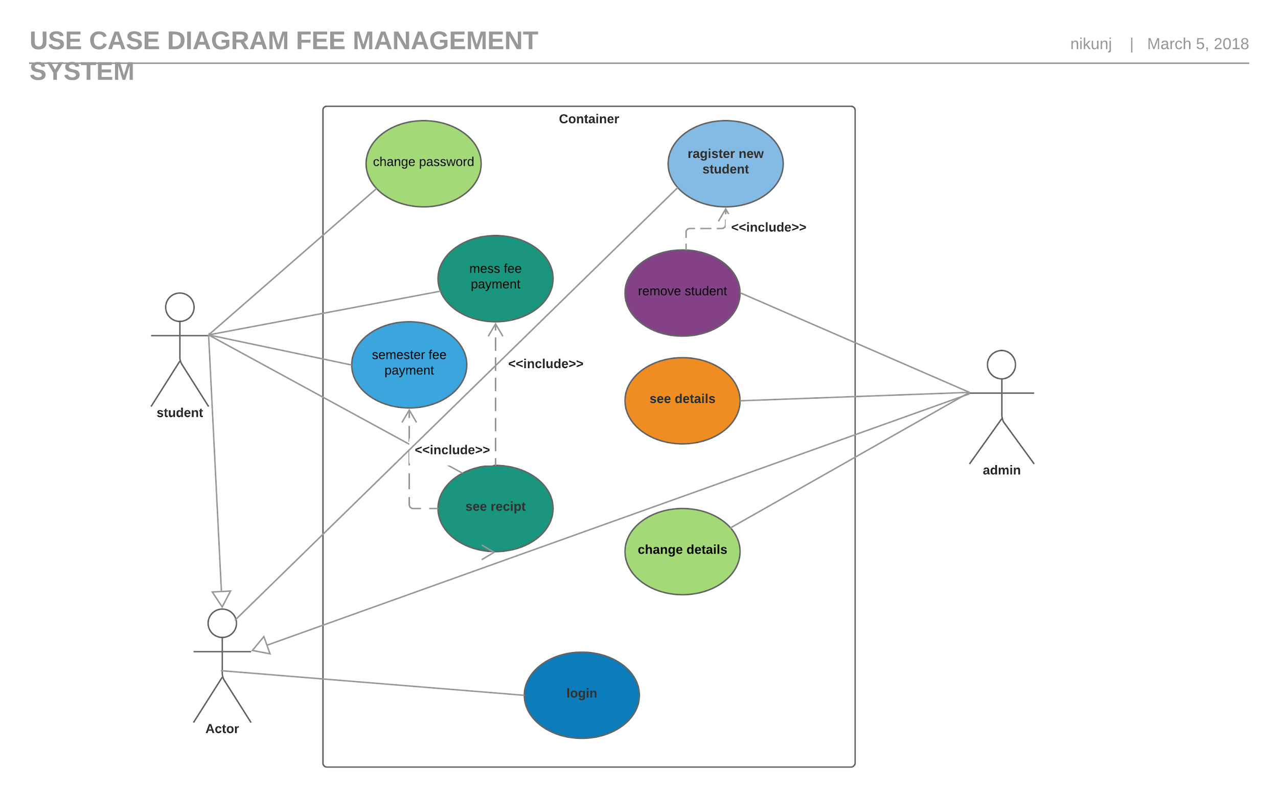

## **2.1.1.2 Class Diagram**

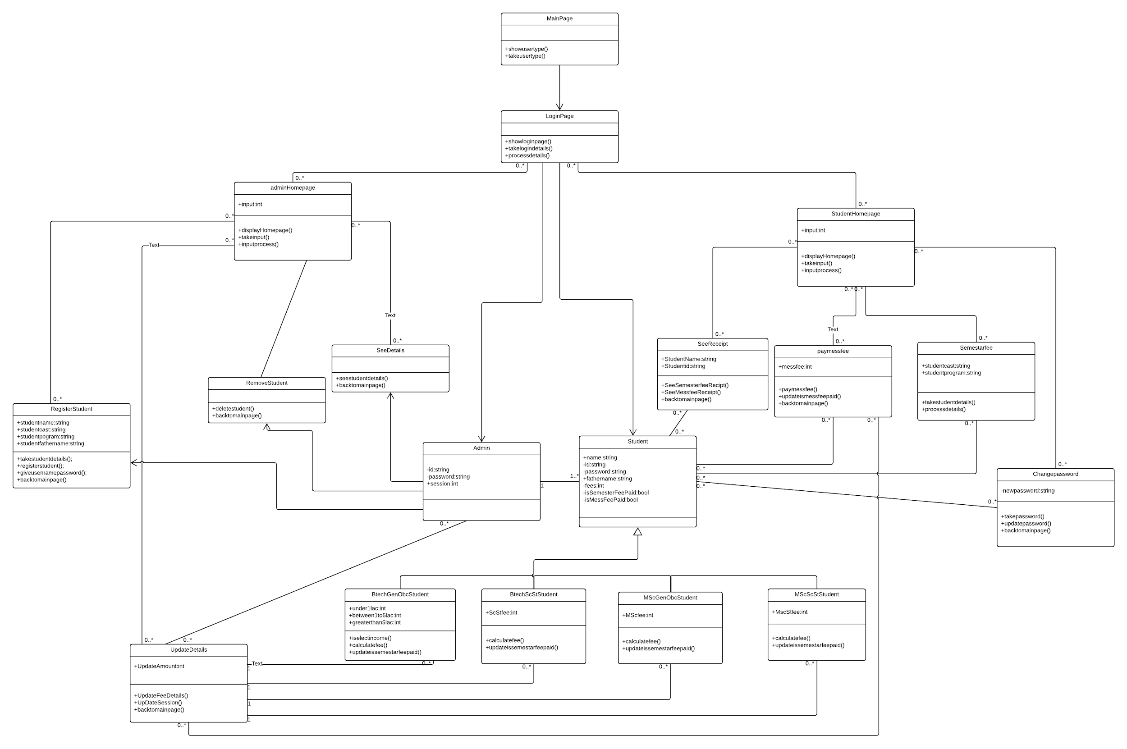

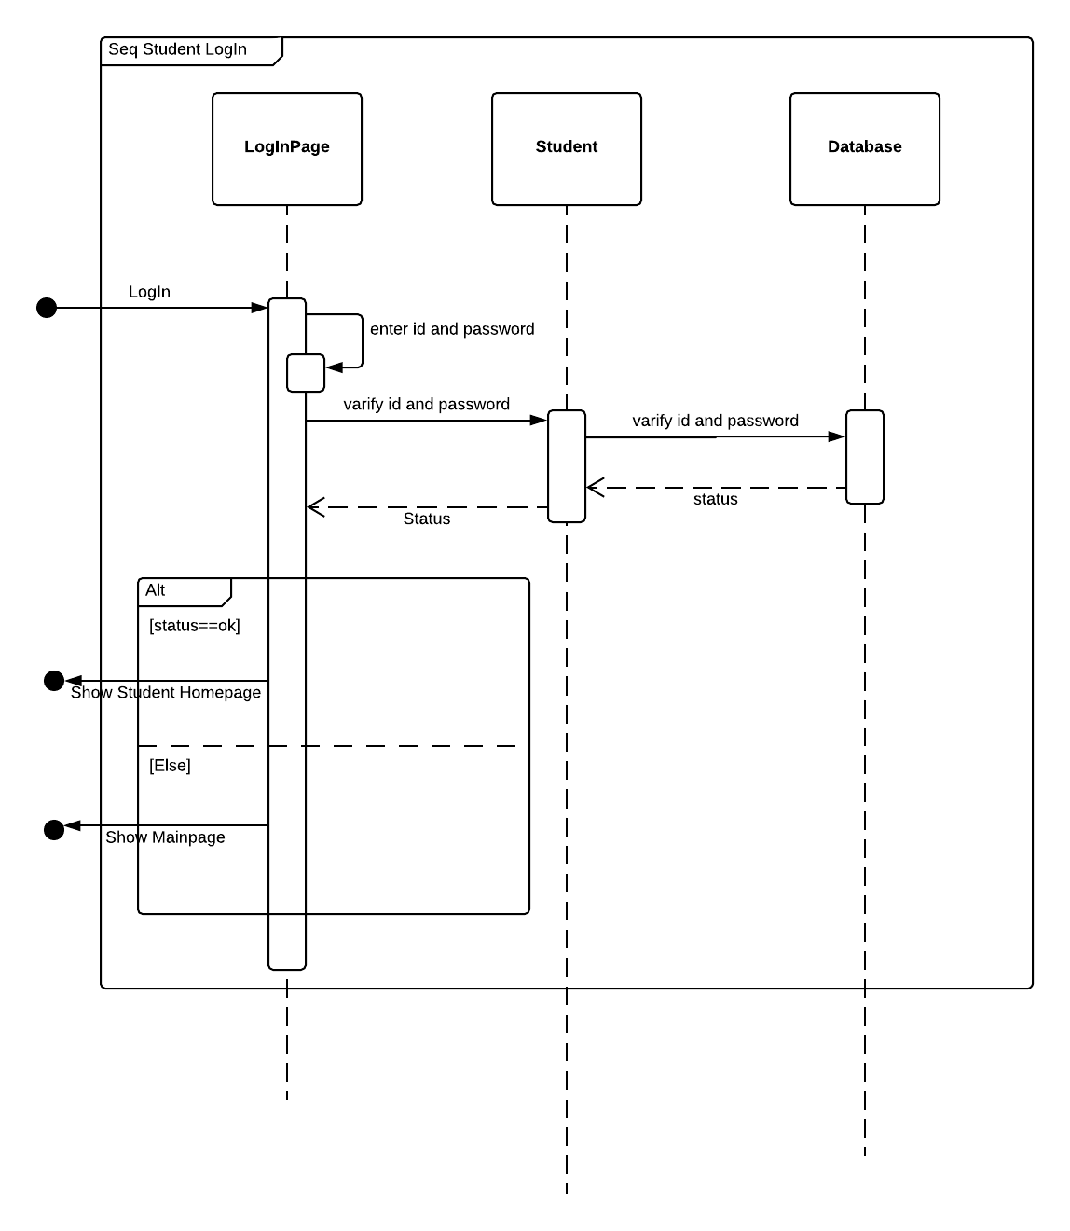

## 

## 

## **2.1.1.4 Activity digram**

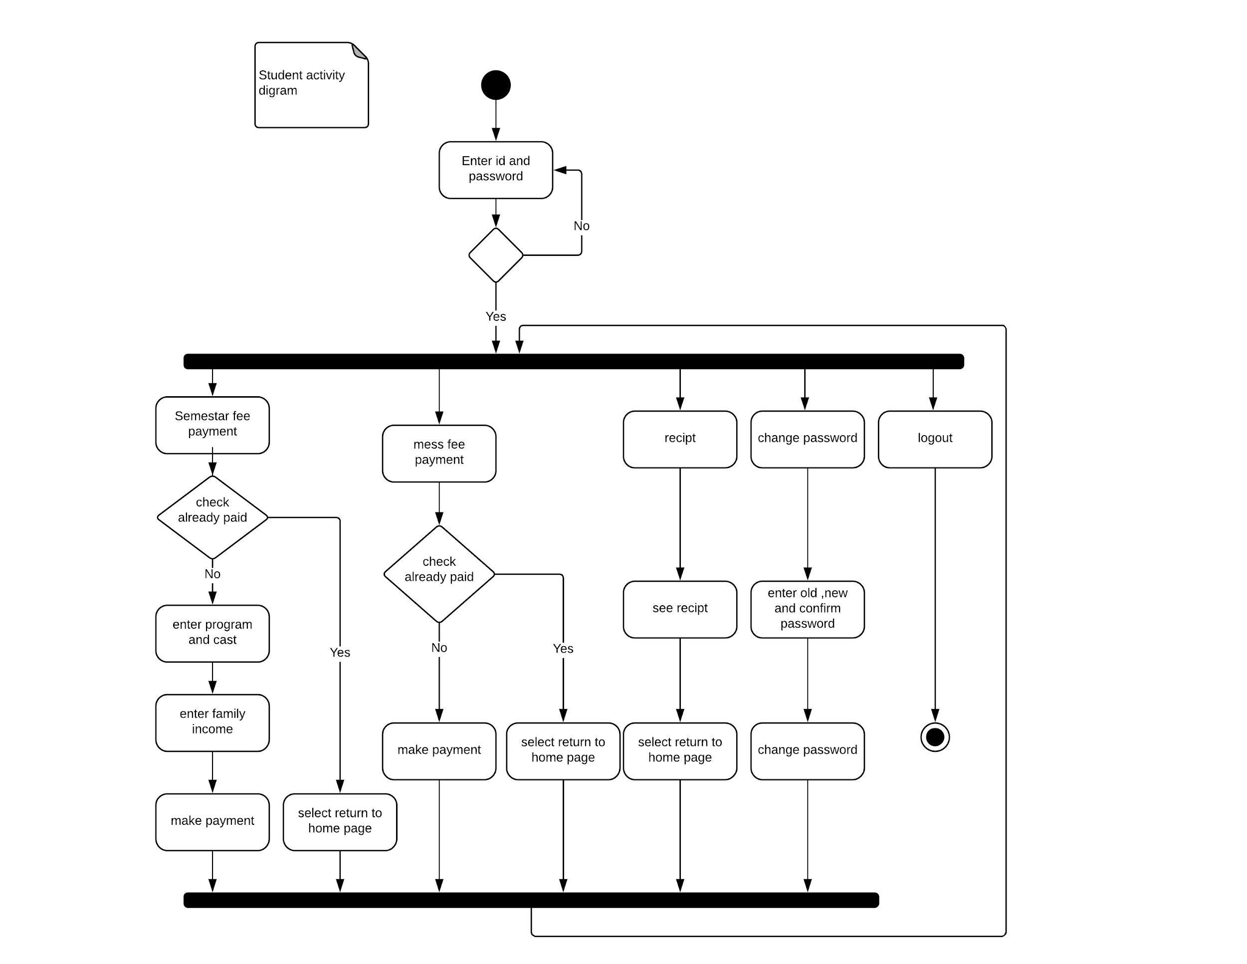

## 

## **2.1.2. Non-Functional Requirement**

Student Fees management system should run on local computer or pc and store data in local hard disk.Proper Internet connection is required.

Whenever new student is registered , his data will be stored in the local hard disk of computer.

## **2.2 User Characteristics**

There are two types of users Administration and Students. They both have particular characteristics.

Students can pay the fees at start of semester using this software if and only if he has not done the payment for that particular semester. There will be different fees structure as per constraints. And they will get the receipt on completion of the process.

Administration will use this software to register new students at the start of admission.He can also make changes in the fees structure if needed. He will maintain the fees record of all students.

He will remove those students from the database if they are no longer a part of institute.

# **3. Specific Requirements**

## **3.1 Use Case Description**

## **3.1.1 Administration : Register Students**

|  |  |
| --- | --- |
| **Use Case Name** | Register Student |
| **Trigger** | At the time of admission in the Institute |
| **Precondition** | 1.Admin should be logged in.  2.Student should provide his name,caste,program. |
| **Basic Path** | 1.Select ‘Register Student ‘ option.  2.Take details from student.  3.Will give ID and password(this password can be  changed later by student) |
| **Alternative Paths** | No |
| **Postcondition** | Student will be registered and data will be stored in the system. |
| **Exception Paths** | 1.Admin denies registration if the student is already registered. |
| **Other** | None. |

## **3.1.2 Administration : View Fee Details**

|  |  |
| --- | --- |
| **Use Case Name** | View Fee details |
| **Trigger** | Admin wants to check fees record of any session. |
| **Precondition** | 1.Admin should be logged in. |
| **Basic Path** | 1. Select “View Fee Details” option.  2.Admin will select the session of which he wants to see fee details. |
| **Alternative Paths** | None. |
| **Postcondition** | Details of any academic sessions till date can be seen. |
| **Exception Paths** | Academic session should exist. |
| **Other** | None. |

## **3.1.3 Administration :Update Details**

|  |  |
| --- | --- |
| **Use Case Name** | Update Details |
| **Trigger** | Admin wants to make changes in fees structure . |
| **Precondition** | 1.Admin should be logged in.  2.Admin should know new fees structure.  3.Admin |
| **Basic Path** | 1.Select “Update Details “ option.  2.Select “Semester Fees” or “Mess Fee” or “Change Academic Session” option.  3.Enter new amount if any of the first two options is selected.  4.Enter new academic session if last option is selected. |
| **Alternative Paths** | None. |
| **Postcondition** | Fees has been updated.(It can be mess or semester or both). |
| **Exception Paths** | Can not change fees in between that particular session. |
| **Other** | None. |

## **3.1.4 Administration : Remove Student**

|  |  |
| --- | --- |
| **Use Case Name** | Remove Student |
| **Trigger** | Student is graduated,dropped out etc. from Institute. |
| **Precondition** | 1.Admin should be logged in.  2.Student should be registered. |
| **Basic Path** | 1.Select “Remove Student “ option.  2.Enter student ID.  3.Select “confirm” option to remove. |
| **Alternative Paths** | None. |
| **Postcondition** | Students data will be erased from database. |
| **Exception Paths** | Wrong ID is entered. |
| **Other** | None. |

## **3.2.1 Student : Semester Fee Payment**

|  |  |
| --- | --- |
| **Use Case Name** | Semester Fee Payment |
| **Trigger** | Student wants to pay the semester fee. |
| **Precondition** | 1.Student should be registered and logged in. |
| **Basic Path** | 1.Select “Semester Fee Payment “ option.  2.If caste of student is GEN/OBC he should select any one of the family income options.If he belongs to SC/ST no family income options will be displayed.  3.Select “Proceed to pay “ option. |
| **Alternative Paths** | None. |
| **Postcondition** | Semester fee payment is done. |
| **Exception Paths** | Admin denies payment if already paid. |
| **Other** | None. |

## **3.2.2 Student : Mess Fee Payment**

|  |  |
| --- | --- |
| **Use Case Name** | Mess Fee Payment |
| **Trigger** | Students wants to pay the mess fee. |
| **Precondition** | 1.Student should be registered and logged in.  2.Mess should be valid. |
| **Basic Path** | 1. Select “Mess Fee Payment”option.  2.Select “Proceed to pay “ option. |
| **Alternative Paths** | None. |
| **Postcondition** | Mess fee payment is completed. |
| **Exception Paths** | Admin denies if already paid. |
| **Other** | None. |

## **3.2.3 Student :See Receipt**

|  |  |
| --- | --- |
| **Use Case Name** | See Receipt |
| **Trigger** | Students wants to see receipt. |
| **Precondition** | 1.Student should be registered and logged in. |
| **Basic Path** | 1.Select “See receipt” option. |
| **Alternative Paths** | None. |
| **Postcondition** | Viewed receipt of ongoing session. |
| **Exception Paths** | None. |
| **Other** | None. |

## **3.2.4 Student : Change Password**

|  |  |
| --- | --- |
| **Use Case Name** | Change Password |
| **Trigger** | Student wants to change password. |
| **Precondition** | 1.Student should be registered and logged in. |
| **Basic Path** | 1.Select “Change Password ” option.  2.Enter old password.  3.Enter new password.  4.Re-Enter new password to confirm. |
| **Alternative Paths** | None. |
| **Postcondition** | Password is successfully changed. |
| **Exception Paths** | none |
| **Other** | none |

**3.3 supportability**

Student fees management system support local computers and easy to use.