CC31 - Introduction To LabVIEW & Simple Feedback.


Aims
By the end of this experiment students should develop a thorough understanding of:
- how a PC can control an analogue system with awareness of sampling rate and both A/D, D/A conversion,
- the use of LabVIEW to control and monitor a ‘DC Servo Motor’, &
- the effect sampling rate can have on the performance of a system.

Equipment
- 1 x Feedback Power Supply 01-100
- 1 x Feedback Mechanical Unit 33-100
- 1 x IBM PC (min Pent. 166) with PC-LPM-16/PnP card and LabVIEW software
- 1 x PC2MI circuit box (PC to Motor Interface)
- 1 x Printer (B&W)

Reading
Students are required to read from ‘LabVIEW - Student Edition User’s Guide’:
- pp6-8 - An Introduction to LabVIEW
- pp53-56 - Wiring Up
- Shortcut Keys For LabVIEW, Reference
Prior to entering this lab students should have a clear understanding of LabVIEW, especially how to use & wire up a sub ‘VI’. The User’s Guide can be found in full at the Engineering Library.

Introduction
In this experiment students will be working with discrete time systems, in contrast to continuous time systems in Control 3. While much of the theory remains the same, one of the key differences is the consideration of sampling rate and method of sampling.
One of the goals in developing these labs was to ensure that designing controllers was as simple as possible. In previous labs students would only have used LabVIEW as a monitoring device, however in these labs LabVIEW will also be responsible for controlling the motor. Students will be required to develop different types of controllers, and analyze their performance with the motor.

Computer Control System - Component Breakdown
With the aid of LabVIEW and a DAQ (Data Acquisition) card (PC-LPM-16/PnP), we are able to monitor a DC servo motor, and display its features on the screen using 'Virtual Instruments' (VIs).

PC-LabVIEW
User Interface,
Monitor and Control
Digital To Analogue Converter
(PC2MI)

DC Servo Motor
PC-LPM-16/PnP
DAQ Card
Analogue to Digital

Analogue
Digital

DC Servo Motor
A simple motor, which is controlled by a single power amplifier input. It provides three important signals:
- Revolution Speed (RPM) of the output shaft which is the motor shaft speed divided by 32 - a tachogenerator provides a voltage signal proportional to speed.
- Position of Motor (Degrees) - Output Angle
- Required Position of Motor (Degrees) - Input Angle
The output shaft can rotate as fast as ±85 RPM. However due to non-linearity of the tachometer at high speeds, we shall restrict the motor to the -60 to +60 RPM range.

The DAQ card, PC-LPM-16/PnP
This card (located in an expansion slot of the PC) has 16 analogue input channels, 8 digital input pins (which are unused), and 8 digital output pins. Four analogue channels are used to read the ‘Power Amplifier Input’, ‘Tachogenerator’, ‘Input Angle’ and ‘Output Angle’ parameters of the motor. As the PC can only operate on signals that are discrete in time and amplitude, the card performs conditioning and analogue to digital conversion. Eight digital output pins are used to control the motor rotational speed and direction.

PC2MI circuit (PC to Motor Interface)
The purpose of this circuit is to interface the motor to the DAQ card. While the 'Tachometer', 'Input Angle' and 'Output Angle' voltages can be connected directly to the DAQ, when it comes to controlling the motor we only have an 8 bit digital signal. Thus we need an 8 bit Digital-to-Analogue converter (plus some conditioning circuitry) to transform this digital signal into an analogue usable voltage for the motor. e.g. 10000000b => 0V, 00000001b => -5V (-80RPM), and 11111111b => 5V (+80RPM).

LabVIEW
The user interface, through it one can specify sampling rate, apply voltage signals to the motor, monitor the response of the motor and develop controllers. Reading material has been provided for students to develop an understanding of LabVIEW prior to their lab.
Experiment
1. Setup
When starting any of the computer control labs, to prevent the DC servo motor from spinning at full speed, it is important that the following procedure is implemented.
- Set the Feedback Power Supply switch off, verify that the PC is connected to the Feedback Mechanical Unit (FMU) via the box labeled PC2MI, and that the power supply is connected to the FMU.
- Set the switch on the PC2MI to “OFF”.
- Start up the program LVSE on the PC and open the file “c:\cclabs\ccdcm1.llb” (ask the demonstrator if you cannot find the program/file).
- On the ‘FMU’ ensure the brake lever is at its highest position, and the leftmost switch has been set to RPM - NOT DVM.

2. Testing the Motor
Students will:
- be introduced to the open loop control of the motor,
- develop an understanding of the ‘PC2MI’ box and the purpose it serves, &
- observe the linearity of the motor for various voltage settings.
- Press ‘Ctrl-f’ to open up the options (Fig 3). Start up the ‘Motor Control Unit’ program by double clicking on the icon.
- Initially just run the program once by clicking on the leftmost icon shown in Fig. 1, and then switch the PC2MI on. This will set the Data Acquisition Card’s digital output port to 10000000b which the PC2MI converts to 0Volts, so that the motor will be stationary.
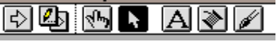
Figure 1- LabVIEW commands
- Hold the Motor Check switch to the ‘V+’ position, count the number of revolutions the output shaft does in a minute and compare with the value seen on the display.
- What speed does the motor rotate at according to the digital readout? Is this similar to the actual motor speed?
- Similarly, hold the switch in the ‘V-’ position and verify that the motor rotates in the opposite direction at approximately the same speed. This should indicate that the motor is functioning properly.
- Run the program in continuous mode by clicking initially on the arrow hidden by the pen (Fig. 1) from the LabVIEW commands.
- This should bring up a set of icons as shown in Fig. 2, click the 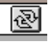 icon. The program will now run continuously, to stop press the ‘STOP’ icon, which appears when the program is running.
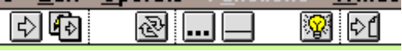
Figure 2 - LabVIEW commands 2

- To change values in the program use the ‘hand’ cursor which can be enabled by clicking the  icon.
- Click the switch so the program reads RPM instead of Voltage, then increment the RPM control on the screen, and, this should cause the motor to start spinning.
- Notice that the motor does not start spinning immediately, explain why.
- As the motor speed is increased on the screen, looking at the ‘Binary Code’ display, for every bit increment, by how much does the ‘FMU’ RPM display increase? Is it always the same? How would your answer differ if instead a 16bit DAC had been used in the ‘PC2MI’ ?
- To observe the ‘source code’ press ‘Ctrl-f’. If you write 6V or 70RPM to the ‘program’, what digital value will be written to the PC2MI? Explain.
- For different RPM settings, plot ‘RPM Specified Vs RPM Displayed’ (in 10RPM steps). This should give you the factor by which to alter the constant (≈1) used to convert the RPM specified into the actual RPM.
- Change the switch back to voltage, the voltage control will be used when implementing the ‘Motor Control Unit’ Program (MCU) in a closed-loop system.
- Ensure that the switch is set back to voltage prior to exiting!!!
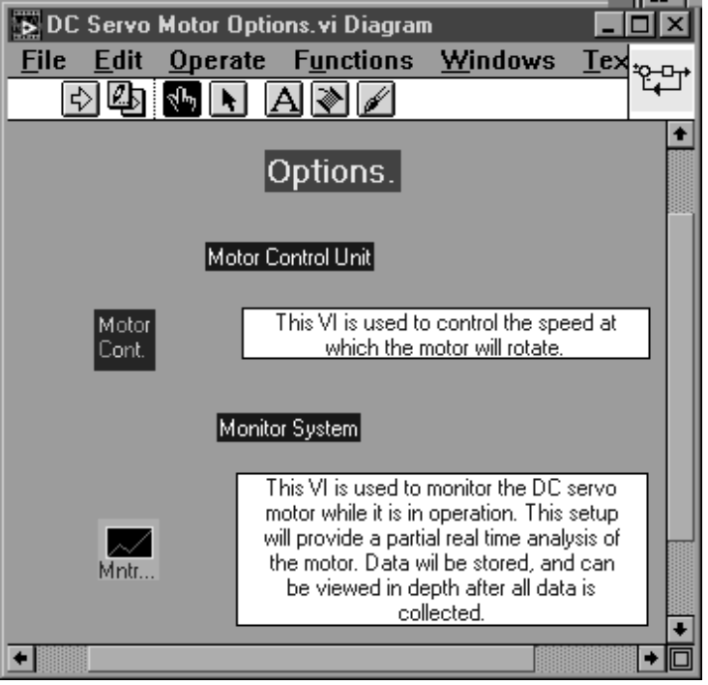
Figure 3 - Main Menu
3. The Monitoring System
Students will:
- develop a feel for the user interface that has been developed to monitor the DC servo motor,
- be aware of intricacies which will make data analysis more simplified.
- Return to the options menu shown in Fig. 3 and double click the ‘Monitor System’ icon.
- Initially observe the different types of signals that can be generated. Varying the settings of the multicoloured option controls, and running the program can do this. The generated signal can be seen in the ‘Power Amplifier Input’ graph.
- How would you generate a 2Vp-p, 1Hz Square wave signal over a 5-second time span?
- Observe the three grey graphs, these display the Tachogenerator voltage (proportional to the rotational speed), and input and output angles. The axes on these graphs are set to auto-scale, so that only the relevant region is displayed.
- If a particular region is of more interest, one can click and hold on the magnifying glass below the graph and choose the top left option. Then click and drag over the region required, and this will be zoomed in. To zoom out simply use the mouse to highlight the final value on the x-and-y axes, then type in the larger value.
- If the ‘Input Angle’ graph seems very erratic (note the y-axis scale) this is due to minor fluctuations (order of 10⁻³ Volts) in voltages being read in.
- Run the program for 10 seconds and vary the ‘Input Angle’ dial on the mechanical unit. What do you observe on the ‘Input Angle’ graph?

4. A Simple Feedback System
In this section the output angle of the Mechanical Unit will be controlled so that it follows the input angle. Students will be:
- introduced to negative and reversed polarity feedback, &
- required to wire up and implement these systems using the graphical interface provided by LabVIEW.
- Open up the monitoring system, and switch into the ‘Diagram’ view of LabVIEW.
- Double click on the icon labeled ‘Controller.vi’ (Fig. 4). Choose the ‘Save As’ option, and save the file under your group name. This is because you will be required to make changes to these files, and other students will be required to use these files as well.
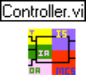
Figure 4 - Controller.vi
- Switch to the diagram view of this VI and re-wire the setup as shown in Fig. 5. To see what the ‘Degrees to Voltage.vi’ icon does simply double click on it, then press ‘Ctrl-f’.
- Save the file. This will automatically update the file in the monitoring system diagram.
- Set a ‘Sample Time Span’ of 5 seconds, move the ‘Input Angle’ dial on the Mechanical Unit to 0º and start the program. While it is running, move the input angle to 90º. Once the data has been sampled, the graphs will be updated.
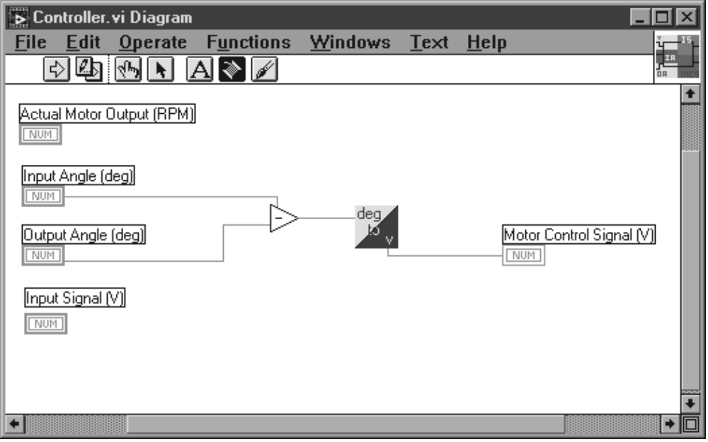
Figure 5 - Controller.vi : Diagram
- Explain how the output angle is able to follow the input angle. What type of control is this?
- What would happen if the inputs to the minus terminal were reversed (i.e. output angle - input angle)? Verify your answer by experimentation.
- Rewire as in Fig. 5 for the next section.

5. Sampling Frequency.
Students will be required to:
- understand how sampling takes place, &
- choose a sampling frequency in a computer-controlled system, where sampling frequency has a direct relationship with the stability of a feedback system.
- Switch to diagram mode in the Monitoring System VI. The ‘Sampling Frequency’ constant can be found coloured in blue. This determines the rate at which LabVIEW will observe and control the mechanical unit. An upper limit of 37Hz exists due to the speed of the processor, however the initial setting is 25Hz.
- From the icon panel shown in Fig. 2, choose the  icon. This causes the VI to indicate the flow of data while running.
- Run the program for a chosen sample time. From what you observe in the yellow region (an iteration of a ‘for’ loop) outline the processes involved for one sampling period.
- Stop execution of the program and press the icon again to disable it. Then return to the main display (Ctrl-f).
- Set the input angle to 90°.
- For each of the frequencies 25Hz, 12.5Hz, 5Hz, 2Hz and 1Hz:
- Use the motor check switch on the mechanical unit to set the output angle to 0°.
- Run the program. Investigate the time required for the mechanical unit to follow the input angle from 0º to 90º.
- Explain the effect sampling frequency has on the speed of response and potential stability of the system. Which sampling frequency would be most convenient for this motor and why?

Report
Your report should have the following sections:
- Aim
- Apparatus
- Experimental - Observations & answers to questions which are italicised
- Conclusion

End Lab.
Please delete your files, and switch the PC2MI box ‘OFF’ prior to exiting LabVIEW.

Appendix 1
Appendix 2
Appendix 3
located on the left hand side
found on the ‘FMU’

