CC32 - Digital Controller Design Using State Space Methods and LabVIEW

Aims
By the end of this experiment students should develop a thorough understanding of:
- how to model a computer-controlled DC Servo Motor using a state-space description &
- using the model and full state feedback to achieve a desired closed loop response to an initial disturbance.

Equipment
- 1 x Feedback Power Supply 01-100
- 1 x Feedback Mechanical Unit 33-100
- 1 x IBM PC (min. Pent 166) with PC-LPM-16/PnP card and LabVIEW software
- 1 x PC2MI circuit box (PC to Motor Interface)
- 1 x Printer (B&W)

Reference
Franklin, Powell & Workman, Digital Control of Dynamic Systems, Addison-Wesley, 1990 (Section 6.2)

Introduction
In this experiment a DC Servo Motor will be analysed using transient response measurements and then modelled in state space form. The motor is a second order system, where two linearly independent states are measured (in volts) using LabVIEW:
- the output angle (x₁)
- the tachogenerator output (speed of the output shaft) (x₂)
The actual angle (in degrees) and revolution speed (in RPM) are simply related to these states by constants of proportionality. The output (y) to be controlled will be the output angle x₁.

The analogue motor's performance may be approximated by the following differential equations:
dx₁/dt = ax₂(t)
dx₂/dt = -bx₂(t) + cu(t)
y(t) = x₁(t),
where a, b and c are positive constants and u(t) is the input to the motor.
Hence the state-space description of the motor alone is given by:
dx/dt(t) = Ax(t) + Bu(t)
y(t) = Cx(t),
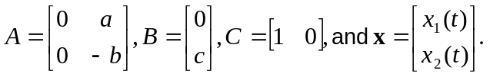where
The computer will control the motor by performing a zero-order hold (ZOH) on the discrete-time signals that it manipulates. Assuming a sampling period of T seconds, we have the discrete representation given by
x(k+1) = Φx(k) + Γu(k) (*)
y(k) = Cx(k),
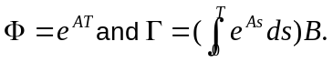 where

Exercise: With A and B as given, show that
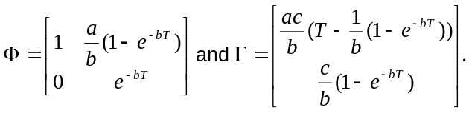

Hint: Use the definition e^{A} = L⁻¹{(sI - A)⁻¹}.
A VI in LabVIEW has been set up where these formulae are used to calculate the entries of Φ and Γ given the constants a, b, c and T. Another VI then simulates the state-space system, enabling one to compare its performance with the actual motor.
In the final part of the lab we suppose the output angle of the motor is initially at some non-zero angle and we wish it to go to 0° with given specifications (e.g. 15% overshoot). A control law will be designed so that the closed loop roots of the system are at the desired locations in the z-plane. There will be feedback of a linear combination of the states x₁ and x₂ (see Fig.1):
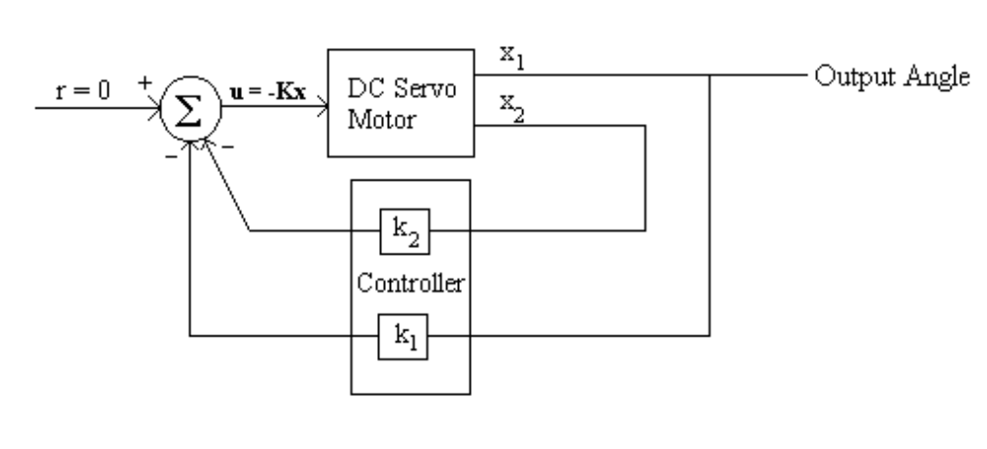
Figure 1 - Full state feedback controller
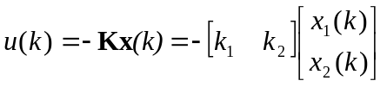

By substituting this into equation (*), then rearranging and taking the z-transform of both sides, it can be shown that the characteristic equation of the closed loop system is
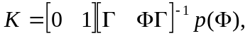det (zI - Φ + ΓK) = 0. K (i.e. k₁ and k₂) must then be found so that the resulting roots of the equation are as specified. One way of determining K is by use of Ackermann's Formula:

where p(z) is the desired characteristic polynomial.
This can be an involved calculation, but is carried out by another VI in LabVIEW. One only needs to provide the entries of Φ & Γ and the coefficients of p(z).

Preparation
It is assumed that students have some familiarity with LabVIEW, in particular how to set controls and run programs. Further information can be found in the appendices to the previous experiment.
The answer to the following question will be used in the lab, so it is important that it be calculated prior to it.
Determine the required z-plane roots and characteristic equation p(z) so that the damping ratio and undamped natural frequency of the closed loop response are ζ = 0.6 and ω_{n} = 2 rad/s. Assume that the sampling period is T = 0.2 seconds.
(Hint: In the s-plane, s = -ζω_{n} ± j ω_{n}√(1-ζ²) and to convert to the z-plane, use z = e^{sT}.)

Experiment
1. Setup
When starting any of the computer control labs, to prevent the DC servo motor from spinning at full speed, it is important that the following procedure is implemented.
- Set the Feedback Power Supply switch off, verify that the PC is connected to the Feedback Mechanical Unit (FMU) via the box labelled PC2MI, and that the power supply is connected to the FMU.
- Set the switch on the PC2MI to “OFF”.
- Start up the program LVSE on the PC and open the file “c:\cclabs\ccdcm2.llb” (ask the demonstrator if you cannot find the program/file).
- On the ‘FMU’ ensure the brake lever is at its highest position, and the leftmost switch has been set to RPM – NOT DVM.

2. Step response of the motor
By applying a step input to the motor, its transfer function can be determined. This involves finding values of the constants a, b and c as defined in the introduction.

- In the 'DC Servo Motor Options' diagram select 'Monitoring Environment'.
- Initially just run the program once and then switch the PC2MI on.
- Using the waveform settings apply a 0.2Hz 3V-amplitude 10-second duration square (step) waveform to the motor. Obtain a printout of the response.
- From the ‘Tachogenerator Output’ graph calculate both the gain of the tachogenerator (this can be shown to be equal to c/b) and motor time constant 1/b (this is the time taken for the motor speed to change by approximately 63% of its total change). As the tachogenerator output is proportional to the rate of change of input angle, use the slope of the output angle graph to find a.
- What are the constants a, b and c? It is essential that at least approximate values be obtained, as they will be needed for the rest of the experiment.
- Go back to the Options menu and select 'Continuous to Discrete'. Then enter the values of a, b and c you have calculated as well as the sampling period of T = 0.2 seconds. Run the program and obtain a printout showing the calculated values of Φ and Γ.
- Note that a discrete environment (the computer) has been used to determine the transfer function of an analogue system. Would the same constants a, b and c have been obtained had a continuous-time external function generator been used to provide the square wave? Explain.

3. A State Space Model of the Motor
Students will use the above calculations to model a discrete state space representation of the motor and compare its open loop performance with the motor itself.
- Return to the options menu, and select the 'Simulation System' icon.
- Some controls are given where you can enter the elements of Φ and Γ just calculated. This VI automatically constructs a discrete state space model of the system without use of the motor.
- Apply each of the following signals to both the simulation (Motor Simulation Environment.vi) and the actual motor (Monitoring Environment.vi), comparing the tachogenerator and output angle waveforms for easy comparison. Use a time span of 10 seconds. In between each test apply a signal of amplitude 0 to ‘reset’ the motor. Obtain a printout of the discrete step response.
- 3V, 0.1 Hz step
- 3V, 1 Hz sinusoid
- 3V, 0.1 Hz sinusoid
You will note that one key difference is that discrete steps are viewed in the input ‘Power Amplifier’ waveform for the actual motor response itself. This is because the Monitoring Environment samples the analogue inputs from the motor at 25 Hz, five times faster than the rate at which it writes to the motor. The other waveforms may appear jagged because straight lines connect the sample points.
- If time permits experiment with sending other waveforms of different amplitudes and frequencies. Indicate any noteworthy observations.
- How well does your modelled system compare with the actual system?

4. Controller design using Pole Placement and Ackermann's Formula
In this section the output angle of the Mechanical Unit will be controlled so that from an initial non-zero angle it goes to 0° with maximum overshoot less than 10% and peak time of 2 seconds. This corresponds roughly to a damping ratio of 0.6 and undamped natural frequency of 2 rad/s. A full state feedback controller will be implemented in LabVIEW to achieve this.
- Switch into the 'Diagram' view of 'Monitoring Environment.vi'.
- Select the icon labelled 'Controller.vi'. Within it one is able to enter the K matrix. For the moment set k₁ to 1 and k₂ to 0. This corresponds to unity feedback of the angle
- Go back to the Monitoring Environment and choose a time span of 10 seconds and amplitude of 0. As we are assuming zero reference input, the output angle should then eventually settle to 0°. Use the motor check switch on the mechanical unit to set the output angle initially to 90°. Run the program. What do you observe on the output angle graph?
- To dampen the oscillations, we must choose a more suitable K matrix. To do this Ackermann's formula will be used. Select 'Ackermann’s Formula' under the options menu.
- Enter Φ, Γ and the coefficients of the desired characteristic equation as determined when preparing for the lab. Run the program. What is the K matrix given?
- Enter these constants into the 'Controller.vi' program, then run the monitoring system again for an initial angle of 90°. Obtain a printout of the response.
- Does the closed loop system now have the desired response? If not, where are the most likely sources of error?
- Investigate the effects of changing k₁ and k₂ on the overshoot and rise time of the closed loop system. What should be done to k₁ and k₂ to further increase the damping ratio?

Report
Your report should have the following sections:
- Aim
- Apparatus
- Experimental - Observations & answers to questions which are italicised (including the exercise given in the Introduction)
- Conclusion

End Lab.
Please switch the PC2MI box 'OFF' prior to exiting LabVIEW and do not save changes made to files.

located on the left hand side
Recall that one can zoom into the graph for more detail

