IT3051 Fundamentals of Data Mining
Mini Project 2026
Used Car Price Prediction System
for the Georgian Market
Technical Report
Group KND_11
Name | Registration number
N S Devapriya (Nirodha) | IT23557956
W G B S Wijerathna | IT23630734
R A N K Ranasinghe (Rupasinghe) | IT23780088
T M A R Gunasekara | IT23614208
October 2026

Contents
1. Introduction and Problem Definition 4
1.1 Background 4
1.2 Problem Statement 4
1.3 Objectives 4
1.4 Scope 4
1.5 Structure of the Report 4
2. Assigned Scenario and User and Stakeholder Requirements 5
2.1 Scenario 5
2.2 Users and Decisions Supported 5
2.3 Data Mining Task 5
2.4 Requirements 5
2.5 Inputs and Outputs 6
3. Dataset Identification, Source, Citation and Validation 6
3.1 Source and Citation 6
3.2 Description and Real-World Context 7
3.3 Why the Dataset Suits the Scenario 7
3.4 Attributes 7
3.5 Data Quality Observations and Known Limitations 8
3.6 Ethical, Privacy and Licensing Considerations 8
3.7 Instructor Validation 8
4. Data Understanding and Exploratory Data Analysis 8
4.1 Structure and Variable Types 9
4.2 The Target Variable 9
4.3 Missing Values and Duplicates 9
4.4 Outliers and Unusual Observations 9
4.5 Relationships in the Data 10
4.6 Balance of the Categorical Variables 11
4.7 Data Leakage Risks 11
4.8 Observations That Shaped Later Decisions 12
5. Data Cleaning and Preprocessing 12
5.1 Cleaning Steps 12
5.2 Decisions Worth Justifying 13
6. Feature Engineering and Feature Selection 13
6.1 Engineered Features 13
6.2 Features That Were Not Used 14
6.3 Feature Selection 14
7. Algorithms Implemented and Their Rationale 15
8. Model Evaluation and Comparison 16
8.1 Validation Strategy and Metrics 16
8.2 Baseline Models 16
8.3 Interpretation 16
8.4 Where the Models Make Large Errors 17
9. Hyperparameter Tuning and Optimisation 17
9.1 Search Strategy 17
9.2 Selected Settings 18
9.3 Effect of Tuning 18
9.4 Feature and Target Choices 19
10. Final Model Selection and Justification 19
10.1 Selection Rule and Result 19
10.2 Justification 20
10.3 Behaviour of the Final Model 20
11. System Architecture and Implementation 20
11.1 Overview 20
11.2 Components 21
11.3 Technology 21
11.4 Data Flow of One Prediction 22
12. Backend and Frontend Development 22
12.1 Backend (Stage 9) 22
12.2 Frontend (Stage 10) 23
12.3 Running the System 27
13. System Testing and Results 27
13.1 Automated Tests 27
13.2 Consistency Between Training and Serving 27
13.3 Manual Tests of the Page 28
13.4 Model Results in the System 28
14. Limitations and Possible Future Improvements 29
14.1 Limitations 29
14.2 Possible Improvements 29
15. Individual and Group Contributions 30
References 30

1. Introduction and Problem Definition

1.1 Background
Buying or selling a used car is hard to do well because the price depends on many things at the same time: how old the car is, how far it has been driven, the make, the engine, the fuel, the gear box and the equipment it carries. Online marketplaces in Georgia list thousands of used cars, and each seller chooses the asking price. A buyer who sees two similar cars at very different prices has no easy way to know which price is reasonable, and a seller has the opposite problem when deciding what to ask.
Data mining can help here. If we have a large set of past listings, a model can learn how the specifications of a car relate to its price and then estimate the price of a car it has not seen. This project builds such a model and wraps it in a small web application so that an ordinary user can use it without any technical knowledge.

1.2 Problem Statement
Given the specifications of a used car (production year, mileage, make, body type, engine, fuel, gear box, drive wheels, equipment and, optionally, the customs levy), estimate its market price in US dollars, and show the user how reliable that estimate is.

1.3 Objectives
- Select a public dataset that fits the problem and have it validated by the instructor.
- Understand, clean and prepare the data without leaking information from the test set into training.
- Train and compare at least four regression algorithms using a sound validation strategy.
- Tune the models with a proper search and choose the final model with a rule that does not use the test set.
- Build a backend that validates input, applies exactly the same preprocessing as in training and returns a prediction, and a frontend that lets a user work with it.
- Test the complete system and report its limitations honestly.

1.4 Scope
The system estimates a single price for one car at a time. It is trained on listings with production years from 1980 to 2020 and therefore only accepts cars in that range. It is an estimation aid and not a formal valuation. Value retention scoring, deal classification and price forecasting were considered during preprocessing but are outside the final system; the reason is explained in Section 2.5.

1.5 Structure of the Report
Sections 2 and 3 describe the scenario and the dataset. Sections 4 to 6 cover data understanding, cleaning and feature engineering. Sections 7 to 10 describe the algorithms, their evaluation, tuning and the final model choice. Sections 11 to 13 describe the system and how it was tested. Section 14 lists limitations and future work and Section 15 records the contribution of each member.

2. Assigned Scenario and User and Stakeholder Requirements

2.1 Scenario
The scenario chosen by the group is a web-based price estimation service for the Georgian used-car market. A user opens the page, enters the details of a car and receives an estimated price, a likely price range and, if they entered an asking price, a statement of how that asking price compares with the estimate.

2.2 Users and Decisions Supported
Table 1. Stakeholders and the decisions the system supports
Stakeholder | Need | How the system helps
Private buyer | Decide whether an advertised price is reasonable before contacting the seller. | Shows an estimate and range; the asking-price check says whether the advertised price is below, inside or above the range.
Private seller | Choose a sensible price to list a car at. | Gives an estimate and range from the car's specification.
Small dealer or trader | Appraise trade-in cars quickly and consistently. | Gives an instant estimate and shows what four different models predict, so a large disagreement is visible.

2.3 Data Mining Task
The task is supervised regression. The target variable is the listing price in US dollars (Price). Models are judged by R², root mean squared error (RMSE) and mean absolute error (MAE) on cars that were not used for training.

2.4 Requirements
Table 2. Functional and non-functional requirements
ID | Requirement
FR1 | The user can enter the specification of a car through a form with clear labels, units and allowed ranges.
FR2 | The system checks every input and tells the user exactly which field is wrong and why.
FR3 | The system applies the same preprocessing as in training before calling the model.
FR4 | The system returns an estimated price in USD and a likely price range.
FR5 | If the user gives an asking price, the system compares it with the estimate.
FR6 | The user can see what each of the four trained models predicts and how accurate each model was on test data.
FR7 | Missing optional input (the customs levy) is handled by a documented default and the user is told.
NFR1 | Results appear in about a second on an ordinary computer.
NFR2 | The page works on a normal desktop screen and on a phone-sized screen.
NFR3 | The estimate is presented with its uncertainty and is not described as a guaranteed price.
NFR4 | Training can be repeated from the saved scripts and gives the same results (fixed random seeds).

2.5 Inputs and Outputs
Table 3. Inputs and outputs of the system
Type | Items
Required inputs (15) | Manufacturer, production year, body type, colour, engine volume, turbocharged, cylinders, fuel type, gear box, drive wheels, steering wheel side, mileage, airbags, doors, leather interior.
Optional inputs (3) | Customs levy (USD), asking price (USD), prediction model (default is the final model).
Outputs | Estimated price (USD), likely price range, asking-price check, estimates and test accuracy of the four models, notices about defaults that were applied.

Scope decision. During Stage 4 the group also derived a value retention index and a three-class deal label (bargain, fair, overpriced) from the price. These are stored in the processed files but are not part of the final system. The final model's median error is about 17% of the price, which is larger than the plus or minus 15% band used to define the deal classes, so a hard bargain or overpriced verdict would often be wrong. The system therefore compares the asking price with the estimated range and leaves the judgement to the user.

3. Dataset Identification, Source, Citation and Validation

3.1 Source and Citation
Table 4. Dataset summary
Item | Detail
Name | Car Price Prediction Challenge
Original source | Used-car listings from a Georgian online car marketplace (reported to be myauto.ge), published on Kaggle.
URL | https://www.kaggle.com/datasets/deepcontractor/car-price-prediction-challenge
Citation | Contractor, D. (n.d.). Car Price Prediction Challenge [Data set]. Kaggle. https://www.kaggle.com/datasets/deepcontractor/car-price-prediction-challenge
File used | car_price_prediction.csv (kept as data/raw_car_price_prediction.csv)
Records and features | 19,237 records, 18 columns
Target variable | Price (listing price in USD)
Task | Regression

3.2 Description and Real-World Context
Each row is one advertisement for a used car and describes the car as the seller entered it: make, model, production year, body category, engine volume, fuel, mileage, gear box, drive wheels, doors, steering wheel side, colour, airbags, leather interior and the customs levy. The price is what the seller asked, not necessarily what was finally paid. The data therefore describes the asking market of Georgia for the period in which the listings were collected; the newest production year is 2020.

3.3 Why the Dataset Suits the Scenario
- It contains the price of real listings, which is exactly the quantity the scenario needs to estimate.
- The features are the attributes that a buyer or seller knows about a car, so the same inputs can be requested from a user.
- It is large enough (19,237 records) for training, cross-validation and a separate test set, and it mixes numeric and categorical features.
- It needs real cleaning work (text-formatted numbers, corrupted values, missing values, extreme prices), which gives meaningful EDA and preprocessing.
- It is public and every group member can access it for academic use.

3.4 Attributes
Table 5. Raw attributes and the main quality issue found in each
Attribute | Type | Meaning | Quality observation
ID | Integer | Listing identifier | No predictive meaning; dropped.
Price | Integer | Asking price in USD (target) | Ranges from $1 to $26,307,500; many unrealistic values.
Levy | Text | Customs levy in USD | Contains "-" for 5,819 records (30.2%).
Manufacturer | Text | Make | 65 distinct makes; a long tail of rare ones.
Model | Text | Model name | 1,590 distinct values; too sparse to use directly.
Prod. year | Integer | Year of production | 1939 to 2020.
Category | Text | Body type | 11 categories.
Leather interior | Text | Yes or No | Clean.
Fuel type | Text | Fuel | Seven values; Hydrogen occurs once.
Engine volume | Text | Volume in litres, sometimes with the word Turbo | Must be split into a number and a turbo flag.
Mileage | Text | Odometer, written like 12345 km | Must be converted to a number; extreme values.
Cylinders | Float | Number of cylinders | Strongly related to engine volume.
Gear box type | Text | Transmission | Four values.
Drive wheels | Text | Drive layout | Front, Rear, 4x4.
Doors | Text | Door count | Corrupted into dates: "04-May" (18,332 rows) and "02-Mar" (777) instead of 4-5 and 2-3.
Wheel | Text | Steering wheel side | Left wheel 17,753, right-hand drive 1,484.
Color | Text | Colour | 16 values.
Airbags | Integer | Number of airbags | 0 to 16.

3.5 Data Quality Observations and Known Limitations
- Extreme and unrealistic prices (from $1 up to $26,307,500) that distort any model trained on the raw data.
- 3,512 repeated listings once the ID column is ignored.
- Prices are asking prices set by sellers. Some very low prices on recent cars do not look like real sale prices, so the labels are noisy.
- Only 1.6% of the cleaned records are cars produced in 2019 or 2020, so the newest cars are poorly represented.
- The data comes from one country and one marketplace and reflects the market at the time of collection.

3.6 Ethical, Privacy and Licensing Considerations
The records describe cars only. They contain no names, telephone numbers, addresses or registration plates, so there is no personal data to protect. The data was collected from a public website and shared on Kaggle; the licence terms shown on the dataset page apply and the data is used here for academic purposes only. The model reflects one market and one period, so its estimates should not be treated as a formal appraisal or used for lending decisions.

3.7 Instructor Validation
The dataset proposal was submitted and approved before any analysis or modelling started. [Insert the name of the instructor, the date of approval and the reference to the approval evidence.]

4. Data Understanding and Exploratory Data Analysis
The exploration below was done on the raw data and then on the cleaned data. The code is in the Stage 3 part of the project notebook (source_stages_1_to_8/stages_1_to_5_eda_and_preprocessing.ipynb) and the figures in this report were redrawn by report/make_figures.py.

4.1 Structure and Variable Types
The raw file has 19,237 rows and 18 columns. Seven columns are numeric after conversion (price, levy, production year, engine volume, mileage, cylinders, airbags) and the rest are categorical. Three numeric fields are stored as text and need conversion: levy (because of the "-" entries), mileage (the unit "km" is part of the text) and engine volume (the word "Turbo" is appended for turbocharged engines).

4.2 The Target Variable
The raw price is extremely skewed (skewness 136.5). The median is $13,172, but the mean is $18,556 and the maximum is $26,307,500. The left histogram in Figure 1 shows a large block of listings priced at almost nothing, which are not real prices. After restricting prices to the range $500 to $150,000 (Section 5) the median is $15,681, the middle half of the prices lies between $9,095 and $24,462, and skewness falls to 2.32. Taking the logarithm of the price removes the right tail but leaves a small group of very cheap cars on the left (right histogram), which is a first sign that some low prices are unreliable.
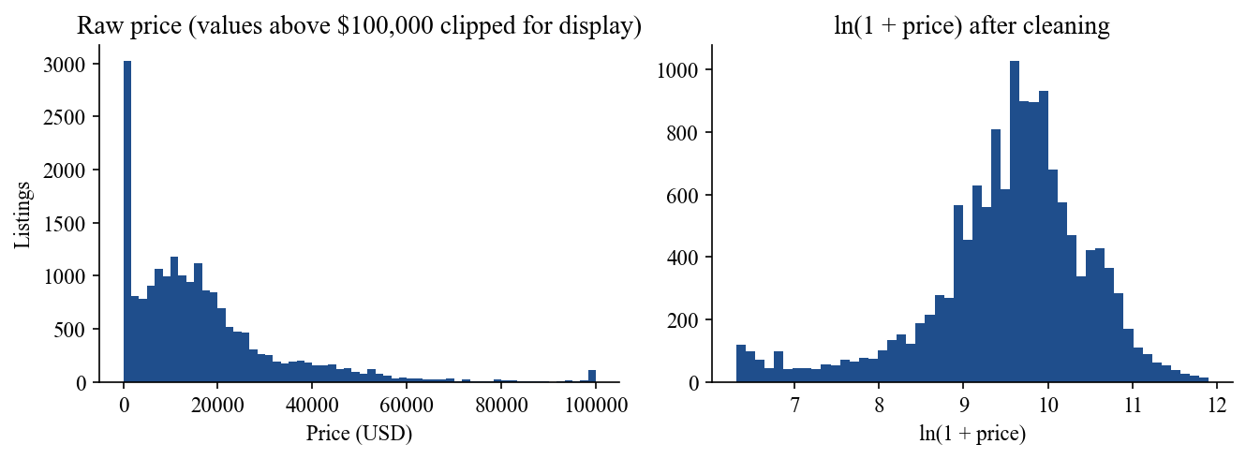
Figure 1. Distribution of the price before and after cleaning.

4.3 Missing Values and Duplicates
Only the levy column has missing values, coded as "-": 5,819 of 19,237 records (30.2%). After cleaning, 4,900 records (35%) are still missing a levy, so it cannot simply be dropped. The levy is a customs charge that depends on the make, engine and age of the car, so it is imputed from similar cars (Section 5).
Duplicates need care. Only 313 rows are exact duplicates including the ID, but 3,512 rows are identical once the ID is ignored, meaning the same car was advertised more than once. Keeping them would make the model see the same car several times and would let identical cars appear in both training and test data, so repeated rows were removed.

4.4 Outliers and Unusual Observations
Four kinds of unrealistic value were found: prices below $500 or above $150,000 (951 records after removing duplicates), implausible odometer readings below 10 km or above 500,000 km (824), engine volumes outside 0.5 to 7.0 litres (33) and production years outside 1980 to 2026 (22). A record can break more than one rule. The limits were chosen from what is realistic for passenger cars on this market, not from the statistics of the sample, so that genuinely expensive cars are not removed just because they are rare.

4.5 Relationships in the Data
Age and price. Correlation with price is strongest for age (-0.40), followed by mileage (-0.27) and engine volume (0.21). Levy (0.08) and airbags (0.03) have almost no linear relationship with price. These values are small, which already suggests that price depends on combinations of features and not on any one of them.
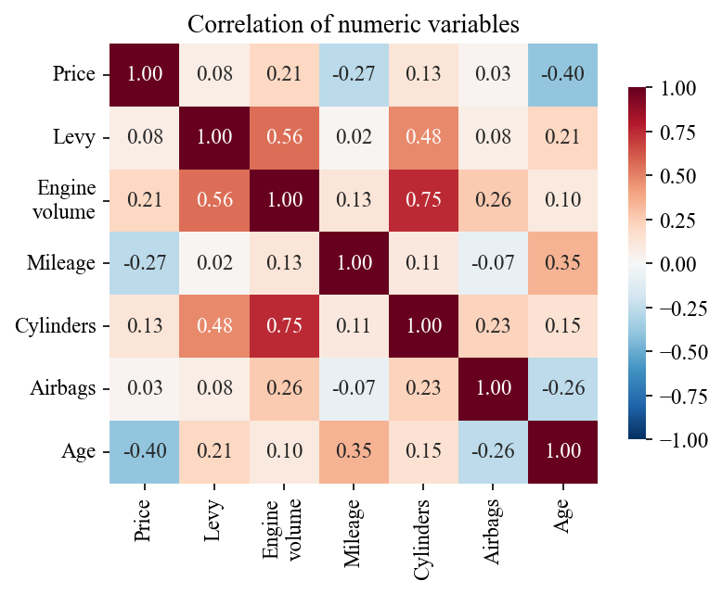
Figure 2. Correlation between the numeric variables.
Collinearity. Engine volume and the number of cylinders are strongly correlated (0.75), and age and mileage moderately (0.35). This is a problem for plain linear regression and is one reason a regularised linear model was chosen as the linear baseline.
Steering wheel side. Right-hand-drive cars are a small group (1,237 of 14,011 cleaned records) but sell for much less: the mean price is $9,887 against $20,754 for left-hand drive (52% lower), and the medians are $9,095 and $16,741. Steering wheel side is therefore kept as a feature.
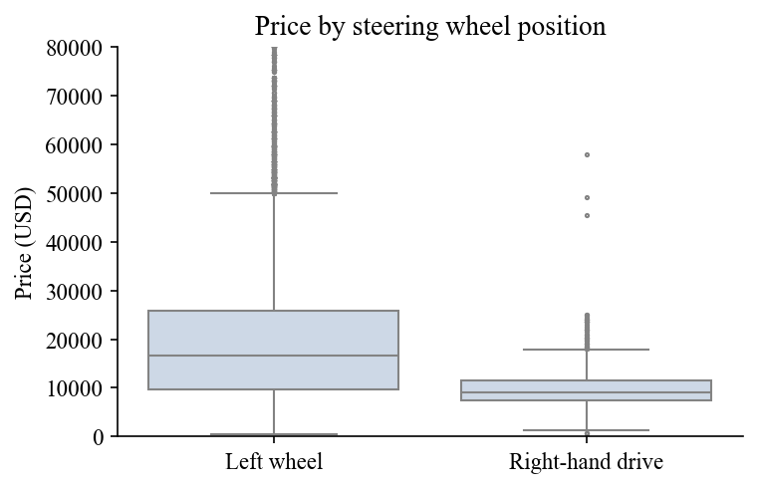
Figure 3. Price of left-hand-drive and right-hand-drive cars.
Age and fuel type. Prices fall as cars get older for all fuel types (Figure 4). For the youngest cars (age 6 to 8 years) the average price varies a lot between fuel types, because there are few such cars and a large share of them are expensive makes. The diesel line starts far above the others for this reason and not because diesel engines are worth more in general. Luxury makes have a higher average price ($24,472) than the other makes ($18,667).
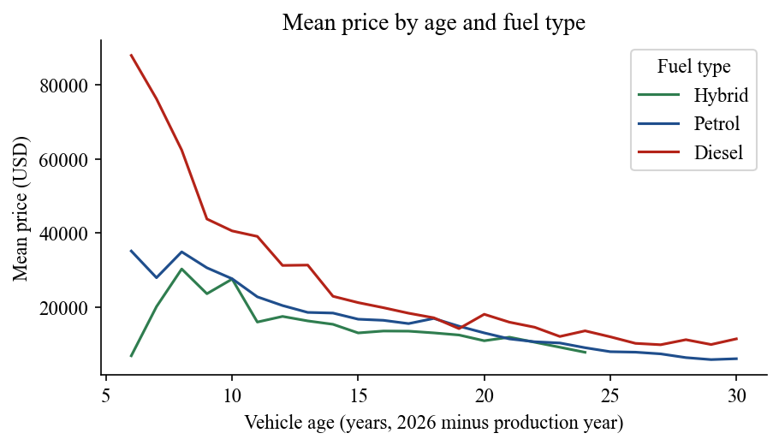
Figure 4. Mean price by age and fuel type.

4.6 Balance of the Categorical Variables
Class imbalance in the classification sense does not apply because the target is numeric. The categorical features are unevenly spread, however. Petrol (7,859), diesel (3,033) and hybrid (2,065) cars make up almost all records while LPG, CNG, plug-in hybrid and hydrogen are rare (the hydrogen category has a single car). Makes and colours also have long tails. This is handled by grouping rare makes and colours (Section 6) and by allowing the encoder to ignore categories it did not see in training.

4.7 Data Leakage Risks
Table 6. Leakage risks identified and how each is prevented
Risk | Prevention
The ID column identifies a listing and could let a model memorise cars. | Dropped before any modelling.
Test cars influencing the scaler, the encoder or the imputation values. | The data is split first. Scaling, encoding and levy medians are fitted on the training split only and then applied to the test split.
The same car appearing in training and test through repeated listings. | Repeated rows removed before the split. A check afterwards still found 73 test rows with the same features as a training row (different listings of the same specification); this is about 2.6% of the test set and removing them changes test R² from 0.7628 to 0.7667, so the effect is small.
Targets derived from the price (value retention index, tax overhead ratio, deal class) being used as inputs. | They are stored with the targets and are excluded from the feature matrix.
The levy is a customs charge that may carry some information about the car's value. | Its correlation with price is only 0.08. It is optional in the application, and the ablation test in Section 9.4 shows what the model loses without it.
Hyperparameters and the final model chosen by looking at the test set. | All tuning uses cross-validation inside the training split; the test split is used once for reporting and is not used to choose the model.

4.8 Observations That Shaped Later Decisions
Table 7. From observation to decision
Observation | Decision
Unrealistic prices, mileage, engine volume and years. | Domain-range filtering (Section 5).
Numbers stored as text; Doors corrupted into dates. | Parsing and a mapping back to 4-5 and 2-3.
35% of levies missing after cleaning. | Imputation by the training median of the make.
Repeated listings. | Duplicates removed before the split.
Strong relationship between price and age, mileage, make and wheel side; weak linear correlations. | Engineer age, mileage per year and flags; use non-linear models.
Long tails in make and colour. | Group the rare values as Other.
Collinear numeric variables. | Include a regularised linear model; rely on trees for the rest.
Few cars produced in 2019 and 2020. | Accept only years 1980 to 2020 in the application and report the weakness (Section 14).

5. Data Cleaning and Preprocessing

5.1 Cleaning Steps
Table 8. Cleaning and preprocessing steps in the order they were applied
Step | Action | Reason
1 | Drop ID | No predictive meaning; avoids memorising listings.
2 | Remove repeated listings (3,512 rows; 19,237 to 15,725) | Same car counted more than once.
3 | Convert Mileage to a number by removing " km" | Needed for modelling.
4 | Split Engine volume into a number (Engine_displacement) and a flag (Is_Turbo) | Two separate pieces of information in one text field.
5 | Map "04-May" to "4-5" and "02-Mar" to "2-3" in Doors | Spreadsheet software had turned the ranges into dates.
6 | Treat "-" in Levy as missing | It means the value is unknown.
7 | Keep records with price $500 to $150,000, mileage 10 to 500,000 km, engine 0.5 to 7.0 L, year 1980 to 2026 (15,725 to 14,011 rows) | Remove unrealistic values (Section 4.4).
8 | Split into 11,208 training (80%) and 2,803 test (20%) records, seed 42 | Hold-out set for the final evaluation.
9 | Impute the missing levy with the training median of the make, or the overall training median if the make has none | Uses information from training data only.
10 | Scale 7 numeric features (standardisation), one-hot encode 9 categorical features, pass 2 binary flags through; fitted on the training split only | Required by the linear model and keeps the test set unseen.

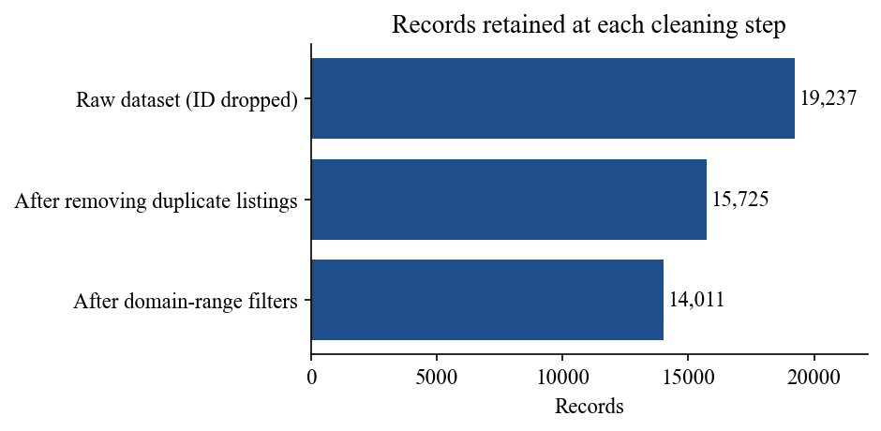
Figure 5. Number of records after each cleaning step.
In total 14,011 of the 19,237 raw records (72.8%) were kept. Most of the loss comes from the repeated listings and the unrealistic prices. The levy imputation uses the training median, which for the whole training set is $779.

5.2 Decisions Worth Justifying
- Fixed range limits instead of an automatic outlier rule. Cars above $100,000 are rare but real, so a statistical rule such as the interquartile range would have removed valid luxury cars.
- Median imputation by make. The levy depends on the type of car, so the median of the same make is a better guess than one value for all cars.
- Split before fitting anything. The split happens before the medians, the scaler and the encoder are fitted so that nothing is learned from the test set.
- One saved pipeline. The fitted transformer is saved (data/preprocessing_pipeline.joblib) and loaded by the backend, so training and serving use the same objects.
- Result. The processed training matrix has 11,208 rows and 57 feature columns, the test matrix 2,803 rows, and neither contains missing values.

6. Feature Engineering and Feature Selection

6.1 Engineered Features
Table 9. Features used by the models
Feature | Kind | How it is built | Why
Age | Numeric | 2026 minus production year | Price falls with age; easier to read than the year.
Mileage | Numeric | Odometer in km | Wear on the car.
Mileage_per_year | Numeric | Mileage divided by (Age + 1) | Separates a car that is driven hard from one that is old but little used.
Engine_displacement | Numeric | Number part of Engine volume | Engine size.
Cylinders, Airbags, Levy | Numeric | As recorded (levy imputed) | Power, equipment and import cost.
Is_Turbo | Binary | 1 if the engine text contains Turbo | Turbocharged engines tend to cost more.
Is_Luxury_Make | Binary | 1 for 12 premium makes (Mercedes-Benz, BMW, Lexus, Porsche, Audi, Land Rover, Jaguar, Maserati, Bentley, Ferrari, Aston Martin, Cadillac) | Gives rare premium makes a shared signal even when the make itself is grouped as Other.
Manufacturer_grouped | Categorical | 15 most frequent makes in the training split, the rest as Other | Avoids dozens of almost empty columns.
Color_grouped | Categorical | 8 most frequent colours, the rest as Other | Same reason.
Category, Leather interior, Fuel type, Gear box type, Drive wheels, Doors, Wheel | Categorical | One-hot encoded, first level dropped | Models need numbers.

Together these give 57 input columns after encoding. The age is measured from 2026, the year the project was done. Because every car is shifted by the same amount this does not change the ordering of the cars, and the same reference year is used by the application.

6.2 Features That Were Not Used
- ID: no meaning for prediction.
- Model: 1,590 distinct values, most with very few cars. Using it would cause overfitting, so it is not an input of the system. The model name is also not asked from the user.
- Prod. year: replaced by Age to avoid two copies of the same information.
- Raw Engine volume text: replaced by the numeric part and the turbo flag.
- Value retention index, tax overhead ratio and deal class: derived from the price, so they would leak the target.

6.3 Feature Selection
Feature selection was done in three ways. First, features were removed on principle, as listed above. Second, groups of features were removed one at a time from the final model and the cross-validated score was compared (Section 9.4). Third, the importance values of the final model were inspected.
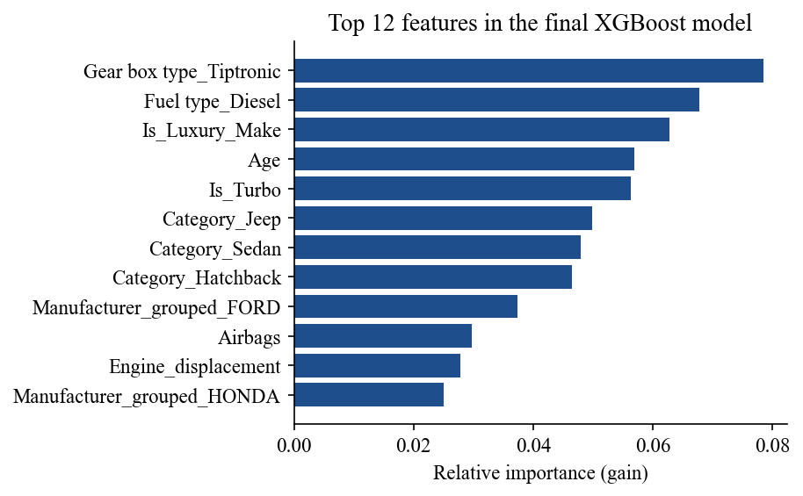
Figure 6. The twelve most important features of the final XGBoost model.
The importance chart shows that the information is spread over many features: gear box type, fuel type, luxury make, age, turbo, body type and make all contribute. No feature dominates, and none of the engineered features is useless. The ablation tests did not find a group whose removal clearly improved the model, so all 57 features were kept. Dropping the colour columns or the mileage-per-year feature changed the scores by less than the fold-to-fold variation, so they are kept at no cost to accuracy.

7. Algorithms Implemented and Their Rationale
Four algorithms from different families were implemented so that the comparison shows what kind of model suits this problem. All of them predict the price directly. Tree models do not need scaled inputs, but all four receive the same processed matrix so that the comparison is fair.
Table 10. The four algorithms and why they were chosen
Algorithm | Family | Idea | Why it is included
Ridge Regression | Regularised linear | Fits a straight-line relationship and shrinks the coefficients with an L2 penalty so correlated inputs do not make them unstable. | A simple, fast baseline. If it did well, a complex model would not be needed; it also handles the correlated numeric features better than ordinary least squares.
Random Forest | Bagged trees | Averages many decision trees, each built on a random sample of cars and a random subset of features. | Captures non-linear relationships and interactions, resists overfitting and needs little tuning.
LightGBM | Gradient boosting (histogram) | Builds trees one after another, each correcting the errors of the previous ones, using binned feature values and leaf-wise growth. | Boosting usually beats bagging on tabular data and LightGBM is fast.
XGBoost | Gradient boosting (regularised) | Boosted trees with explicit penalties on tree size and leaf values and with row and column subsampling. | Strong tabular-data method with fine control over overfitting.

The expectation before running the experiments was that the three tree methods would be close to each other and clearly better than Ridge, because used-car prices depend on interactions (for example, a luxury make loses value with age differently from an economy make), which a straight-line model cannot represent.

8. Model Evaluation and Comparison

8.1 Validation Strategy and Metrics
The 11,208 training records were used with 5-fold cross-validation (shuffled, seed 42). Each model is trained five times on four fifths of the training data and scored on the remaining fifth; the mean and standard deviation of the five scores show how stable the model is. The 2,803 test records were not touched until the end and are used only to report the final performance. Three metrics are reported:
- R² is the share of the variation in price that the model explains (1 is perfect).
- RMSE is the typical error in dollars, giving extra weight to large mistakes.
- MAE is the average absolute error in dollars and is easy to explain to a non-technical user.

8.2 Baseline Models
The baselines use reasonable default settings, not tuned values: Ridge with alpha 10; Random Forest with 100 trees, depth 15 and a minimum leaf size of 2; LightGBM with 150 trees, learning rate 0.08 and 31 leaves; XGBoost with 150 trees, depth 6 and learning rate 0.08.
Table 11. Baseline results (CV on the training split, metrics on the test split)
Model | CV R² (mean ± sd) | Test R² | Test RMSE | Test MAE
Ridge Regression | 0.4303 (± 0.0073) | 0.4312 | $12,621 | $8,321
Random Forest | 0.7331 (± 0.0201) | 0.7437 | $8,472 | $4,863
LightGBM | 0.7457 (± 0.0134) | 0.7553 | $8,279 | $4,850
XGBoost | 0.7394 (± 0.0166) | 0.7503 | $8,363 | $4,890

8.3 Interpretation
The three tree-based models reach a cross-validated R² of about 0.73 to 0.75, while Ridge reaches only 0.43. The straight-line model explains less than half of the variation in price. The reason is the structure of the problem: the effect of age, mileage or engine size on price is not a constant number of dollars but depends on the make, the body type and the fuel, and trees can represent these interactions while a linear model cannot. Within the tree family, the two boosting methods are slightly ahead of Random Forest, which fits the usual finding that boosting reduces bias that a forest of fully grown trees keeps.
The standard deviation over the folds (about 0.01 to 0.02) is larger than most differences between the three tree models. The comparison between them therefore has to be read with care; Section 10 returns to this point.

8.4 Where the Models Make Large Errors
Overall accuracy hides large differences between cheap and expensive cars. Table 12 shows the final model's errors by price band on the test set. In dollars the error is smallest for mid-priced cars and largest for cars above $30,000. In relative terms the error is large for the cheapest cars: for cars priced under $3,000 the median error is more than three times the price. These cars are mostly very cheap listings whose price does not follow the specification (Section 4.2), so the model cannot learn them.
Table 12. Error of the final model by actual price band (test set)
Actual price | Cars | MAE | Median absolute % error
under 3k | 190 | $6,020 | 355%
3k-8k | 384 | $2,807 | 26%
8k-15k | 737 | $2,768 | 17%
15k-30k | 990 | $3,860 | 13%
over 30k | 502 | $10,076 | 15%

Across all test cars the median absolute error is 17% of the price; 45% of the estimates are within 15% of the real price and 64% within 25%.

9. Hyperparameter Tuning and Optimisation

9.1 Search Strategy
Ridge has one setting, the penalty alpha, and was tuned with RidgeCV over 30 values between 0.01 and 10,000 on a logarithmic scale. The three tree models have many settings, so a full grid would be very large. Randomised search was used instead: it tries a fixed number of random combinations from the search space, which is known to find good settings with far fewer trials than a grid when only a few of the settings really matter. Every candidate was scored with the same 5-fold cross-validation on the training split, and the best candidate was refitted on the whole training split. The test split was not used in the search.
Table 13. Search spaces
Model | Candidates x folds | Search space
Random Forest | 10 x 5 | n_estimators {150, 250}; max_depth {12, 16, 20}; min_samples_leaf {2, 3, 5}; min_samples_split {4, 8}; max_features {0.5, 0.7, 0.9}
LightGBM | 30 x 5 | n_estimators {200, 400, 600}; learning_rate {0.02, 0.04, 0.08}; num_leaves {15, 31, 63}; min_child_samples {10, 20, 40}; subsample {0.7, 0.85, 1.0} with bagging every iteration; colsample_bytree {0.6, 0.8, 1.0}; reg_lambda {0, 1, 5}
XGBoost | 25 x 5 | n_estimators {300, 500, 800}; max_depth {4, 6, 8, 10}; learning_rate {0.02, 0.04, 0.08}; subsample {0.7, 0.85, 1.0}; colsample_bytree {0.6, 0.8, 1.0}; min_child_weight {1, 3, 5}; reg_lambda {1, 3, 10}
Ridge | 30 alphas, 5 folds | alpha from 0.01 to 10,000 (logarithmic)

9.2 Selected Settings
Table 14. Best settings found by the search
Model | Best settings
Ridge Regression | alpha = 1.89
Random Forest | n_estimators = 150, min_samples_split = 8, min_samples_leaf = 2, max_features = 0.9, max_depth = 16
LightGBM | subsample_freq = 1, subsample = 1, reg_lambda = 0, num_leaves = 31, n_estimators = 200, min_child_samples = 10, learning_rate = 0.08, colsample_bytree = 0.8
XGBoost | subsample = 0.7, reg_lambda = 1, n_estimators = 500, min_child_weight = 5, max_depth = 8, learning_rate = 0.02, colsample_bytree = 1

9.3 Effect of Tuning
Table 15. Baseline compared with tuned models
Model | CV R² baseline | CV R² tuned (± sd) | Test R² baseline | Test R² tuned | Test MAE tuned
Ridge Regression | 0.4303 | 0.4304 (± 0.0071) | 0.4312 | 0.4318 | $8,330
Random Forest | 0.7331 | 0.7334 (± 0.0194) | 0.7437 | 0.7477 | $4,803
LightGBM | 0.7457 | 0.7512 (± 0.0195) | 0.7553 | 0.7597 | $4,819
XGBoost | 0.7394 | 0.7525 (± 0.0192) | 0.7503 | 0.7628 | $4,688

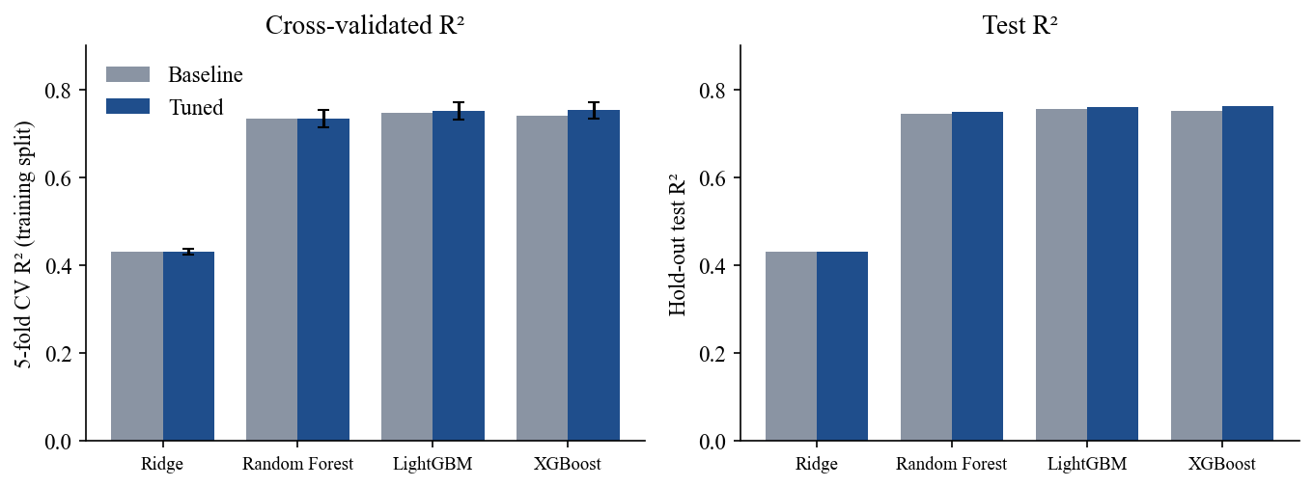
Figure 7. Baseline and tuned models: cross-validated R² (left) and test R² (right).
Tuning helped the boosted models a little: the cross-validated R² of XGBoost rose from 0.7394 to 0.7525 and that of LightGBM from 0.7457 to 0.7512. Random Forest and Ridge hardly changed. The gain is small because the default settings were already sensible; the larger improvement over the baselines comes from the choice of model family, not from the settings.

9.4 Feature and Target Choices
To check whether feature selection, feature engineering or a different target would improve the final model, the tuned XGBoost settings were re-run with parts of the feature set removed and with the log of the price as the target (scripts/ablation_experiments.py).
Table 16. Ablation results for XGBoost (CV on the training split, test split for reference)
Configuration | Features | CV R² | Test R² | Test MAE
All 57 features (final configuration) | 57 | 0.7525 | 0.7628 | $4,688
Without Levy | 56 | 0.7463 | 0.7539 | $4,800
Without Mileage_per_year | 56 | 0.7548 | 0.7609 | $4,694
Without Is_Turbo and Is_Luxury_Make | 55 | 0.7351 | 0.7228 | $4,926
Without colour dummies | 49 | 0.7530 | 0.7598 | $4,698
Without Age and Mileage_per_year | 55 | 0.6500 | 0.6453 | $5,859
Log-price target (all features) | 57 | 0.7096 | 0.7088 | $4,860

- Age and mileage matter most. Removing Age and Mileage_per_year drops CV R² from 0.7525 to 0.6500.
- The luxury and turbo flags help. Removing them lowers CV R² to 0.7351 and test R² to 0.7228, so the engineered flags are worth keeping.
- Levy helps a little. Without it CV R² is 0.7463. The levy is optional in the application, so a user who does not know it still gets an estimate, with slightly lower expected accuracy.
- Mileage per year and colour make no real difference (changes within the fold-to-fold variation) and are kept.
- Predicting the logarithm of the price was worse (CV R² 0.7096 against 0.7525), so the model predicts the price directly.

10. Final Model Selection and Justification

10.1 Selection Rule and Result
The final model was chosen by a rule fixed before looking at the test results: the tuned model with the highest cross-validated R² on the training split. Using the test set to choose would make the reported test score optimistic. The rule selects XGBoost.
Table 17. Tuned models ranked by the selection rule
Rank | Model | CV R² (± sd) | Test R² | Test RMSE | Test MAE
1 | XGBoost | 0.7525 (± 0.0192) | 0.7628 | $8,150 | $4,688
2 | LightGBM | 0.7512 (± 0.0195) | 0.7597 | $8,204 | $4,819
3 | Random Forest | 0.7334 (± 0.0194) | 0.7477 | $8,406 | $4,803
4 | Ridge Regression | 0.4304 (± 0.0071) | 0.4431 | $12,489 | $8,167

10.2 Justification
- Best on the agreed criterion. XGBoost has the highest cross-validated R² (0.7525) and also the highest test R² (0.7628), the lowest RMSE ($8,150) and the lowest MAE ($4,688). Both measures point to the same model.
- The tree models are close. The difference between XGBoost and LightGBM in cross-validated R² (0.0013) is much smaller than the standard deviation across folds (about 0.02). We therefore do not claim that XGBoost is clearly better than LightGBM; it is the best by the stated rule and no worse in any metric. What is clear is that the boosted and bagged tree models are all far better than Ridge (R² 0.44).
- Practical reasons. The saved XGBoost model is about 1.3 MB (the Random Forest is about 8.4 MB), predicts a single car in milliseconds and handles the mix of numeric and one-hot features without extra work.
- Regularisation. Row and column subsampling and the L2 penalty on leaf values reduce overfitting on rare makes and trims.

10.3 Behaviour of the Final Model
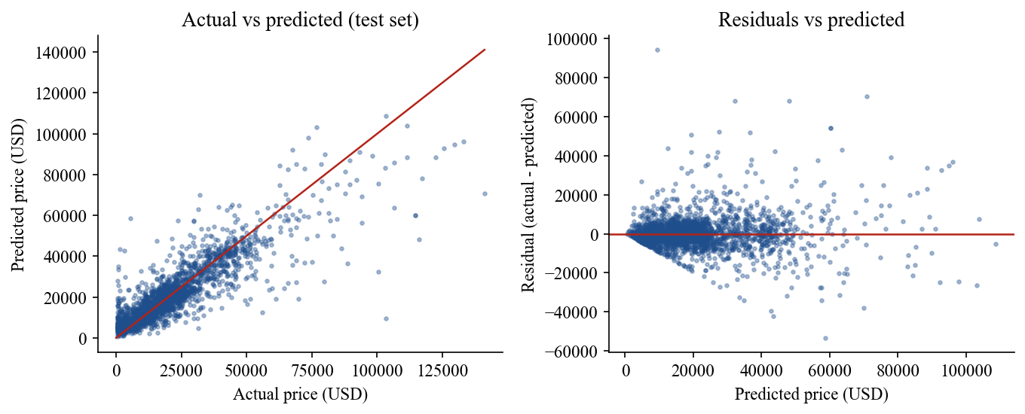
Figure 8. Final model on the test set: actual against predicted price (left) and residuals (right).
The points in the left chart follow the diagonal, which is the line of perfect prediction, and scatter more widely for expensive cars. The right chart shows that the size of the error grows with the price, so the model is more uncertain for expensive cars in dollar terms. The model also tends to predict too low for the most expensive cars. To describe this uncertainty in the application, the estimate is shown with a likely range. The range was built from the test set: for 80% of the test cars the real price was between 0.565 and 1.382 times the model's estimate, so the application shows the estimate multiplied by these two factors. The range is wide, and it is shown to the user as it is.

11. System Architecture and Implementation

11.1 Overview
The system has two parts that talk through a small JSON interface. The browser shows the form and the result. A Flask server receives the request, validates the input, rebuilds the training features, asks the models for a price and returns the answer. No database is needed because nothing is stored.
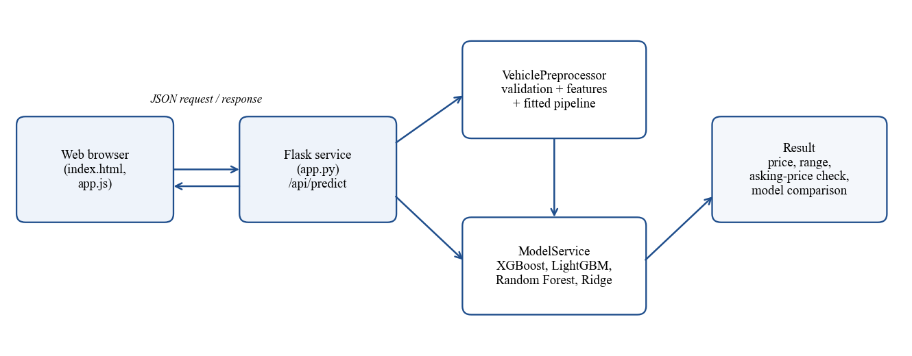
Figure 9. Architecture of the prediction system.

11.2 Components
Table 18. Main components and files
Component | File | Responsibility
Website | templates/index.html, static/css/style.css | Header, home, analysis, cars, estimator, models, presentation, contact and footer.
Estimator logic | static/js/app.js | Loads dropdown values, checks input before sending, calls the API, shows errors and results.
Site logic and charts | static/js/site.js, static/js/cars.js | Animated home scene, selectable car points, charts, car cards, model section, slide deck and contact form; car illustrations drawn in code.
Web service | app.py | Routes and JSON responses; error handling.
Preprocessing | backend/preprocessor.py | Validation, feature building and the fitted transformer.
Model service | backend/model_service.py | Loads the four models and evaluation numbers, predicts, builds the price range.
Artifacts | models/*.joblib, data/*.joblib, data/*.json | Trained models, fitted pipeline, levy medians, dropdown values, metrics and the website insights.
Tests | tests/test_api.py | Automated tests of the service.

11.3 Technology
Python 3 with pandas and NumPy for data handling, scikit-learn for the preprocessing pipeline, Ridge and Random Forest, XGBoost and LightGBM for the boosted models, joblib for saving models, Flask for the web service, Chart.js for the charts, and plain HTML, CSS and JavaScript for the page. The font (Inter) and the Chart.js library are stored in the project folder. The package versions are pinned in requirements.txt because saved models can only be loaded safely with the library versions that created them.

11.4 Data Flow of One Prediction
- The user fills in the form. The browser checks required fields, whole numbers and ranges and shows messages next to the fields that are wrong.
- The browser sends the values as JSON to POST /api/predict.
- The server checks every field again (the browser cannot be trusted) and returns the error messages if anything is wrong.
- The server builds the same features as in training: age, mileage per year, grouped make and colour, luxury and turbo flags; it fills a missing levy with the training median of the make.
- The saved transformer scales and encodes the features into the 57 columns the models expect.
- The selected model predicts the price; the other three models are also run for the comparison table.
- The server returns the estimate, the range, the asking-price check, the model comparison and any notices, and the browser displays them.

12. Backend and Frontend Development

12.1 Backend (Stage 9)

Interface
Table 19. Service endpoints
Endpoint | Method | Purpose
/ | GET | The web page.
/api/options | GET | Values for the dropdowns and the allowed production years.
/api/models | GET | The four models with cross-validated and test scores, the final model and the range factors.
/api/insights | GET | Numbers behind the charts, callouts and presentation on the website.
/api/health | GET | Simple check that the service is running.
/api/predict | POST | Validates the car, predicts the price and returns the result. Returns status 400 with a message per field if the input is invalid, and 500 with a general message if the prediction itself fails.

Input validation
All validation is in VehiclePreprocessor.validate. Invalid input is rejected with a message for each wrong field; the server never replaces a wrong value with a default without telling the user. The only automatic default is the optional levy.
Table 20. Validation rules
Field | Rule
Production year | Required; whole number from 1980 to 2020 (the range of the training data).
Mileage | Required; number from 0 to 1,000,000 km. A trailing km and thousands separators are accepted.
Engine volume | Required; number from 0.5 to 7.0 litres.
Cylinders, airbags | Required; whole numbers from 1 to 16 and from 0 to 16.
Customs levy | Optional; 0 to 20,000. If empty, the training median of the make is used and a notice is shown.
Asking price | Optional; 1 to 1,000,000.
Manufacturer, colour, body type, fuel, gear box, drive wheels, doors, steering wheel, leather | Required; must be one of the listed options (case does not matter).
Turbocharged | True or false.
Prediction model | Optional; one of the four models, default is the final model.
Any number field | Text, empty values, nan and infinite values are rejected.

Preprocessing and prediction
The preprocessor rebuilds the 18 input columns used in training and applies the saved ColumnTransformer, so scaling and one-hot encoding use exactly the values learned from the training split. Makes and colours not among the frequent ones in training are mapped to Other, as in training. The predicted price is limited to $500 to $150,000, which is the range of prices the models were trained on.
The estimate range is the estimate multiplied by 0.565 and 1.382. If an asking price is given, the response says whether it is below, inside or above this range and by how many per cent it differs from the estimate.

12.2 Frontend (Stage 10)
The front end is one scrolling website built like a product page, so that a visitor who is not technical can follow the project without reading this report. A fixed header links to every section and a footer repeats the links, the data source and the team. The sections are:
- Home. A full-screen animated scene (a car driving past mountains at dusk), a short statement of our thinking that changes every few seconds, a live example estimate and four headline numbers. The motion can be paused, follows the browser's reduced-motion setting and stops while the section is off screen. A video file placed in the project folder replaces the animation.
- Our thinking. Three cards that explain why the system exists: price from evidence, explanation as well as prediction, and honesty about uncertainty.
- Analysis. A car illustration with eight selectable points (age, body type, airbags, gear box, engine size, make, fuel type and drive wheels). Selecting a point shows how much of the model's accuracy depends on that factor and a fact from the data. Seven charts below it show the importance of each factor, price by age, body type, fuel type, steering side, make and the spread of prices.
- Cars. Eight cards, one per body style, with the median price, typical age and typical mileage.
- Price estimator. The form and the result described below.
- Models. A card for each of the four models, the tuning chart, predicted against actual price, the error by price band, the feature tests of Section 9.4 and a short explanation of why XGBoost is the final model and why the top three are close.
- Presentation. The ten slides of the final presentation for non-technical decision-makers, with arrows, dots, keyboard control and a full-screen mode.
- Contact us. The four team members and a message form that opens a draft in the visitor's email program. The recipient is set with the CONTACT_EMAIL setting; the page itself sends nothing.

Figure 10. Home section with the animated scene, the live example and the headline numbers.
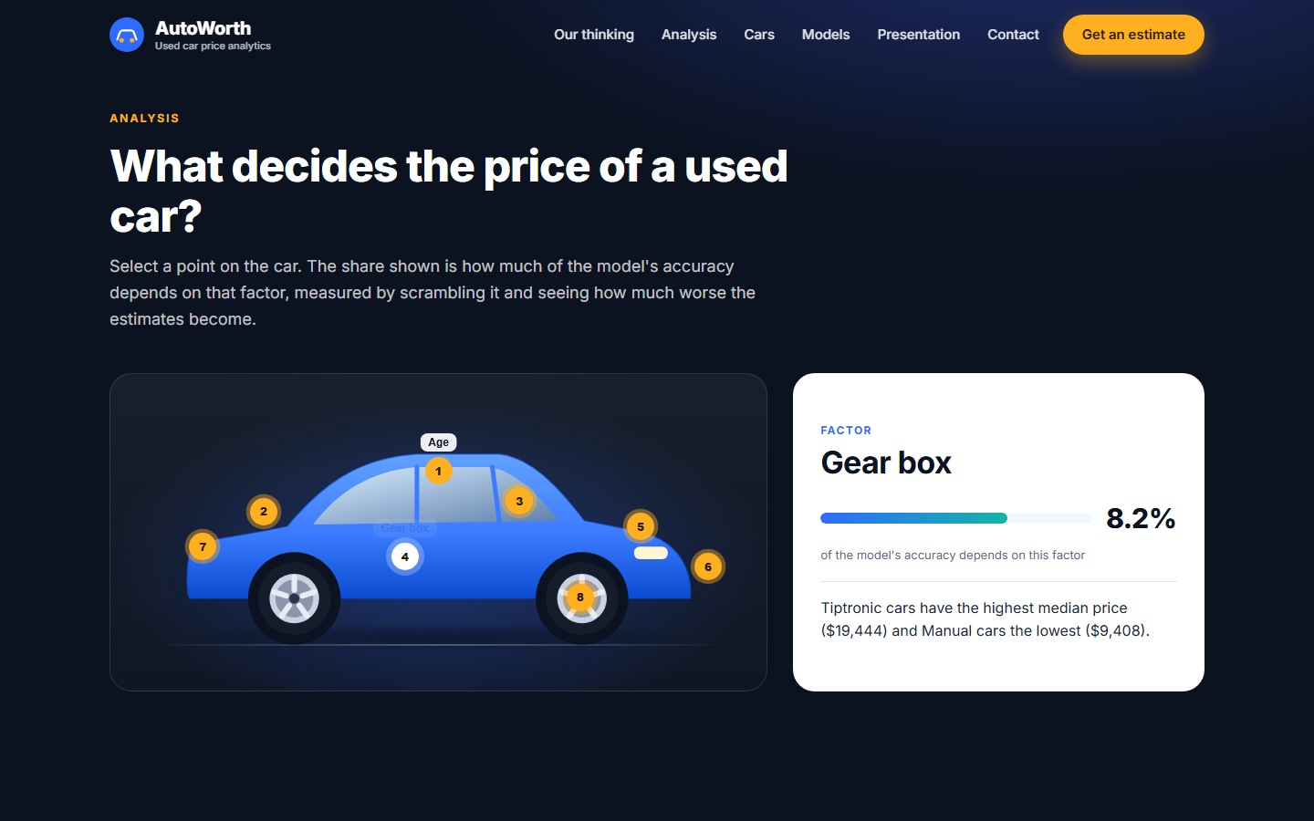
Figure 11. Analysis section: a selected point on the car shows its share of the model's accuracy and a fact from the data.
The estimator is the part of the page that works with the backend. Its design follows the requirements of Stage 10:
- Clear inputs. Fields are grouped under four headings (vehicle, engine and drivetrain, condition and equipment, optional). Every label states the unit, required fields are marked with an asterisk, and a short hint under a field gives the allowed range. A link fills in an example car.
- Dropdowns, not free text, for all categorical fields, so a spelling mistake is not possible; the options come from the server.
- Validation. The browser checks required fields, whole numbers and ranges before sending, and the server repeats the checks. Messages are shown beside the field and the first wrong field in page order gets the focus. Server-side messages are shown in the same way.
- Clear result. The estimated price is the largest item in the result panel, followed by the range, a bar that shows the range with the estimate (and the asking price, if entered) marked on it, a plain-language sentence about the asking price, notices (for example that a typical levy was used) and bars that compare the four models.
- Honesty about uncertainty. The range is explained under the price as the interval that held the real price for 80% of the test cars.
- Connection errors. If the server cannot be reached, a message tells the user to check that the application is running.
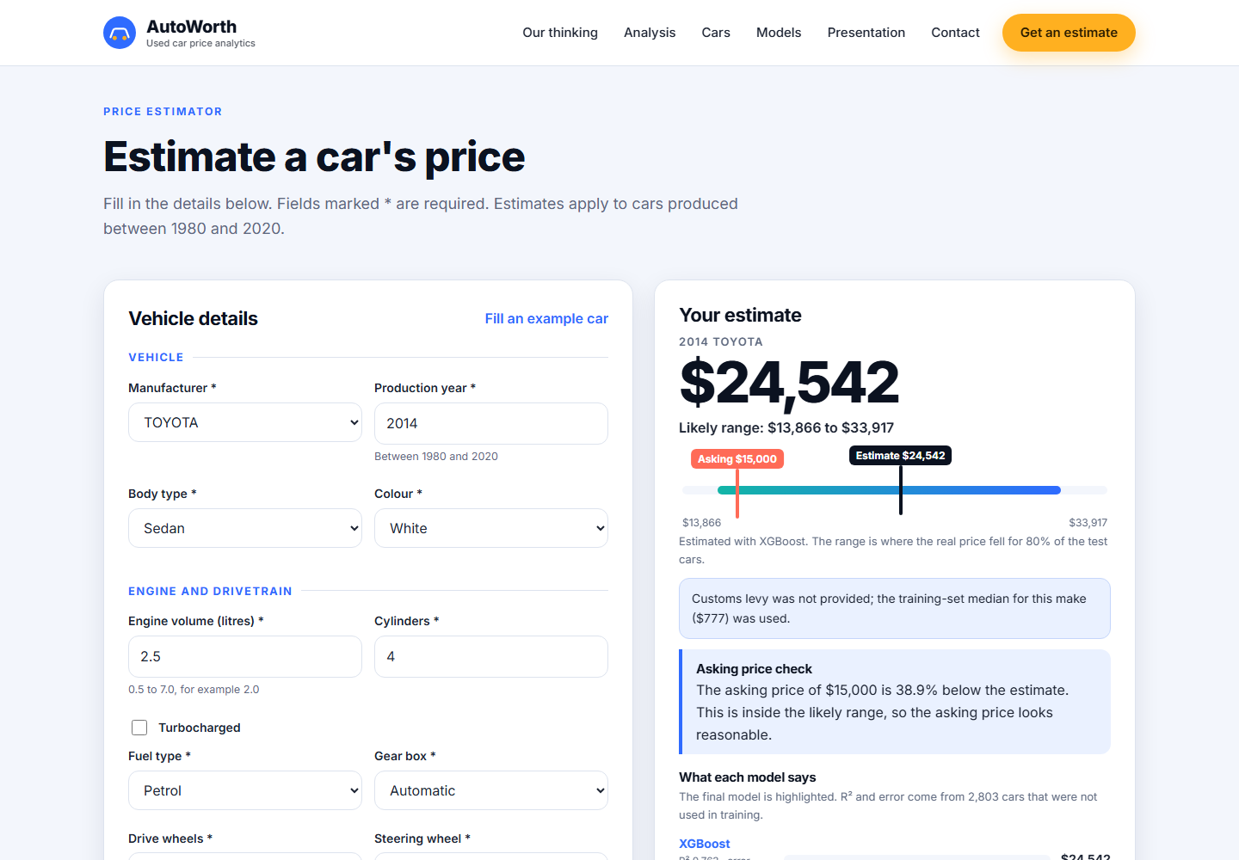
Figure 12. The estimator with a result: price, range bar with the asking price marked, notices and the asking-price check.
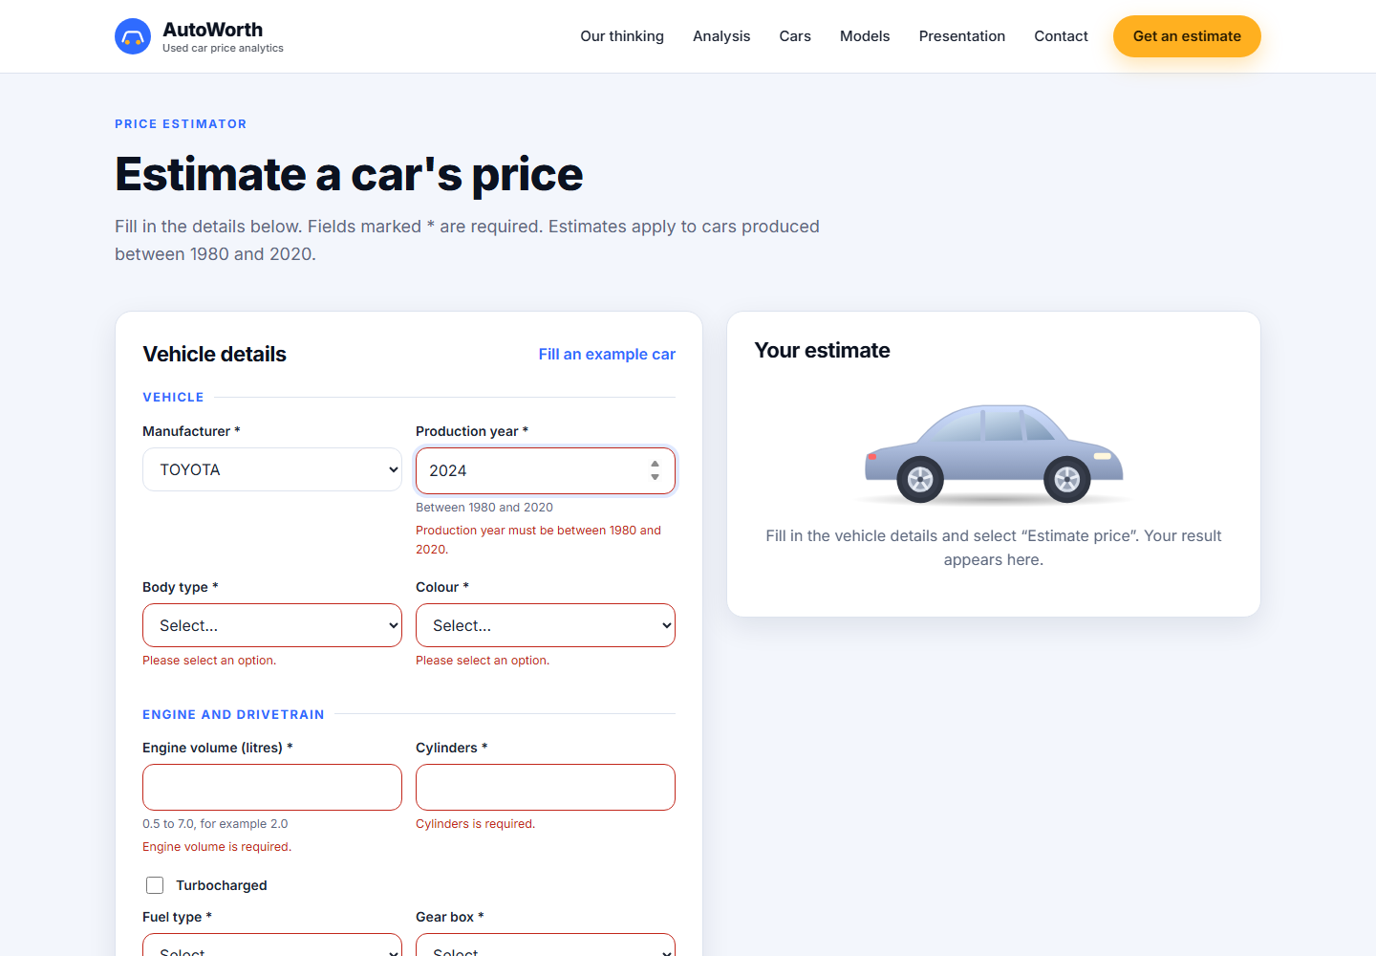
Figure 13. Messages shown next to fields that are missing or out of range.
All charts, callouts and presentation numbers come from the endpoint /api/insights, a file built by scripts/build_insights.py from the same data and models as this report, so the website and the report quote the same figures. The charts use the Chart.js library and the car illustrations are drawn in code, so the page needs no image files. The font and the library are stored in the project and the page works without an internet connection.

12.3 Running the System
From the project folder run pip install -r requirements.txt and then python app.py. The application opens at http://127.0.0.1:5000 on the same computer. Instructions to repeat the training are in README.md. To show a video in the home section, put a file named hero.mp4 in static/media; to set the recipient of the contact form, start the server with the environment variable CONTACT_EMAIL.

13. System Testing and Results

13.1 Automated Tests
tests/test_api.py contains 13 tests that call the service the way the browser does. All 13 pass in about two seconds (command: python -m unittest discover -s tests -v).
Table 21. Automated tests
Test | What it checks
Valid prediction | A complete valid car returns a price within limits, a range around it, four model results and a notice that the levy default was used.
Every model selectable | Each of the four models can be chosen and is the one reported.
Unknown model rejected | An invalid model name returns status 400.
Missing required fields | Missing year, mileage and manufacturer each return their own message.
Invalid values rejected | 24 invalid values across 9 fields (text in number fields, negative numbers, nan, infinity, values out of range, non-whole numbers, unknown fuel type or colour) are each rejected with status 400 and a message for that field.
Year range | 1980 and 2020 are accepted; 2021 is rejected.
Turbo flag | The text value false behaves like false and does not change any other field.
Asking price check | A price far above and far below the estimate is reported as above and below the range; no asking price gives no check.
Bad request bodies | Broken JSON, a JSON list and a wrong HTTP method get a clear error and not a server crash.
Options and models | The option lists and the model list are complete and exactly one model is marked final.
Page renders | The home page loads and contains the analysis, cars, models, presentation and contact sections and the footer.
Insights data | The website data endpoint returns every block the page needs, exactly one final model and importance shares that add up to 100%.
Static files | The stylesheet, scripts, chart library and font are all served.

13.2 Consistency Between Training and Serving
The most important check of Stage 9 is that the application gives the same answer as the training pipeline. The 2,803 test cars were rebuilt from the raw file with the cleaning rules and the same split, and each car was sent through the application's validation, feature building and model (scripts/check_serving_consistency.py). The prices were then compared with the predictions made from the processed test file. 2,803 of 2,803 predictions were identical (largest difference $0) and no valid test car was rejected by the validation. This confirms that the backend applies the same preprocessing as the training code.

13.3 Manual Tests of the Page
Table 22. Manual tests in the browser
Action | Expected | Observed
Press Estimate with an empty form | A message under every required field, no request sent, focus on the first wrong field | Passed: 14 messages shown and the focus moved to the manufacturer field.
Enter production year 2024 | Message that the year must be between 1980 and 2020 | Passed.
Enter mileage -20 | Message about the allowed range | Passed.
Enter a valid car without a levy | Estimate, range, model table and a notice about the levy | Passed.
Enter a valid car with an asking price | A sentence comparing the asking price and the estimate, and the asking price marked on the range bar | Passed (Figure 12).
Choose another model | That model's estimate is the main figure | Passed: LightGBM selected, its estimate shown and named under the price.
View at a phone width (375 pixels) | Form and result stacked, menu button shown, no horizontal scrolling | Passed: one column, menu button shown, no horizontal scrolling.
Pause motion on the home section | Animation stops and the button changes to Play motion; pressing again resumes | Passed.
Select a point on the car in the Analysis section | Name, share of accuracy and a data fact change | Passed (for example Gear box 8.2%).
Move through the presentation with the arrow button and the arrow keys | Slide counter changes one slide at a time | Passed.
Send the contact form empty | A message under each of the three fields and no email draft | Passed.
Follow every link in the header and the footer | Each link goes to an existing section | Passed.

13.4 Model Results in the System
The accuracy shown in the application's comparison table comes from data/model_metrics.json, which is computed from the saved models and the test split, so the page and this report quote the same numbers: for the final model R² 0.7628, RMSE $8,150 and MAE $4,688.

14. Limitations and Possible Future Improvements

14.1 Limitations
- Moderate accuracy. The median error is 17% and only 45% of estimates are within 15% of the real price. The likely range is wide (0.565 to 1.382 times the estimate) and the system should be used as a guide, not as a valuation.
- Noisy prices. The labels are asking prices. Cheap listings, especially for recent cars, often do not follow the specification, and the model cannot predict them (Table 12).
- Few recent cars. Only 1.6% of the cleaned records are from 2019 or 2020 and none is newer, so the application accepts only 1980 to 2020 and estimates for the newest cars are the least reliable.
- Old market data. Prices are those of the time the listings were collected. They are not corrected for inflation or for changes in the market since then, and the age is measured from 2026 while the prices belong to an earlier period.
- One country, one marketplace. The model should not be used for other markets.
- No model or trim. The car model name (for example Camry or Corolla) is not used because of its many rare values, although it clearly affects price.
- Close competitors. XGBoost, LightGBM and Random Forest cannot be separated with confidence given the fold-to-fold variation. A different random split could change the order.
- Residual duplicates. 73 test cars have the same feature values as a training car; the effect is small but not zero.
- Local deployment. The application runs on the user's own computer with Flask's built-in server; it is not hosted online.

14.2 Possible Improvements
- Collect more recent listings and a second source to reduce the noise and to cover new cars.
- Use the car model through a smarter encoding (for example grouping by make and body type, or target encoding inside cross-validation).
- Predict the range directly with quantile regression so that the interval depends on the car and not on one factor for all cars.
- Detect suspicious listings (for example a very cheap price for a new car) and remove them in a documented way.
- Explain each estimate to the user with feature contributions (for example SHAP values).
- Re-introduce a value-retention score or a deal rating once the error is small enough to support it.
- Host the service with a production web server, add logging and monitor the error against newly collected listings.

15. Individual and Group Contributions
The table lists the work of each member as recorded in the project notebook and the group's allocation file. All members took part in the discussion of the results and in the preparation of the report and presentation.
Table 23. Contributions by member
Member | Registration number | Contribution
N S Devapriya (Nirodha), team leader | IT23557956 | Data cleaning engine and anomaly handling (Stage 4); XGBoost model; Flask service and integration of the models into the backend (Stage 9); coordination of the deliverables.
W G B S Wijerathna | IT23630734 | Exploratory analysis of steering wheel side and of price against age and fuel type, and the correlation analysis (Stage 3); deal-class target (Stage 4); Random Forest model.
R A N K Ranasinghe (Rupasinghe) | IT23780088 | Target and mileage distribution analysis (Stage 3); feature engineering (Stage 4); LightGBM model.
T M A R Gunasekara | IT23614208 | Train and test split and levy imputation, preprocessing pipeline (Stage 4); Ridge Regression and its tuning.

Stages 6 and 7 (model comparison, tuning and selection), Stage 10 (frontend), the testing and this report were completed as a group.

References
Bergstra, J. and Bengio, Y. (2012). Random search for hyper-parameter optimization. Journal of Machine Learning Research, 13, 281-305.
Breiman, L. (2001). Random forests. Machine Learning, 45(1), 5-32.
Chen, T. and Guestrin, C. (2016). XGBoost: A scalable tree boosting system. Proceedings of the 22nd ACM SIGKDD International Conference on Knowledge Discovery and Data Mining, 785-794.
Contractor, D. (n.d.). Car Price Prediction Challenge [Data set]. Kaggle. https://www.kaggle.com/datasets/deepcontractor/car-price-prediction-challenge
Hoerl, A. E. and Kennard, R. W. (1970). Ridge regression: Biased estimation for nonorthogonal problems. Technometrics, 12(1), 55-67.
Ke, G., Meng, Q., Finley, T., et al. (2017). LightGBM: A highly efficient gradient boosting decision tree. Advances in Neural Information Processing Systems, 30.
Pallets Projects. (n.d.). Flask documentation. https://flask.palletsprojects.com/
Pedregosa, F., Varoquaux, G., Gramfort, A., et al. (2011). Scikit-learn: Machine learning in Python. Journal of Machine Learning Research, 12, 2825-2830.

