Readme

gorkhali_store/api/config contains database.php to change the database login credentials

1. to send request for order information **(Get method)**

<http://localhost/gorkhali_store/api/orders/read.php?status=completed&date_start=1990-01-01&date_end=2010-01-01>

where parameters are status, date_start and date_end

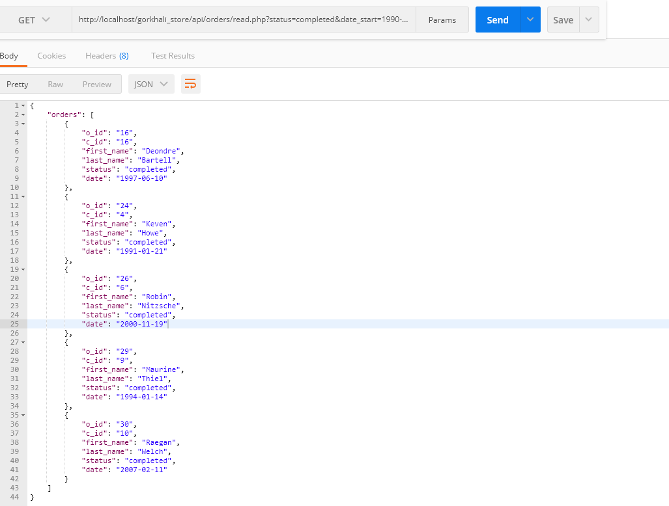

1. to send request for customer information **(Get method)**

http://localhost/gorkhali_store/api/customer/read.php?first_name=Niroj&last_name=Shrestha

http://localhost/gorkhali_store/api/customer/read.php?first_name=Niroj

<http://localhost/gorkhali_store/api/customer/read.php?last_name=Shrestha>

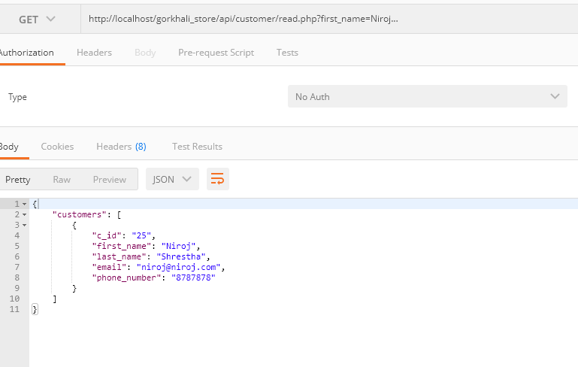

1. For Rest API crud process

* Insert values into customer (**Post method)**
* <http://localhost/gorkhali_store/api/customer/read.php?first_name=Jone&last_name=Cena&email=john@john.com&phone_number=1236987>

postman screenshot

* 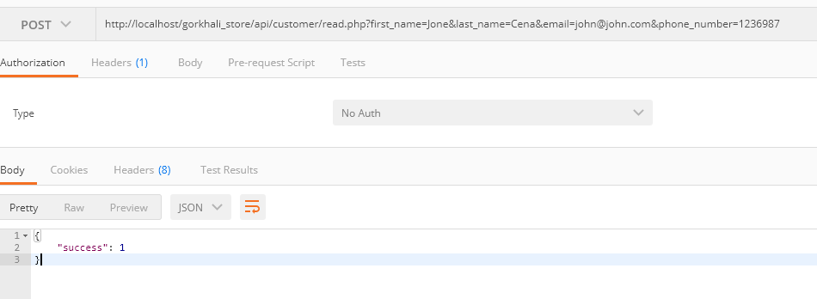

Database screenshot: note that new customer with name John is created with c_id=26

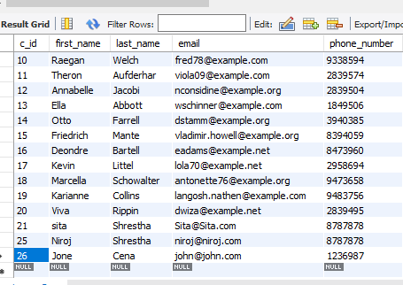

* Update value in customer (**Put method)**
* http://localhost/gorkhali_store/api/customer/read.php?first_name=Dywan&last_name=Johnson&email=rock@rock.com&phone_number=1236987&c_id=26

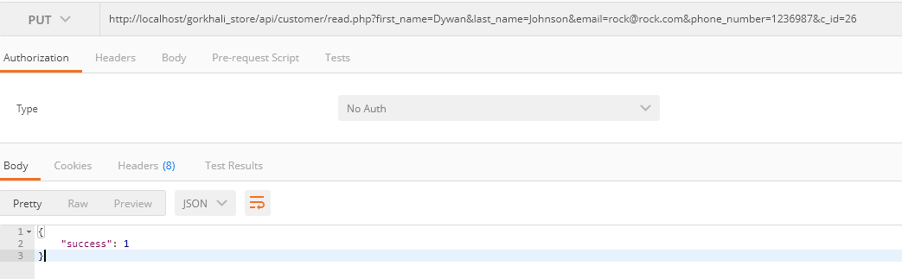

Database screenshot: note that customer with name John having c_id=26 is updated to first_name=Dwyan, lastname = Johnson, and email = rock@rock.com

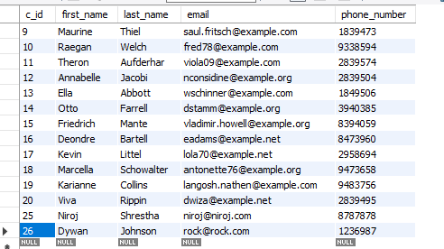

* Delete values from customer (**Delete method)**
* http://localhost/gorkhali_store/api/customer/read.php?c_id=26

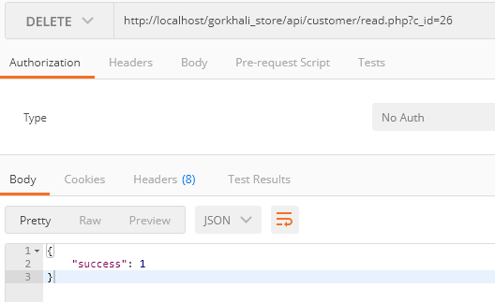

Note that customer with c_id = 26 is deleted

