Mini Project Report on

“Regional Weather Monitoring”

By

Niroop C Naik

RNS Institute of Technology

USN: 1RN17EE024

Electrical & Electronics Branch

2021 Batch

To

VI Solutions



**Abstract**

Regional Weather Monitoring project was carried out using LabVIEW software by National Instruments which is used for data acquisition, instrument control and for industrial automation and is a graphical development environment.

Data is acquired from the web using an API (Application Program Interface). Open Weather Map API is used in this project to acquire data from the server using HTTP Client GET Method.

**Objective**

The main objective of this project is for the end-user to access weather data easily.

Other objectives include

* Designing an effective Weather Data Acquisition System.
* Utilising data already present in the web directly using APIs.
* Using a graphical development environment like LabVIEW to acquire data.

**Overview**

A plain JSON string text is acquired using HTTP Client GET Method, then the text is parsed to access the required weather data like Temperature, Pressure, Wind Speed etc.

All the outputs are connected to Graphical Meters displayed in the front panel of LabVIEW to display the readings of Temperature, Humidity, Wind Speed, Wind Direction etc.

Other outputs include information regarding Sky, Cloud Coverage, Visibility etc.

**Requirements**

* **Functional requirements**

“Enter City” String control has to be filled by the end-user in the front panel to access weather data of required city.

An API Key has to be entered in the “API Key” string control in the front panel.

Weather data provider *Open Weather Map*’s API Key has to be known before using the program.

An API key can accessed freely from <https://home.openweathermap.org/api_keys>

* **Dependencies**

These following packages are used in LabVIEW

1. JSONtext
2. LabVIEW HTTP Client
3. JDP Utility
4. NI Packed Library Utility
5. NI File Type

If package isn’t available in LabVIEW, it can be installed from VI Package Manager.

JSONtext is used to extract JSON object and JSON array data from the already acquired string from the API url.

**API Workflow**

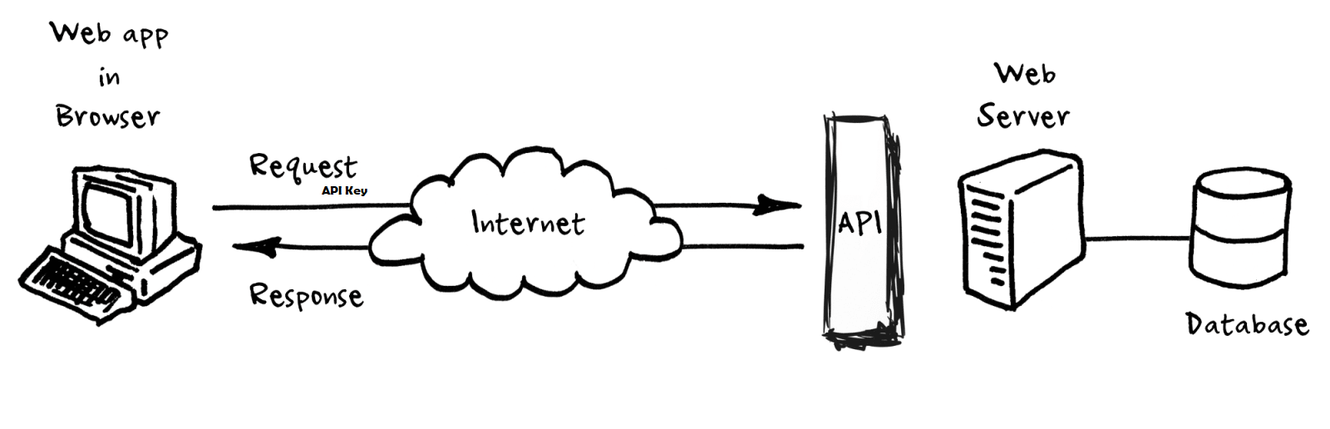

URL of API along with the API Key is sent to the server using GET Method from LabVIEW HTTP Client. If the API Key is valid, API server searches it’s database and sends back with the weather data of the region requested.

**Using SubVI packages**

* **LabVIEW HTTP Client**

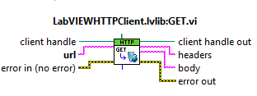

Using the LabVIEW HTTP Client with the API url, a request is sent to the server and response is received. A header and body string indicators must be created to access the output of the response from the server.

The received response in body string indicator is of JSON string format type.

* **JSONtext**

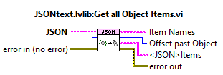

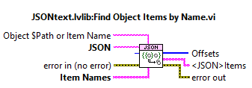

The received response is in the form of JSON string.

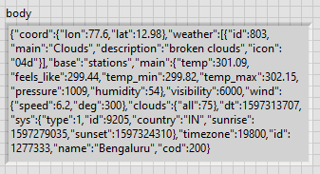

This data has to be parsed from the string to give numeric inputs for the Graphical Indicators (Temperature meter, Humidity meter, Wind Speed meter)

Get all Object Items sub-vi from the JSONtext palette is used to access all Objects from string. Ex: coord(coordinates), weather.

Find Object Items by Name is used to access only the required data from the string.

The data output is in form of a string array which has to be converted from 1d array of string to to a Cluster in order to unbundle to access data separately. The separated data string can be converted from string to numeric value for required operation.

**Front Panel**

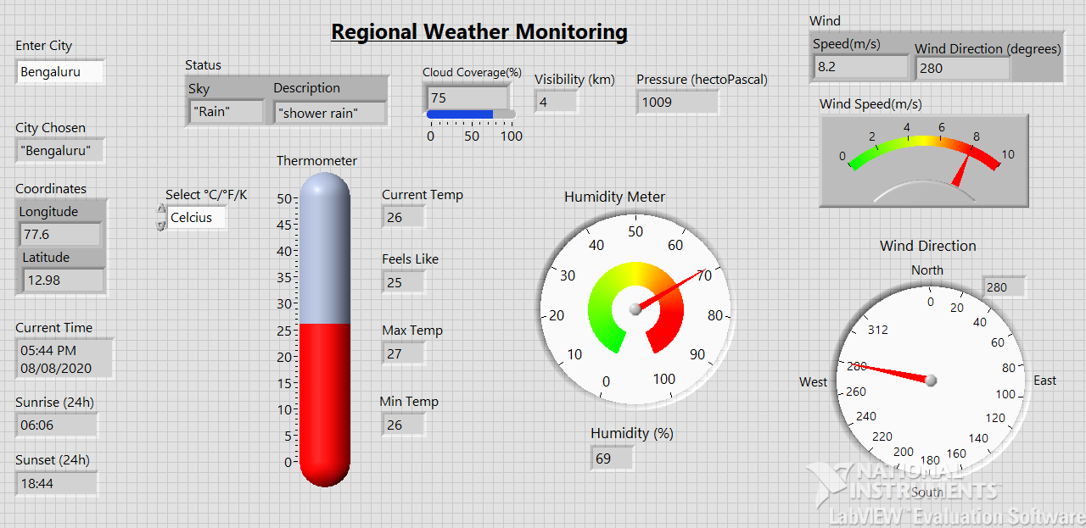

* **Temperature**

Temperature Meter: It shows the current temperature of the city chosen.

Scale of Temperature (°C/°F/K): Celsius, Fahrenheit or Kelvin scales can be chosen.

There is also information regarding Maximum Temperature, Minimum Temperature and also Feels Like.

* **Wind**

Wind Speed Meter: Shows speed of wind in meters per second.

Wind Direction Meter: Shows direction of wind in degrees.

* **Humidity**

Shows information regarding water vapour present in air in percentage(%).

* **Status**

Information regarding Weather Status of sky and description of clouds are displayed.

Cloud coverage in terms of percentage(%) is displayed. Visibility in km is displayed.

* **Pressure**

Pressure in terms of hectoPascal (hPa) is displayed.

* **Location Data**

Longitude and Latitude values of the chosen city is displayed.

Sunrise and Sunset time of that chosen city is shown.

**Block Diagram**

