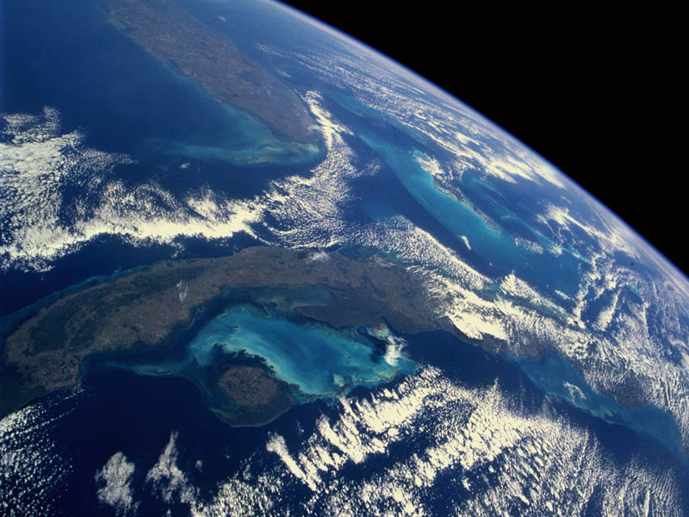
University
Of
Melbourne
Satellite
Tracking
Station.
Thaya Thanabalasingham
Sujee Sivasubramanium
Niroshan Rajadurai

