Forking a repository
In this tutorial, you will fork a remote repository, configure upstream (to get updates from the original repository) and propose a change to the owner.
- Make sure you're logged into your GitHub account.
- Go to any public repository available. This one for example.
- To fork the repository, click on Fork (in the top-right of the page):
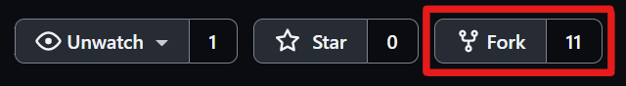
This will create a copy of the repository under your account.
- You will then be redirected to your account's version of the repository.
- Click on the green Code button and copy the SSH URL.
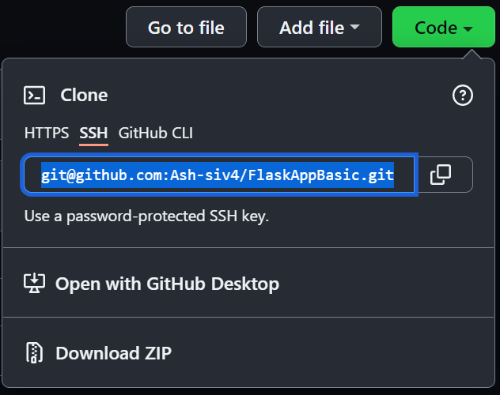
- Open a Git Bash terminal in the location you want to clone your project into.
- Run the command git clone [URL], but replace [URL] with the repository URL you copied in the previous step.
- Change directory to the project you just cloned.
- Run the following command, to confirm that you have cloned the correct repository: git remote -v.
You should get a similar output for fetch and push, but the URL will be pointing to your repository.
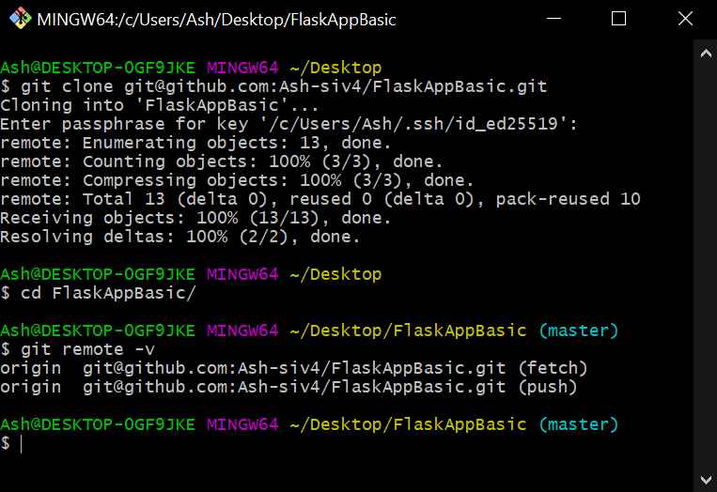

Updating forked repository from original
Next, we'll set up your local project to receive updates from the original repository. This is required, so that when the owner of the original repository adds new functionality, such as bug fixes, you will be able to get these changes as well.
- Open your Bash terminal, in the root directory of your project. You should be able to see that you're on the main branch.
Next, you want to execute git remote -v to make sure that the upstream to the original repository is not set up yet.
You should see a similar output to this:
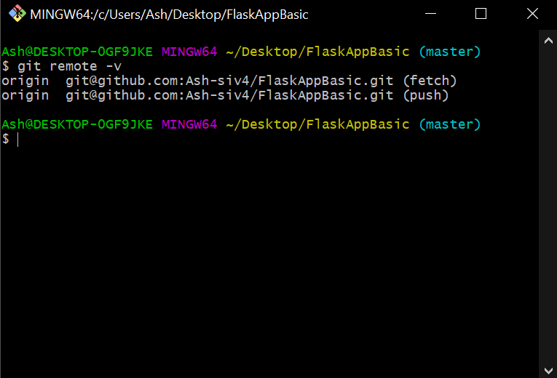
- In your browser, go to the original git repository and copy the repository URL.
You can do this by clicking on the green Code button and copying the SSH URL:
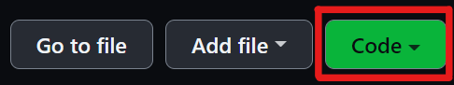
- Execute the following command in your Bash terminal but replace the [URL] with the one you just copied: git remote add upstream [URL].
- Next, you want to check that this has worked, which you can do by executing the git remote -v command.
The output should look similar to this:
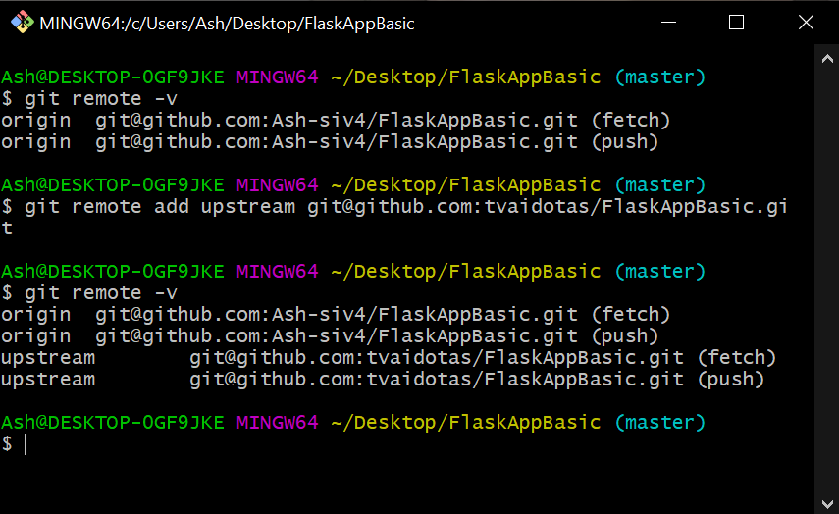
- Now you will pull the changes from the original repository into yours, which you can do by executing the git fetch upstream command in your Git Bash terminal.
The output will depend on whether there are new changes or not:
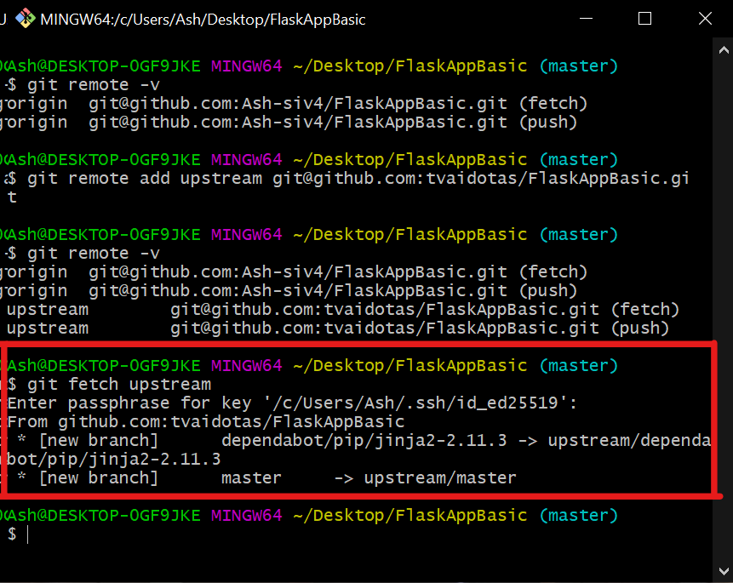
- You will want to update the main branch, so we will merge the upstream/main into the local origin/main.
You can do this by executing the git merge upstream/[name_of_main_branch command.
Example command: git merge upstream/main
Keep in mind that there may be merge conflicts that you will need to resolve.
If you have resolved the merge conflicts, or if there were none, you should push to update your origin/main (or origin/master) branch.
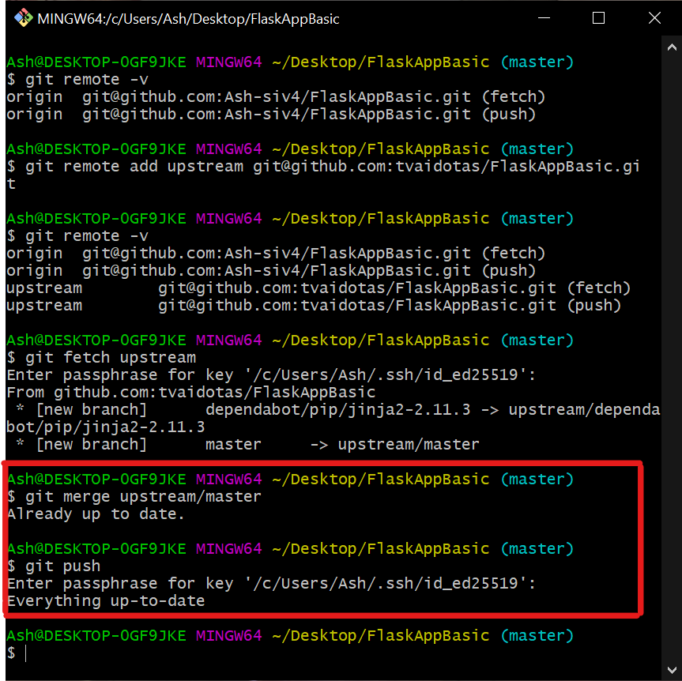

Handling Merge Conflicts
You will now go through the steps required to cause a merge conflict.

Initialize a Repository for Testing Merge Conflicts
- Open a terminal
- Create a new directory by executing mkdir git-merge-conflict
- Change directory by executing cd git-merge-conflict
- Initialize this directory as a git repository by executing git init .
- Create a new text file hello.txt in the directory
- Add some text, such as "hello world", to the hello.txt file. Save and close the file
- Now you need to make git track changes for the hello.txt file, which can be done by executing the git add hello.txt command
- Now you need to create a save point, which is known as a commit. This will have the current state of the *hello.txt file in it.
Execute the git commit -m "initial commit" command to achieve this.

Create a Branch with a Conflict
Now that you have a repository and a main branch with a file on it, the next step is to create a new branch to use to cause the merge conflict.
- Checkout a new branch by executing git checkout -b new-branch
- Open the text file hello.txt and add a new line of text to it, such as "making a change to the file". Your text file should now look like this:
- hello world
making a change to the file
- Let's ensure Git keeps track of the hello.txt file that we made a change to. This can be done by executing the git add hello.txt command.
Let's commit this change and add a message that reflects the change made i.e. - git commit -m "made a change to hello.txt file". The change we made will now try to override the changes in main branch, for the text file hello.txt.
- A change to the text file hello.txt is now required before we can cause a merge conflict. Let's go back to our main branch, by executing the git checkout main command.
- Open the text file hello.txt and add a new line of text to it, such as "making a bigger change".
Your text file on main should now look like this:
hello world
making a bigger change
The hello.txt on the new-branch branch should look like this:
hello world
making a change to the file
Let's commit the change we made to the hello.txt file to the main branch, by executing git add hello.txt followed by git commit -m "modified hello.txt file".

Attempt to Merge the New Branch
Now, we want to merge changes from the new-branch branch to the main branch.
However, Git will not be able to figure out which version of the second line to use, creating a merge conflict, which the developer will be responsible for resolving.
- Let's go ahead and actually cause the merge conflict, by executing the git merge new-branch command. You should get an output
similar to this:
Auto-merging hello.txt
CONFLICT (content): Merge conflict in hello.txt
Automatic merge failed; fix conflicts and then commit the result.
- Let's take a look at the contents of the hello.txt file now, which should look similar to this:
hello world
<<<<<<< HEAD
making a bigger change
=======
making a change to the file
>>>>>>> new-branch
The main thing to recognise is that the first line (hello world) doesn't have a conflict, but there is a conflict between the second line of the main and new-branch branches.

Resolving the Conflict
To resolve the merge conflict, there are a couple of steps needed:
- Firstly, decide which second line to keep out of making a bigger change or making a change to the file. You could also choose something entirely different, such as keeping or deleting both lines.
- Secondly, delete the lines Git added, to show where the merge conflict is happening i.e. <<<<<<< HEAD, =======, >>>>>>> new-branch.
Let's say you decide to keep the second line that's currently in main branch. After cleaning up the file, it should look like this:
hello world
making a bigger change
- Next, you need to save the changes made. This can be done by executing the git add hello.txt command, followed by the git commit -m "resolved merge conflict" command.
Running git status should now indicate that there are no longer any conflicts to resolve.

Revert and Reset
- Create a folder called "tmp"
- Initialize the folder as a git repository.
- Create a new file called test.txt.
- Stage the file and commit, with an explicit commit message reflecting the additions made.
- Repeat the previous two steps (using a different file name each time) until you have done 5 commits.
- Check your git log history for the branch you are on (try out the additional flags for viewing the git log history).
At this stage, note down what you see in your history!
- Use the git revert HEAD command to undo the last commit you did.
- Use the ls command to see what happened.
Note down what you see in your directory!
- Use the reset command to go back to your first commit.
- Use the ls command to see what happened.
- Check the history for the branch you're working on.

Github Reviews
NB. This task works much better with somebody else. If you really want to do it individually, you will need to make another GitHub account...
- Create a Pull Request, similar to how you will have done in the Pull Requests module, to merge a feature change from a feature branch into the main branch (ideally, you will make something that requires changing - for example, some broken code).
- Add a Reviewer to the PR.
- Have the other person/other account do the same thing on their GitHub (requesting a review from you).
- Start the review, making sure to test the new feature(s).
- Make some comments for the other person/account.
- Either approve the review, or request changes.
- Complete the review.
- Complete the merge once your own PR has been reviewed and approved by the other person/account.

