**Data Visualization**

**#** Documentation of tableau Vizzes by Pravin Bhandari

My Tableau Link: [https://public.tableau.com/profile/pravin.bhandari#!/](https://public.tableau.com/profile/pravin.bhandari%23!/)

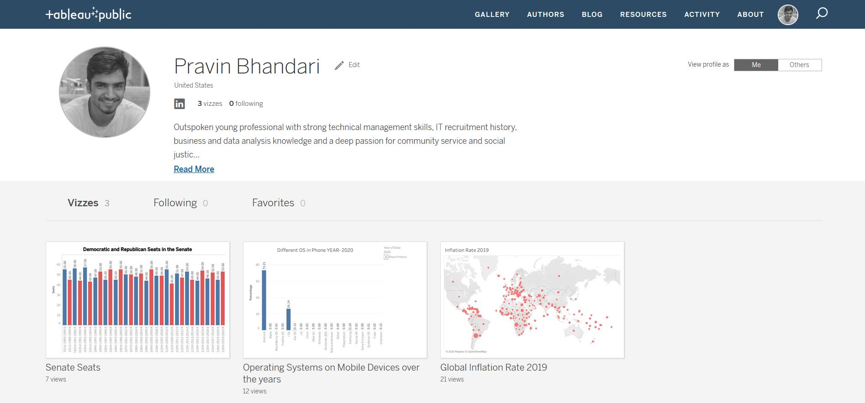

I completed this lab by performing following:

* After opening, the tableau public software, I linked the source file.
* Then, I managed and made data clear in data source tab
* Then opened the data source in the new sheet.
* Added desired data names and values in the respective tabs
* Selected the data visualization tools that I wanted to use.
* Edited X and Y axis values. And edited fields like colors and size
* Saved the worksheet after linking it with my online profile.
* Added description for each Vizzes.

1. **Senate Seat:** This visualization is a bar diagram of senates seats held by top two parties of United States over the past few years from 101st to 116th Congresses.  
   Data Source: <https://www.brookings.edu/multi-chapter-report/vital-statistics-on-congress/>

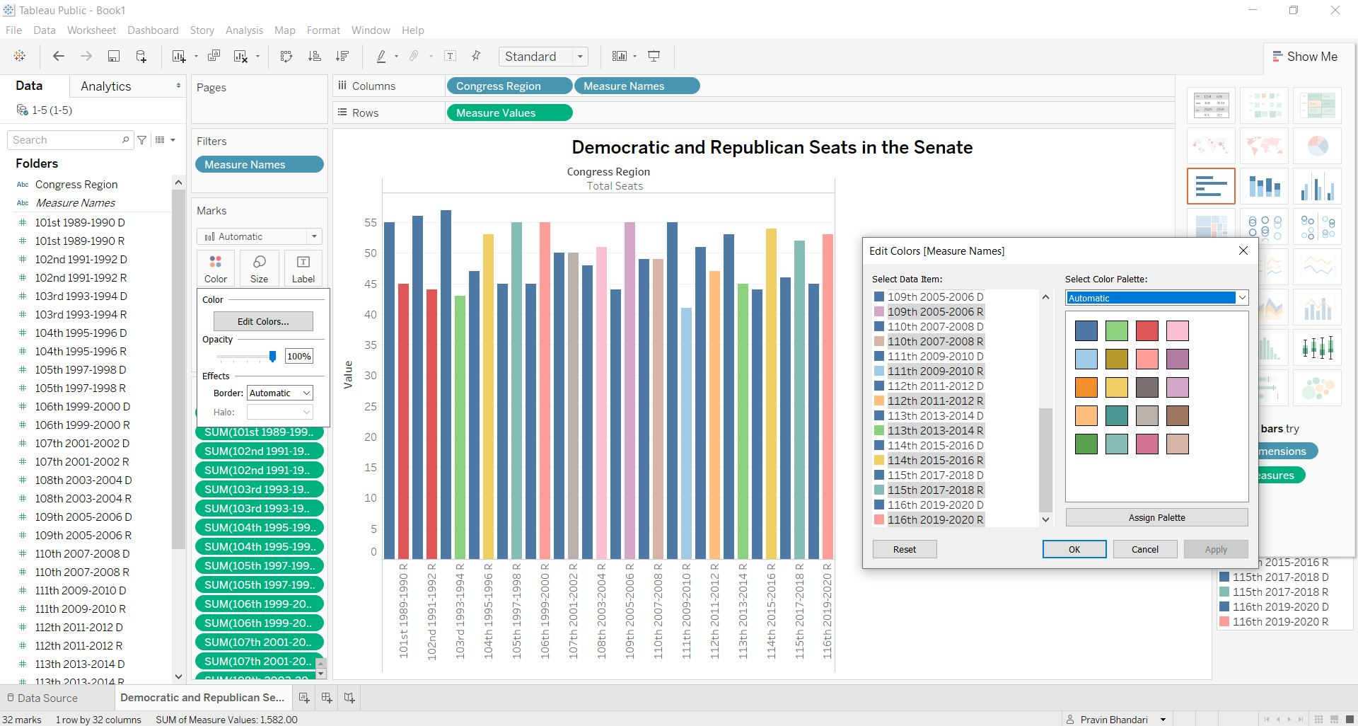

1. **Global Inflation Rate:** This visualization provides a world map for Inflation rates for countries in 2019. The size of the dot is related to the size of inflation rate. i.e, higher the inflation rate, bigger the dot and vice versa.   
   Data source: <https://data.worldbank.org/indicator/NY.GDP.DEFL.KD.ZG?view=chart>

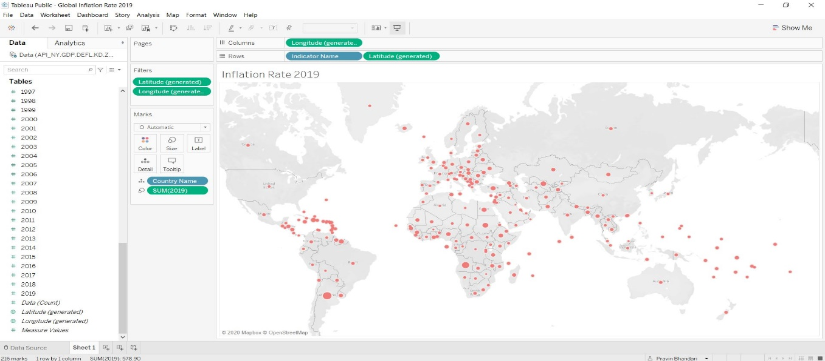

1. In this visualization, I have utilized the bar diagrams to show the history of OS market share over the years in mobile phones. If you click on the arrow of the tool on the left side bar, the bars will change to reflect the changes of the market dominance of each OS over the past years.

Data Source: [https://gs.statcounter.com/os-market-share#yearly-2010-2020](https://gs.statcounter.com/os-market-share%23yearly-2010-2020)

