A Cloud-Native Flood Risk Prediction System Using Machine Learning and Geospatial Visualization on Google Vertex AI
GROUP 5 AIE B

Muhammed Rashid R
AM.SC.U4AIE23132
School of Computing
Amrita Vishwa Vidyapeetham,Amritapuri
Kollam,India
am.sc.u4aie23132@am.students.amrita.edu

Vishnu J
AM.SC.U4AIE23160
School of Computing
Amrita Vishwa Vidyapeetham,Amritapuri
Kollam,India
am.sc.u4aie23160@am.students.amrita.edu

Nirranjan Narayan MR
AM.SC.U4AIE23138
School of Computing
Amrita Vishwa Vidyapeetham,Amritapuri
Kollam,India
am.sc.u4aie23138@am.students.amrita.edu

Adith Aneesh
AM.SC.U4AIE23103
School of Computing
Amrita Vishwa Vidyapeetham,Amritapuri
Kollam,India
am.sc.u4aie23103@am.students.amrita.edu

Muhammed Hashir R
AM.SC.U4AIE23131
School of Computing
Amrita Vishwa Vidyapeetham,Amritapuri
Kollam,India
am.sc.u4aie23131@am.students.amrita.edu

Divya Udayan J(Project Guide)
Department of Computer Science and Engineering
Amrita Vishwa Vidyapeetham
Kollam,India divyaudayanj@am.amrita.edu

Flooding is among the most devastating natural disasters, leading to death, devastation of buildings and other structures, and significant economic concerns. Timely and accurate flood risk prediction is critical for creating disaster preparedness and minimizing their impact. This article presents a cloud-based prediction of flood risk developed using Google Vertex AI. This tool analyzes rainfall, flows of rivers, elevations of land, types of soil, and past flooding to determine if there is a risk of flooding in any given area. The machine learning model is created and deployed as a public service via Vertex AI and Cloud Run. Users can input the latitude and longitude of any location and select any relevant environmental factors into a simple web interface, and the system will find the actual geographical location and then render the areas at risk for flooding on a world map. The experiment results confirm that the proposed Prediction System provides flood-risk prediction that is up-to-date and is therefore suitable for disaster management and decision-making processes.
Keywords — Flood Risk Prediction, Machine Learning, Vertex AI, XGBoost, Cloud Computing, Geospatial Visualization, Disaster Management

Introduction
Floods are among the most widespread Natural Hazards and therefore can have devastating Effects globally for both developed and developing nations alike. Reports from global disaster mapping organisations indicate that Flooding is directly responsible for thousands of Deaths annually and Costs billions in Economic Infrastructure Losses: Recurrent Flooding due to Heavy Rains and Changing Climate Patterns is Further Compounded by many areas near rivers with a growing urban population and Returning to Pre-Disaster Conditions will Not be the Same.

Historic Prediction Techniques Use Hydrological and Hydraulic Models. While these methods provide good Prediction Models, achieving good Accuracy will require considerable Investment to develop detailed knowledge about the Area Surrounding The Specific Model, and also Extensive Calibration and High Computing Resources Availability. By nature, Hydrological and Hydraulic Models are Generally Specific to a specific Area for example; and if you attempt to apply them to another Area it will Provide Poor Forecasts.

Machine learning has been introduced as an alternative method for predicting flood risk by utilizing historical and other data to identify patterns. While machine learning models have the capability of recognizing complex, non-linear relationships between environmental factors and flood events, they also have the ability to process high volumes of data in bulk. Thus, machine learning techniques are well suited to the flood risk assessment process. However, there are three considerations that need to be resolved before deploying to the real-world environment; reliable infrastructure, a scalable method for deploying services, and user-friendly interfaces.

A number of cloud computing companies, such as Google Cloud, provide products to help facilitate the training and deployment of machine learning models. In particular, Vertex AI offers a single platform for model development, deployment, and scaling, without requiring any additional work on the part of users or developers for provisioning the back-end technology. This project leverages Google Vertex AI to create a cloud-based flood risk prediction system that will provide accurate, real-time results on flood-prone areas and allow users to visualize these areas on interactive maps.

As mentioned previously, the primary contributions of this project are as follows:

• The creation of a flood risk prediction model based on both environmental data and geographical information

• The ability to deploy the predictive model to the public via a Google Vertex AI service

• The design of a simple-to-use web interface for users to input their data and receive predictions

Integration of map-based visualization to improve understanding of flood risk results

II. Related Work
Flood risk prediction continues to be an active research topic, with advances in both traditional hydrological models as well as modern machine learning techniques. Traditionally, hydrological models were based primarily on rainfall-runoff simulations along with physical modelling. To use these types of models, high-quality environmental data is required to accurately predict flooding. Furthermore, in order to successfully run these models, considerable computational resources are necessary to obtain accurate results. While traditional hydrological models provide reliable flood risk predictions, they are not easy to scale to systems that require either fast or near real-time predictions.
Recently, machine learning has become an increasingly popular approach for building predictive systems for flood risks. Examples include logistical-regression, decision trees, random forests, support vector machines, and gradient boosting algorithms. Of those types of models, Random Forest and XGBoost are two of the best-performing ensemble models for flood risk prediction. They have been found to accurately identify patterns associated with complex relationships among multiple environmental variables, and have been shown to perform well when provided with noisy data and incomplete information.
A number of researchers have employed geographic information systems (GIS) for both identifying flood-prone areas and for visualizing high-risk flood areas. GIS and other map-based systems allow for an improved level of spatial knowledge compared to many of the available non-GIS-based systems. However, GIS and other mapping systems using GIS technology are often required to be used offline and do not offer the capability of supporting updated data to be delivered in a near real-time manner. Finally, most of the current predictions of flood risks do not provide an adequate cloud-based deployment and do not offer a user-friendly interface for the public or other operational users to easily utilize.
Cloud-based platforms (e.g. Google Vertex AI and AWS SageMaker) provide infrastructure for massive-scale training and deployment of machine-learning models; however, most of these platforms focus primarily upon backend predictions and do not offer significant support for user interaction or the ability to visualize spatial data. The lack of support for either user interaction or the visualization of spatial data is addressed through this project by creating a comprehensive, integrated flood risk prediction system that incorporates all three components: cloud-based machine-learning and real-time user interaction with geospatial visualization of results.

III. System Architecture
A cloud-based, modular, and scalable architecture for a flood risk prediction system has been created that incorporates the use of machine learning, serverless computing, and geospatial data analysis. It provides real-time flood risk predictions with high availability and clear separation of the various components of the system. A representation of the system architecture is shown in Figure 1.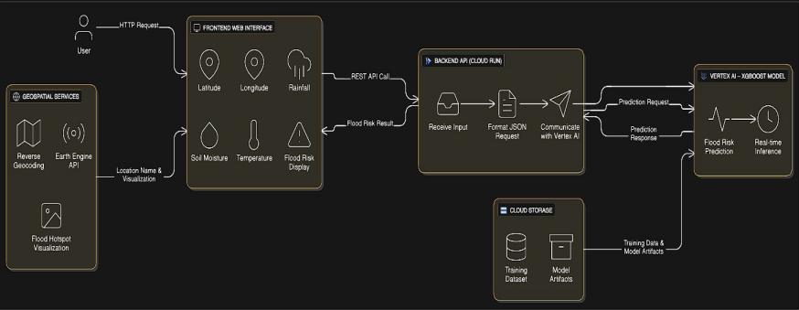Figure 1: Overall System Architecture

A. Overall System Design
The system follows a client–server architecture implemented entirely on the Google Cloud Platform (GCP). It is composed of five major layers:
- Presentation Layer (Frontend Interface)
- Application Layer (Backend Services)
- Machine Learning Layer (Vertex AI)
- Data Storage Layer (Cloud Storage)
- Geospatial Intelligence Layer (Earth Engine and Geocoding APIs)
Each layer performs a distinct function and communicates with other layers through secure, REST-based API calls.

B.Web Interface
The presentation layer manages all user interactions and is implemented as a web-based interface accessible through any standard web browser.
Functions:
- Collects user inputs such as latitude and longitude
- Accepts environmental parameters including rainfall, temperature, humidity, river discharge, water level, and elevation
- Gathers land cover and infrastructure-related details
- Validates user inputs for completeness and correctness
- Displays flood risk prediction results
- Visualizes flood-prone areas on a global map
Key Features:
- Real-time updates of prediction results
- Simple and intuitive interface suitable for non-technical users

C. Application Layer (Backend on Cloud Run)
The application layer coordinates activity across the system as a whole. It has been built out as a RESTful API service hosted on Google Cloud Run, meaning it's able to serve up Docker containers in a "serverless" environment. Some of the things that this layer does include:
- Accepting user input in the form of JSON data sent to it by the frontend
- Taking that input and preparing it for use as machine learning features
- Sending the input features to Vertex AI's trained model for prediction
- Sending the prediction results back to the layer
- Using Geocoding services to determine the real-world location of the user
- Combining the prediction and location result
- Sending the final response to the frontend
The advantages of using Cloud Run are:
- Automatically scales based on the load of incoming requests
- Has no need for managing servers
- Efficient use of resources and low cost
- Very reliable and highly available

By effectively decoupling the front-end interface from the machine learning model, the application layer allows for independent updates of both the front end and machine learning models and therefore allows each to scale on its own.

D. Machine Learning Layer (Vertex AI)
The machine learning layer is responsible for performing flood risk prediction. It utilizes Google Vertex AI, a fully managed platform for training, deploying, and monitoring machine learning models.
Model Training:
- Trained using historical environmental and geographical datasets
- XGBoost algorithm is employed due to its strong performance on structured data
- Training is executed on Vertex AI’s managed infrastructure
Model Deployment:
- The trained model is deployed as a public prediction endpoint
- Accepts input data in JSON format
- Returns classification results indicating flood risk levels (high or low)
Advantages:
- Supports real-time inference
- Automatically scales with demand
- Provides model versioning and performance monitoring
- Enforces secure access through IAM controls

E. Data Storage Layer (Cloud Storage)
Google Cloud Storage serves as the primary storage solution for datasets and model-related files.
Stored Data Includes:
- Training and validation datasets
- Processed feature files
- Trained model artifacts
- Logs and intermediate outputs
Role in the System:
- Provides reliable, long-term data storage
- Integrates seamlessly with Vertex AI
- Efficiently handles large-scale datasets

F. Geospatial Intelligence Layer
The geospatial intelligence layer adds spatial context and visualization capabilities to enhance interpretability.
Components:
- Reverse Geocoding Service:
Converts latitude and longitude into meaningful place names, improving user understanding.
- Google Earth Engine API:
Provides access to extensive geospatial datasets and supports environmental data analysis.
- Visualization Engine:
Displays flood risk regions on a global map and highlights high-risk locations using visual markers.
This layer transforms numerical prediction outputs into meaningful geographical insights.

G. Complete Data Flow
The end-to-end data flow of the system is as follows:
- Users enter geographic and environmental data through the frontend interface
- The frontend sends the data securely to the backend API via HTTPS
- The backend preprocesses the data and forwards a prediction request to Vertex AI
- Vertex AI processes the request and returns the flood risk prediction
- The backend performs reverse geocoding to identify the actual location
- Prediction results and location details are combined
- The frontend displays flood risk information and visual hotspots on the map.

IV. Dataset and Feature Description

This study utilized an extensive historical record of flooding, combined with a variety of environmental, hydrological, geographic, and socio-economic characteristics to guide the features selected for use in this analysis. Literature on both Flood Risk Assessment and Disaster Management corresponds with both natural and anthropogenic influences in relation to Flooding.

The integration of multiple sources of data (Meteorological data, River and Hydrological measurements, Terrain characteristics, Land use information, and Socio-Economic Indicators) provides a complete representation of the physical basis and potential Vulnerabilities of Human Settlements affected by floods.

A. Geographical Features

Geographical features are the basic structures that all of the data records are based on. In this case, the geographical features of a record are represented using latitude and longitude to identify the location of a record and allow for the investigation of flood patterns in various geographic locations. The latitude and longitude of the record can be used to create visual representations of the flood and for geospatial modeling.

The elevation of the area where the flood occurred will have a significant effect on how easily the water will be able to collect and overflow out of the area's rivers and drainage systems. The elevation of the area in conjunction with latitude and longitude provides a means of determining the areas that are susceptible to flooding (i.e., low-lying areas) and the areas where water will quickly flow (i.e., hilly areas) after a flood. In combination with latitude and longitude, elevation helps us to characterize some of the flood risks that result from changes to the topography of the land.

B. Meteorological Features

The prediction of flooding is highly dependent on meteorological information. Rainfall intensity is one of several factors that contributes to flooding. Because of the long-term or heavy rainfall resulting from a storm, rainwater can be more than the soil's ability to absorb it, therefore overwhelming drainage systems. Rainfall amounts are measured in millimeters as the total accumulation of rain that has fallen in a given time frame.

Other weather conditions such as temperature and humidity provide context for the atmospheric conditions surrounding the event. While these weather conditions will not directly cause a flood, they will impact when and how much precipitation will occur, how quickly evaporation will occur, and also how the weather system will evolve in the future, which impacts whether a flood will form or not.

C. Hydrological Features

Hydrologic characteristics reflect the movement and behavior of water within river networks as a function of time (i.e. how much water passes through a given point in a given time). The flow rate of the river can be measured in cubic meters per second (m³/s). Therefore, elevated flow rates indicate the probability of river overflow and lateral flooding to nearby areas due to larger volumes of river flow.

River height is also a very important hydrologic characteristic. This is because river height describes the height of the surface of the water above the terrestrial level (the river banks). If the height of the river surface reaches or exceeds the Critical Levels (levels of height at which flood conditions can occur), the likelihood of the occurrence of flood events increases dramatically. Therefore, hydrological properties provide a basis for predicting both historical and current flood conditions.
D. Land Use and Soil Characteristics

Surface runoff and water infiltration are affected by land use and soil properties. Land cover classification of land uses includes urban, agriculture, forest, and water bodies. Urban areas with their impervious surfaces, such as roads and buildings, inhibit natural infiltration and thus increase the amount of surface runoff; thus there will be an increased risk of flooding.

Soil type affects how well the soil absorbs water. Soils that are highly permeable allow more water to be absorbed and less runoff, whereas soils that are high in clay or that have been compacted are less permeable and tend to hold more water. Because of this, categorical variables about land cover and soil type are encoded numerically to be compatible with machine learning models.

E. Socio-Economic and Infrastructure Features

The dataset also includes socio-economic data and information about infrastructure to show how humans are affected by flooding. Population density is included as a measure of how many people there are in one area, which helps to predict how many people could be displaced and how much property damage may occur.

Infrastructure Index: denotes the extent and type of flood risk management systems (e.g., drainage systems, defenses and other mitigation systems). Regions that have little or no infrastructure are at greater risk from severe flooding even under "normal" rainfall events. These elements help the model to better represent the differences in flood risk management capabilities between different parts of the region.
F. Historical Flood Records

The historical data taken from floods is used to demonstrate how floods typically occur and how often they reoccur over time. When looking at how frequently floods have occurred in the past, it becomes significantly clear that the more a community has seen floods, the more likely they will encounter floods again given that the same conditions exist.

G. Data Preprocessing

Before the model training process commenced, the dataset was subjected to various preprocessing techniques. The missing values present within the dataset were imputed with appropriate techniques to maintain integrity within the dataset. Numerical features were all normalised in order to produce a common scale and thus enhance both convergence and performance of the model. All categorical variables (i.e., Land Use, Soil Type, etc) were converted to numerical values using appropriate methods of encoding.

After preprocessing was complete, the dataset was divided into subsets for training and testing purposes. The prediction task is treated as a binary classification problem, with a label value of 1 indicating the presence of a flood event and 0 indicating the complete absence of flooding.

H. Importance of Feature Integration

A more complete view of what will contribute to flood risk is provided through combining geo-, meteo- and hydrologic objects, land use objects and socio-economic objects. Such a comprehensive set of features allows the machine learning model to better represent complex relationships between social systems (human actions) and natural systems (natural processes). As such, the accuracy of predictions in different regions and environmental contexts can be improved through these relationships.
V. Machine Learning Model

Flood risk prediction in this study is formulated as a binary classification problem. The objective is to determine whether a given geographic location is likely to experience flooding based on a set of environmental, hydrological, and socio-economic attributes. Machine learning techniques are well suited for this task due to their ability to model complex, nonlinear relationships among heterogeneous features.

A. Problem Formulation

Let the input data for each location be represented by a feature vector:
X=[x1,x2,x3,....,xn]
where each feature xicorresponds to an observed attribute such as rainfall intensity, river discharge, elevation, land cover, or soil type.

The target variable is defined as: y∈{0,1}
where: y=1indicates that the location is flood-prone
y=0 indicates that the location is not flood-prone

B. Model Selection

After comparing several machine learning methods that are typically used for flood vulnerability evaluation, the best-performing predictive model is Extreme Gradient Boosting (XGBoost). This is an ensemble of gradient-boosted trees and has shown good results on structured and tabular data datasets.

The selection of XGBoost was motivated by the following advantages:

- Capability to model nonlinear relationships among features

- Robustness to noisy and partially missing data

- Built-in regularization mechanisms to reduce overfitting

- High computational efficiency during training and inference

- Proven effectiveness in prior flood risk and environmental modeling studies

These characteristics make XGBoost particularly suitable for the heterogeneous and multi-source nature of the dataset used in this work.

C. XGBoost Model Architecture

XGBoost builds a group of decision trees using boosting in a series of steps. Each new tree is created to improve the mistakes made by the earlier trees. The final prediction from XGBoost is made up of all of the predictions from each of the component decision trees.

The model optimizes the following objective function:

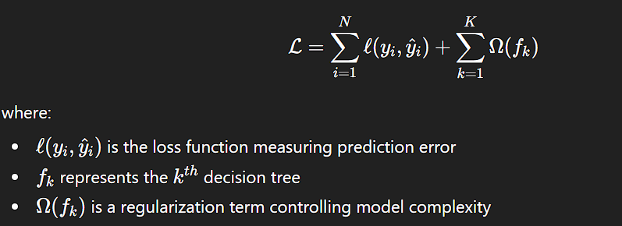

The regularization component helps control tree depth and leaf weights, thereby improving generalization performance and reducing the risk of overfitting.

D. Feature Handling and Learning Behavior

XGBoost leverages the numerical feature and categorical variable encoding to provide suitable training of this study's diverse feature set. Continuous feature variables (rainfall intensity, river discharge, elevation) affect the splitting of trees while the features representing categorical variables (land cover, soil type) help identify patterns of regional flood susceptibility.

The XGBoost Model provides an adequate representation of interaction effects across multiple features:

- Increased flood risk under conditions of high rainfall combined with low elevation

- River overflow resulting from high discharge coupled with poor soil infiltration

- Elevated vulnerability in densely populated regions with inadequate infrastructure

Such complex interactions are difficult to represent using linear models but are efficiently learned by tree-based ensemble methods.

E. Training Process on Vertex AI

In training the model, we utilized the managed training environment from Google Vertex AI and its ability to scale up compute resources and manage the experiment tracking process within. To evaluate the generalization ability of the model, we split the dataset into groups designated “training” and “testing.” All training was performed as a result of the following steps that make up the pipeline for developing the Training Process.

- Loading the dataset from the Bucket

- Applying preprocessing and feature encoding techniques

- Training the XGBoost classifier

- Evaluating model performance on a validation dataset

- Persisting trained model artifacts for deployment

The use of Vertex AI ensured reproducibility, scalability, and efficient resource utilization without the need for manual infrastructure management.

F. Model Evaluation Strategy

While this project largely emphasises deployment and real time flood predictions, standard classification metrics were used to evaluate the performance of the models which included:
• Overall classification accuracy (86%)
• Precision and recall for flood-prone classifications

The model performed consistently and stably while being trained through diverse environments indicating that this model is viable for assessing operational flood risks and deployment in reality.

VI. Model Deployment Using Vertex AI
Subsequent to training, Google's Vertex AI API was used to expose the model as a publicly accessible endpoint via the web; the steps in deploying the model included wrapping it into an accessible format for distribution, configuring all predictions that could be made using the model and exposing the URL for users of the model to make predictions on a "real time basis".

Utilizing Cloud Run, a back-end service that provides an interface for communicating with Google’s Vertex AI, the server less environment provided through use of Google Cloud's platform offers automatic scaling, support for high-volume operations and cost-effective operations.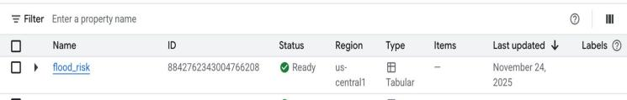
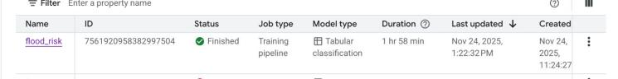

VII. Frontend Interface and Geospatial Visualization
Users can input data into the frontend interface through a clearly laid out form and receive predictive feedback with each submission of their data. Latitude and Longitude co-ordinates are translated into a recognisable human format through an operation called Reverse Geocoding.
To assist users to better understand flood risk predictions through space, the project's Global Flood Risk Map provides a Hotspot to highlight areas that are most susceptible to flooding, thus enhancing the interpretability of data and improving intuitive comprehension of flood risk by users through Visual Cues about Flood Risks across the globe.
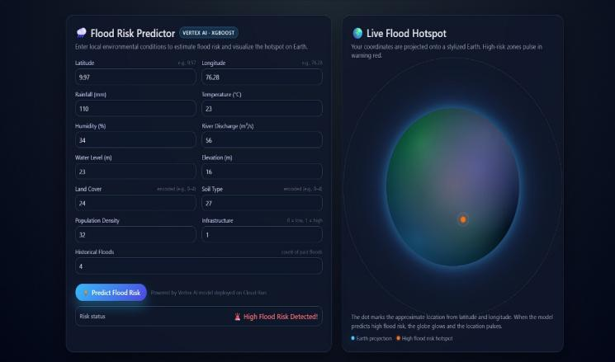

VIII. Experimental Results and Discussion

The system is capable of accurately forecasting flood risks resulting from many different input scenarios as demonstrated by its consistent results regardless of geographical location. The application of using machine learning predictions combined with geospatial visualization techniques enhances the user's ability to understand and develop confidence in the accuracy of the flood risk prediction system.

IX.. Novelty of the Proposed System

This flood prediction system represents multiple unique contributions through combining the features of cloud-native ML, real-time inference, and geospatial visualization. It differs from most techniques that mainly concentrate on enhancing predictability performance with offline-based data to a greater extent than enhanced predictability performance alone and focuses on end-to-end deployability, timely access and real-world usability.

A primary contribution of the research is providing a public cloud deployment of the flood predictive model via Google Vertex AI. By providing a trained ML model as a scalable cloud endpoint, this system allows for flood risk assessment via an as needed basis without the need for individuals using the system to have access to specialised hardware and/or software. This structure significantly reduces the barriers for individuals on boarding to the flood prediction system thereby supporting real-time decision-making.

An additional innovation of the work is the coupling of ML predicted flood risk with geo-spatial information. The system accepts geographic co-ordinates as inputs, interprets those inputs, and visualises the level of flood risk for each geographic location directly on an interactive global map. As a visualisation that permits users to understand the relative regional susceptibility for floods more easily, this development allows for improved interpretation of the results of the model and enhanced decision-support from the system.

The proposed architecture also provides a modular and flexible architecture in a cloud-based platform through the separation of the user interface, the service layer (backend services), the machine learning models and the geospatial visualisation functions. This loosely coupled design increases the system's ability to scale, maintain, and extend. This will allow for future enhancements of the system to include the use of real time environmental data feeds, the ability to make multiple level (ranging from low to high severity) predictions and provide support for hybrid or multi cloud deployments.

The overall outcome is that the proposed system transitions from being an analytical model which is standalone (not connected to the cloud), to being a full production ready (cloud-native) cloud-enabled geographical awareness decision support system that can be used in the real world.

X. Conclusion
The research presented in this document provides a complete cloud-hosted flood risk prediction solution through utilizing Machine Learning capabilities, as well as the ability to deploy the model onto the cloud platform and a background GIS capability. Vertex AI allows the ability to train models on demand and performs real-time predictions, whereas the front-end user interface makes the information displayed more user-friendly and interpretable. This flood risk prediction system can be utilized by disaster response organizations and government officials in a proactive manner to prevent future floods.

XI. Future Work
Future enhancements include integrating real-time weather and satellite data, predicting flood severity levels, implementing time-series forecasting models, and deploying the system on Kubernetes for hybrid cloud environments.

XII.References
[1] N. Gorelick, M. Hancher, M. Dixon, S. Ilyushchenko, D. Thau, and R. Moore, “Google Earth Engine: Planetary-scale geospatial analysis for everyone,” Remote Sensing of Environment, vol. 202, pp. 18–27, Dec. 2017.

[2] Google Cloud, “Vertex AI: Unified machine learning platform,” 2024. [Online]. Available: https://cloud.google.com/vertex-ai

[3] T. Chen and C. Guestrin, “XGBoost: A scalable tree boosting system,” in Proceedings of the 22nd ACM SIGKDD International Conference on Knowledge Discovery and Data Mining, San Francisco, CA, USA, 2016, pp. 785–794.
.

