Checking Jenkins Status after installation

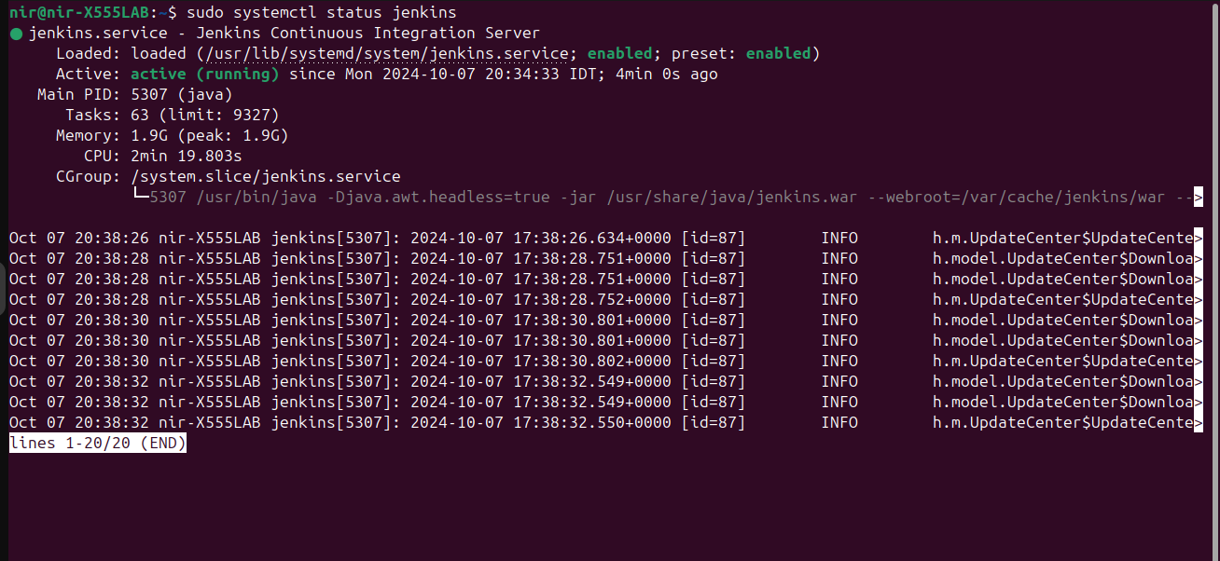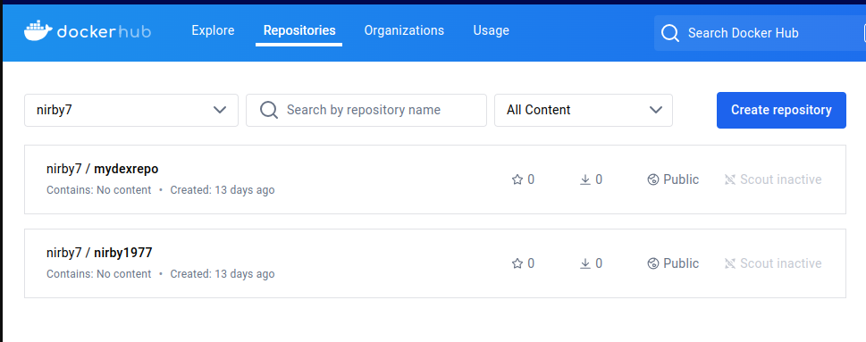

Login to Docker Hub

Install Docker Plugins in Jenkins

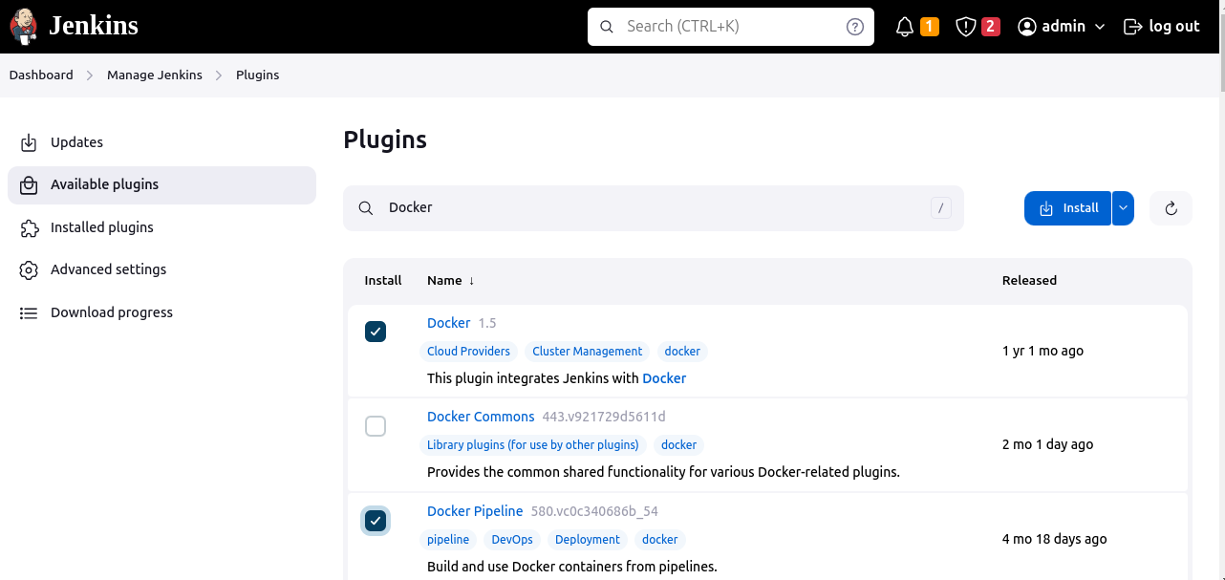

Add new Credentials (With docker hub user/pass)

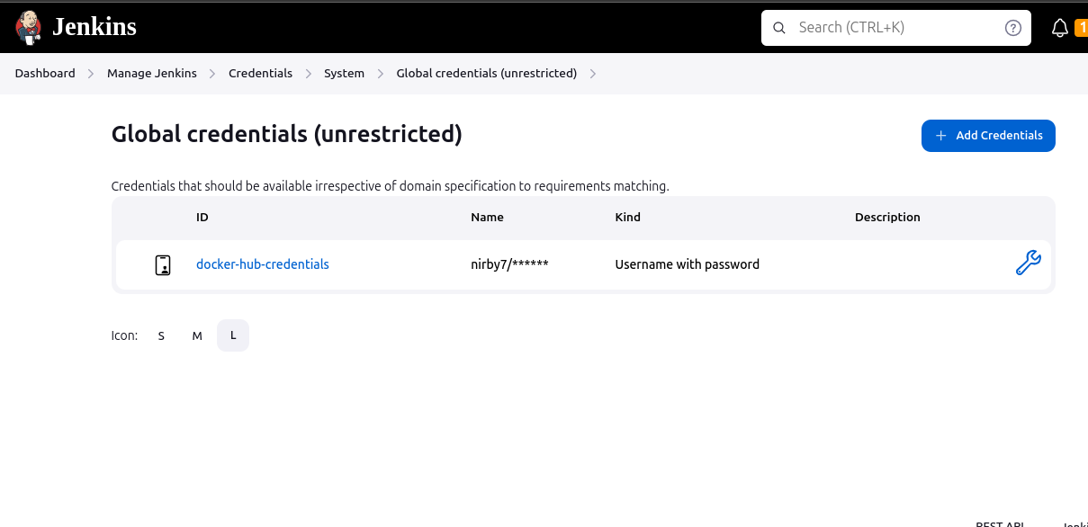

Build the Jenkins Job with all stages

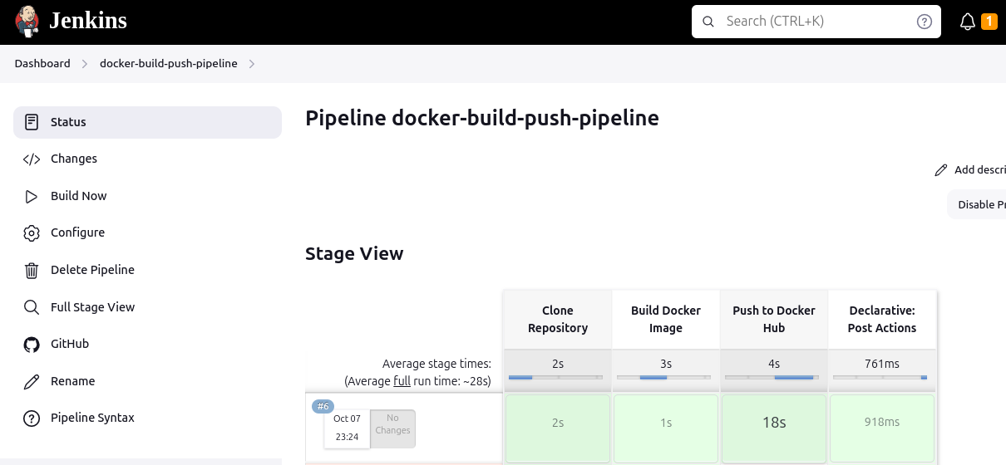

Verify that the app image indeed pushed to the docker hub

