How the Carbon-Aware AI Model Selection Project Was Built
A reproducibility and methodology companion for the PS26 project
This document explains the complete workflow used to create the data assets, notebooks, figures, tables, workflow diagram, posters, and IEEE/PES-style technical report.
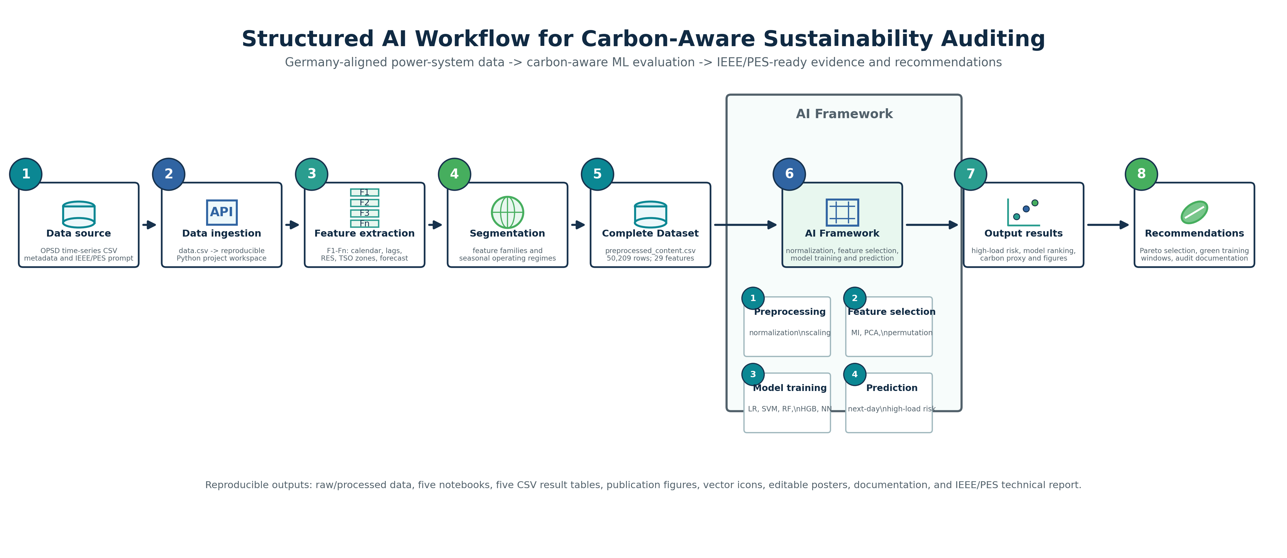
Fig. 1. Structured workflow used to build and audit the project assets.
1. Project Objective
The project studies model selection for German power-system analytics as a responsible AI problem. Instead of ranking machine-learning models only by predictive accuracy, the analysis compares accuracy, F1-score, ROC-AUC, runtime, serialized model size, and a transparent carbon proxy. The final empirical task predicts whether German electricity load 24 hours ahead enters the highest quintile of observed demand.
2. Data Source and Access Link
The raw dataset is Open Power System Data (OPSD) Time Series, version 2020-10-06. It contains load, wind and solar generation, prices, and capacities in hourly resolution, with variables aggregated by country, bidding zone, or control area. The project uses Germany-specific load, forecast, wind, solar, and TSO-zone variables.
TABLE 1. Data source link and local project files.
Item | Value
Direct CSV link | https://data.open-power-system-data.org/time_series/2020-10-06/time_series_60min_singleindex.csv
Metadata link | https://data.open-power-system-data.org/time_series/2020-10-06/datapackage.json
Local raw file | data.csv
Local processed file | preprocessed_content.csv
Processed observations | 50,209 rows
Engineered features | 29 features

3. Research Design
Five research questions were defined to match the course prompt and the IEEE-style technical-report framing: model trade-offs, feature value, seasonal robustness, interpretability, and carbon-aware training windows. Each research question has a separate notebook, a publication-ready PDF figure, and a CSV table.
TABLE 2. Research questions and generated artifacts.
ID | Research question | Figure | Table
RQ1 | Which model family gives the strongest Pareto trade-off between predictive accuracy and estimated computational carbon for German next-day high-load-event classification? | rq1_accuracy_carbon_pareto.pdf | rq1_model_tradeoff_metrics.csv
RQ2 | How much do load history, renewable generation, TSO-zone state, and day-ahead forecast features improve performance relative to a calendar-only baseline? | rq2_feature_ablation.pdf | rq2_feature_ablation_metrics.csv
RQ3 | Are the model rankings stable across German winter, spring, summer, and autumn operating regimes? | rq3_seasonal_f1_heatmap.pdf | rq3_seasonal_generalization.csv
RQ4 | Can an interpretable low-complexity model explain the dominant drivers of high-load risk without a large loss in predictive utility? | rq4_interpretability_efficiency.pdf | rq4_top_interpretable_features.csv
RQ5 | How much carbon-proxy reduction is available if model training is scheduled into low-residual-load windows rather than arbitrary or high-residual-load hours? | rq5_carbon_aware_training_windows.pdf | rq5_training_window_scenarios.csv

4. Data Preparation
The preprocessing script reads the raw OPSD CSV, selects Germany-relevant variables, interpolates sparse gaps, sorts observations by UTC timestamp, and constructs a chronological modeling table. The target is `target_high_load_next_24h`, equal to 1 when German load 24 hours ahead is at or above the 80th percentile of next-day load.
TABLE 3. Main engineered feature families.
Feature family | Variables
Calendar | hour, day-of-week, day-of-year cyclic encodings; weekend flag
Load history | current load; 1 h, 24 h, and 168 h lags; rolling means and volatility
Renewables | solar, wind, renewable share, residual load, residual-load share
Regional/TSO | 50Hertz, Amprion, TenneT, TransnetBW, and zone imbalance
Forecast | German load forecast from OPSD/ENTSO-E transparency source

5. Modeling and Evaluation
The model suite compares logistic regression, linear SVM, random forest, histogram gradient boosting, and a shallow neural network. The split is chronological: 2015-2018 observations are used for training, while 2019-2020 observations are used for testing. The boosted-tree comparator uses scikit-learn histogram gradient boosting so the package remains reproducible without an external XGBoost dependency.
TABLE 4. Key model results.
Model | F1 | ROC-AUC | Carbon proxy (mg CO2e) | Pareto
Histogram Gradient Boosting | 0.899 | 0.993 | 6.592 | True
Neural Network | 0.897 | 0.993 | 28.441 | False
Random Forest | 0.89 | 0.993 | 11.006 | False
Logistic Regression | 0.728 | 0.968 | 5.057 | True
Linear SVM | 0.723 | 0.968 | 0.914 | True

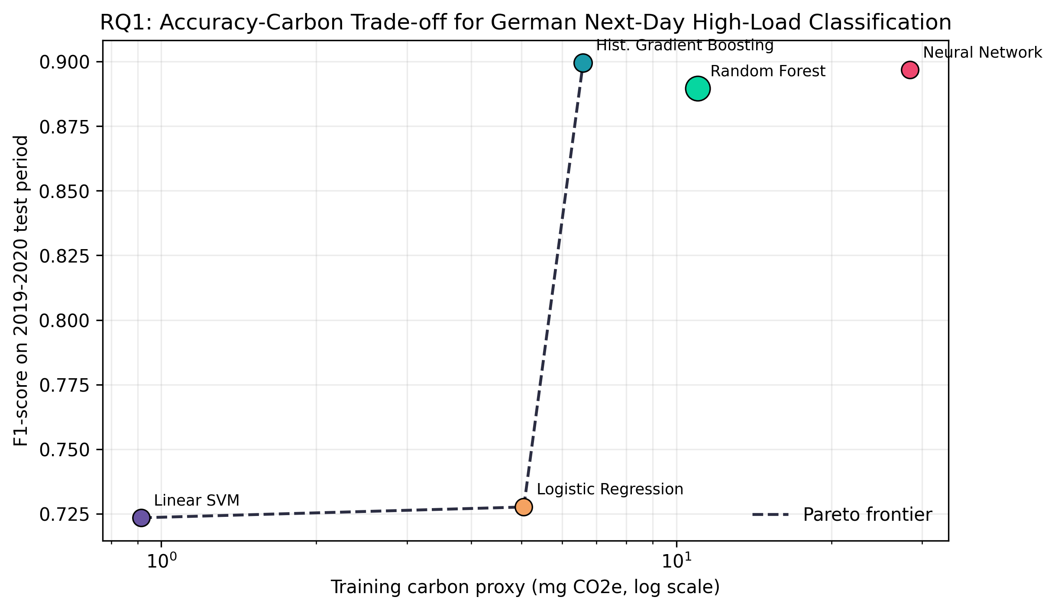
Fig. 2. Accuracy-carbon Pareto result used in the report and posters.
6. Carbon-Aware Accounting
The carbon estimate is a proxy. Training and prediction energy are estimated from measured runtime and assumed CPU power values. The carbon intensity proxy scales with residual load, meaning hours with lower wind/solar coverage receive higher proxy intensity. This is appropriate for comparative sensitivity analysis but should be replaced with measured hardware power and official emission factors in a deployment study.
The strongest model in this run is Histogram Gradient Boosting with F1 = 0.899; the lowest-compute model is Linear SVM with a carbon proxy of 0.914 mg CO2e. Green-window scheduling reduces the training-carbon proxy by 31.9% relative to random-hour scheduling.
7. Generated Assets
TABLE 5. Project asset map.
Asset type | Location
Raw data | data.csv
Processed data | preprocessed_content.csv
Notebooks | notebooks/rq1_carbon_aware_ml.ipynb through rq5_carbon_aware_ml.ipynb
Tables | outputs/tables/*.csv
Figures | outputs/figures/*.pdf and *.png
Workflow | outputs/figures/workflow_structured_ai_esg_style.pdf/png
Posters | posters/carbon_aware_ml_academic_posters_v2.pptx
Technical report | report/Carbon_Aware_ML_Germany_IEEEPES_Technical_Report.docx

8. Poster and Workflow Design
The revised poster deck follows the provided lecture screenshot more closely: a centered title, top corner icons, upper Motivation and Datasets panels, a full-height left methodology strip, and right-side sections for research questions, key results, findings, and conclusion. Three visual variants are included in one editable PowerPoint deck. The structured workflow diagram follows an academic 1-8 left-to-right flow with circular step markers, an AI framework box, and explicit outputs and recommendations.
9. IEEE/PES Report Verification
The technical report was generated from the provided IEEE PES Technical Report template rather than from a blank document. The final report keeps the expected front matter pattern (cover, acknowledgments, keywords, contents), numbered technical sections, centered table labels, centered figure captions, references, and a restrained Times-style technical-report layout. The report was rendered to page images and visually inspected for clipping, orphaned captions, table crowding, and broken figure placement. It also passed the document accessibility audit after adding figure alt text and repeated table-header metadata.
TABLE 6. Report-template compliance checklist.
Check | Evidence | Status
Template base | Built from PES-Technical-Report-Template_Jan_2019.docx | Pass
Front matter | Acknowledgments, keywords, contents | Pass
Technical sections | Introduction, dataset, methodology, results, governance, limitations, conclusions | Pass
Tables/figures | Centered labels/captions and placed near citations | Pass
References | Numbered technical-report style references | Pass
Visual QA | Rendered with artifact-tool and inspected | Pass
Accessibility | 0 high, 0 medium, 0 low findings | Pass

10. How to Regenerate
From the project root, run `python3 scripts/generate_analysis_assets.py` to rebuild the data, notebooks, tables, and core figures. Run `python3 scripts/generate_revised_poster_and_workflow.py` to regenerate the revised workflow and poster deck. Run the bundled Python command for `scripts/generate_report_docx.py` and `scripts/generate_project_documentation_docx.py` to rebuild the Word deliverables.

