--18.02.2022

---HIVE

--creating table movies

create table movies(movie_id int, movie_name varchar(30),year_of_release int,movie_rating float,duration_in_secs long) row format delimited fields terminated by ',';

describe movies;

--loading data into the movies table from local computer

load data local inpath '/home/nirupama/Desktop/Assessment/movies_dataset.txt' into table movies;

select *from movies;

PROBLEM STATEMENTS:-

A)

select count(movie_name) from movies where year_of_release between '1950' and '1960';

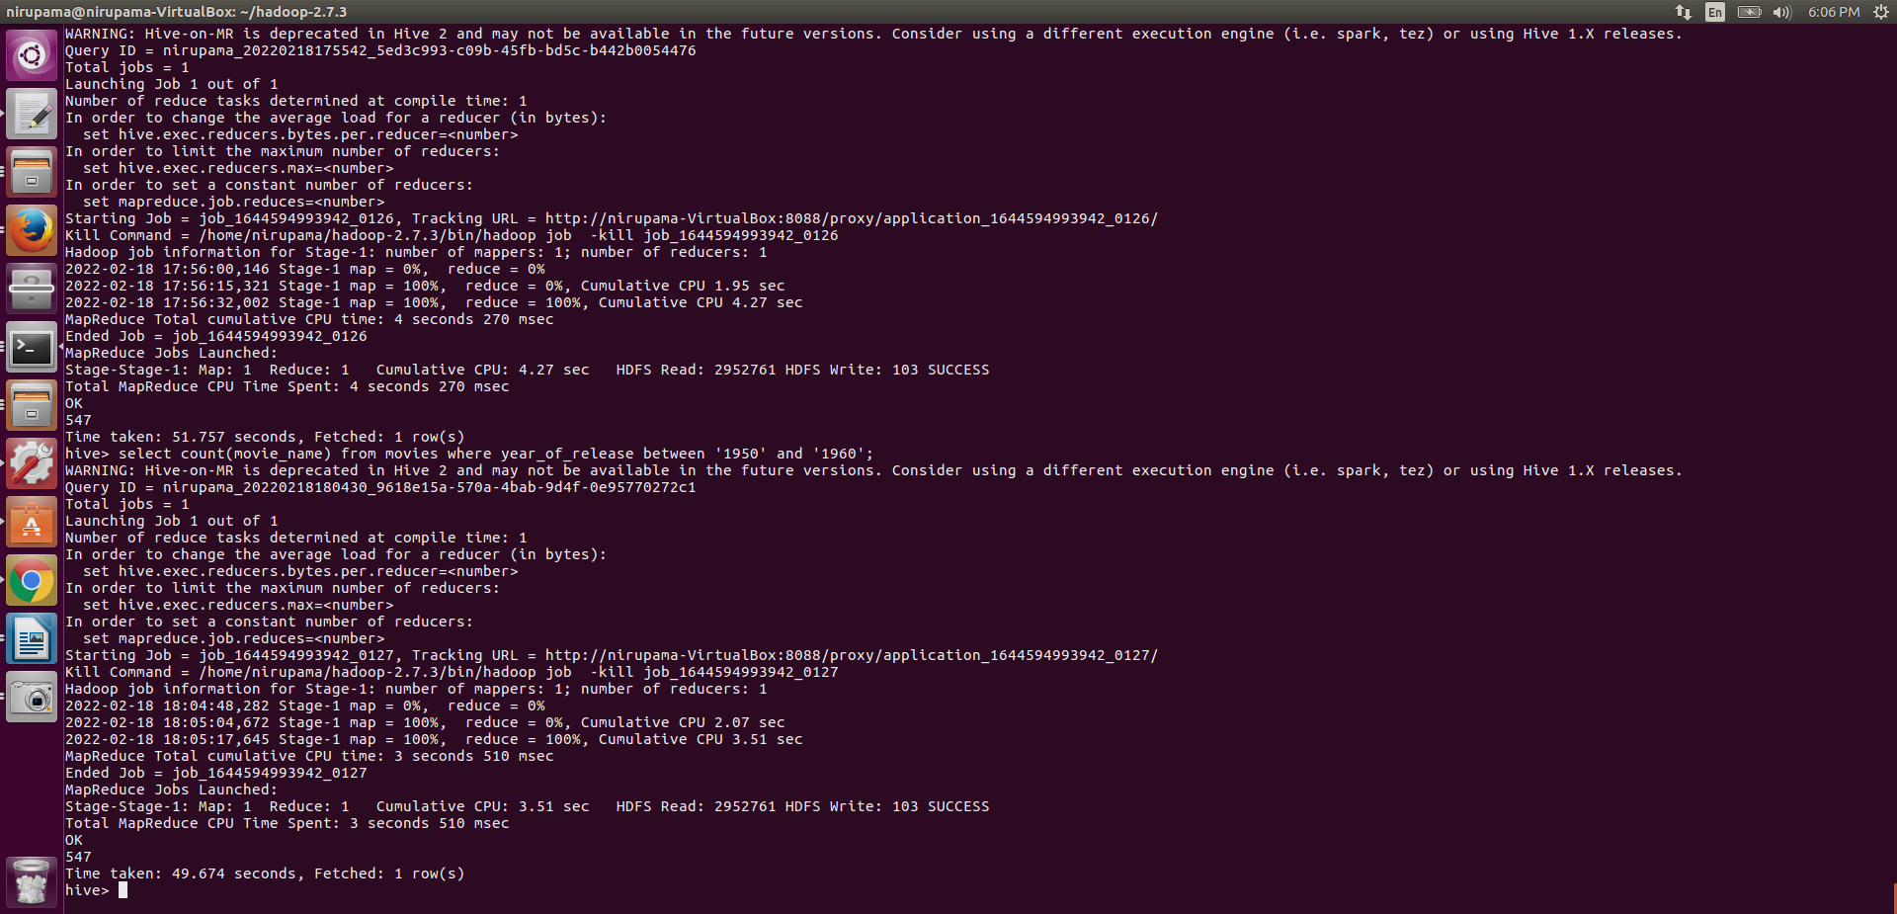

B)

select count(movie_name) from movies where movie_rating > 4.0;

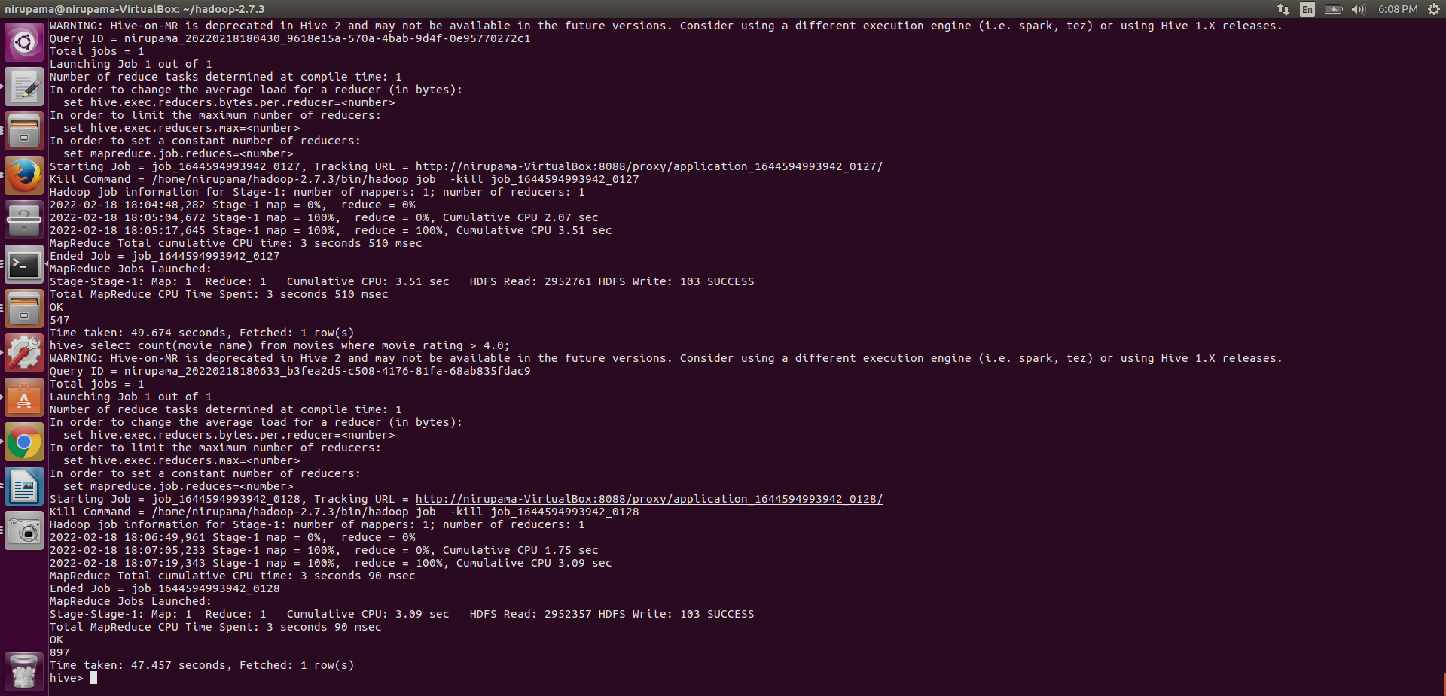

C)

select movie_id,movie_name from movies where movie_rating between 3.0 and 4.0;

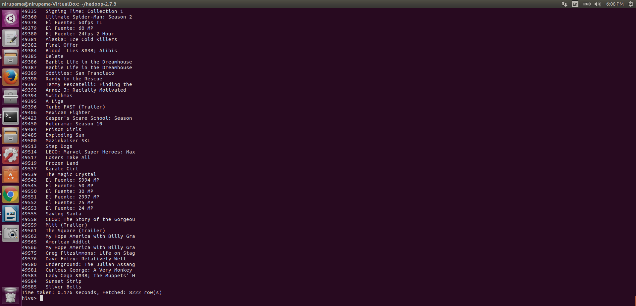

D)

select count(movie_name) from movies where duration_in_secs > 7200;

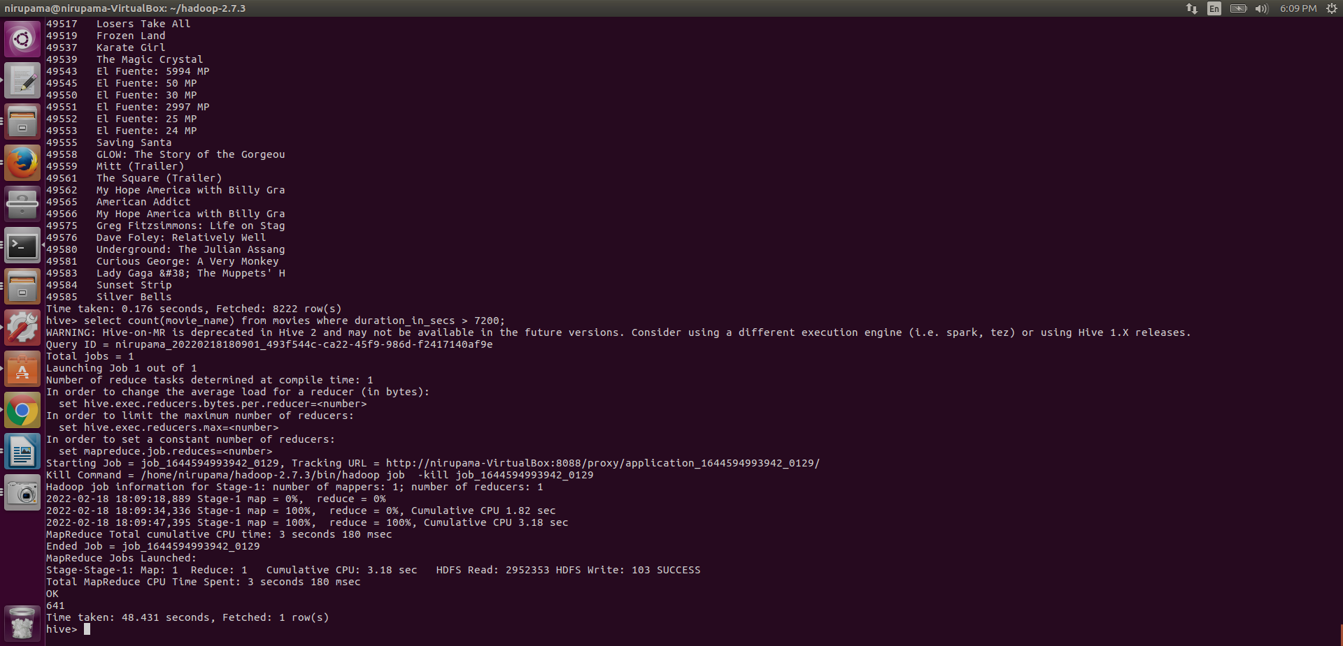

E)

select count(*), year_of_release from movies group by year_of_release;

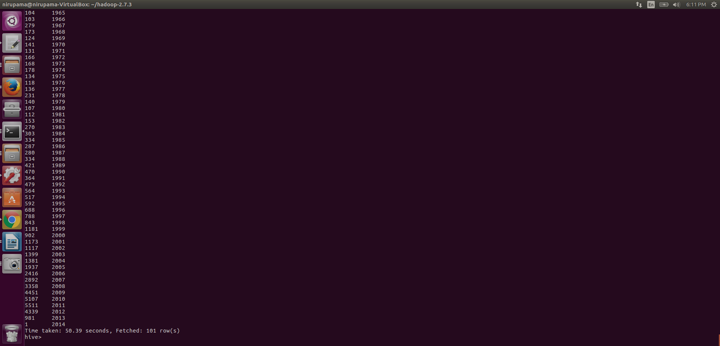

F)

select count(movie_id) from movies;

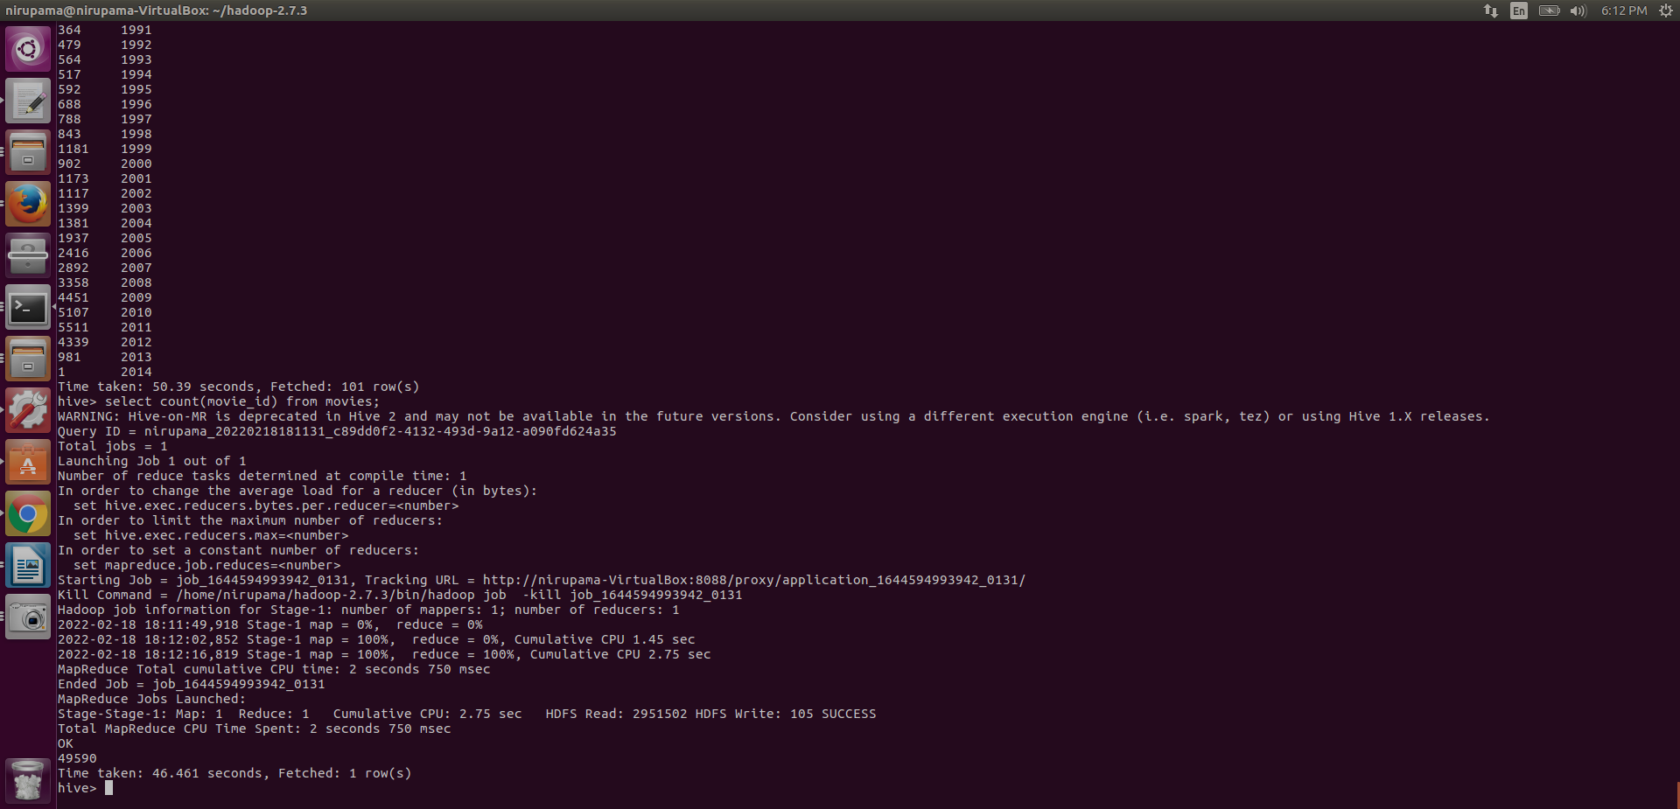

--18/02/2022

--creating assignment directory and inserting country.txt file into hdfs

bin/hdfs dfs -mkdir /assessment/w3

bin/hdfs dfs -put /home/nirupama/Desktop/Assessment/movies_dataset.txt /assessment/w3

--pig

--loading data from hdfs into movies variable

movies = load '/assessment/w3/movies_dataset.txt' using PigStorage(',') as (movie_id:int, movie_name:chararray,year_of_release:int,movie_rating:float,duration_in_secs:long);

describe movies; --to give the schema

illustrate movies; -- gives a random value present

--PROBLEM STATEMENT:-

A)

A1 = FILTER movies by year_of_release >= 1950;

A2 = FILTER A1 by year_of_release <= 1960;

A3 = GROUP A2 All;

count1 = FOREACH A3 GENERATE COUNT(A2);

DUMP count1;

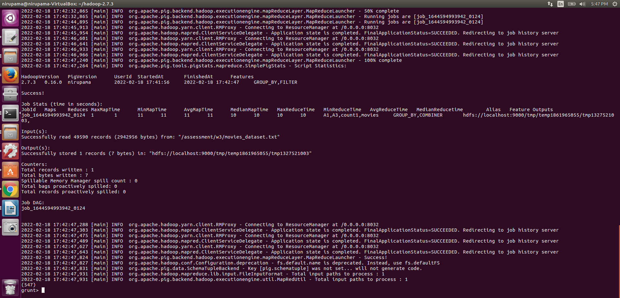

B)

B1 = FILTER movies by movie_rating > 4.0;

B2 = GROUP B1 All;

Count2 = FOREACH B2 GENERATE COUNT(B1);

DUMP count2;

C)

C1 = FILTER movies by movie_rating >= 3.0;

C2 = FILTER C1 by movie_rating <= 4.0;

Mov_list = FOREACH C2 GENERATE movie_name;

DUMP Mov_list;

D)

D1 = FILTER movies by duration_in_secs > 7200;

D2 = GROUP D1 All;

count3 = FOREACH D2 GENERATE COUNT(D1);

DUMP count3;

E)

E1 = FOREACH movies GENERATE year_of_release;

Yr_list = GROUP E1 by year_of_release ;

List = FOREACH Yr_list GENERATE group, count(E1) AS Num_Movies;

DUMP List;

F)

F1 = GROUP movies All;

count4 = FOREACH F1 GENERATE COUNT(movies);

DUMP count4;