Smart Agriculture System

Tinkercad Link:- https://www.tinkercad.com/things/hg5rS0qFnWG-smartagriculturesystem
The Smart Agriculture System is an Arduino-based automated solution designed to monitor and control essential environmental parameters for efficient farming. This system integrates multiple sensors to measure temperature, humidity, soil moisture, and detect intruders, ensuring optimal conditions for plant growth and safety. Based on real-time data, it automatically controls irrigation using a water pump and regulates airflow through servo-operated air vents. Additionally, an alert system using a buzzer enhances security. Developed and tested using Tinkercad, this project demonstrates a cost-effective and practical approach toward modern smart farming and greenhouse automation.

Working in the TinkerCAD:-
The project is designed and simulated using Tinkercad Circuits, an online platform for building and testing Arduino-based systems. All components such as sensors, LCD, and actuators are connected virtually, and the Arduino code is executed within the simulation environment. By clicking the “Start Simulation” button, the system begins to operate like a real hardware setup, displaying outputs on the LCD and Serial Monitor. Users can interact with the simulation by modifying sensor values in real time, allowing easy testing and analysis of the system’s behavior under different conditions.
- Simulation is run using the “Start Simulation” button
- Output is visible on LCD, Serial Monitor, and components
- Sensors can be adjusted using sliders/input boxes
- Changes are reflected instantly in real time
- No physical hardware is required for testing

Circuit Diagram:-
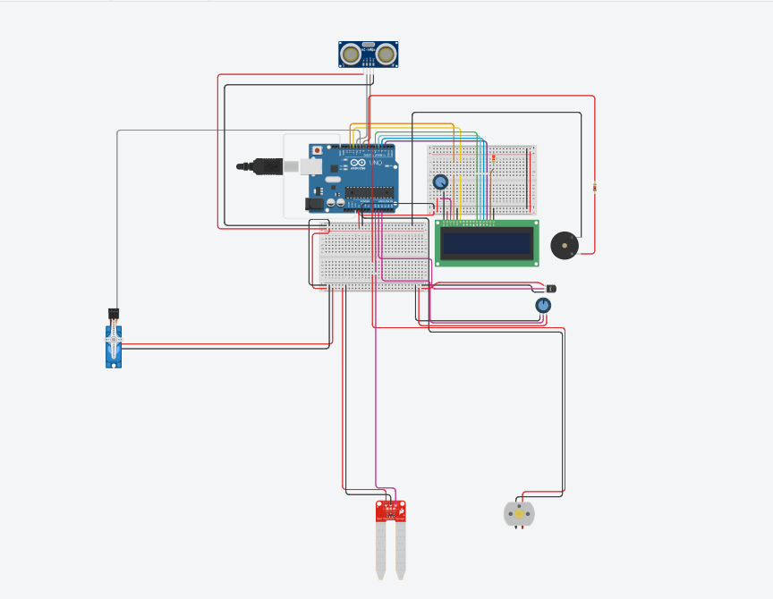

Schematic:-
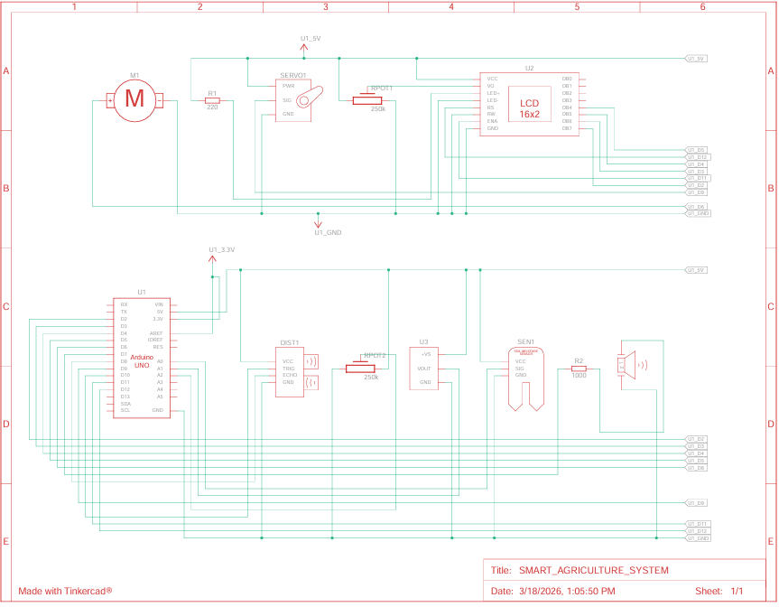

Code Explanation:-
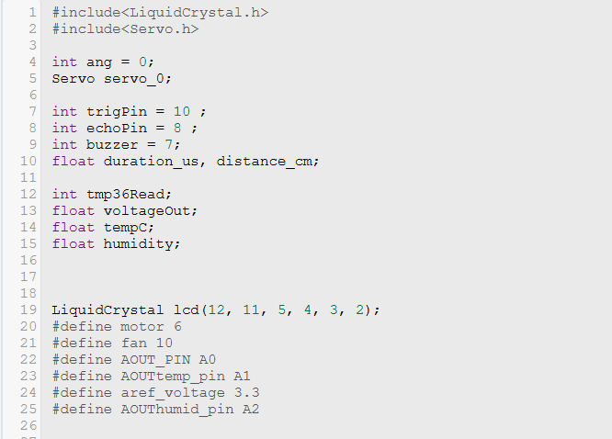
The code begins with #include <LiquidCrystal.h> which includes the library required to control the LCD display, and #include <Servo.h> which includes the library to control the servo motor.
The variable int ang = 0 is used to store the angle position for the servo motor. The object Servo servo_0 is created to control the servo motor.
The variable int trigPin = 10 defines pin 10 as the trigger pin for the ultrasonic sensor, and int echoPin = 8 defines pin 8 as the echo pin. The variables float duration_us and float distance_cm are used to store the time duration of the ultrasonic signal and the calculated distance respectively.
The variable int buzzer = 7 defines pin 7 as the buzzer output pin.
The variables int tmp36Read, float voltageOut, and float tempC are used for temperature sensing, where tmp36Read stores the analog value, voltageOut stores the converted voltage, and tempC stores the temperature in degrees Celsius. The variable float humidity is used to store the humidity value.
The object LiquidCrystal lcd(12, 11, 5, 4, 3, 2) initializes the LCD by connecting its control and data pins to Arduino pins 12, 11, 5, 4, 3, and 2.
The directive #define motor 6 assigns pin 6 for controlling the motor (water pump). The directive #define fan 10 assigns pin 10 for controlling the fan.
The directive #define AOUT_PIN A0 assigns analog pin A0 for the soil moisture sensor input. The directive #define AOUTtemp_pin A1 assigns analog pin A1 for the temperature sensor input. The directive #define aref_voltage 3.3 defines the external analog reference voltage as 3.3 volts. The directive #define AOUThumid_pin A2 assigns analog pin A2 for the humidity sensor input.

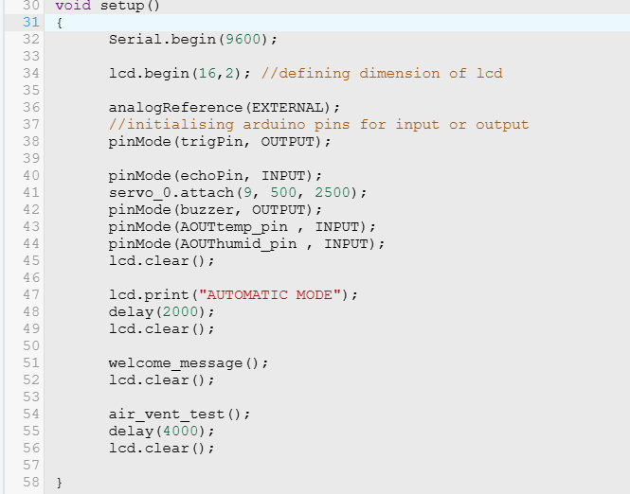
The setup() function is executed once when the system starts and is used to initialize all components. The command Serial.begin(9600) starts serial communication at a baud rate of 9600 for data monitoring. The command lcd.begin(16,2) initializes the LCD with 16 columns and 2 rows.
The command analogReference(EXTERNAL) sets the analog reference voltage to an external source. The command pinMode(trigPin, OUTPUT) sets the trigPin as an output to send signals to the ultrasonic sensor. The command pinMode(echoPin, INPUT) sets the echoPin as an input to receive signals from the ultrasonic sensor. The command servo_0.attach(9, 500, 2500) attaches the servo motor to pin 9 and defines the pulse width range. The command pinMode(buzzer, OUTPUT) sets the buzzer pin as output. The command pinMode(AOUTtemp_pin, INPUT) sets the temperature sensor pin as input. The command pinMode(AOUThumid_pin, INPUT) sets the humidity sensor pin as input.
The command lcd.clear() clears the LCD screen. The command lcd.print("AUTOMATIC MODE") displays the system mode message, and delay(2000) pauses execution for 2 seconds. The command lcd.clear() clears the display again.
The function welcome_message() is called to display the welcome message on the LCD, followed by lcd.clear() to clear the screen. The function air_vent_test() is called to test the servo-controlled air vents. The delay(4000) pauses execution for 4 seconds, and lcd.clear() clears the display before entering the main loop.

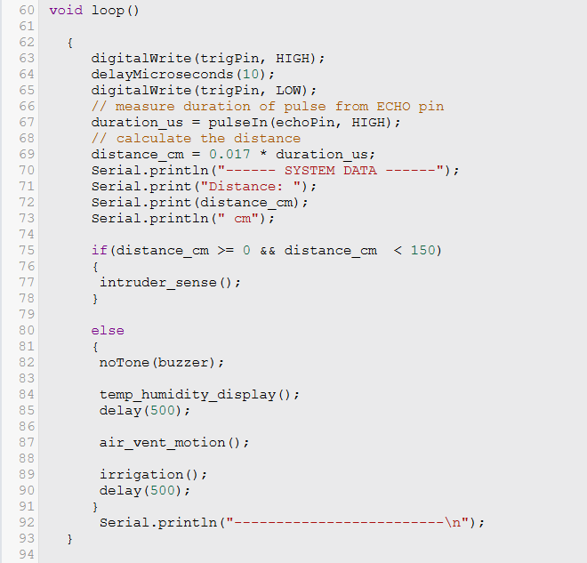
The loop() function runs continuously and controls the overall system operation. The command digitalWrite(trigPin, HIGH) sends a HIGH signal to the ultrasonic sensor to initiate a pulse, and delayMicroseconds(10) maintains this signal for 10 microseconds. Then digitalWrite(trigPin, LOW) stops the pulse. The function pulseIn(echoPin, HIGH) measures the time duration for which the echoPin remains HIGH, which represents the time taken by the ultrasonic wave to travel to an object and return. This time is stored in duration_us. The distance is then calculated using distance_cm = 0.017 * duration_us, where the constant converts time into distance in centimeters.
Serial.println("------ SYSTEM DATA ------") prints a heading on the Serial Monitor. Serial.print("Distance: ") displays the label, Serial.print(distance_cm) prints the measured distance value, and Serial.println(" cm") adds the unit and moves to the next line.
The if condition checks whether the distance_cm is between 0 and 150. If true, the function intruder_sense() is called to handle intrusion detection. If the condition is false, the else block executes. Inside it, noTone(buzzer) stops any sound from the buzzer. The function temp_humidity_display() is called to display temperature and humidity values. The delay(500) pauses execution for 500 milliseconds. The function air_vent_motion() controls the servo motor for air vent adjustment. The irrigation() function manages water flow or irrigation control. Another delay(500) is added for stability.
Finally, Serial.println("-------------------------\n") prints a separator line followed by a newline in the Serial Monitor to organize the output for each loop cycle.
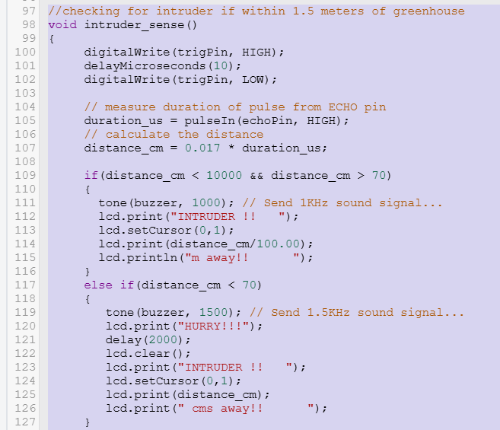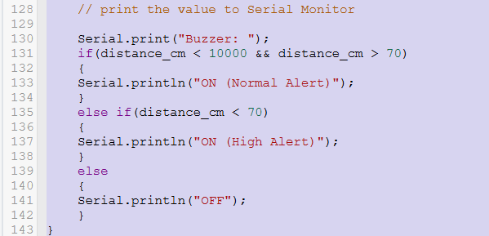
The function intruder_sense() is used to detect the presence of an object and activate alerts accordingly. The command digitalWrite(trigPin, HIGH) sends a HIGH signal to the ultrasonic sensor to start a pulse, and delayMicroseconds(10) maintains this signal for 10 microseconds. The command digitalWrite(trigPin, LOW) stops the pulse. The function pulseIn(echoPin, HIGH) measures the duration for which the echoPin remains HIGH, which represents the time taken by the ultrasonic wave to return after hitting an object. This duration is stored in duration_us. The distance is then calculated using distance_cm = 0.017 * duration_us.
The if condition checks whether the distance_cm is less than 10000 and greater than 70. If true, tone(buzzer, 1000) generates a 1 kHz sound signal on the buzzer. The command lcd.print("INTRUDER !! ") displays a warning message on the LCD. The command lcd.setCursor(0,1) moves the cursor to the second row of the LCD. The command lcd.print(distance_cm/100.00) prints the distance in meters, and lcd.println("m away!! ") displays the unit and moves to the next line.
The else if condition checks whether distance_cm is less than 70. If true, tone(buzzer, 1500) generates a 1.5 kHz sound signal. The command lcd.print("HURRY!!!") displays an urgent warning message. The delay(2000) pauses execution for 2 seconds. The command lcd.clear() clears the LCD display. The command lcd.print("INTRUDER !! ") again displays the warning message. The command lcd.setCursor(0,1) moves the cursor to the second row. The command lcd.print(distance_cm) prints the distance in centimeters, and lcd.print(" cms away!! ") displays the unit.
The command Serial.print("Buzzer: ") prints a label to the Serial Monitor. The next if condition checks if distance_cm is between 70 and 10000, and Serial.println("ON (Normal Alert)") prints the buzzer status as normal alert. The else if condition checks if distance_cm is less than 70, and Serial.println("ON (High Alert)") prints high alert status. The else condition executes when no object is detected in range, and Serial.println("OFF") prints that the buzzer is off.
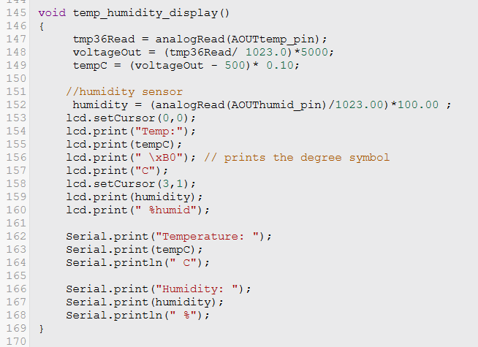
The function temp_humidity_display() is used to read temperature and humidity values and display them on the LCD and Serial Monitor. The command tmp36Read = analogRead(AOUTtemp_pin) reads the analog value from the temperature sensor connected to AOUTtemp_pin. The command voltageOut = (tmp36Read / 1023.0) * 5000 converts the analog reading into voltage in millivolts. The command tempC = (voltageOut - 500) * 0.10 converts the voltage into temperature in degrees Celsius.
The command humidity = (analogRead(AOUThumid_pin) / 1023.00) * 100.00 reads the analog value from the humidity sensor and converts it into percentage.
The command lcd.setCursor(0,0) sets the cursor to the first row and first column of the LCD. The command lcd.print("Temp:") displays the label. The command lcd.print(tempC) prints the temperature value. The command lcd.print(" \xB0") prints the degree symbol, and lcd.print("C") displays the unit. The command lcd.setCursor(3,1) moves the cursor to the second row. The command lcd.print(humidity) prints the humidity value, and lcd.print(" %humid") displays the unit.
The command Serial.print("Temperature: ") prints a label on the Serial Monitor. The command Serial.print(tempC) prints the temperature value, and Serial.println(" C") prints the unit and moves to the next line. The command Serial.print("Humidity: ") prints the humidity label, Serial.print(humidity) prints the humidity value, and Serial.println(" %") prints the unit and moves to the next line.
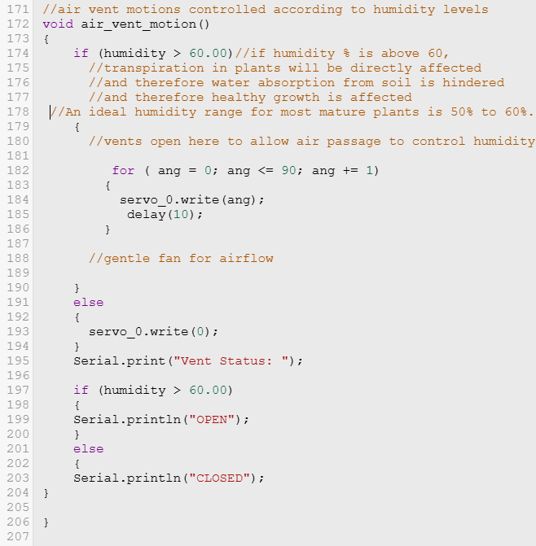
The function air_vent_motion() controls the movement of the air vent based on humidity levels. The if condition checks whether the humidity value is greater than 60.00. If this condition is true, a for loop is executed where ang is initialized to 0, the condition ang <= 90 is checked, and ang is incremented by 1 in each iteration. Inside the loop, servo_0.write(ang) sets the servo motor to the current angle value, and delay(10) pauses execution for 10 milliseconds to allow smooth movement of the servo from 0° to 90°.
If the humidity condition is false, the else block executes, and servo_0.write(0) sets the servo motor back to 0°, closing the air vent.
The command Serial.print("Vent Status: ") prints a label on the Serial Monitor. The next if condition checks again if humidity is greater than 60.00. If true, Serial.println("OPEN") prints that the vent is open. Otherwise, Serial.println("CLOSED") prints that the vent is closed.
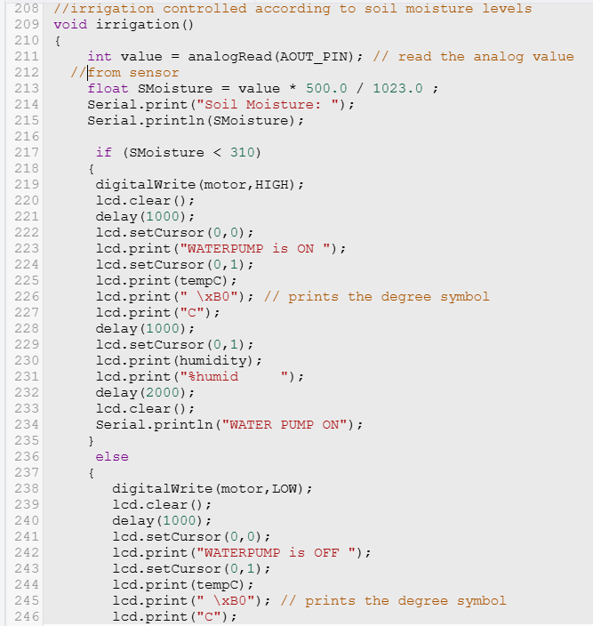
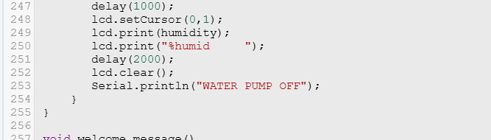
The function irrigation() controls the water pump based on soil moisture levels. The command int value = analogRead(AOUT_PIN) reads the analog value from the soil moisture sensor connected to AOUT_PIN. The command float SMoisture = value * 500.0 / 1023.0 converts the analog reading into a scaled moisture value. The command Serial.print("Soil Moisture: ") prints a label, and Serial.println(SMoisture) prints the moisture value on the Serial Monitor.
The if condition checks whether SMoisture is less than 310. If true, digitalWrite(motor, HIGH) turns ON the motor (water pump). The command lcd.clear() clears the LCD display, and delay(1000) pauses execution for 1 second. The command lcd.setCursor(0,0) sets the cursor to the first row, and lcd.print("WATERPUMP is ON ") displays the pump status. The command lcd.setCursor(0,1) moves the cursor to the second row. The command lcd.print(tempC) prints the temperature value, lcd.print(" \xB0") prints the degree symbol, and lcd.print("C") displays the unit. The delay(1000) pauses execution. The command lcd.setCursor(0,1) again sets the cursor to the second row. The command lcd.print(humidity) prints the humidity value, and lcd.print("%humid ") displays the unit. The delay(2000) pauses execution for 2 seconds. The command lcd.clear() clears the display, and Serial.println("WATER PUMP ON") prints the pump status on the Serial Monitor.
If the condition is false, the else block executes. The command digitalWrite(motor, LOW) turns OFF the motor. The command lcd.clear() clears the display, followed by delay(1000). The command lcd.setCursor(0,0) sets the cursor to the first row, and lcd.print("WATERPUMP is OFF ") displays the pump status. The command lcd.setCursor(0,1) moves the cursor to the second row. The command lcd.print(tempC), lcd.print(" \xB0"), and lcd.print("C") display the temperature value with unit. The delay(1000) pauses execution. The command lcd.setCursor(0,1) sets the cursor again to the second row. The command lcd.print(humidity) prints the humidity value, and lcd.print("%humid ") displays the unit. The delay(2000) pauses execution. The command lcd.clear() clears the display, and Serial.println("WATER PUMP OFF") prints the pump status on the Serial Monitor.
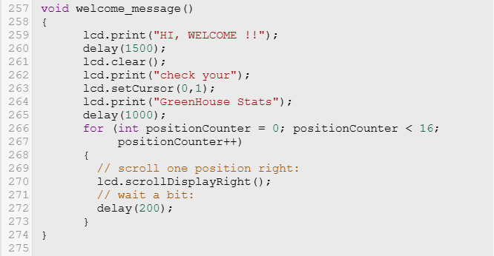
The function welcome_message() is used to display an introductory message on the LCD. The command lcd.print("HI, WELCOME !!") prints a greeting message on the display. The delay(1500) pauses execution for 1.5 seconds. The command lcd.clear() clears the LCD screen. The command lcd.print("check your") displays the text on the first row. The command lcd.setCursor(0,1) moves the cursor to the second row and first column. The command lcd.print("GreenHouse Stats") prints the message on the second row. The delay(1000) pauses execution for 1 second.
The for loop initializes positionCounter to 0, checks the condition positionCounter < 16, and increments positionCounter by 1 in each iteration. Inside the loop, lcd.scrollDisplayRight() shifts the entire display one position to the right, and delay(200) pauses execution for 200 milliseconds to create a scrolling effect on the LCD.
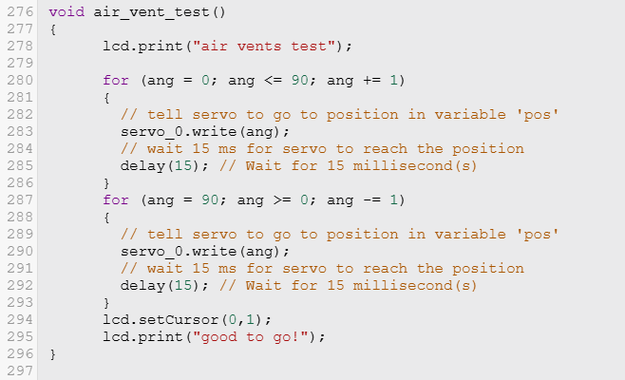
The function air_vent_test() is used to test the movement of the air vent controlled by the servo motor. The command lcd.print("air vents test") displays a message on the LCD indicating that the test is in progress.
The first for loop initializes ang to 0, checks the condition ang <= 90, and increments ang by 1 in each iteration. Inside the loop, servo_0.write(ang) sets the servo motor to the angle stored in ang, and delay(15) pauses execution for 15 milliseconds to allow the servo to reach the position smoothly.
The second for loop initializes ang to 90, checks the condition ang >= 0, and decrements ang by 1 in each iteration. Inside the loop, servo_0.write(ang) moves the servo back from 90° to 0°, and delay(15) provides a delay for smooth reverse motion.
The command lcd.setCursor(0,1) moves the cursor to the second row and first column of the LCD. The command lcd.print("good to go!") displays a message indicating that the air vent system is functioning properly.

Serial Monitor Display:-
