
Guidance Document for Applicants
INSTRUCTIONS FOR FILLING APPICATION FORM
Table of Contents
- User Registration
- Register to Multifactor Authentication (MFA)
- Login as Existing User
- Application Form Filling Workflow
- Reset Passcode

1: User Registration

1.1 New User Creation
- Action: Applicant fills in registration details.
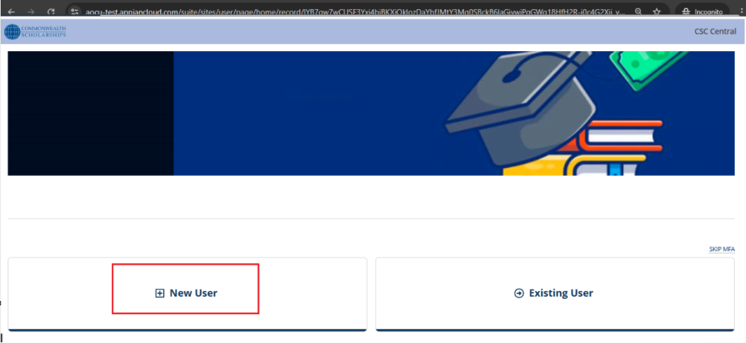
- Trigger: Clicks Submit.
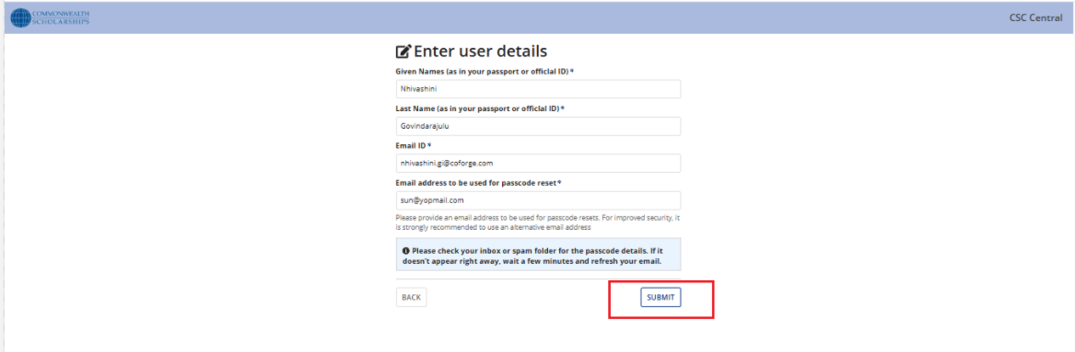
- System Response: Sends an email with a passcode to the applicant.
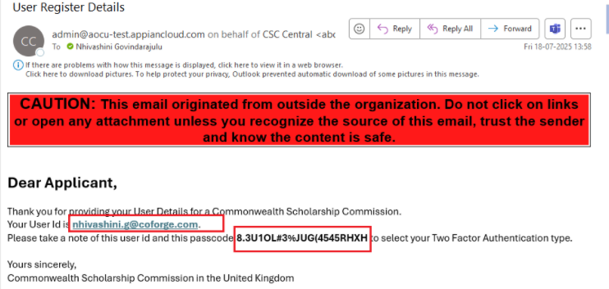

2: Register to MultiFactor Autentication(MFA)

2.1 Login Process
- Action: click on ‘Register ‘MultiFactor Autentication’ button
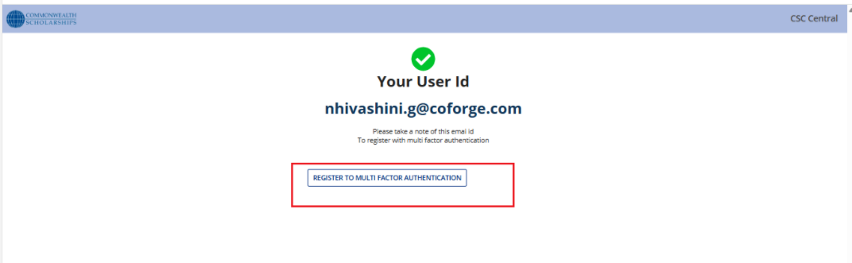
- Input: Registered email ID and passcode.
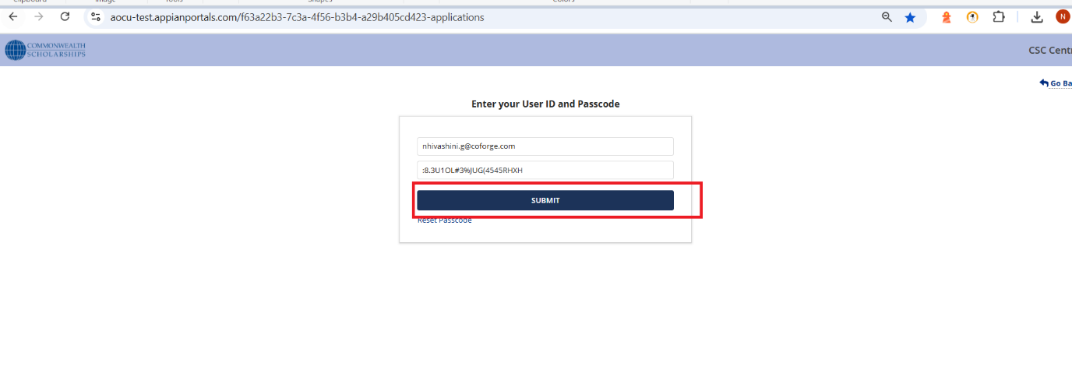
- Next Step: Proceeds to Multifactor Authentication (MFA).
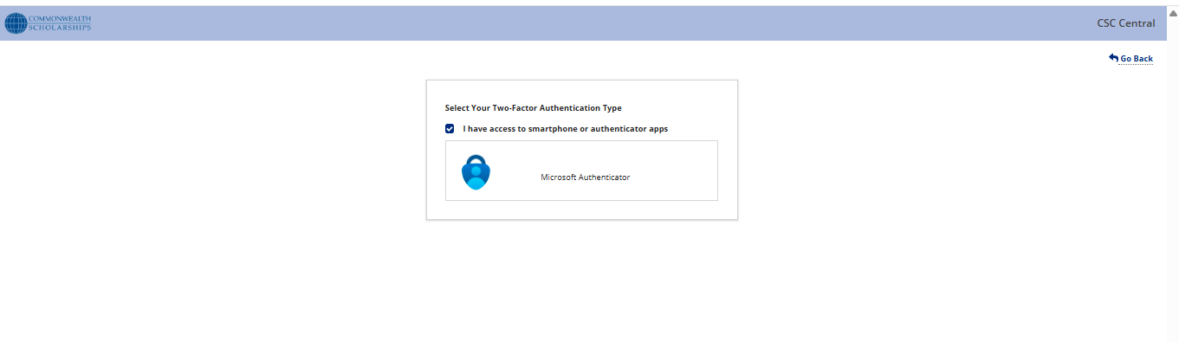

2.2. Multifactor Authentication (MFA)

2.1.1. Type: Email
- Deselect the checkbox.
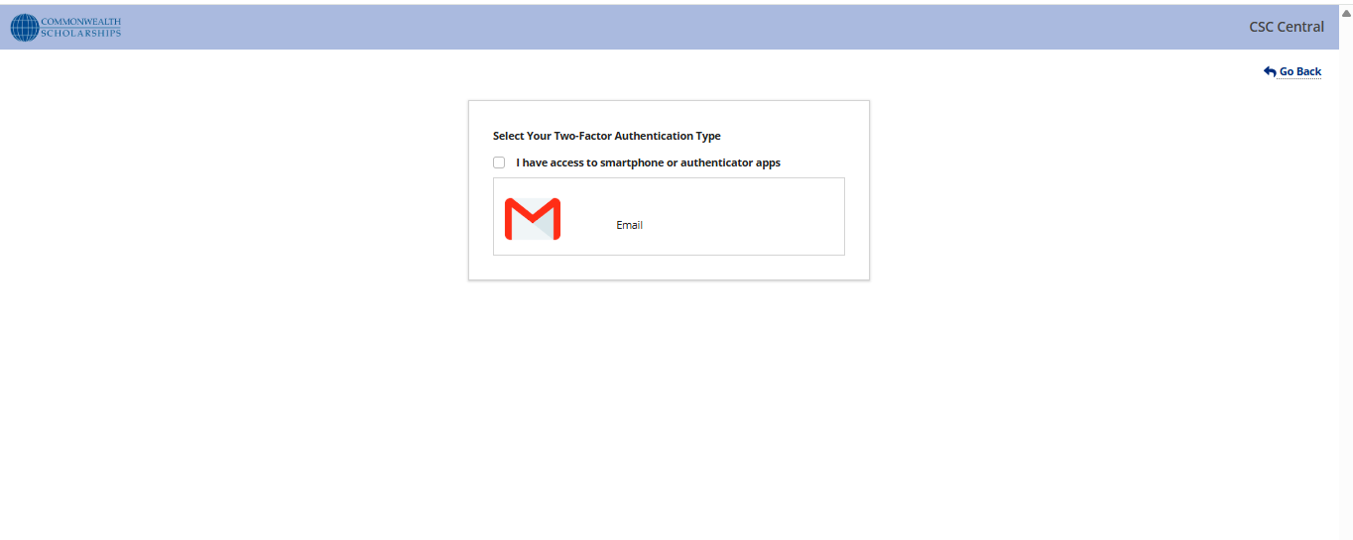
- Click on ‘Email’ button
- Click on ‘Generate OTP’ button
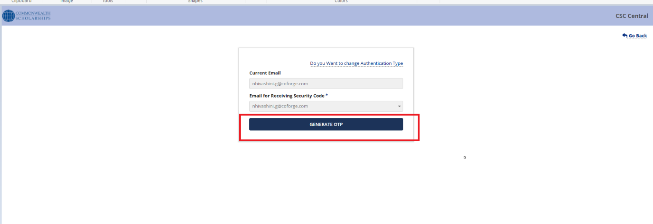
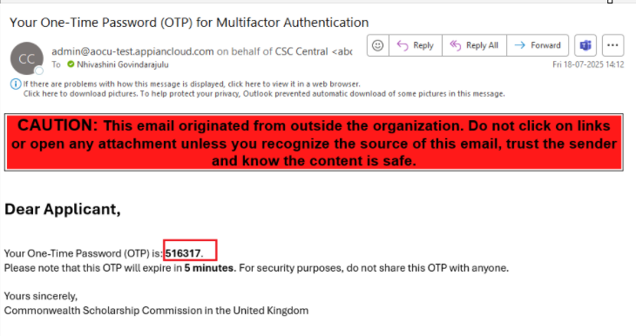
- Click Verify OTP.
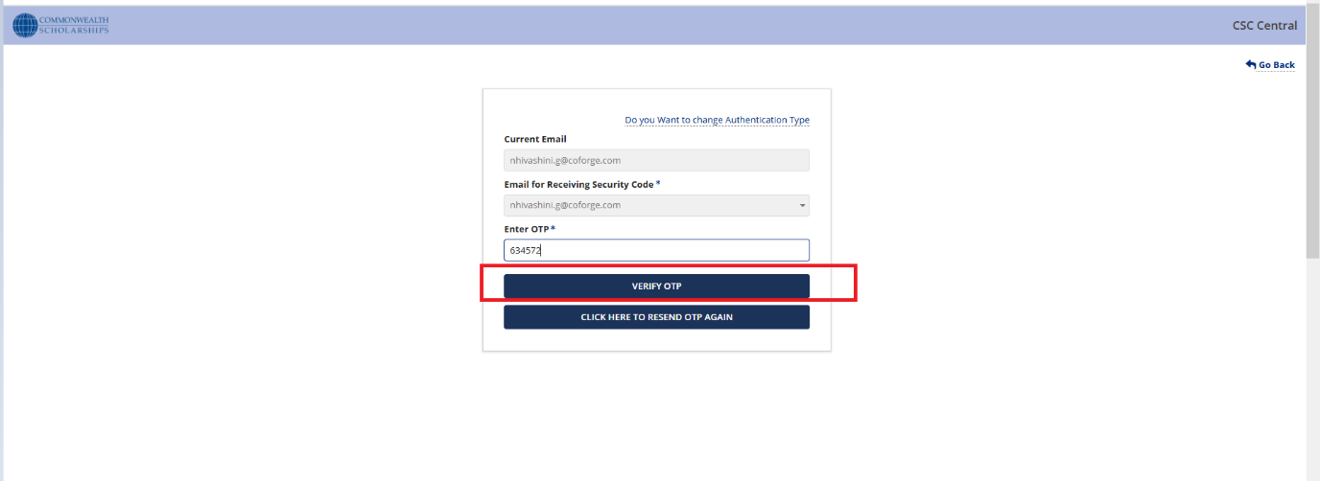
- Click REGISTER.
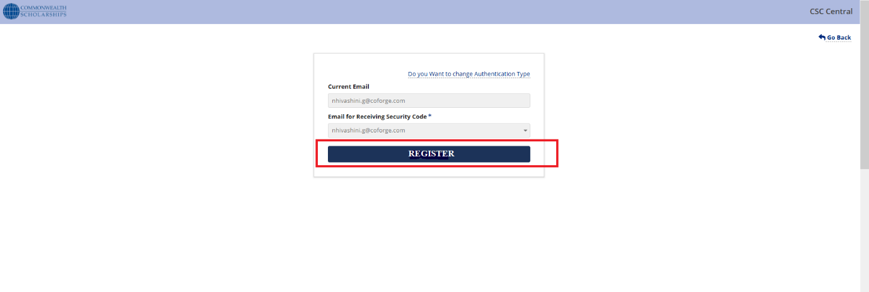
- System Response: Display "Registration Completed" confirmation message.
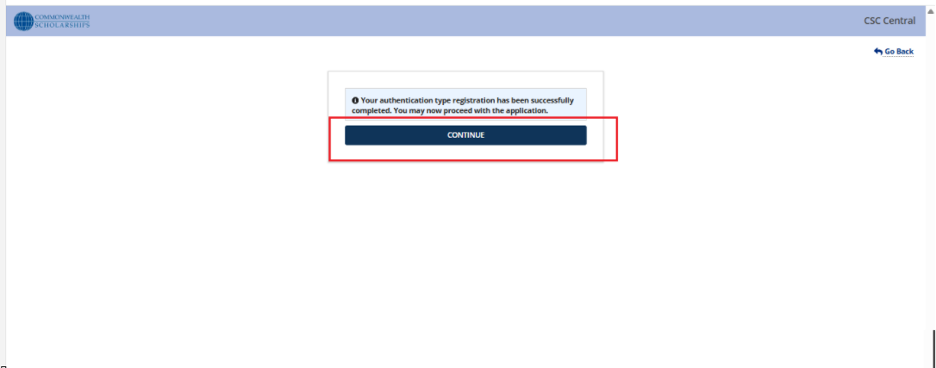
2.1.2. Type: Authenticator App
- Select Microsoft Authenticator option.
- Scan QR code using an authenticator app.
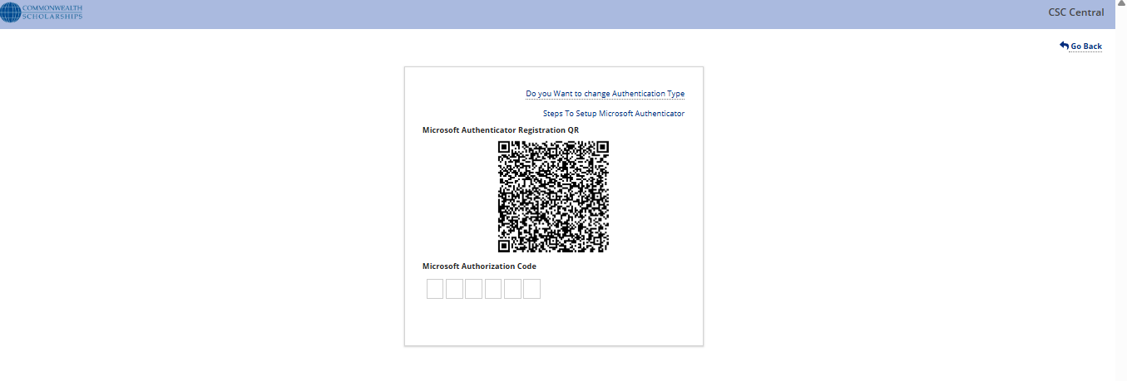
- Enter the code from the app.
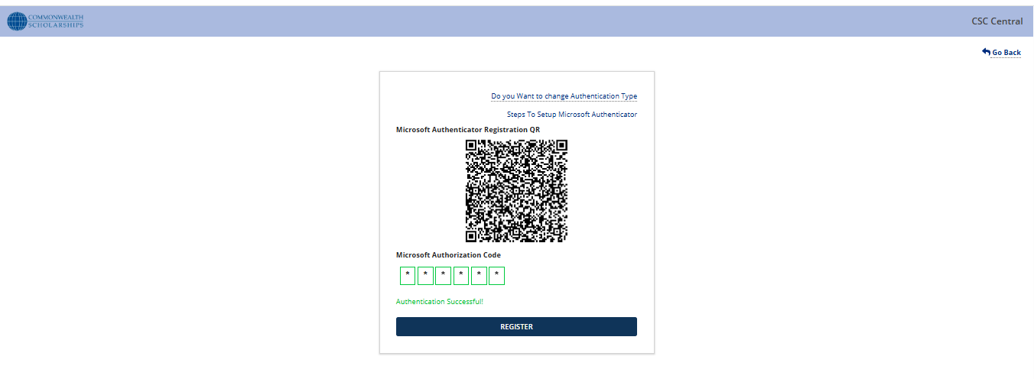
- Click Register.
- System Response: Display "Registration Completed" confirmation message.
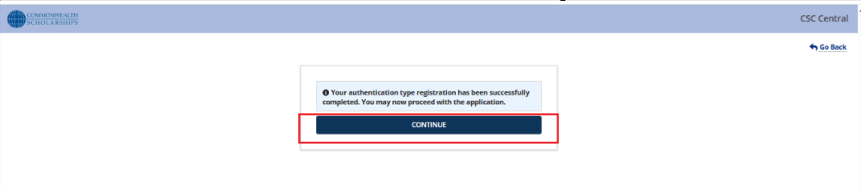3. Login as Existing User

3.1 Login Process
1. Action: Applicant selects Existing User.
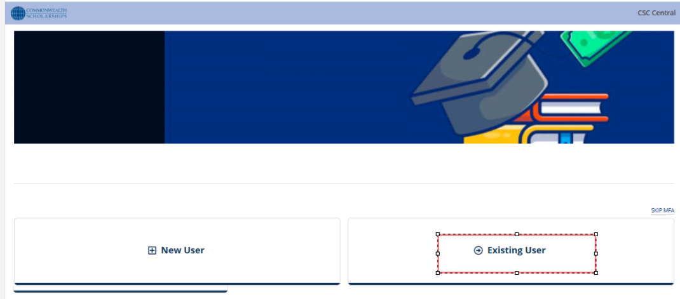
2. Input: Registered email ID and passcode.

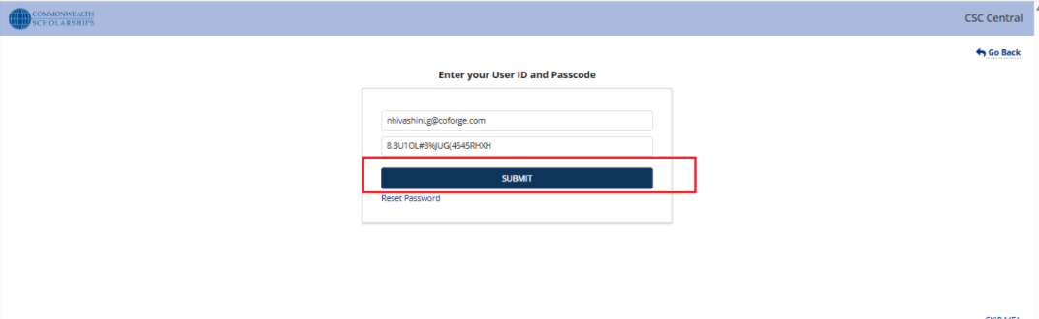
3. Next Step: Proceeds to Multifactor Authentication (MFA).

3.1.1 Once registered using the Authenticator App, the OTP Verification screen is displayed. Enter the code from your linked device to complete authentication.
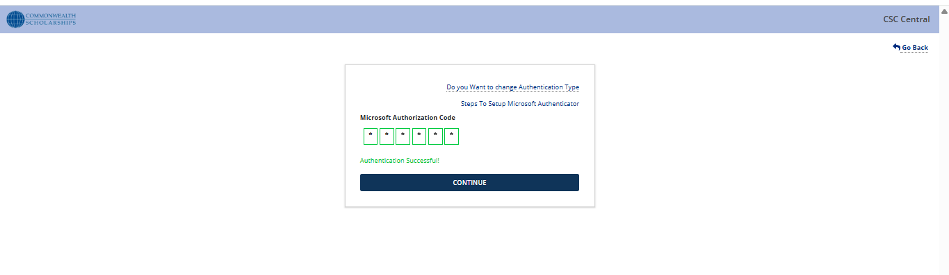3.1.2 Registered with an email, the Email Verification screen is displayed. Enter the new code and click 'Verify OTP' -> ’Continue’ button to login to Landing page of portal

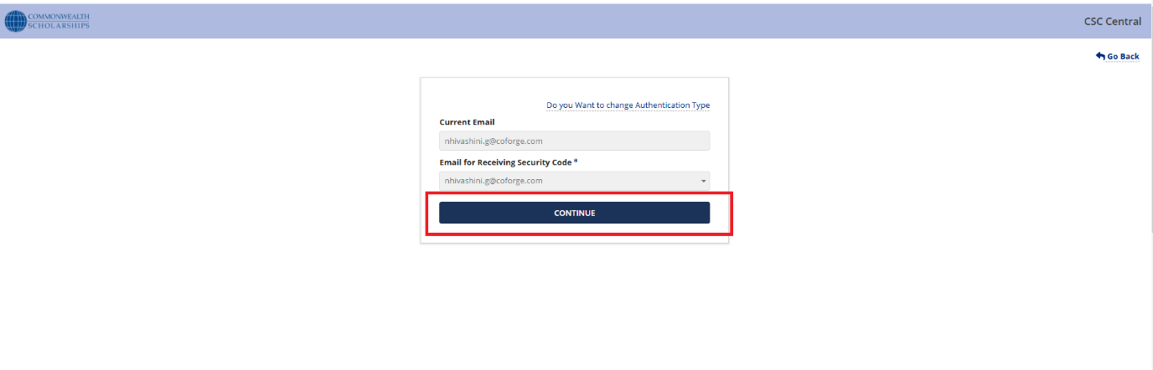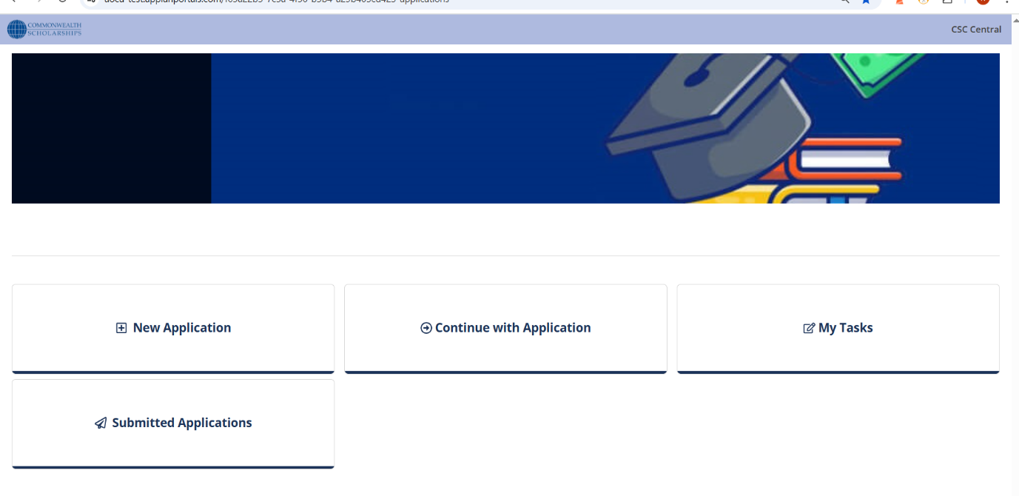

4. Application Form Filling Workflow

4.1 New Application
4.1.1. Start Application
- Applicant initiates a new application process.
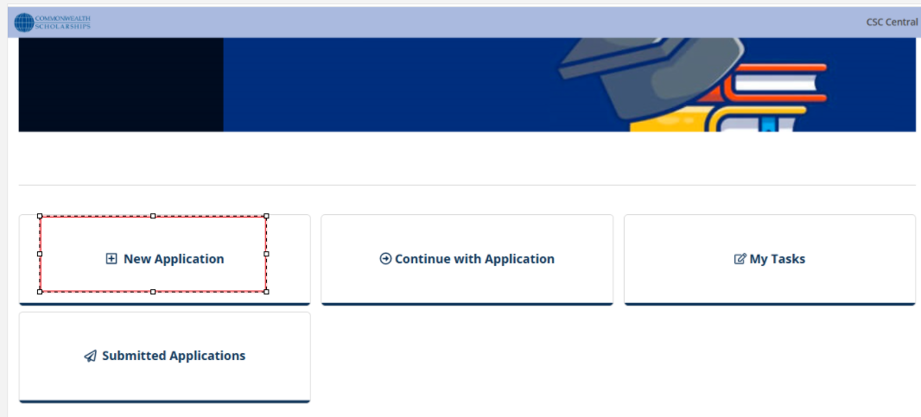4.1.2. Enter Access Details
- Applicant Fills required identification details.
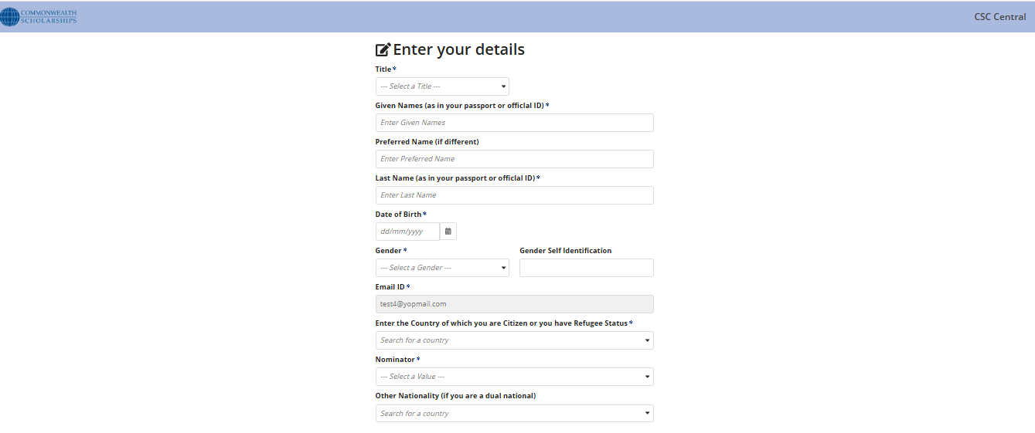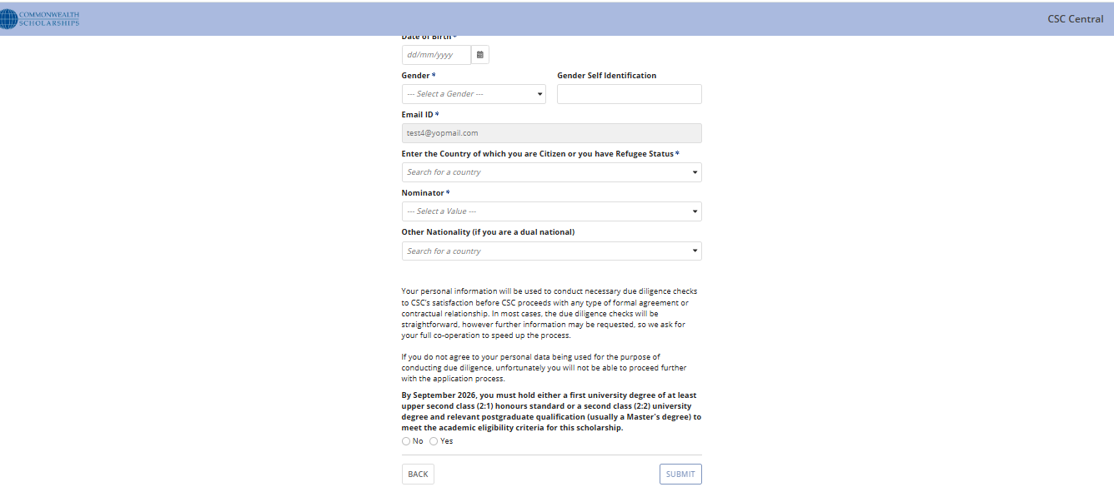

4.1.3. Reference Number Generation
- As an applicant ‘Submits’ Access details, System generates a unique reference number for the application.
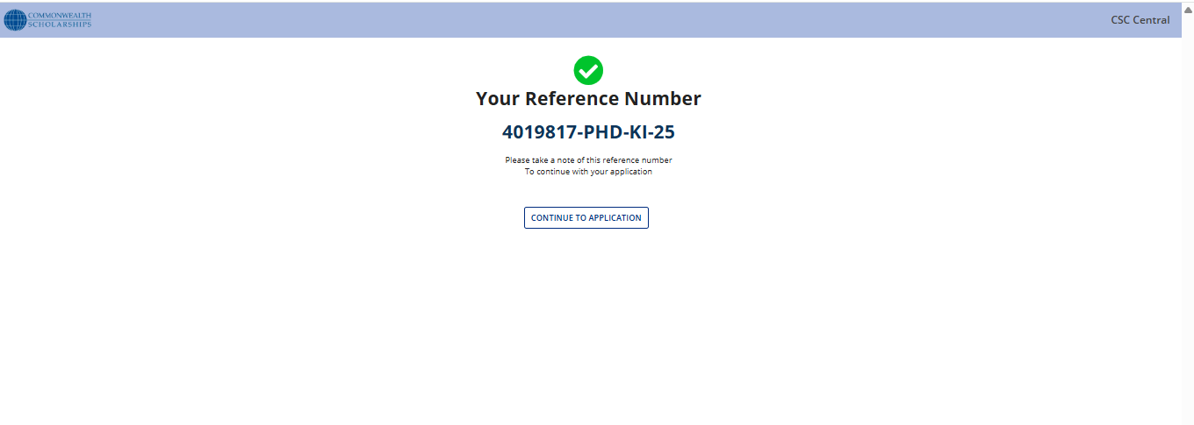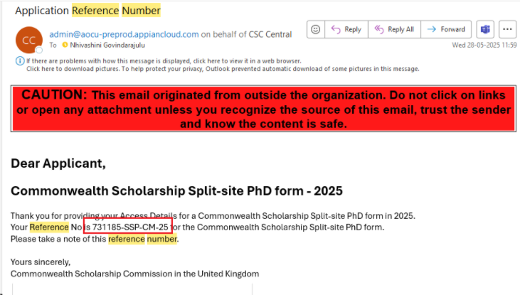

4.1.4. Fill Application Form
- As an applicant when clicking on ‘Continue To Application’, Applicant completes all required fields in the application form.
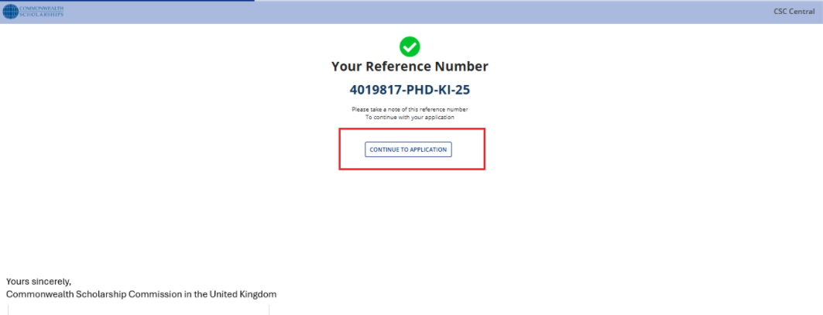
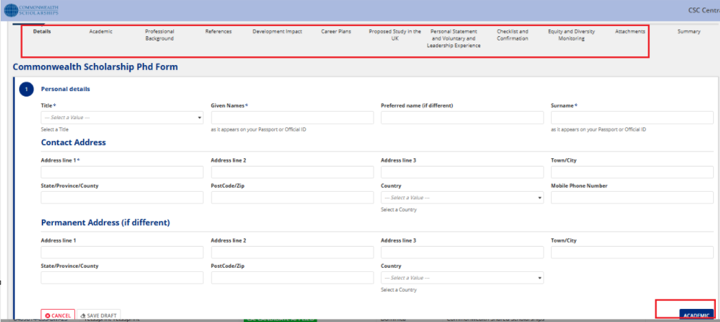

4.1.5. Preview Summary
- As an Applicant reviews a summary of the entered information for accuracy.
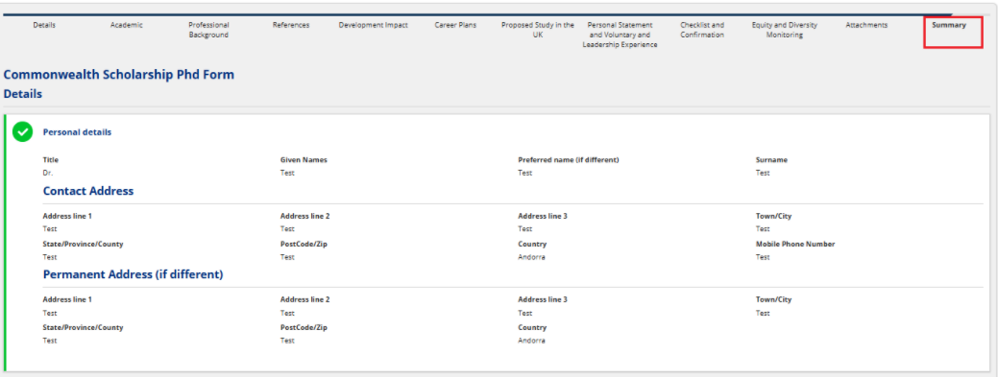

4.1.6. Submit to CSC Team
- As an Applicant’s clicking on ‘Submit’ button, finalized application is submitted to the CSC Team for processing.

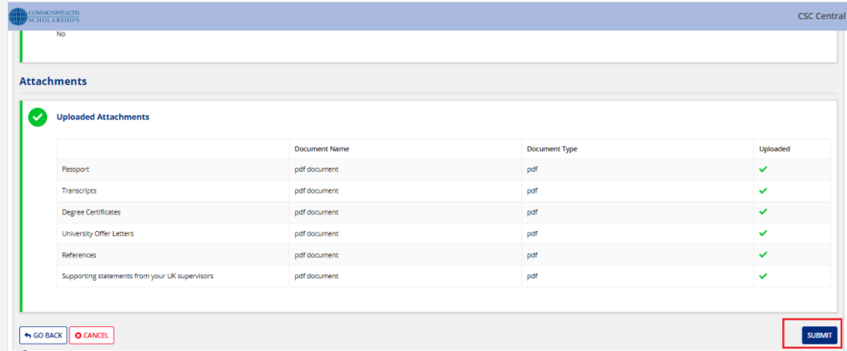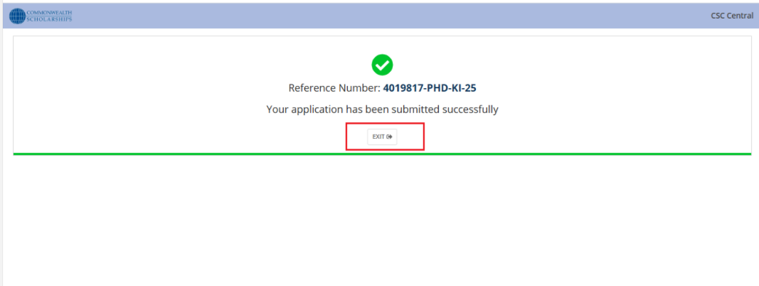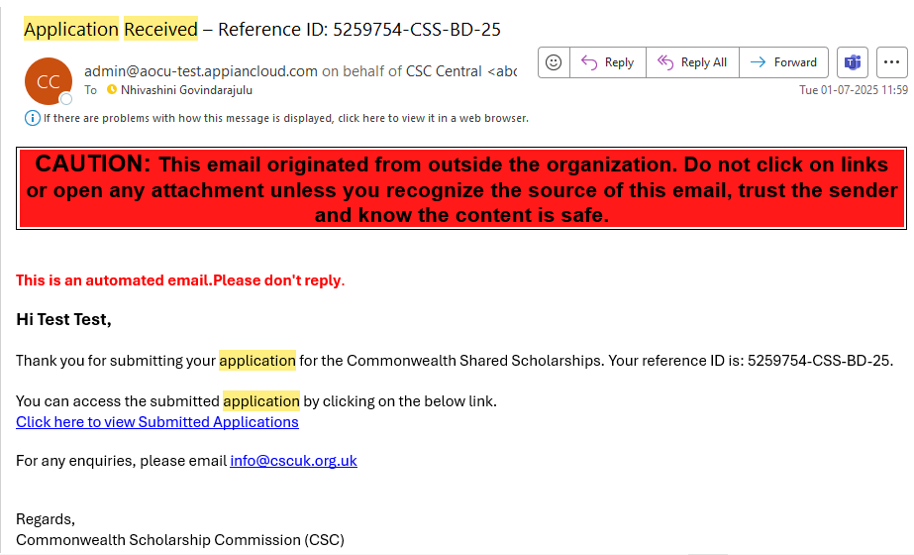

4.2 Continue with Application
- As an applicant, clicking on ‘Save Draft’, Applicant resumes a previously saved application.

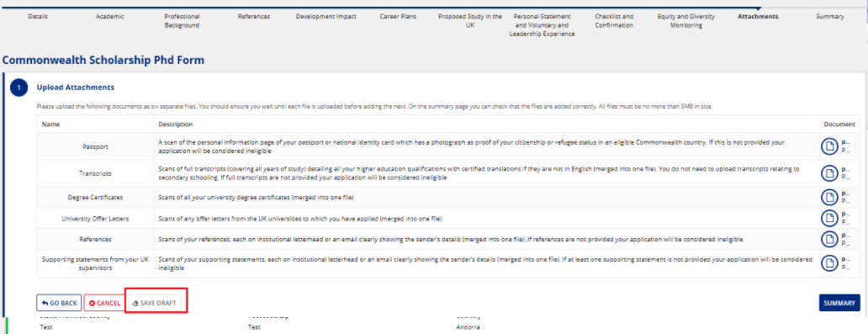
As an applicant, clicking on ’Go To Home Page’, Landing page is displayed
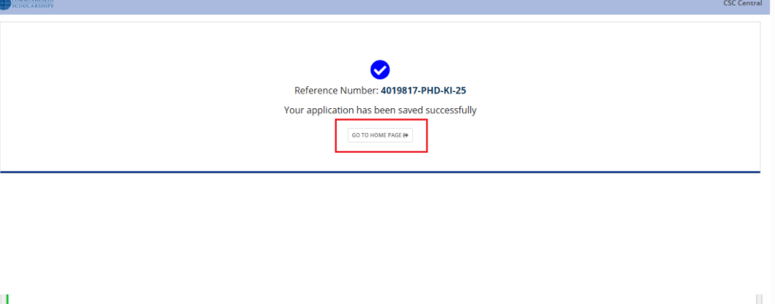As an applicant, clicking on ’Continue with Application’ card, Search by Reference Number/Search by Email ID screen is displayed.
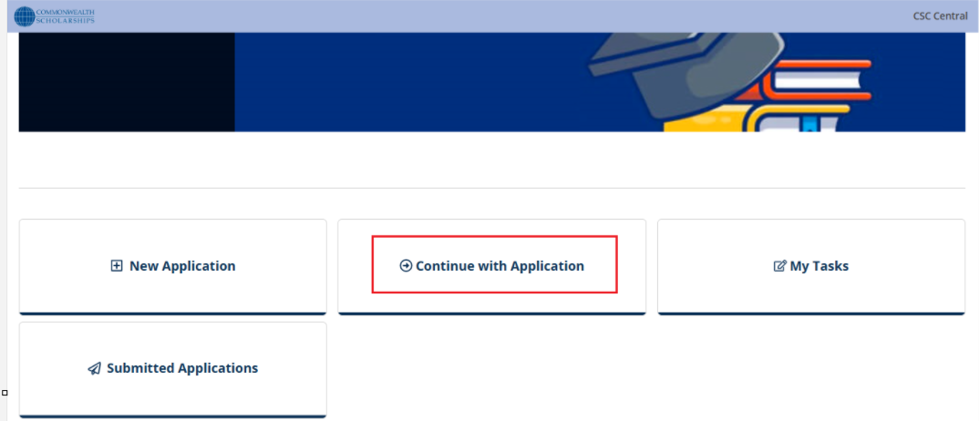
As an applicant, clicking on ‘Continue with Reference Number’, Enter your Reference number screen is displayed.
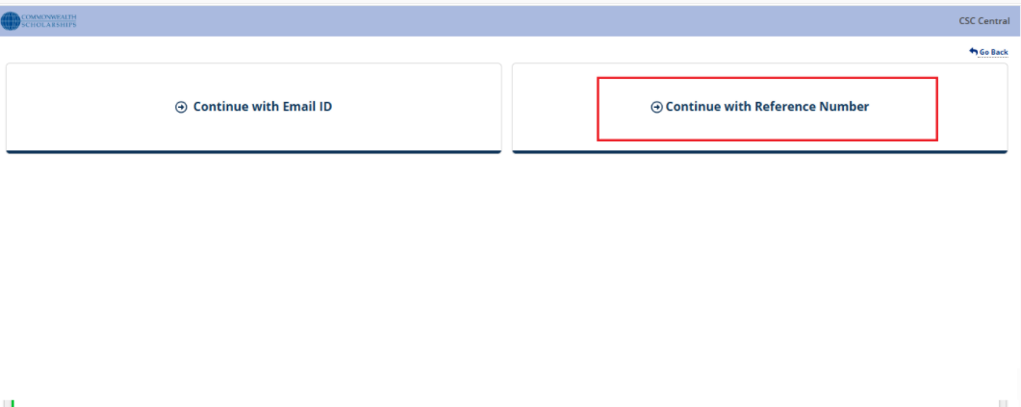
As an Applicant Enter the Reference Number
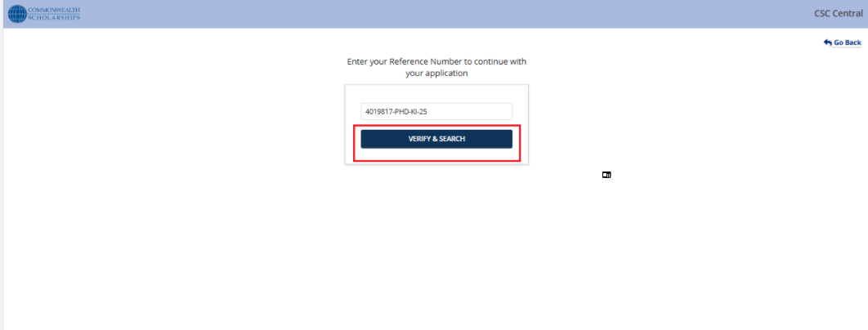As an applicant, clicking on ’Verify & Search’ applicant can resume the application
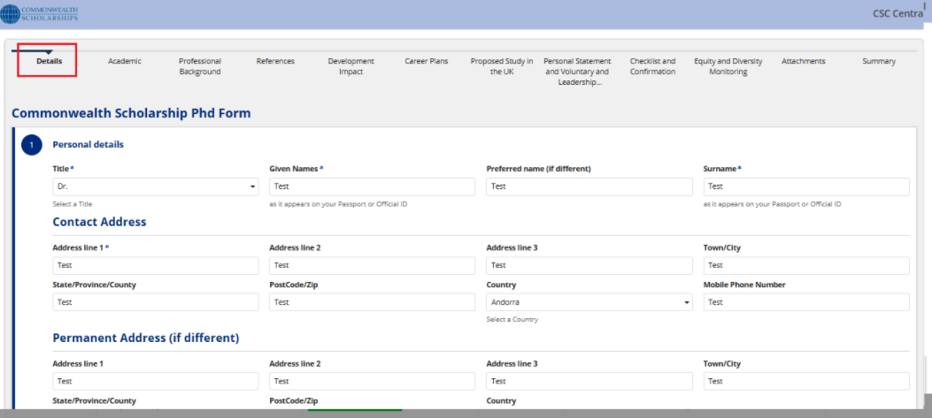
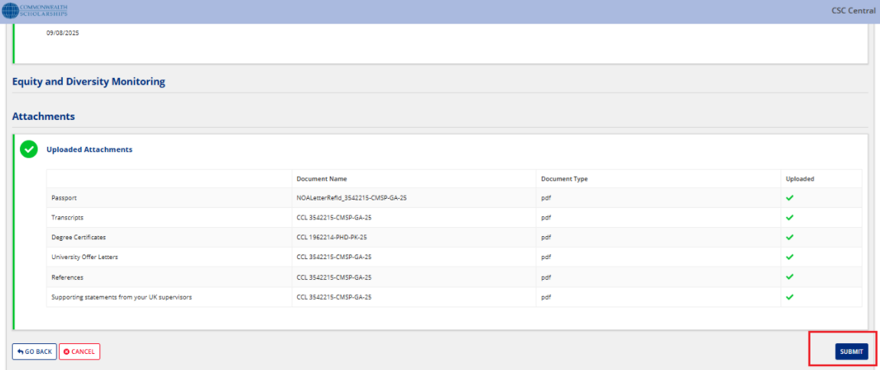

4.3 Submitted Application
- As an applicant, clicking on 'Submitted Applications’ in Landing page
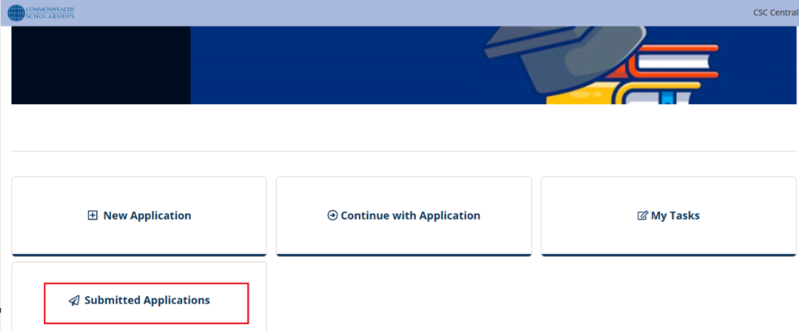As an Applicant Enter the Reference Number
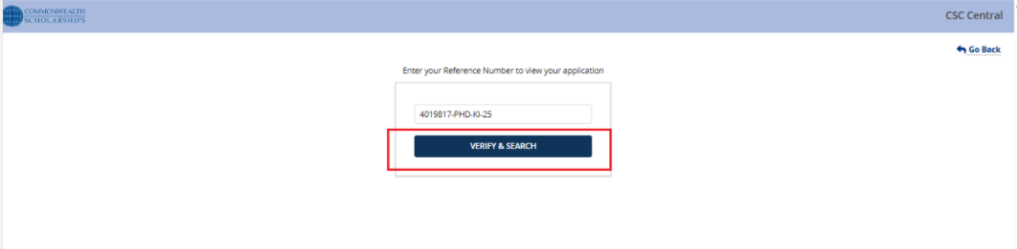
As an Applicant clicking on ‘Verify and Search’, Applicant views a submitted application.
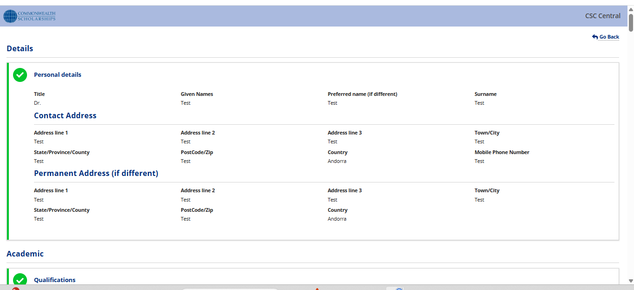
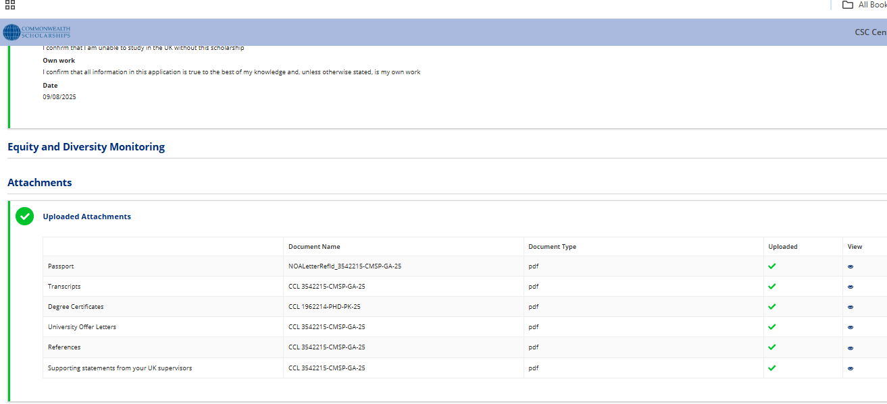

4.4 My Tasks
- Click on ‘My Task’ Card
The applicant accesses the portal and selects the "My Task" section to view pending actions.
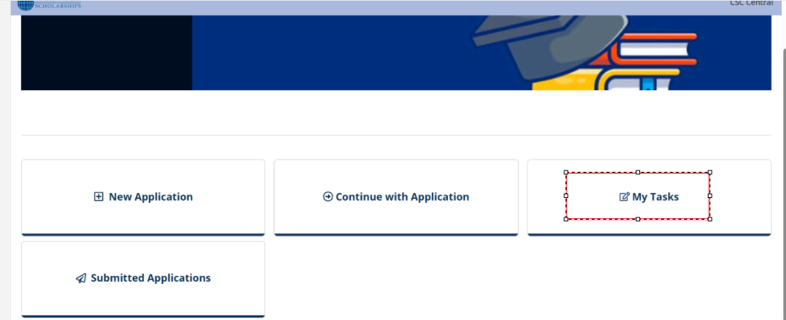
- Enter Email and Reference Number
A form appears prompting the applicant to input:
  - Email ID (used for identification)
  - Reference Number (unique to their application)
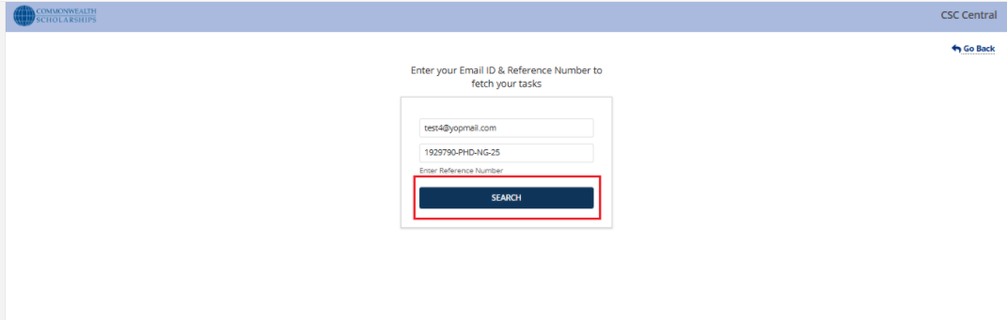
- Click ‘Search’
After entering the details, the applicant clicks the "Search" button.
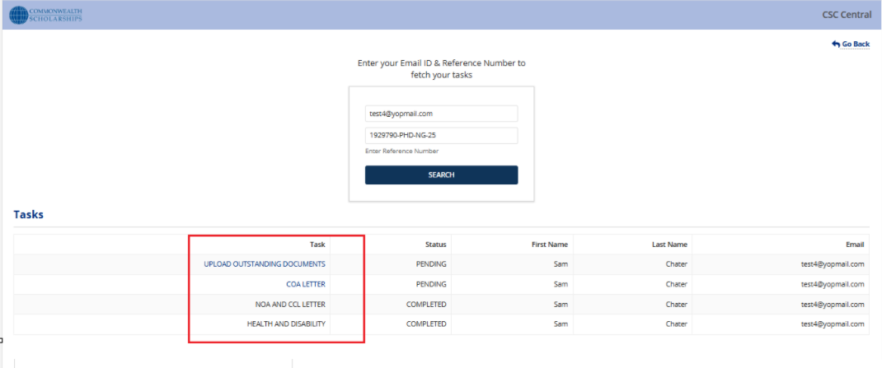
- View and Complete Pending Task
The system retrieves any pending tasks associated with the provided credentials.
The applicant can then:
  - View the task details
  - Upload documents/ fill forms, or complete assessments
  - Submit the task to proceed in the Selection Process

Note:
Below is the email sent to scholars, prompting them to complete their pending tasks as part of the selection process
Provisional Email to Scholar
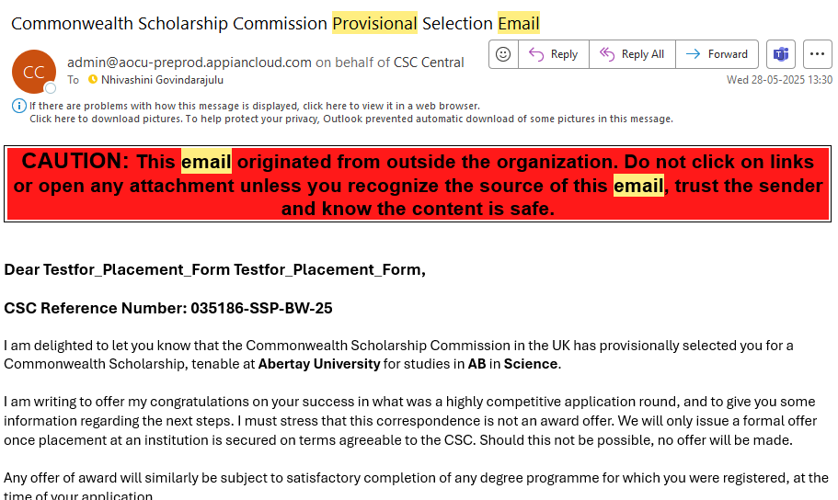
Notification of Award to Scholar
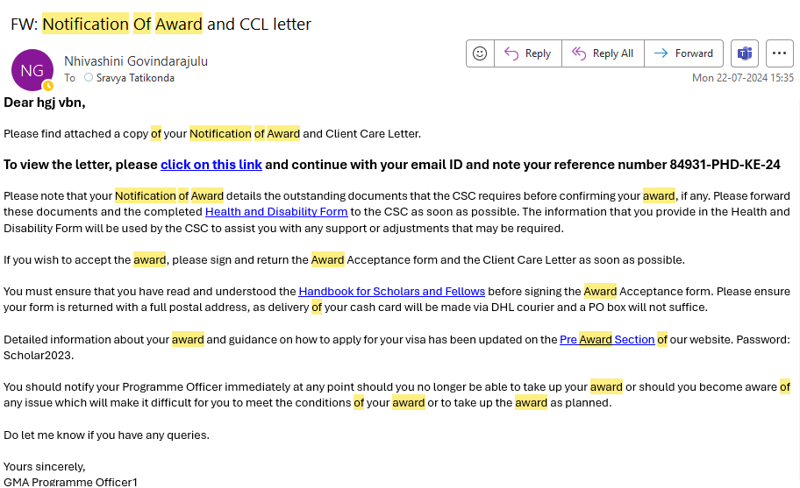

Confirmation of Award to Scholar
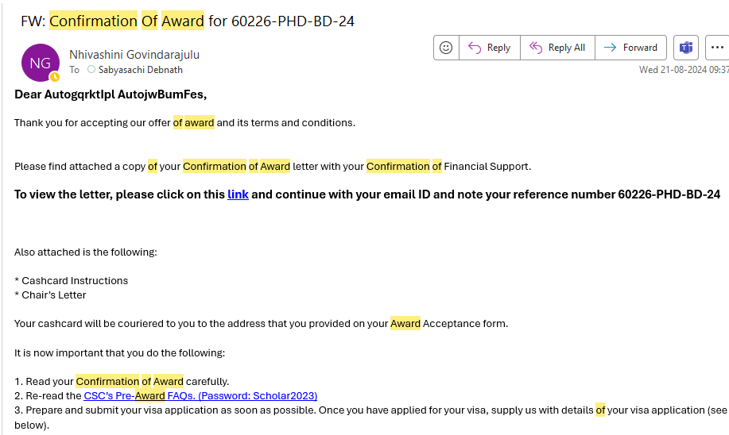
- Reset Passcode
As a Scholar, you can reset your passcode using the following steps:
- In the landing page, Click on the "Existing User" tab.
- Click on the "Reset Passcode" link.
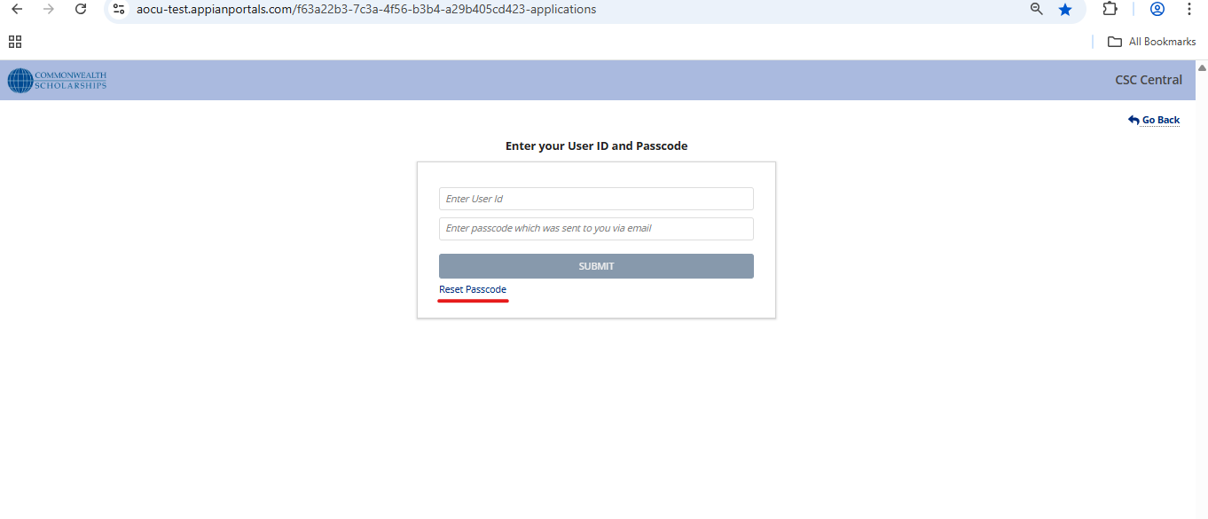
- Enter your registered email address.
- Click the "Validate" button.
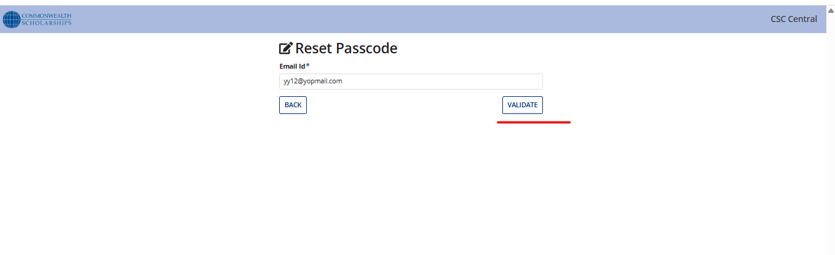
- Click the "Send OTP" button to receive a secure One-Time Passcode via email.
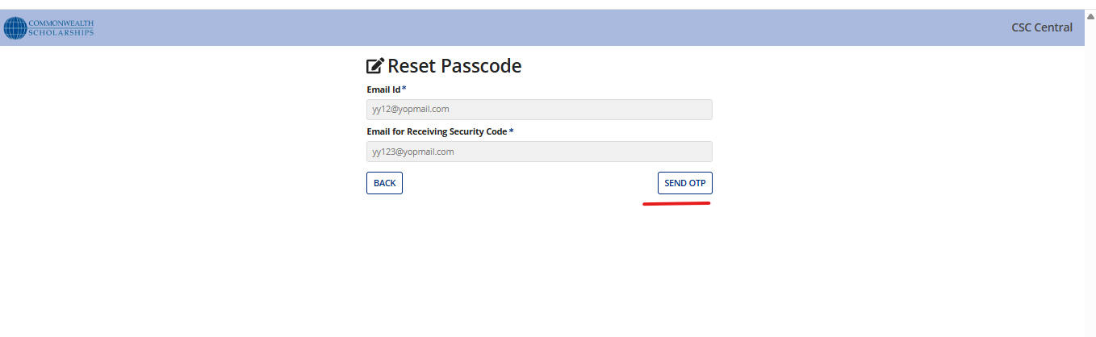
- Receive a secure One-Time Passcode (OTP) sent to your selected email (Secondary).
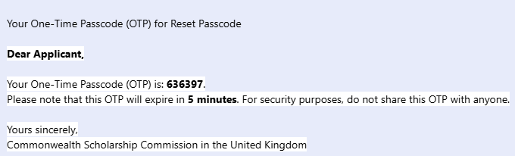
- Use the OTP to reset your passcode and regain access to your account.
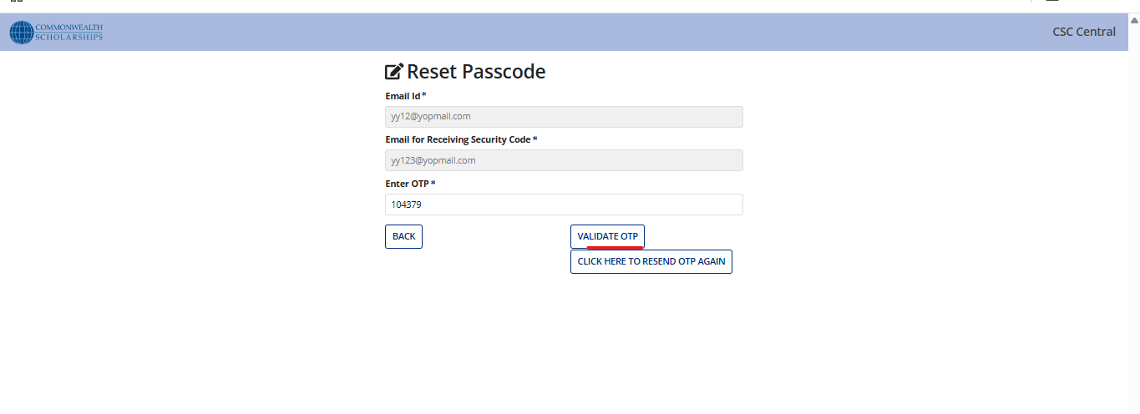
When selecting either your Primary or Secondary email address, the passcode reset email will be sent to that address. You can then log in as an existing user using the new passcode.
