Heuristic analysis

for planning problems for an Air Cargo transport

# Introduction

The project is a part of [Udacity Artificial Intelligence Nanodegree Program](https://www.udacity.com/ai) and consists of deterministic logistics planning problems for an Air Cargo transport system using a planning search agent. It includes skeletons for the classes and functions needed to solve those problems.

# Problem definitions

All problems are classical [PDDL](https://en.wikipedia.org/wiki/Planning_Domain_Definition_Language) problems and defined in the Air Cargo domain. They have the same action schema defined, but different initial states and goals.

* Air Cargo Action Schema

|  |
| --- |
| Action(Load(c, p, a),      PRECOND: At(c, a) ∧ At(p, a) ∧ Cargo(c) ∧ Plane(p) ∧ Airport(a)      EFFECT: ¬ At(c, a) ∧ In(c, p))  Action(Unload(c, p, a),      PRECOND: In(c, p) ∧ At(p, a) ∧ Cargo(c) ∧ Plane(p) ∧ Airport(a)      EFFECT: At(c, a) ∧ ¬ In(c, p))  Action(Fly(p, from, to),      PRECOND: At(p, from) ∧ Plane(p) ∧ Airport(from) ∧ Airport(to)      EFFECT: ¬ At(p, from) ∧ At(p, to)) |

* Problem 1 initial state and goal

|  |
| --- |
| Init(At(C1, SFO) ∧ At(C2, JFK)      ∧ At(P1, SFO) ∧ At(P2, JFK)      ∧ Cargo(C1) ∧ Cargo(C2)      ∧ Plane(P1) ∧ Plane(P2)      ∧ Airport(JFK) ∧ Airport(SFO))  Goal(At(C1, JFK) ∧ At(C2, SFO)) |

* Problem 2 initial state and goal

|  |
| --- |
| Init(At(C1, SFO) ∧ At(C2, JFK) ∧ At(C3, ATL)  ∧ At(P1, SFO) ∧ At(P2, JFK) ∧ At(P3, ATL)  ∧ Cargo(C1) ∧ Cargo(C2) ∧ Cargo(C3)  ∧ Plane(P1) ∧ Plane(P2) ∧ Plane(P3)  ∧ Airport(JFK) ∧ Airport(SFO) ∧ Airport(ATL))  Goal(At(C1, JFK) ∧ At(C2, SFO) ∧ At(C3, SFO)) |

* Problem 3 initial state and goal

|  |
| --- |
| Init(At(C1, SFO) ∧ At(C2, JFK) ∧ At(C3, ATL) ∧ At(C4, ORD)  ∧ At(P1, SFO) ∧ At(P2, JFK)  ∧ Cargo(C1) ∧ Cargo(C2) ∧ Cargo(C3) ∧ Cargo(C4)  ∧ Plane(P1) ∧ Plane(P2)  ∧ Airport(JFK) ∧ Airport(SFO) ∧ Airport(ATL) ∧ Airport(ORD))  Goal(At(C1, JFK) ∧ At(C3, JFK) ∧ At(C2, SFO) ∧ At(C4, SFO)) |

# Uniformed non-heuristic search

I experimented with the following searches:

* **BFS** – Breadth First Search.
* **DFGS** – Depth First Graph Search.
* **UCS** – Uniform Cost Search.

The first two are obligatory according to the task description and the last one I selected, since it works at best for a non-heuristic search and I wanted to compare obligatory searches to it.

| Problem | Search type | No. of expansions | No. of goal tests | Plan length | Time elapsed (sec.) | Is optimal |
| --- | --- | --- | --- | --- | --- | --- |
| **P1** | **BFS** | 43 | 56 | 6 | 0.028 | Yes |
| **P1** | **DFGS** | 12 | 13 | 12 | 0.008 | No |
| **P1** | **UCS** | 55 | 57 | 6 | 0.035 | Yes |
| **P2** | **BFS** | 3343 | 4609 | 9 | 11.769 | Yes |
| **P2** | **DFGS** | 582 | 583 | 575 | 2.704 | No |
| **P2** | **UCS** | 4852 | 4854 | 9 | 9.672 | Yes |
| **P3** | **BFS** | 14663 | 18098 | 12 | 87.707 | Yes |
| **P3** | **DFGS** | 627 | 628 | 596 | 2.763 | No |
| **P3** | **UCS** | 18235 | 18237 | 12 | 42.841 | Yes |

## Memory consumption charts

## Execution time charts

## Analysis

### Columns explanation

“**Time elapsed**” column indicates the speed of the search – the less is better. “**No. of expansions**” indicates the memory consumption – how often a search node was expanded, the less is better. “**Plan length**” indicates optimality – the optimal plan allows a goal achieving in minimal number of steps.

### Optimal plan

Optimal plans for the problem are following:

* Problem 1. The plan has a length of 6:

Load(C2, P2, JFK)

Load(C1, P1, SFO)

Fly(P2, JFK, SFO)

Unload(C2, P2, SFO)

Fly(P1, SFO, JFK)

Unload(C1, P1, JFK)

* Problem 2. The plan has a length of 9:

Load(C1, P1, SFO)

Load(C2, P2, JFK)

Load(C3, P3, ATL)

Fly(P1, SFO, JFK)

Fly(P2, JFK, SFO)

Fly(P3, ATL, SFO)

Unload(C3, P3, SFO)

Unload(C1, P1, JFK)

Unload(C2, P2, SFO)

* Problem 3. The plan has a length of 12:

Load(C1, P1, SFO)

Load(C2, P2, JFK)

Fly(P1, SFO, ATL)

Load(C3, P1, ATL)

Fly(P2, JFK, ORD)

Load(C4, P2, ORD)

Fly(P2, ORD, SFO)

Fly(P1, ATL, JFK)

Unload(C4, P2, SFO)

Unload(C3, P1, JFK)

Unload(C1, P1, JFK)

Unload(C2, P2, SFO)

### Searches analysis

All applied searches do not use any heuristic for a next search node selection.

**Depth First Graph Search** is a fastest search and uses much less memory comparing to other searches. While Breadth First Search and Uniformed Cost Search produced an optimal solution, DFGS never achieved it.

**Breadth First Search** and **Uniformed Cost Search** both produced optimal solutions for the problems. For all problems **BFS** required less memory but was slower than **UCS** on more complex problems. That was a surprise, because according to a table from AIMA Book [1], Chapter 3.4.7

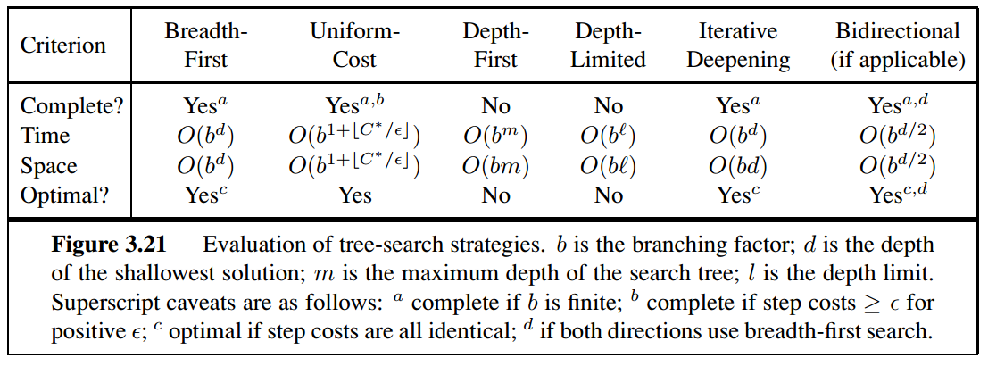

and from common sense, BFS must be faster than UCS since it expands less nodes. The reason of that strange behavior is that BFS uses FIFOQueue, but UCS – PriorityQueue. Both queues are implemented in provided utils and with some changes in the FIFOQueue, the BFS must be faster than UCS. Please see [2] for more details.

I did check that and, indeed, after mentioned changes BFS was, as expected, **20-30%** faster than UCS. I did not include new times here, since it was not my intention to change provided code.

### Recommendation

I do not recommend using of **Depth First Graph Search** since it didn’t produce an optimal result. To me it is a KO criteria for a search.

I recommend using of **Breadth First Search** because it produced optimal solution, was **20-30%** faster than **Uniformed Cost Search** after correct implementation of underlying FIFO queue and consumed **20-30%** less memory.

# A* heuristic search

I experimented with 2 heuristics for A* search:

* **Ignore Preconditions**, where we relax a problem by ignoring preconditions of actions.
* **Level Sum**, where we follow the subgoal independence assumption, returning the sum of level costs of the goals.

| Problem | Heuristic | No. of expansions | No. of goal tests | Plan length | Time elapsed (sec.) | Is optimal |
| --- | --- | --- | --- | --- | --- | --- |
| **P1** | **Ignore Precond.** | 41 | 43 | 6 | 0.028 | Yes |
| **P1** | **Level Sum** | 11 | 13 | 6 | 0.675 | Yes |
| **P2** | **Ignore Precond.** | 1450 | 1452 | 9 | 3.01 | Yes |
| **P2** | **Level Sum** | 86 | 88 | 9 | 61.425 | Yes |
| **P3** | **Ignore Precond.** | 5040 | 5042 | 12 | 12.375 | Yes |
| **P3** | **Level Sum** | 318 | 320 | 12 | 303.83 | Yes |

## Memory consumption charts

## Execution time charts

## Analysis

Here we have the same metrics as for non-heuristic searches, please see above the column explanation and optimal plans for the problems.

### Comparing heuristics

A* search produced optimal solution with both heuristics, significant differences were memory consumption and speed. With “**Ignore Preconditions**” heuristic the A* search was **order 10 faster** than with “**Level Sum**”. From the other side, “**Level Sum**” allowed **order of 10 memory saving**.

### Recommendation for heuristic

Depending on the problem and requirements I recommend:

* Using of “**Ignore Precondition**” heuristic if the speed matters and A* search do not result “Out of Memory” exception.
* Using of “**Level Sum**” in a case of complex problems where a great memory consumption is expected and a problem can be decomposed well.

## Conclusion

Comparing uniformed non-heuristic searches with A* search that uses heuristics I recommend using the latter, because of memory consumption and running time. My favorite is **A* search with “Ignore Precondition” heuristic** for the following reasons:

* It found optimal solutions.
* It was fastest among considered searches that produced optimal results.
* It had approx. factor 3 of memory saving comparing to non-heuristic searches, though its memory consumption was not the best.

**References**

1. Peter Norvig, Stuart J. Russell. “Artificial Intelligence: A Modern Approach (3rd Edition)”
2. Udacity AIND forum: <https://discussions.udacity.com/t/uniform-cost-search-faster-than-breadth-first/324045/3>