Cheney’s Algorithm and Mark and sweep Algorithm

Cheney’s Algorithm :

Cheney’s Algorithm is a stop and copy method of tracing garbage collection in computer software systems. In this scheme, the heap is divided into two equal halves, only one of which is in use at any one time. Garbage collection is performed by copying live objects from one semispace to the other, which then becomes the new heap. The entire old heap is then discarded in one piece.

Mark Compact:

A mark compact algorithm is a type of garbage collection algorithm used to reclaim unreachable memory. Mark compact algorithm can be regarded as a combination of the mark sweep algorithm and cheney’s copying algorithm. First,reachable objects are marked,then a compacting step relocates the reachable objects towards the beginning of the heap area.

Concluding statements:

Since a mark sweep collector transverses the heap by following pointers to referenced objects starting at the root, it is necessary for a mark sweep collector to transverse the heap multiple times in order to mark and sweep objects to be freed. In contrast, a copy collector copies objects reachable from a root node from the from-space in memory to the to-space as the nodes are traversed with Cheney’s bread-first search. Both garbage collectors can be utilized effectively in different environments or for different languages and the Mark compact is better to use in c++.

Sample program of cheney’s algorithm:

initialize() =

tospace = N/2

fromspace = 0

allocPtr = fromspace

scanPtr = whatever -- only used during collection

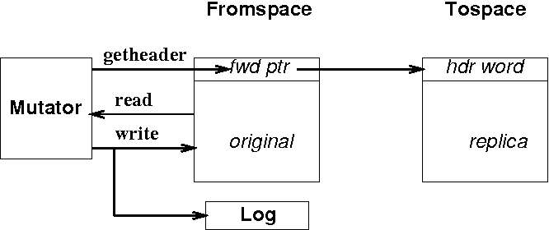.

Mark compact algorithm:

