**Program: Define the size of array from the user and assign the values to element and print the assigned value in while loop.**

**Source Code:**

namespace Array2

{

class Program

{

static void Main(string[] args)

{

//Define the size of array from the user and assign the values to element and print the assigned value in while loop.

int i;

Console.WriteLine("Input the size of array:");

int n = Convert.ToInt32(Console.ReadLine());

int[] IntArray = new int[n];

Console.WriteLine("Input number");

for (i = 0; i < n; i++)

{

IntArray[i] = Convert.ToInt32(Console.ReadLine());

}

Console.WriteLine("The values are");

for(i=0;i<n;i++)

{

Console.WriteLine(IntArray[i]);

i++;

}

}

}

}

**Source in Visual Studio:**

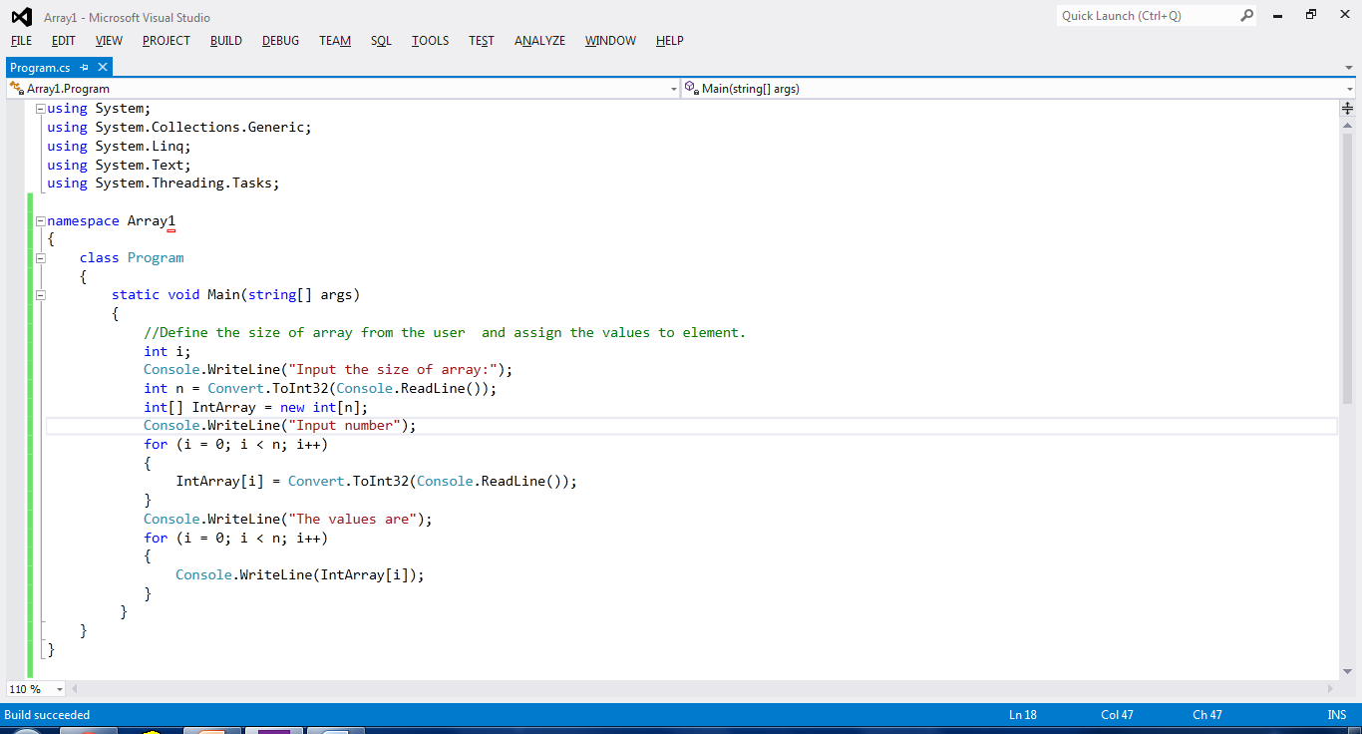

**Output:**

