**Program: Define any data type array of size 5 take the input from the user and print it.**

**Source Code:**

namespace Array3

{

class Program

{

static void Main(string[] args)

{

//Define any data type array of size 5 take the input from the user and print it.

int i;

int[] IntArray = new int[5];

Console.WriteLine("Input 5 numbers");

for (i = 0; i < IntArray.Length; i++)

{

IntArray[i] = Convert.ToInt32(Console.ReadLine());

}

Console.WriteLine("The values are");

for(i=0;i<IntArray.Length;i++)

Console.WriteLine(IntArray[i]);

}

}

}

**Source in Visual Studio:**

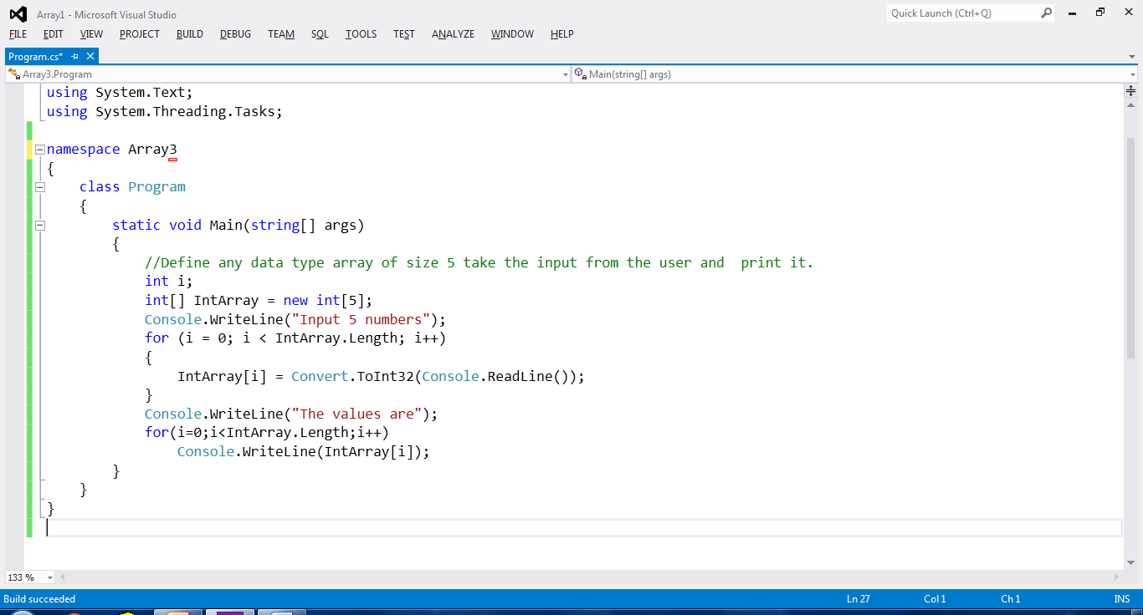

**Output:**

