**Display in following orders:**

**Order 1:**

1

12

123

1234

12345

**Source code:**

int i,j;

for(i=1;i<=6;i++)

{

for(j=1;j<i;j++)

{

Console.Write(j);

}

Console.Write("\n");

}

**Output:**

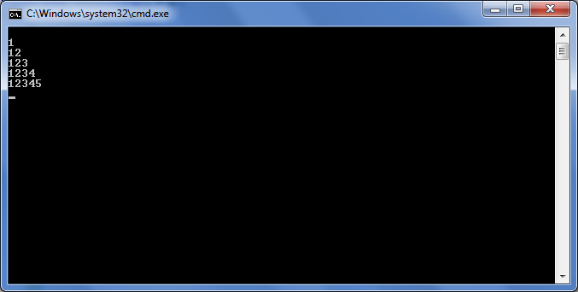

**Order 2:**

12345

1234

123

12

1

**Source Code:**

int i,j;

for (i = 6; i >= 1; i--)

{

for (j = 1; j < i; j++)

{

Console.Write(j);

}

Console.Write("\n");

}

**Output:**

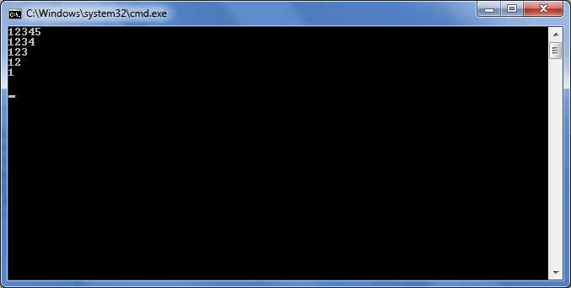

**Order 3:**

54321

4321

321

21

1

**Source Code:**

int i,j;

for (i = 5; i >= 1; i--)

{

for (j = i; j >= 1; j--)

{

Console.Write(j);

}

Console.Write("\n");

}

**Output:**

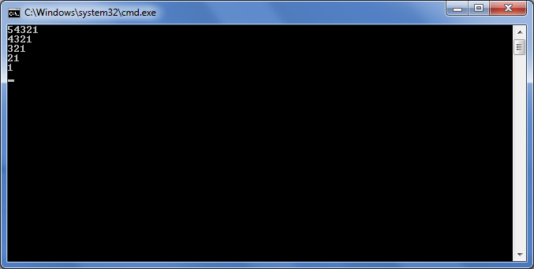

**Program: To enter the name in a multi-dimensional string array taking input from user.**

**Source Code:**

namespace MultiDimensionalArrayString

{

class Program

{

static void Main(string[] args)

{

string[,] nameOfStudent = new string[3, 2];

int i, j;

Console.WriteLine("Enter the name of the Students");

for (i = 0; i < 3; i++)

for (j = 0; j < 2; j++)

nameOfStudent[i, j] = Console.ReadLine();

Console.WriteLine("\nThe name of the Students are:");

for (i = 0; i < 3; i++)

for (j = 0; j < 2; j++)

Console.WriteLine("Name[{0},{1}]={2}",i,j,nameOfStudent[i, j]);

}

}

}

**Output:**

