**Program: Convert the String IsTrue="true" to Boolean data type also convert int isIntTrue=0 to boolean data type implicity.**

**Source Code:**

namespace ConversionProgram4

{

class Program

{

static void Main(string[] args)

{

//Convert the String IsTrue="true" to Boolean data type also convert int isIntTrue=0 to boolean data type implicity

String IsTrue = "true";

Boolean boolVal = Convert.ToBoolean(IsTrue);

Console.WriteLine(boolVal);

int isINtTrue = 5 ;

bool boolVal2 = Convert.ToBoolean(isINtTrue);

Console.WriteLine(boolVal2);

}

}

}

**Source in Visual Studio:**

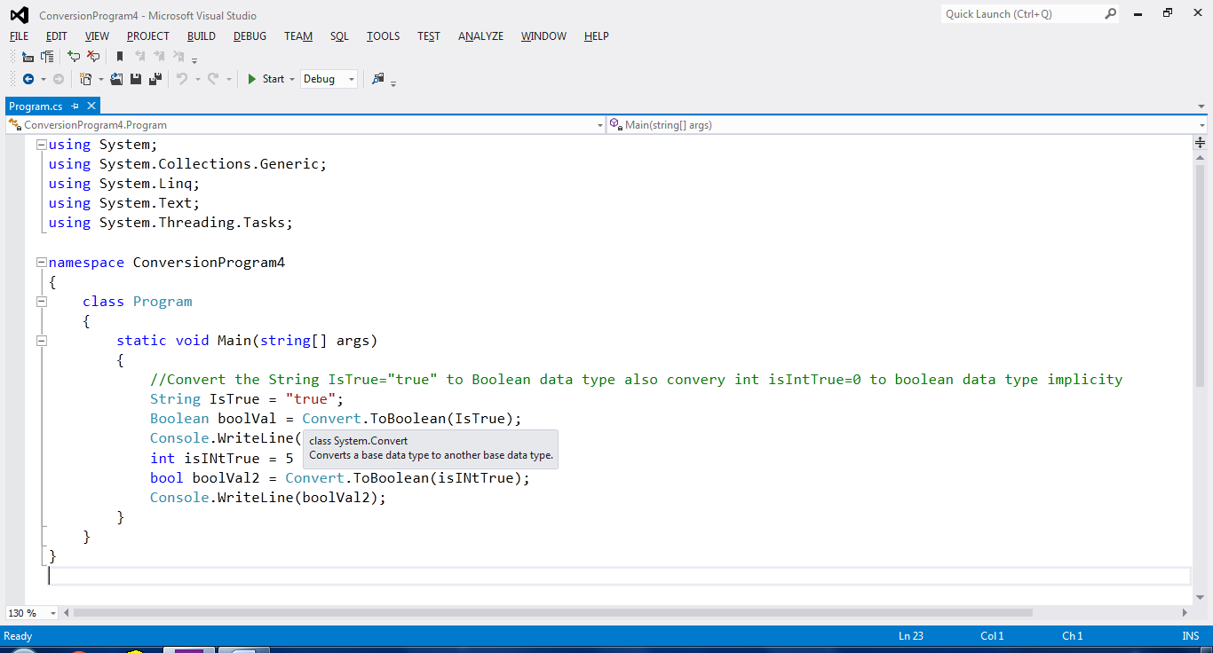

**Output:**

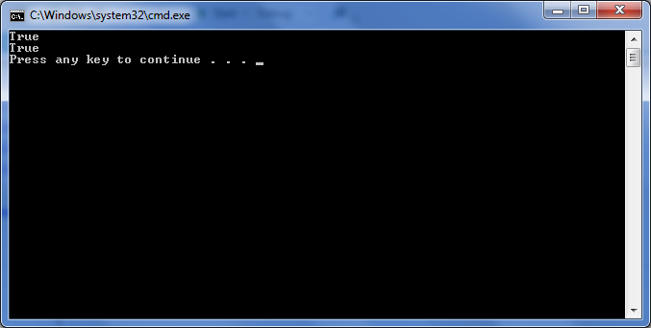

**Program: Use toString method to the convert integer, float and double variable to the string data type variables**

**Source Code:**

namespace Conversion2

{

class Program

{

static void Main(string[] args)

{

//Use toString method to the convert integer, float and double variable to the string data type variables

int integerValue = 5;

string changedInt=integerValue.ToString();

Console.WriteLine(changedInt);

float floatValue = 56.2f;

string changedFlt=floatValue.ToString();

Console.WriteLine(changedFlt);

double doubleValue = 6.5;

string changedDouble = doubleValue.ToString();

Console.WriteLine(changedDouble);

}

}

}

**Source in Visual Studio:**

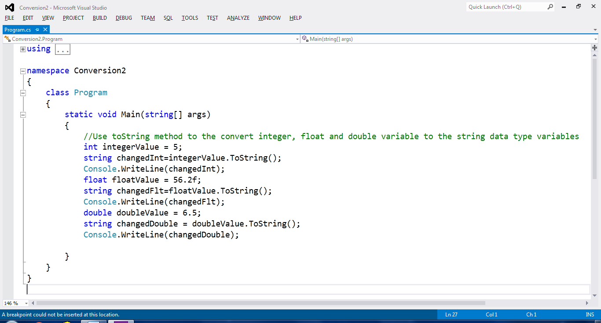

**Output:**

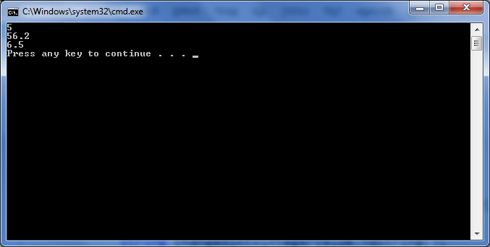

**Program: Convert float data type variable to int long and short data type explicitly.**

**Source Code:**

namespace Conversion3

{

class Program

{

static void Main(string[] args)

{

//Convert float data type variable to int long and short data type explicitly.

float floatValue = 5.6589f;

Console.WriteLine("The float value is "+floatValue);

int intVal = (int)floatValue;

Console.WriteLine("The int value is "+intVal);

long longVal = (long)floatValue;

Console.WriteLine("The long Value is "+longVal);

short shortVal = (short)floatValue;

Console.WriteLine("The Short Value is "+shortVal);

}

}

}

**Source in Visual Studio:**

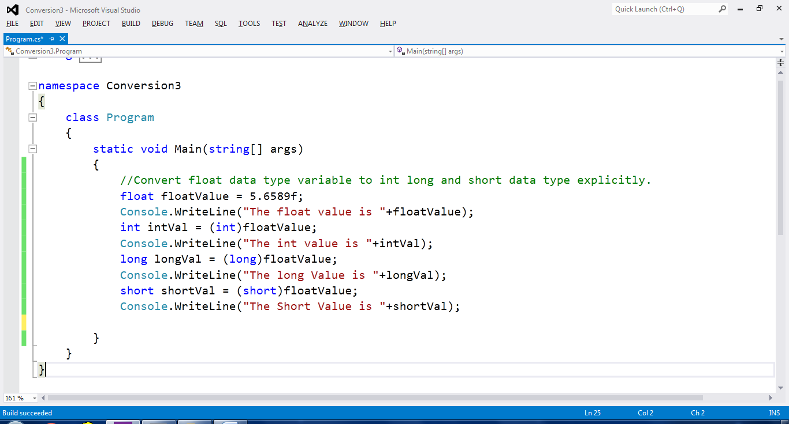

**Output:**

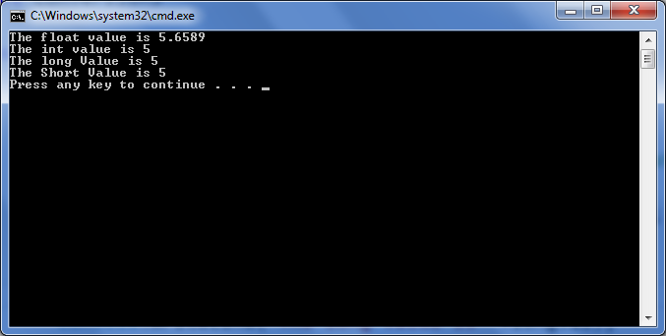

**Program: WAP to assign value to meaningful variables of data types int, float, char, String, bool, double taking input from user**

**Source Code:**

//WAP to assign value to meaningful variables of data types int, float, char, String, bool, double taking input from user

namespace ConversionProgram3

{

classProgram

{

staticvoid Main(string[] args)

{

Console.WriteLine("Enter the value of int datatype");

int intType=Convert.ToInt32(Console.ReadLine());

Console.WriteLine(intType);

Console.WriteLine("Enter the value of float datatype");

float floatTyp = float.Parse(Console.ReadLine());

Console.WriteLine(floatTyp);

Console.WriteLine("Enter the value of char datatype");

char charType=Convert.ToChar(Console.ReadLine());

Console.WriteLine(charType);

Console.WriteLine("Enter the value of string datatype");

String stringType=Console.ReadLine();

Console.WriteLine(stringType);

Console.WriteLine("Enter the value of bool datatype");

bool boolType=Convert.ToBoolean(Console.ReadLine());

Console.WriteLine(boolType);

Console.WriteLine("Enter the value of double datatype");

double doubleType=Convert.ToDouble(Console.ReadLine());

Console.WriteLine(doubleType);

}

}

}

**Source in Visual Studio:**

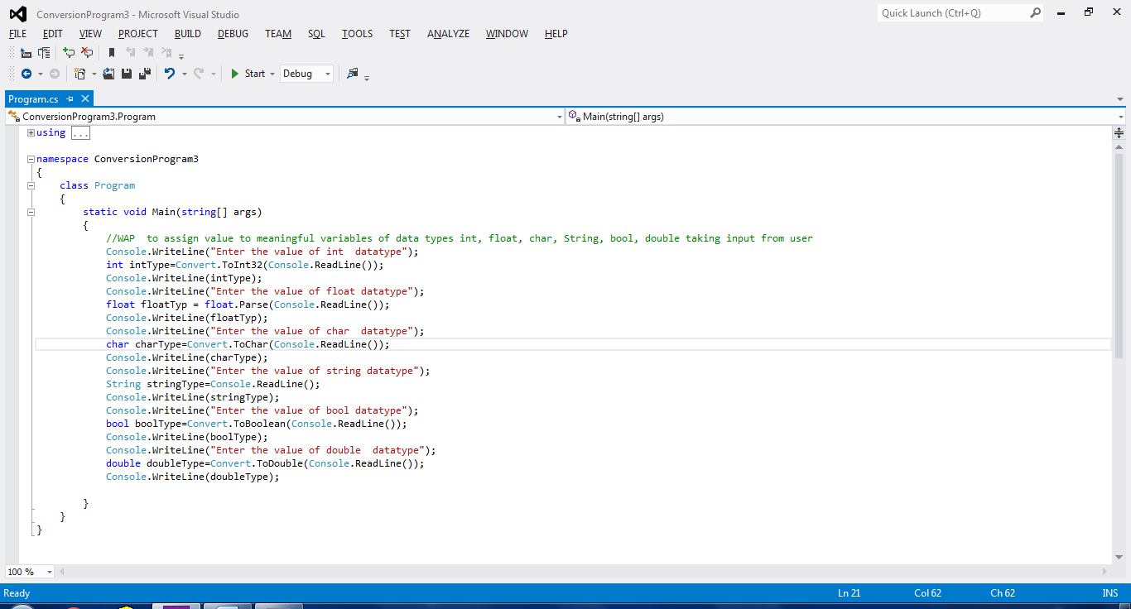

**Output:**

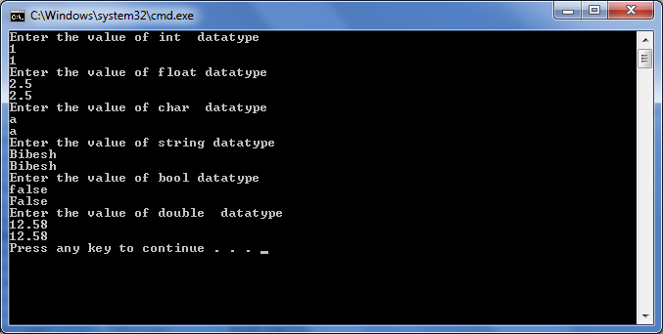

**Program: How to convert char value to equivalent ascii code.**

**Source Code:**

//How to convert char value to equivalent ascii code

namespace Char2Ascii

{

class Program

{

static void Main(string[] args)

{

Console.Write("Input Character:");

int asciiValue = Console.Read();

Console.WriteLine(asciiValue);

}

}

}

**Source in Visual Studio:**

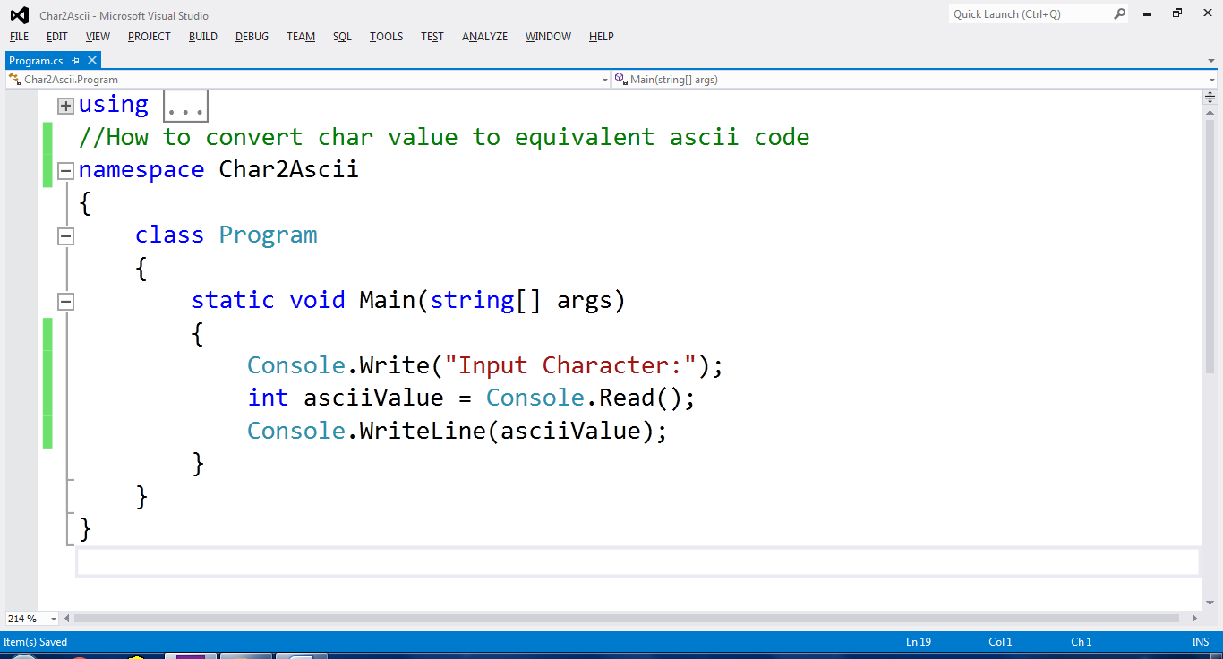

**Output:**

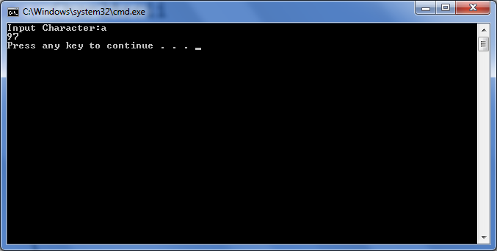

**Program: Print the date time in the format “M d h:mm yy”**

**Source Code:**

//Program to print the date time in the format “M d h:mm yy”

namespace DateNdTime

{

classProgram

{

staticvoid Main(string[] args)

{

DateTime date = DateTime.Now;

string format = "M d h:mm yy";

Console.WriteLine(date.ToString(format));

Console.ReadKey();

}

}

}

**Source in Visual Studio:**

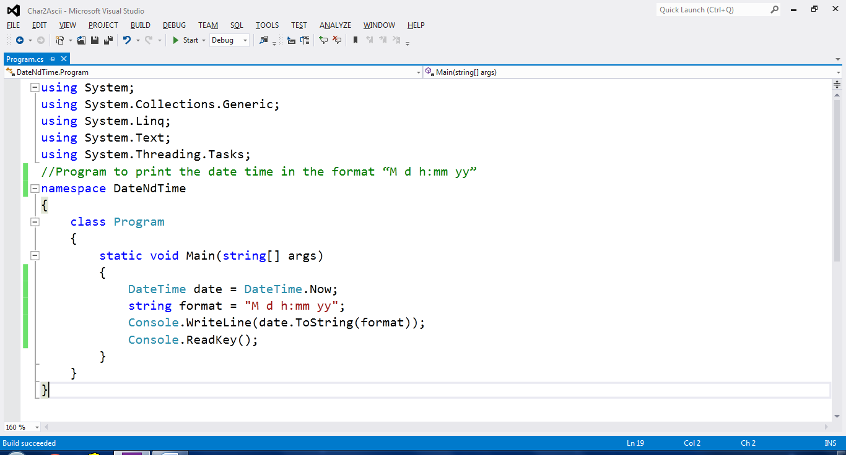

**Output:**

