**Step-by-step methods of installing the Visual Studio (Visual C#) with images:**

Step 1: Run the Visual Studio setup file. We can install the whole program at once or install programs i.e. Visual C#, Visual C++ etc. one by one.

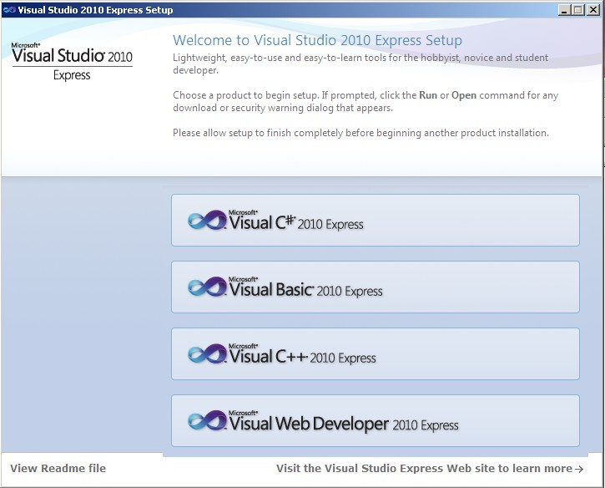

Step 2: Now a welcome screen will be displayed. Press on next button.

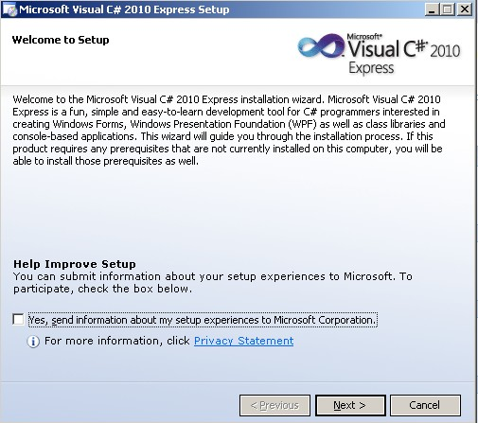

Step 3: After the welcome screen, the license terms will be displayed in our screen. Click on accept the license terms and press on next button.

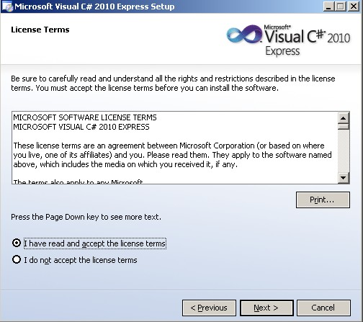

Step 4: After accepting the license terms, the installing process will begin which automatically choose the location of the program.

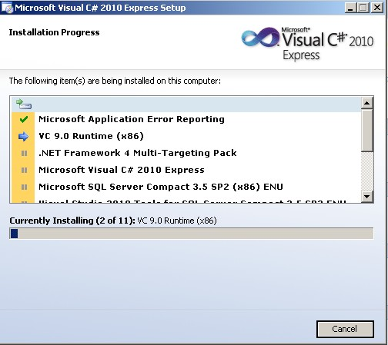

Step 5: We can see the following message in our screen after successfully completion of the setup installation.

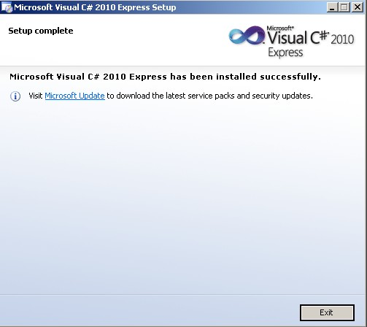

Step 6: After completing the installation of program, run the program. A welcome screen will be displayed in our screen which will look like the following image.

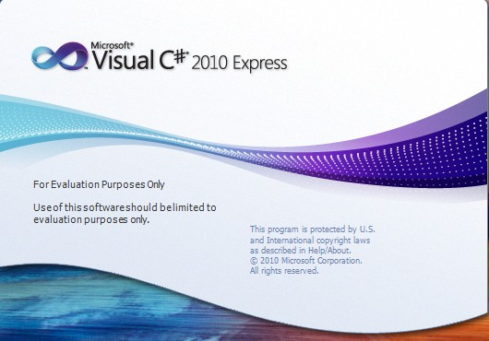

Step 7: Click on new project to make new project or programs.

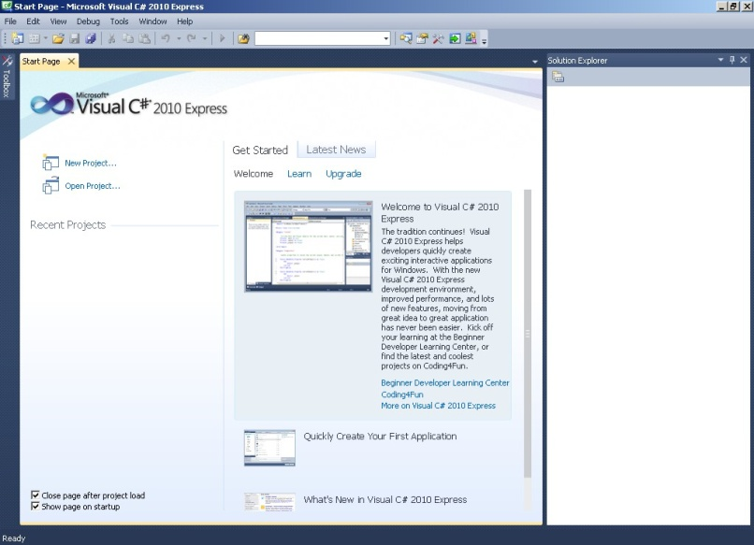

Step 8: Among different templates choose on Visual C# and on Console Application. We can give a different name to our project. We should use came casing while giving the name to the project.

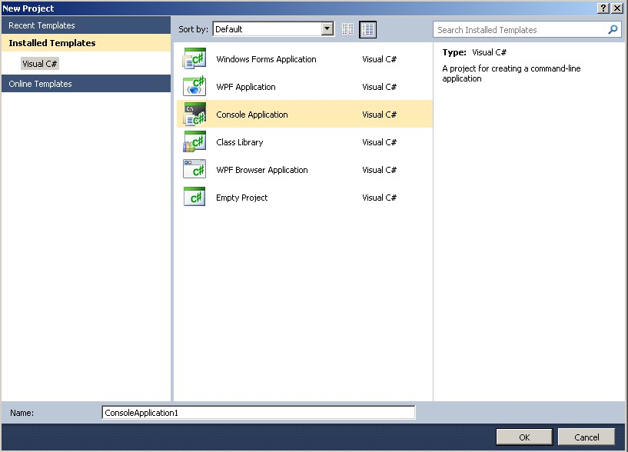

Step 9: Now, we can write our source codes in our project. Codes are written after the 'static void Main(string[] args)' function. In the following images, codes are written in '//program codes are written here' place.

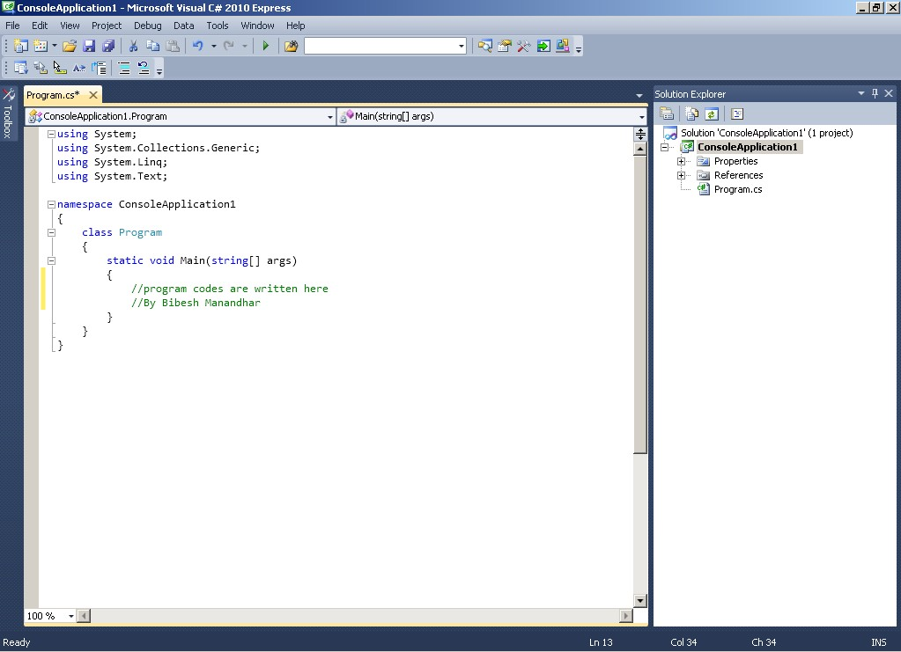

Conclusion: In this way we can easily install and use the visual studio program. ☺