**Program: To print output in console application.**

**Source code:**

*using System;*

*using System.Collections.Generic;*

*using System.Linq;*

*using System.Text;*

*namespace FirstProgram*

*{*

*class Program*

*{*

*static void Main(string[] args)*

*{*

*Console.WriteLine("Hello Bibesh");*

*}*

*}*

*}*

**Source Code in Visual studio:**

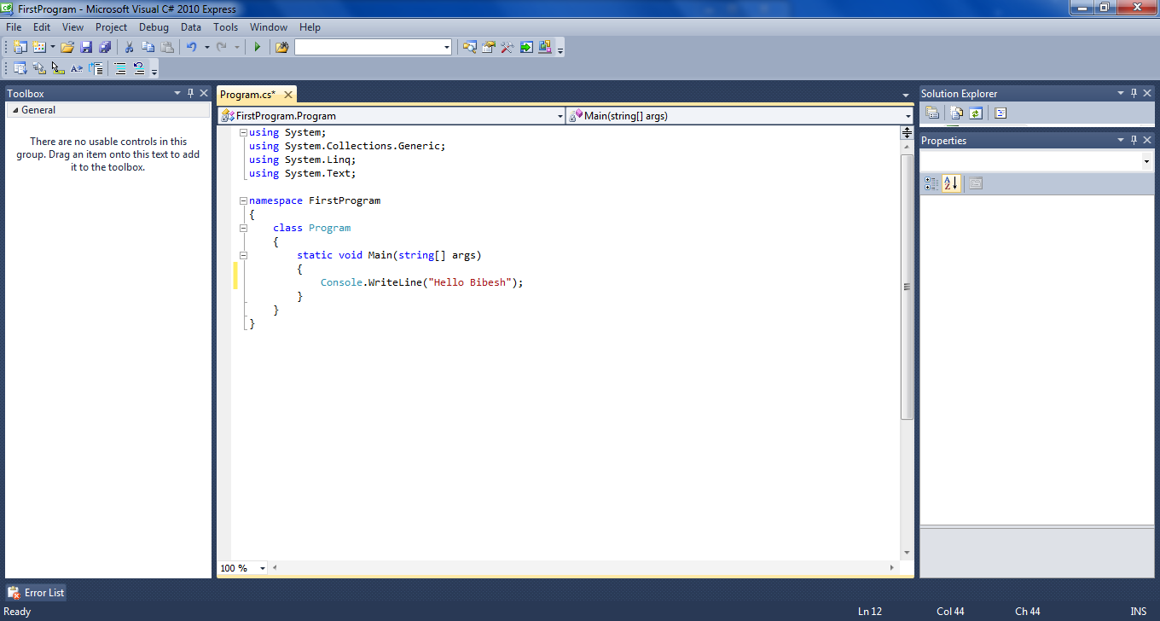

**Output:**

