**Numerical Evaluation of Maxwell’s Equations**

**Lab 8**

IDName: Niruyan Rakulan Zhiwei Chen

ID:214343438 212654265

**Introduction:**

The purpose of this lab is to solve Faraday’s Law using Matlab, and a self-made function called ‘faraday’. The function receives a ‘x’ and ‘y’ value that correspond to the bounds of a rectangular loop(-x to x, and -y to y), and t(time values for which voltage is to be calculated). The function outputs an array with voltage values for the respective time values.

**Methodology**

It was known that the directions of **B** and the differential area(**dS**) are the same(in z direction), so a scalar of Bds is produced in the double integral. The sin(8*π*t) is taken out of the integral because it is not dependent on x or y.

The approach taken to solve the double integral was to approximate the integral using the midpoint rule. The x, and y coordinate in which the rectangle loop occupies is split into mxn, infinitesimally small rectangles(length of dx, and width of dy), and the function was evaluated at the midpoints of the rectangles, were summed up, and multiplied with dA(which is equal to dx*dy). dx, and dy are equal to a small number such as 0.001; if the number is made too small, Matlab will take a long time to complete the program.

Another methodology for solving the integration was discussed. Instead of initializing dx, and dy to be small numbers, a value m and n were initialized to be large values(ex. 10000). Using the m, and n values, dx=xo-(-xo)/m and dy=yo-(-yo)/n; this way, for whatever x, and y value, the number of infinitesimally small areas is the same, and the time to complete the program will be the same. It was noticed however this methodology was inaccurate for large values of x, and y because the values of dx, and dy increases as the span of the axis increases, and as result the accuracy decreases.

The chosen method(first method) is more accurate for long spans, however the time varied, as the x, and y values got longer. In choosing the first method, faster completion was sacrificed in favor of accuracy for larger values of x, and y.

The derivative was evaluated by using the definition of a limit. h was chosen to be 0.0000001.  
http://tutorial.math.lamar.edu/Classes/CalcI/DefnOfDerivative_files/eq0006M.gifhttp://tutorial.math.lamar.edu/Classes/CalcI/DefnOfDerivative_files/empty.gif

**Results**

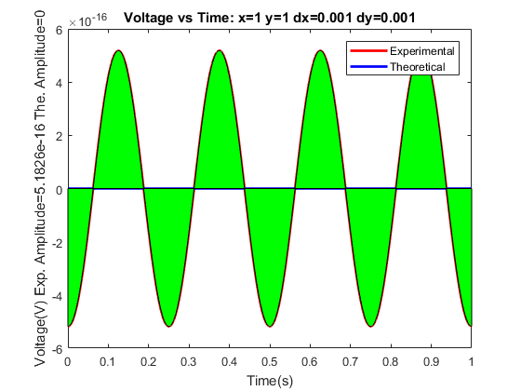

Figure 1a: Shows the values of the voltage when using the self-made function(Experimental), and the actual voltage(Theoretical); green is difference between the values. Theoretically, the value of the voltage is supposed to be zero for when both x, and y have values that are multiples of 0.25(ie 0.25,0.5, 1) since period is 0.5. The value found by the self made function is close to 0(amplitude is less than 1.53x10^-16).

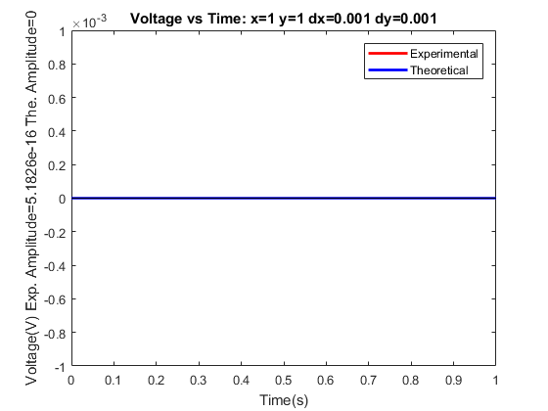

Figure 1b: Shows a better representation of the voltage measured after rescaling the y-axis

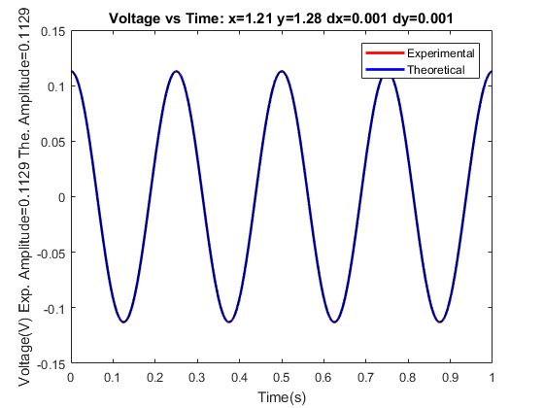

Figure 2: Voltage for when x=1.21, and y=1.28. The voltages for experimental, and theoretical are almost identical.

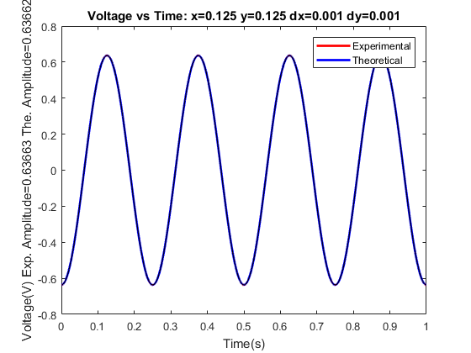

Figure 3: Max Voltage is around 0.637v for when x=0.125+0.5n, and y=0.125+0.5n, since periodic with 0.5. The voltages for experimental, and theoretical are almost identical.

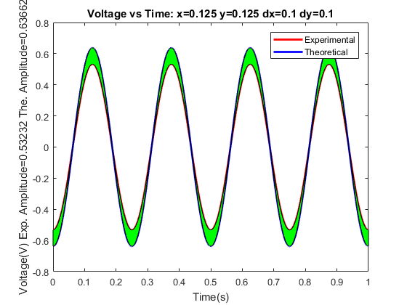

Figure 4a: The difference between the theoretical and experimental voltages when dx=0.1, and dy=0.1.

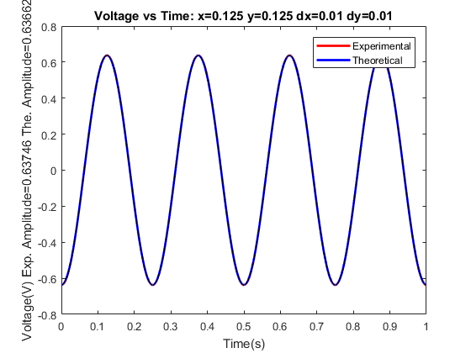

Figure 4b: Voltage values for when dx=0.01 and dy=0.01. The experimental value is closer to theoretical as supposed to dx=0.1, and dy=0.1.



Figure 4c: Voltage values for when dx=0.001 and dy=0.001. The experimental value is closer to theoretical as supposed to dx=0.01 and dy=0.01

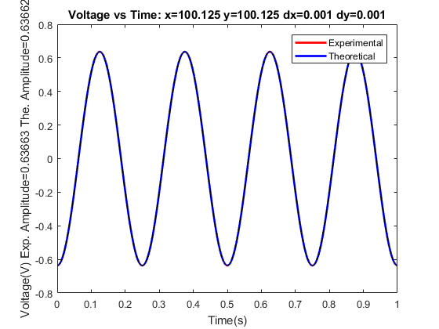

Figure 5a:Method 1 at x=100.125, and y=100.125. This method is more accurate for this specific surface, however takes longer time to complete in Matlab

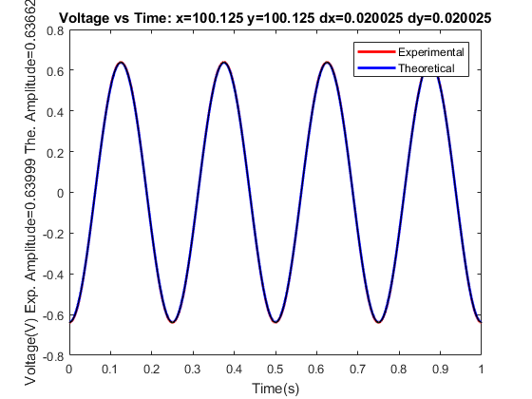

Figure 5b:Alternative method at x=100.125, and y=100.125. This method took less time for this specific surface, however less accurate

**Conclusion:**

It was shown in the lab that if the points were closely spread out, the answer is more accurate, however, if the points were infinitesimally far apart, the Matlab program will take much longer to finish. It was also shown the method chosen is better for bigger surfaces however, takes longer time to complete in comparison to the alternative method.

References:

<https://www.youtube.com/watch?v=9AA91hpNHno>

<http://tutorial.math.lamar.edu/Classes/CalcI/DefnOfDerivative.aspx>