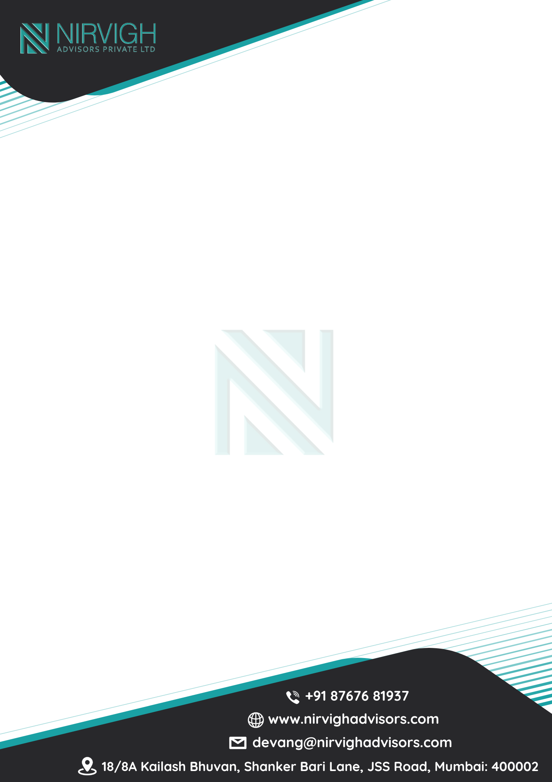
Employment Offer Letter
Date:
To,

Dear
Subject: Offer Of Employment
We are pleased to offer you the position of {designation} with Nirvigh Advisors Pvt.Ltd. We are confident that your experience and skills will be valuable assets to our organization.
- Commencement of Employment
Your employment with the Company will commence on {Date}, subject to the completion
of necessary documentation and background verification.

- Designation and Reporting
You will be designated as {designation} and will report to {managerName}

- Compensation
Your Annual Cost to Company (CTC) will be INR {ctcFigures}/- {ctcWords}

Note: Applicable statutory deductions like PF, Professional Tax, TDS, etc. will be deducted as per prevailing laws.

- Leave Policy
You will be entitled to Annual Leaves, Sick Leaves, Casual Leaves, and Public Holidays etc in accordance with the Company’s official Leave Policy.

All leave balances, policy details, and holiday calendars are dynamically managed and can be viewed at any time by logging into your NAPHRMS Employee Portal. All leave requests must be applied for in advance and approved through the portal
.



- Probation Period
You will be on probation for a period of three (3) months from your date of joining. Upon satisfactory performance during this period, your employment will be confirmed

- Working Hours
The standard working hours are 10:30 AM to 7:30 PM, six days a week. You may be required to work beyond these hours in accordance with business needs.

- Termination and Notice Period
Either party may terminate this employment by giving 30 days’ written notice or payment in lieu thereof. The Company reserves the right to relieve you earlier by compensating for the remaining notice period.

- Confidentiality and IP
You are required to maintain the highest level of confidentiality regarding Company data and client information, during and after the term of your employment. Any intellectual property developed during your tenure shall be the exclusive property of the Company.

- Code Of Conduct
You are expected to adhere to the Company’s Code of Conduct and policies at all times. Any violation may result in disciplinary action, up to and including termination.

- Acknowledgment & Acceptance
I, {employeeName}, accept the offer as per the terms and conditions stated in this letter.

We are excited to welcome you to Nirvigh Advisors Pvt. Ltd. and look forward to a mutually rewarding relationship.

{%signature} (Authorized Signatory)

