**﻿#NAME: NIRZARI IYER**

**#ASSIGNMENT 10**

**#ID NO: 1001117633**

**#BATCH TIME: 6:00 to 8:00**

A) **READ ME and Explanation of code:**

 -Execute the Programming assignment 9 by executing this command into EC2 instance

This will execute the project on docker.

-sudo docker run -p 8080:8080 lec00q/mysql

-Go to URL: <http://ec2-52-26-15-146.us-west-2.compute.amazonaws.com:8080/>

- When user selects student ID from the range of 1 to 50, it will be redirected to <http://ec2-52-26-15-146.us-west-2.compute.amazonaws.com:8080/pie_chart>

- A pie chart will be displayed showing student grade distribution.

- This application will help students to decide on which subject they need to work more for coming exam.

B) **Results:**

Screenshot 1:

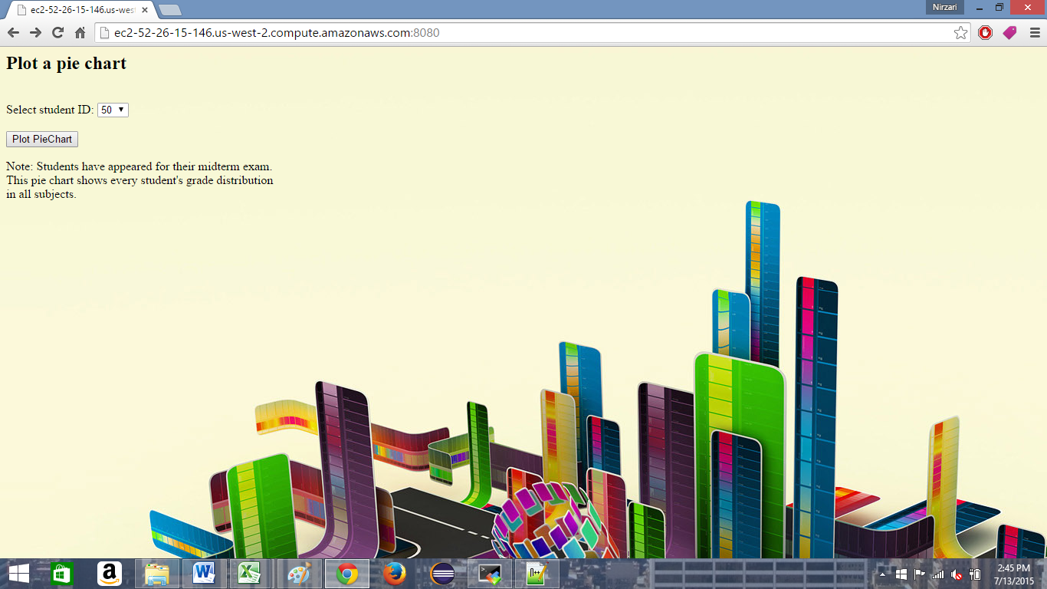

Screenshot 2:

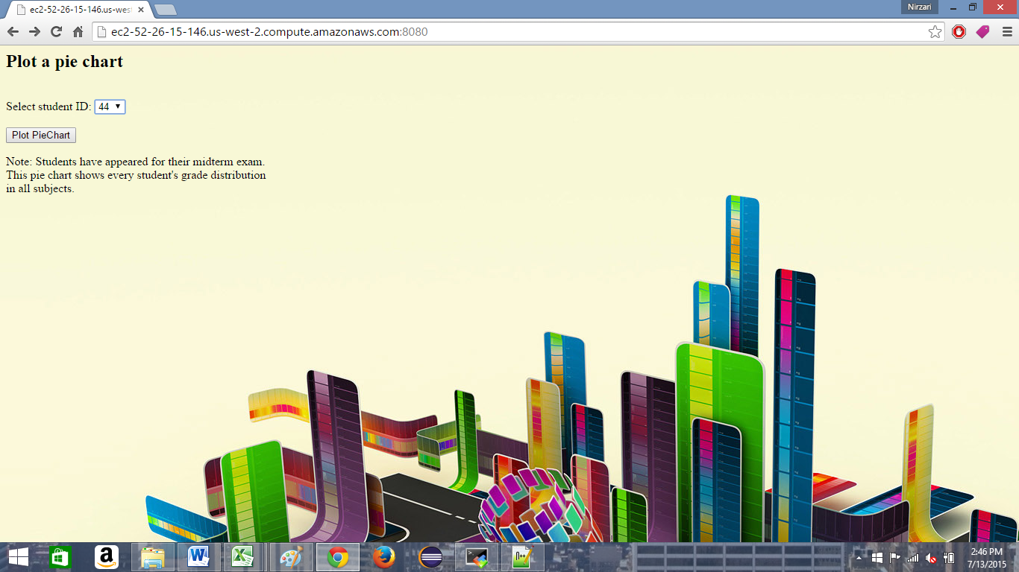

Screenshot 3:

For student id = 44

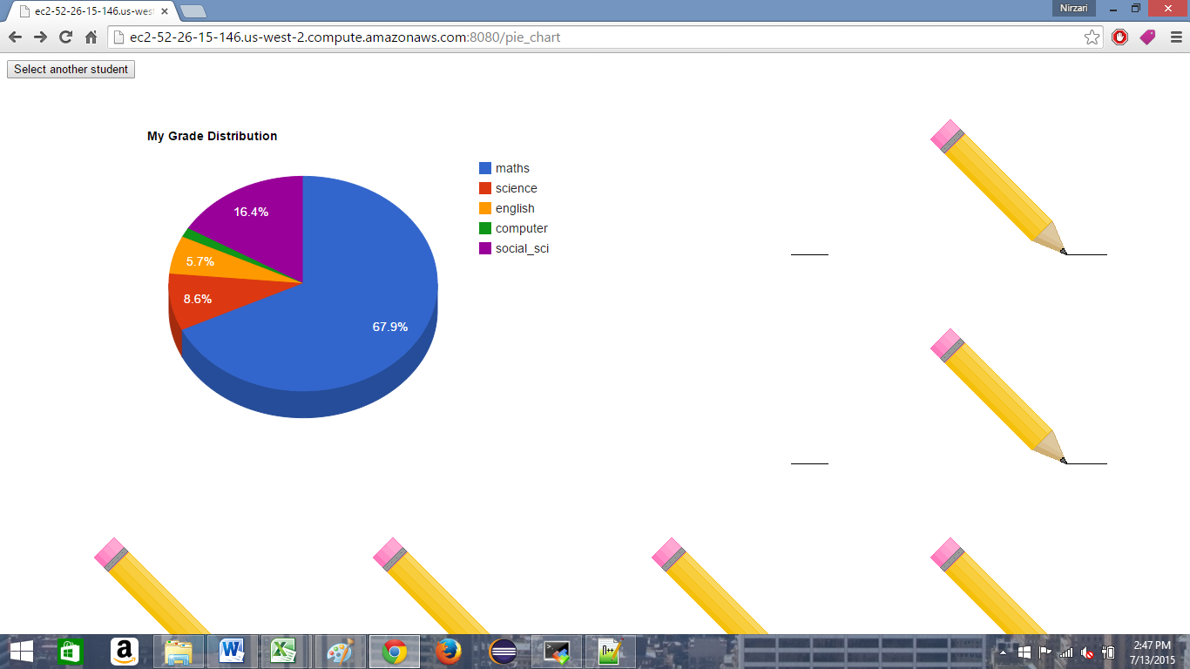

Screenshot 4:

For student id = 18

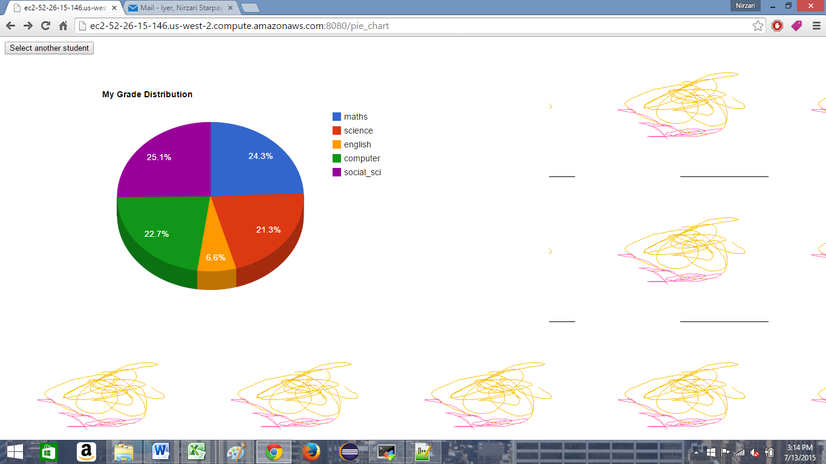

Screenshot 5:

For student id = 24

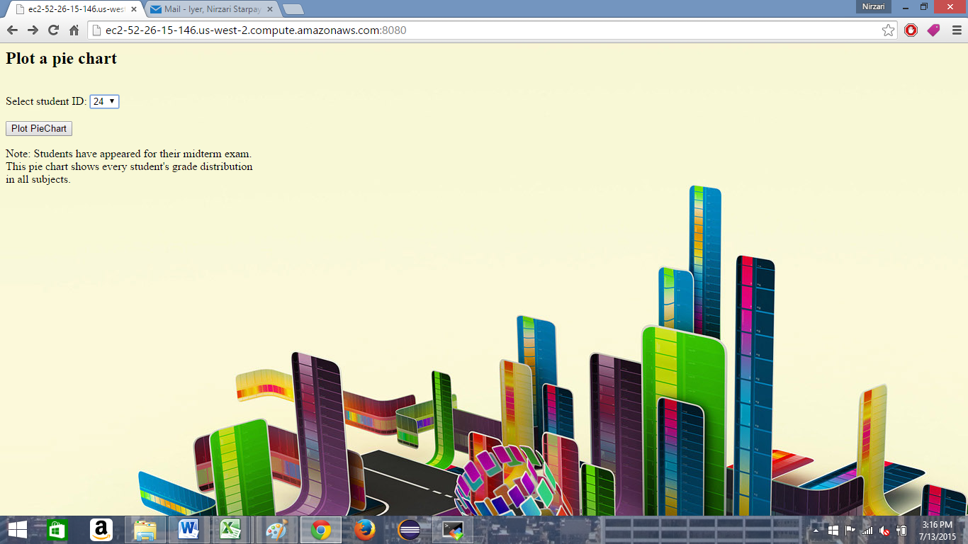

Screenshot 6:

For student id = 24

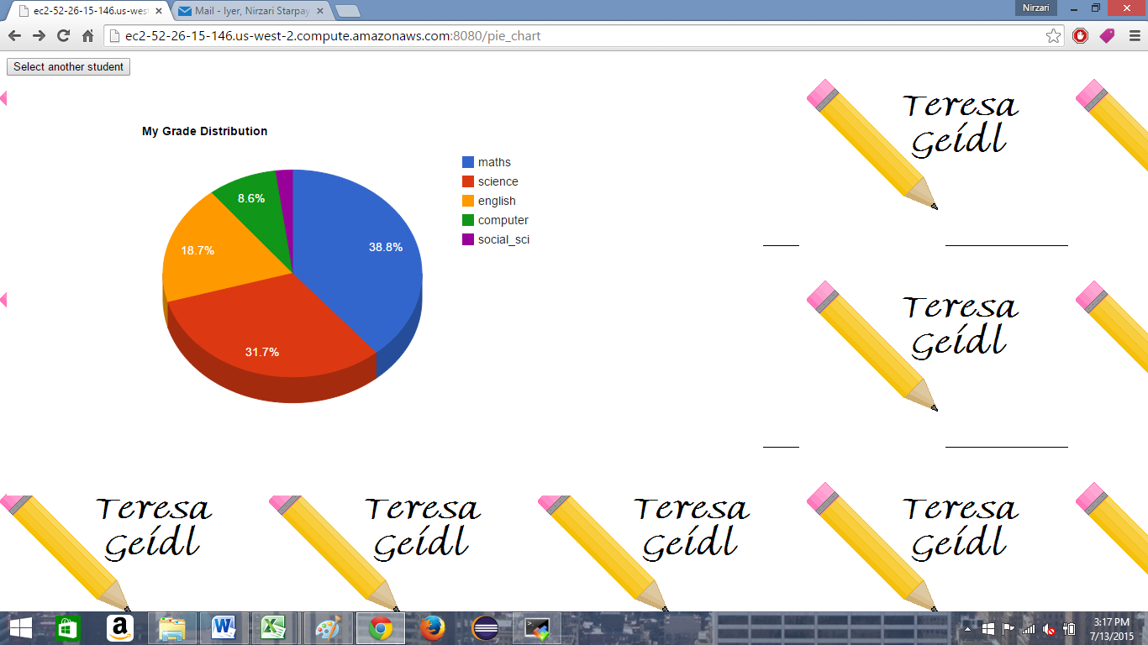

C) **References:**

-http://www.2createawebsite.com/build/build-html-website.html

-http://learnpythonthehardway.org/book/ex50.html

-http://stackoverflow.com/questions/15868512/python-list-to-array

-http://www.wired.com/2011/08/python-notes-lists-vs-arrays

-http://stackoverflow.com/questions/3488934/simplejson-and-numpy-array/24375113#24375113

-http://stackoverflow.com/questions/29500787/error-not-an-array-in-google-charts

-http://stackoverflow.com/questions/19400497/google-chart-uncaught-error-not-an-array

-http://www.widecodes.com/0NyjUgkWXq/google-chart-uncaught-error-not-an-array.html

-http://docs.docker.com/windows/started/

-http://docs.docker.com/linux/step_one/

-http://docs.docker.com/linux/step_four/

-https://registry.hub.docker.com/u/docker/whalesay/

-https://github.com/lec00q/docker-mysql/blob/master/Dockerfile