**﻿#NAME: NIRZARI IYER**

**#ASSIGNMENT 8**

**#ID NO: 1001117633**

**#BATCH TIME: 6:00 to 8:00**

A) **READ ME and Explanation of code:**

 -Execute the Programming assignment 8 by executing python file cluster.py in console

-User can insert any two attributes (e.g,) latitude / longitude / nst as well as number of clusters

- Output for cluster 1 (Screenshot 1)

- Output for cluster 2 (Screenshot 2)

-Output for cluster 3 (Screenshot 3)

-Output for cluster 4 (Screenshot 4)

-Console Sample Input (Screenshot6)

B) **Results:**

Screenshot 1:

ubuntu@ip-172-31-45-189:~/pro8$ python cluster.py

Choose Attribute from

1) latitude

2) longitude

3) depth

4) mag

5) nst

6) gap

7) dmin

8) rms

Enter value of attribute 1: gap

Enter value of attribute 2: rms

Enter number of clusters k: 1

No of points in cluster with yellow is: 4999

Cluster Created, Check folder for output file

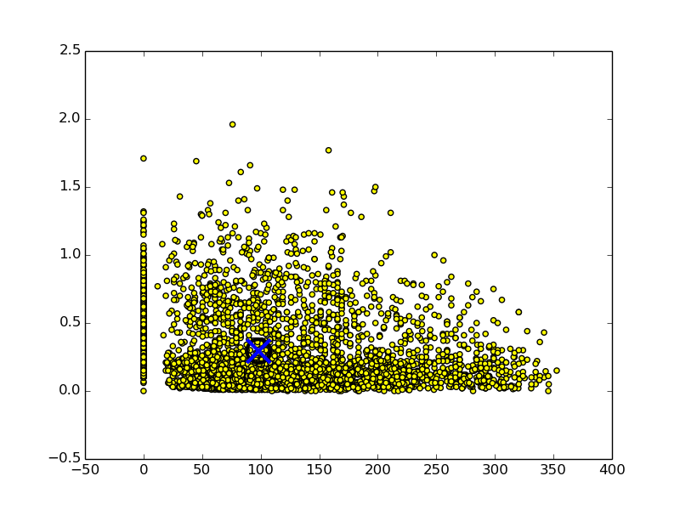

Screenshot 2:

ubuntu@ip-172-31-45-189:~/pro8$ python cluster.py

Choose Attribute from

1) latitude

2) longitude

3) depth

4) mag

5) nst

6) gap

7) dmin

8) rms

Enter value of attribute 1: depth

Enter value of attribute 2: mag

Enter number of clusters k: 2

Distance between cluster 0 and cluster 1 is: 109.891693703

No of points in cluster with green is: 4440

No of points in cluster with yellow is: 559

Cluster Created, Check folder for output file

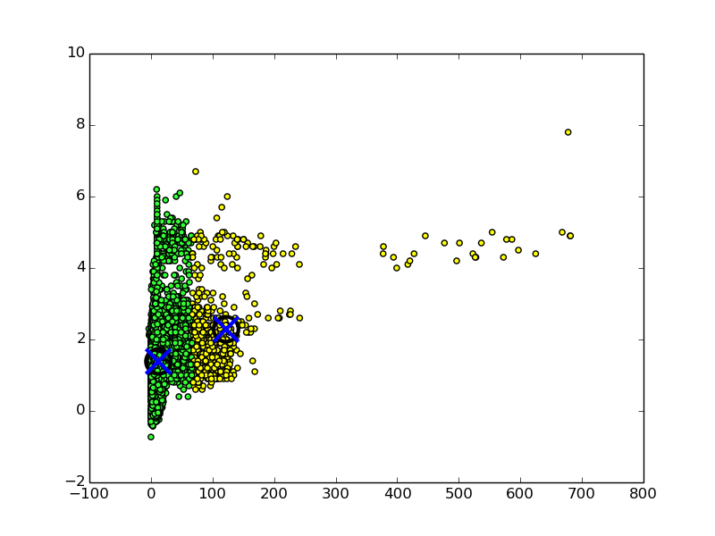

Screenshot 3:

ubuntu@ip-172-31-45-189:~/pro8$ python cluster.py

Choose Attribute from

1) latitude

2) longitude

3) depth

4) mag

5) nst

6) gap

7) dmin

8) rms

Enter value of attribute 1: latitude

Enter value of attribute 2: longitude

Enter number of clusters k: 3

Distance between cluster 0 and cluster 1 is: 286.353592352

Distance between cluster 0 and cluster 2 is: 245.30508095

Distance between cluster 1 and cluster 2 is: 44.7050746225

No of points in cluster with green is: 1637

No of points in cluster with red is: 3130

No of points in cluster with yellow is: 232

Cluster Created, Check folder for output file

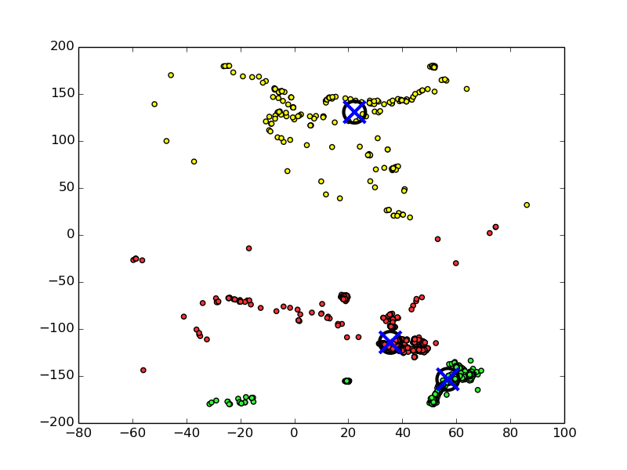

Screenshot 4:

ubuntu@ip-172-31-45-189:~/pro8$ python cluster.py

Choose Attribute from

1) latitude

2) longitude

3) depth

4) mag

5) nst

6) gap

7) dmin

8) rms

Enter value of attribute 1: latitude

Enter value of attribute 2: gap

Enter number of clusters k: 4

Distance between cluster 0 and cluster 1 is: 84.6479088046

Distance between cluster 0 and cluster 2 is: 160.92378227

Distance between cluster 0 and cluster 3 is: 99.8619567203

Distance between cluster 1 and cluster 2 is: 77.6552285748

Distance between cluster 1 and cluster 3 is: 184.436000068

Distance between cluster 2 and cluster 3 is: 260.64268833

No of points in cluster with blue is: 465

No of points in cluster with green is: 2203

No of points in cluster with red is: 1319

No of points in cluster with yellow is: 1012

Cluster Created, Check folder for output file

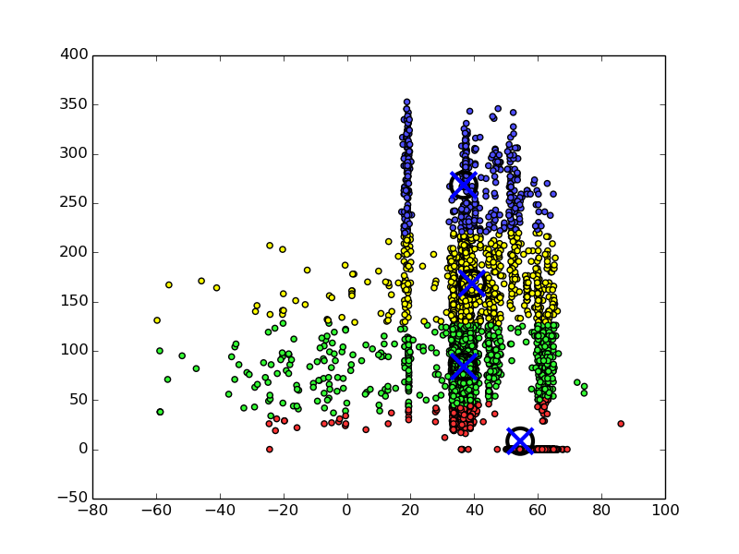

Screenshot 5:

Console Input Sample

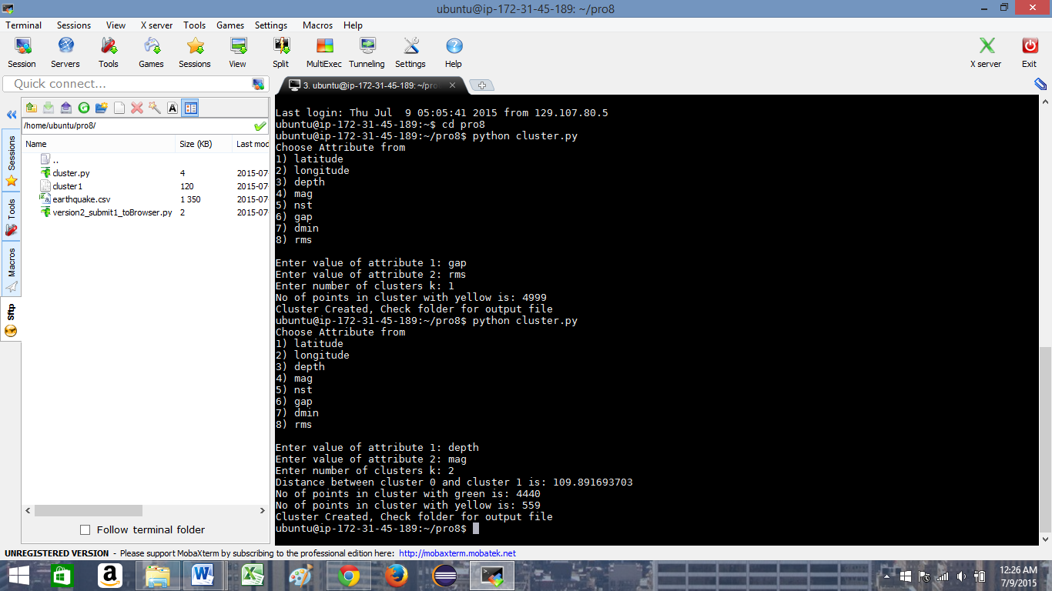

C) **References:**

- http://matplotlib.org/api/colors_api.html

- http://stackoverflow.com/questions/455612/limiting-floats-to-two-decimal-points

- http://scikit-learn.org/stable/modules/generated/sklearn.cluster.KMeans.html

- http://docs.scipy.org/doc/scipy/reference/cluster.vq.html

- https://datasciencelab.wordpress.com/2013/12/12/clustering-with-k-means-in-python/

- http://stackoverflow.com/questions/1545606/python-k-means-algorithm

- http://www.tutorialspoint.com/python/python_dictionary.htm

- https://docs.python.org/2/library/csv.html