**﻿#NAME: NIRZARI IYER**

**#ASSIGNMENT 9**

**#ID NO: 1001117633**

**#BATCH TIME: 6:00 to 8:00**

A) **READ ME and Explanation of code:**

 -Execute the Programming assignment 9 by executing python file bar.py in console

 -Open browser and type URL: http://ec2-52-26-244-170.us-west-2.compute.amazonaws.com:8089/bar1

(‘amazon EC2 instance public dns’:’port number’) (Reference: Last line of main.py (used bottle framework)) (Screenshot1) ( index1.html) (data.tsv)

-Open browser and type URL: http://ec2-52-26-244-170.us-west-2.compute.amazonaws.com:8089/bar2

(‘amazon EC2 instance public dns’:’port number’) (Reference: Last line of main.py (used bottle framework)) (Screenshot2) ( index2.html) (data.tsv)

-Open browser and type URL: http://ec2-52-26-244-170.us-west-2.compute.amazonaws.com:8089/scatter

(‘amazon EC2 instance public dns’:’port number’) (Reference: Last line of main.py (used bottle framework))(Screenshot3) ( index3.html) (data2.tsv)

- http://ec2-52-26-244-170.us-west-2.compute.amazonaws.com:8089/koutput.png for kmeans cluster

-Data files are in static folder

-tpl file is in view folder

B) **Results:**

Screenshot 1:

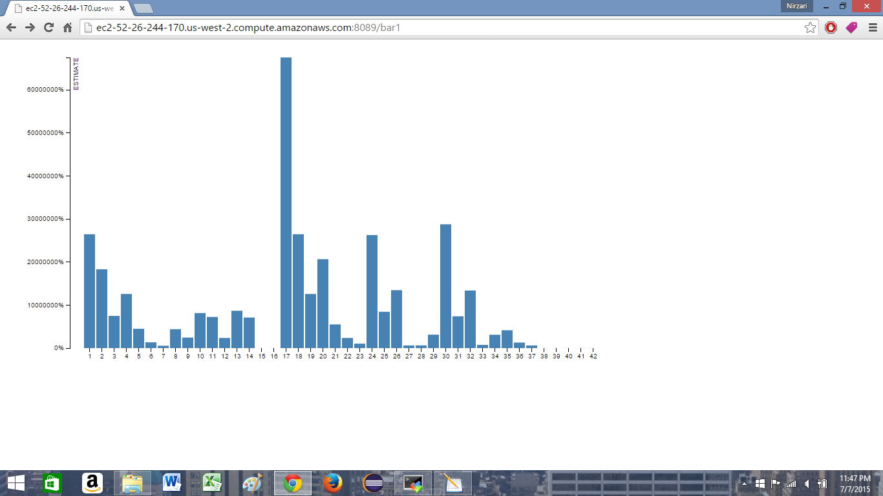

Screenshot 2:

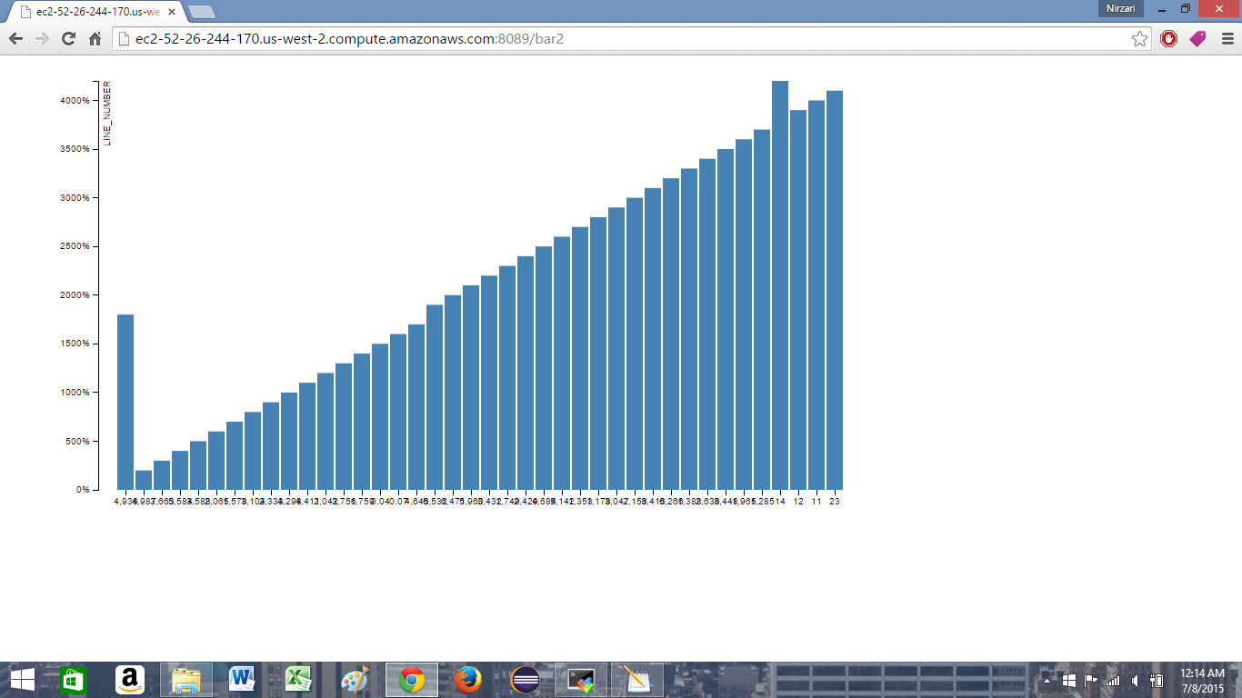

Screenshot 3:

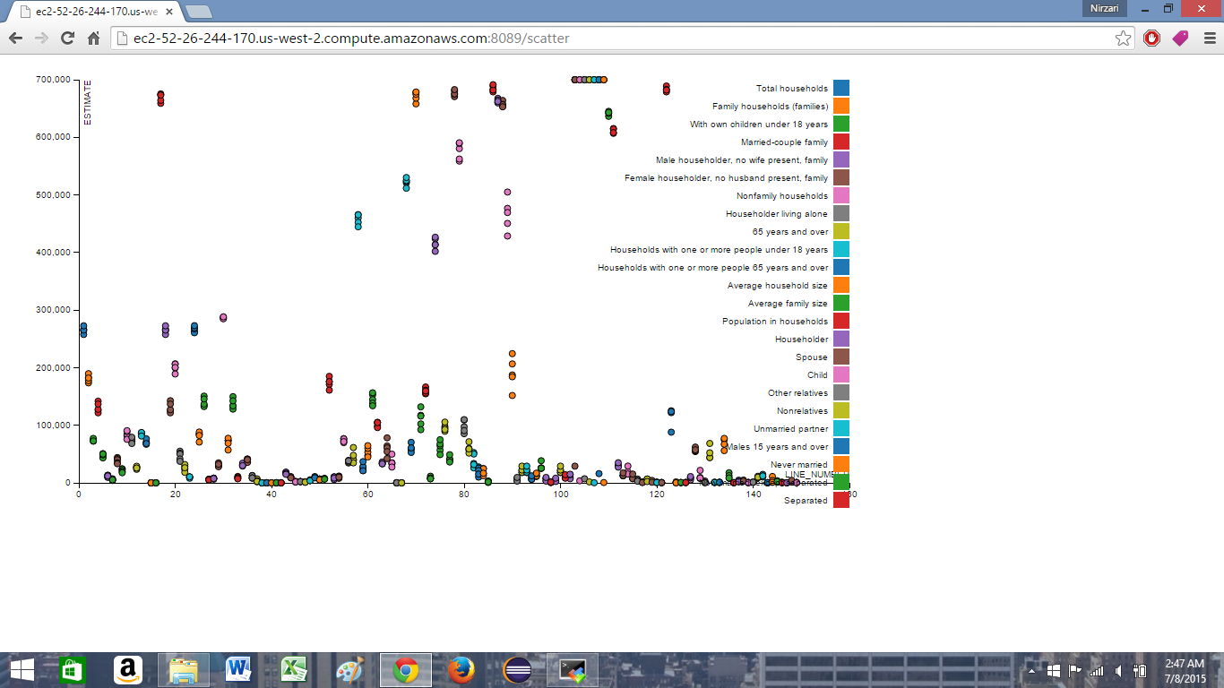

Screenshot 4:

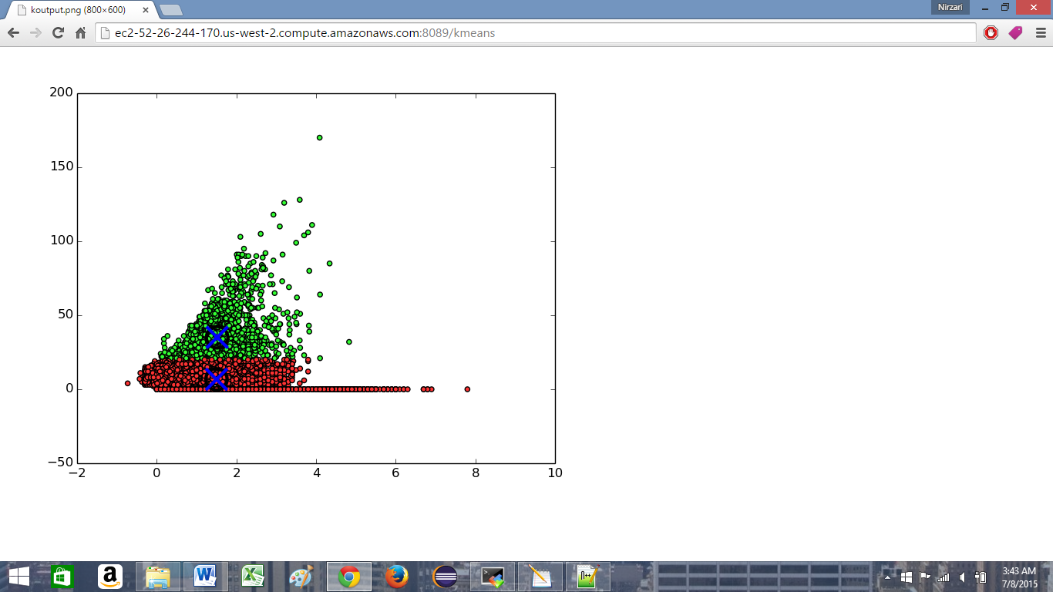

C) **References:**

- http://d3js.org/

- https://gist.github.com/mbostock/3887118

- http://api.prototypejs.org/ajax/Ajax/Request/

- http://www.w3schools.com/js/js_function_invocation.asp

- https://docs.python.org/2/tutorial/inputoutput.html

- http://stackoverflow.com/questions/6159900/correct-way-to-write-line-to-file-in-python

- https://docs.python.org/2/library/csv.html