**﻿#NAME: NIRZARI IYER**

**#ASSIGNMENT 5**

**#ID NO: 1001117633**

**#BATCH TIME: 6:00 to 8:00**

A) **READ ME and Explanation of code:**

 -Execute the Programming assignment 4 by executing python file main.py in console

 -Open browser and type URL: http://ec2-52-26-244-170.us-west-2.compute.amazonaws.com:8080/

(‘amazon EC2 instance public dns’:’port number’) (Reference: Last time of main.py (used bottle framework))

-Enter values for the respective field. If the result exists, it will show the data otherwise it won’t show the result.

-Time taken to execute the query using ajax request is also printed before the data.

B) **Results:**

Result 1:

This will show the result for hpi_type = ‘traditional’ and frequency = ‘monthly’ and yr = 2015 and location LIKE ‘%Div%’

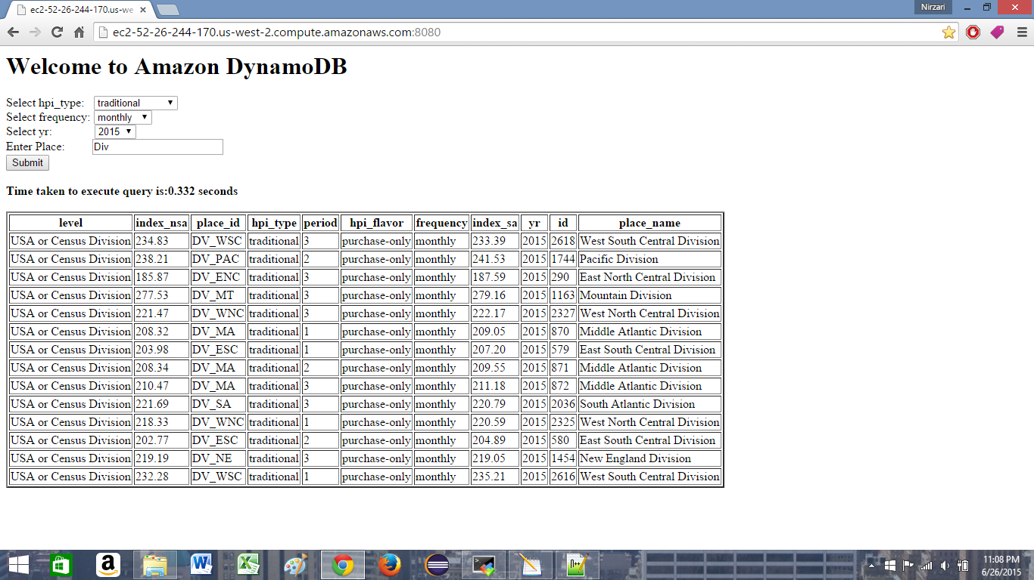

Result 2:

This will show the result for hpi_type = ‘distress-free’ and frequency = ‘quarterly’ and yr = 2015

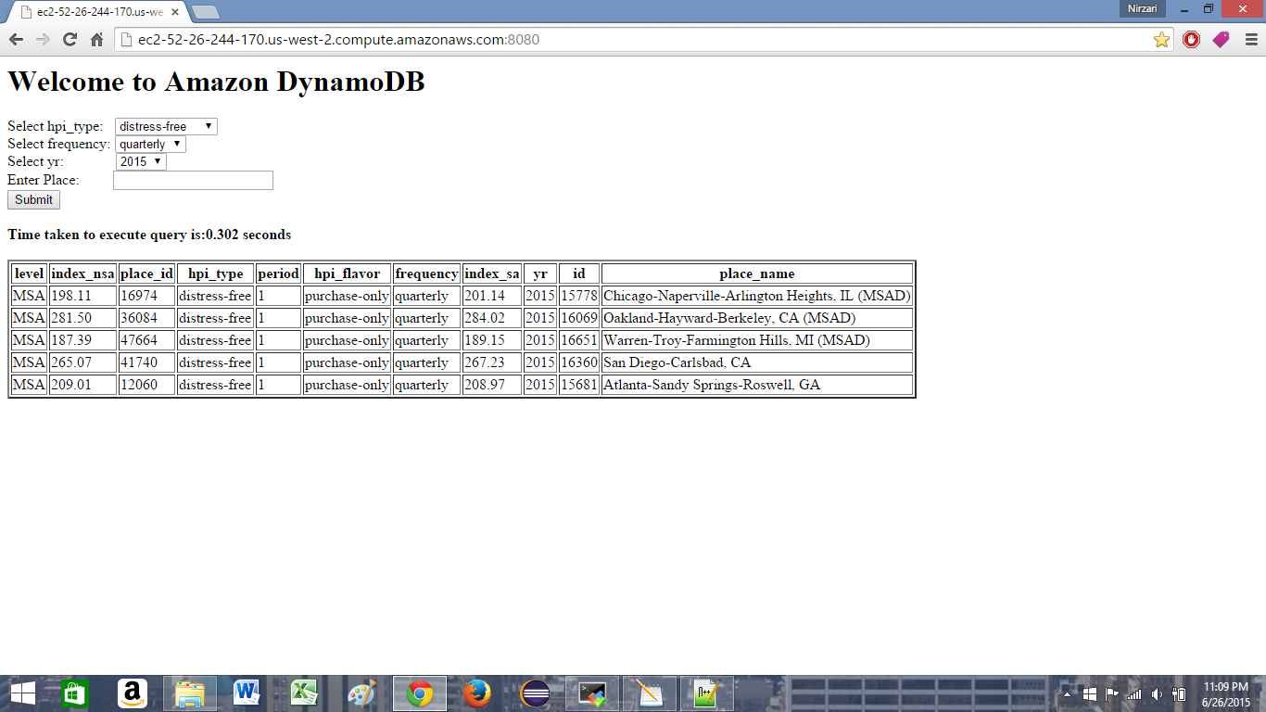

Result 3:

This will show the result for yr = 2015 and location LIKE ‘%TX%’

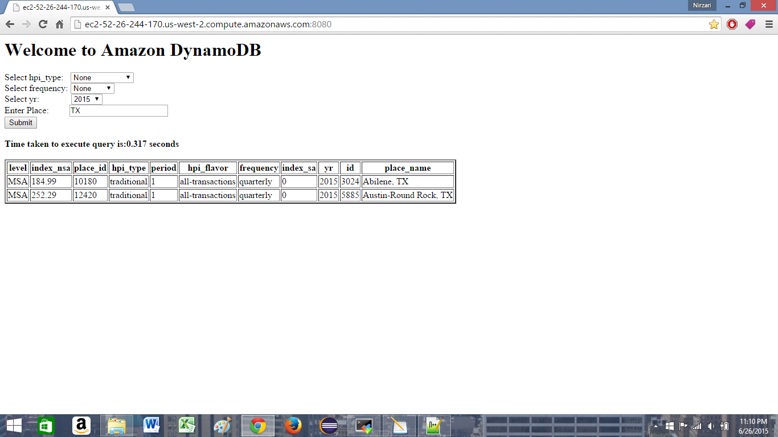

Result 4:

This will show the result for all records that has yr = 2014

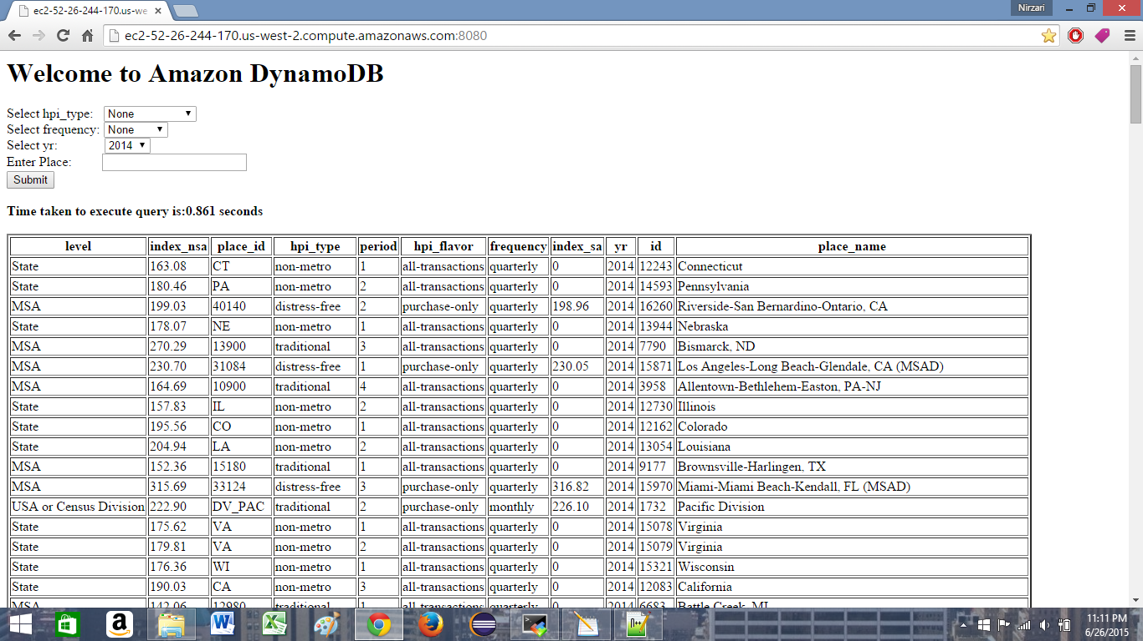

C) **References:**

-http://aws.amazon.com/developers/getting-started/python

-http://boto.readthedocs.org/en/latest/

- http://boto.readthedocs.org/en/latest/dynamodb2_tut.html#getting-an-item-accessing-data

- http://api.prototypejs.org/ajax/Ajax/Request/

- http://www.w3schools.com/js/js_function_invocation.asp

- http://stackoverflow.com/questions/28176056/inserting-items-in-dynamodb-range-key