  - CODEALPHA INTERNSHIP

Iris Flower Classification
  - Project design, findings, and reproducibility
Prepared for nisa3131
19 October 2026 · Asia/Dhaka
Standard design report layout approved by the user. Findings use the uploaded datasets and measured outputs from the accompanying projects.

Iris Flower Classification
REPOSITORY CodeAlpha_IrisFlowerClassification

1 Objective
Classify setosa, versicolor, and virginica flowers from sepal length, sepal width, petal length, and petal width. The task covers supervised classification, preprocessing, model comparison, and evaluation on held-out examples.

2 Data and provenance
Input: the user-supplied archive.zip, containing Iris.csv. The task document links to https://www.kaggle.com/datasets/saurabh00007/iriscsv. That link is cited as the assignment’s dataset reference; these analyses use the uploaded files rather than a new download. Original collection details and redistribution licensing were not independently verified. No dataset license is asserted.
Attribute | Observed data / treatment
Observations | 150; 50 per species
Predictors | Four flower measurements in centimetres; Id excluded
Data quality | No missing values or duplicate complete rows
Repeated measurements | 3 repeated measurement rows; 147 unique measurement groups
Duplicate treatment | Retain observations; keep identical measurement groups together in every split
Identical measurements can represent separate flowers, so they are retained. Their group identity is used for both the train/test partition and cross-validation to prevent the same measurement vector appearing on both sides. No identical measurement group has conflicting species labels.

3 Method and evaluation
With random seed 42, the first fold from a shuffled five-fold StratifiedGroupKFold creates 120 training and 30 held-out observations. Each held-out species has 10 examples, and no measurement group crosses the partition. Group constraints make stratification approximate in general.
Four candidates are compared: a most-frequent-class baseline, logistic regression, k-nearest neighbours, and a radial-basis support vector classifier. Numeric scaling is inside each estimator’s pipeline and therefore fit only on the training portion of each fold. Predefined grids are C = 0.1, 1, 10 for logistic regression and SVM, and k = 3, 5, 7 for neighbours.
Training-only, five-fold group-aware cross-validation selects hyperparameters using mean macro F1. Model-level ties use mean CV accuracy and then model name. The winner is fit on the full training partition and evaluated once on the held-out partition. The test score does not choose the model.

4 Results and interpretation
Candidate | CV macro F1  mean ± SD | CV accuracy
logistic regression | 0.9666 ± 0.0312 | 0.9667
knn | 0.9582 ± 0.0264 | 0.9583
rbf svm | 0.9582 ± 0.0264 | 0.9583
dummy most frequent | 0.1667 ± 0.0000 | 0.3333
Training cross-validation scores. The standard deviation describes variation across five folds, not a confidence interval.
Selected model: logistic regression (C = 10). Its mean CV macro F1 is 0.9666. Held-out accuracy and macro F1 are 1.000 and 1.000, respectively. The most-frequent baseline reaches 0.333 accuracy and 0.167 macro F1.
Species | Test n | Precision | Recall | F1
setosa | 10 | 1.000 | 1.000 | 1.000
versicolor | 10 | 1.000 | 1.000 | 1.000
virginica | 10 | 1.000 | 1.000 | 1.000
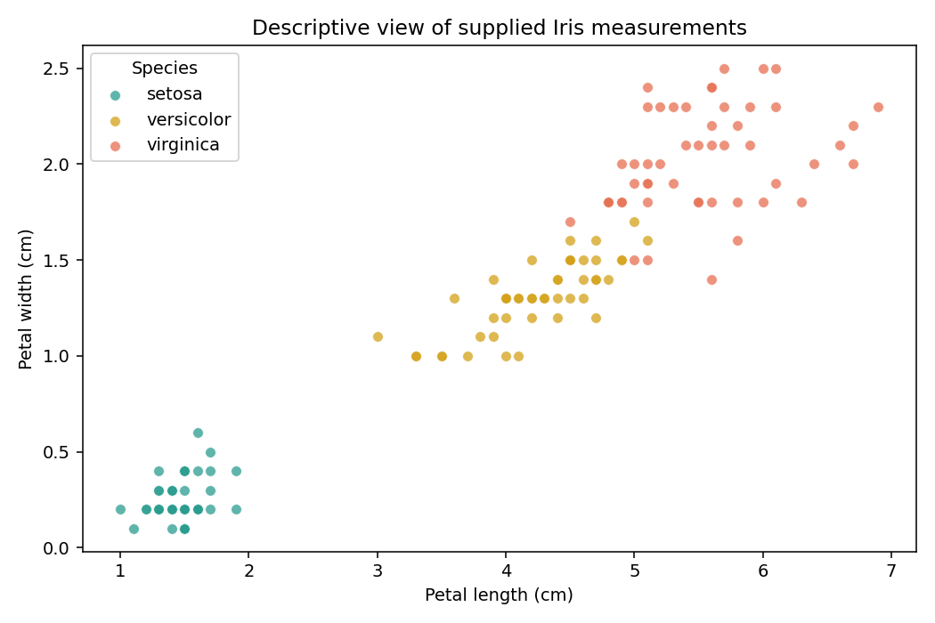
Figure 1. Descriptive petal measurements in the supplied dataset. Setosa is visibly separated; versicolor and virginica overlap more.
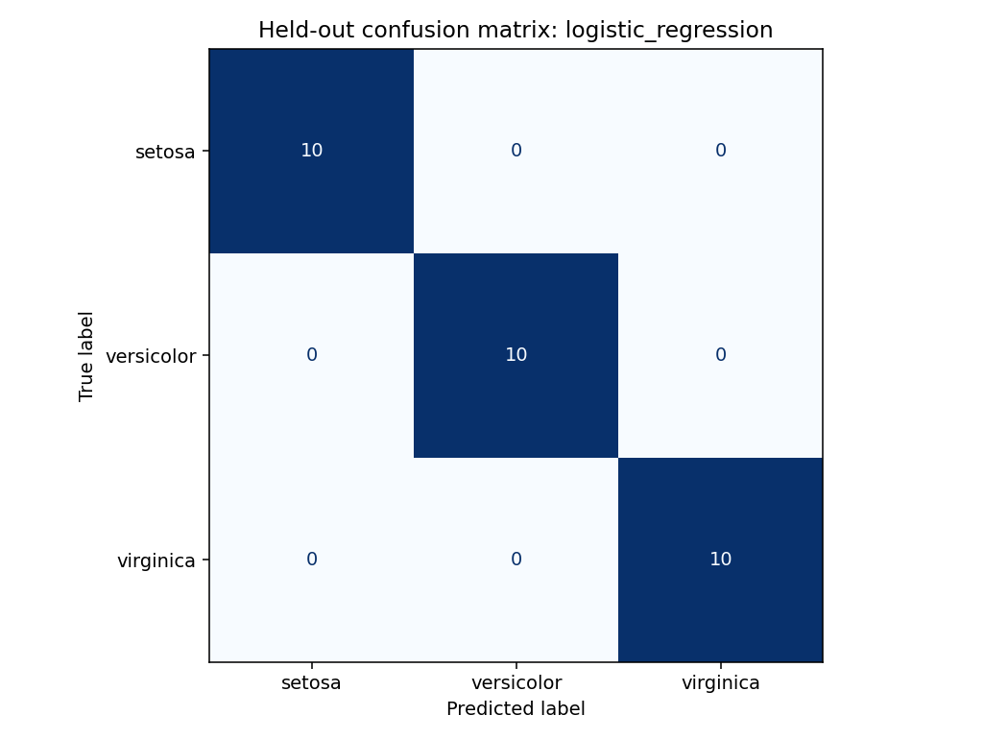
Figure 2. Held-out confusion matrix for the CV-selected model. All 30 test observations are correctly classified in this split.

5 Limitations and next steps
- A perfect score on 30 held-out examples has substantial sampling uncertainty. It does not establish performance on flowers from new locations, instruments, or populations.
- Grouping identical vectors reduces direct duplicate leakage; unrecorded biological or collection relationships may still remain.
- The labels and measurements are not independently verified. This is an educational model, with no external validation or deployment assessment.
- The next evaluation should use an independently collected, well-documented flower dataset and report uncertainty before relying on predictions operationally.

6 Reproducibility
Validation recorded on 19 October 2026: the delivered notebook executed 4 code cells with 0 recorded errors. The analysis pipeline and its built-in data/evaluation checks completed successfully. The project’s 2 unit tests also passed.
Install the pinned requirements and rerun from the repository root. The notebook calls the same analysis pipeline.
python -m venv .venv
. .venv/bin/activate
python -m pip install -r requirements.txt
python analysis.py
python -m unittest discover -s tests -v
outputs/metrics.json records versions, split sizes, selected parameters, and per-class evaluation. outputs/data_audit.json records the source SHA-256 and quality checks. split_assignments.csv and cv_results.csv expose group membership and every tried configuration; test_predictions.csv records held-out outcomes. The final estimator is fit on training data only.

