Derivatives and backpropagation

Derivatives

Univariate scalar function
For a univariate scalar function, the derivative is simply defined as the derivative of the function.

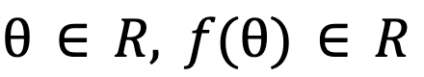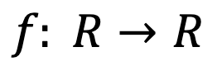

[[DRAWING]]

$\frac{df}{dθ}∈R$

Notes
$f: R→R$, $θ∈R, f(θ)∈R$

Multivariate scalar function
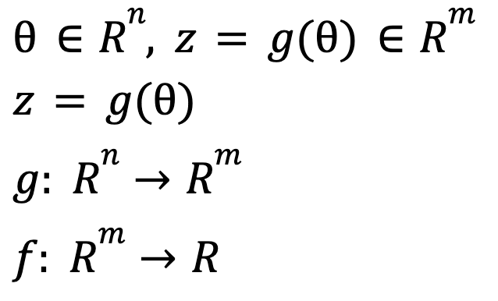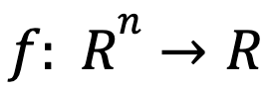

[[DRAWING]]
For a multivariate scalar function, the partial derivatives of $f: R^{n}→R$ can be arranged in its gradient:
${∇_{θ}}^{T}f=\left[\frac{∂f}{∂θ_{1}}, \frac{∂f}{∂θ_{2}}, ..., \frac{∂f}{∂θ_{n}}\right]∈R^{n}$.
The gradient is a column vector where each element is the partial derivative of $f$ with respect to the corresponding input dimension.

Notes
$f: R^{n}→R$, $θ∈R^{n}, f(θ)∈R$

Multivariate vector-valued function
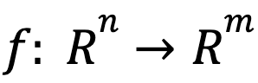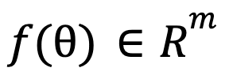

[[DRAWING]]
The partial derivatives of $f: R^{n}→R^{m}$can be arranged in its Jacobian matrix $\frac{∂f}{∂θ}∈R^{m × n}$.
$\frac{∂f}{∂θ}∈R^{m × n}$ contains
- In its rows, ${∇_{θ}}^{T}f_{i}∈R^{n}$ the transpose of the gradient of the components $f_{i}$ of $f$.
  - Each row $i$ contains the derivative of the component $f_{i}$ with respect to all the input dimensions.
- In its columns, $\frac{∂f}{∂θ_{j}}$ the partial derivatives of $f$ with respect to $θ_{j}$.
  - Each column $j$ contains the derivation of all the components of $f$ with respect to $θ_{j}$ (the input dimension $j$).
${\frac{∂f}{∂θ}}^{T}=\left[∇_{θ}f_{1}, ∇_{θ}f_{2}, ..., ∇_{θ}f_{m}\right]∈R^{n × m}$

When $m=1$
$f$ is a multivariate scalar function and its Jacobian is the transpose of its gradient.

When $m=n=1$
$f$ is an univariate scalar function.

Notes
$θ∈R^{n}, f(θ)∈R^{m}$

Chain rule

Univariate scalar function
When univariate scalar functions are composed, the derivative is the product of the intermediate derivatives.

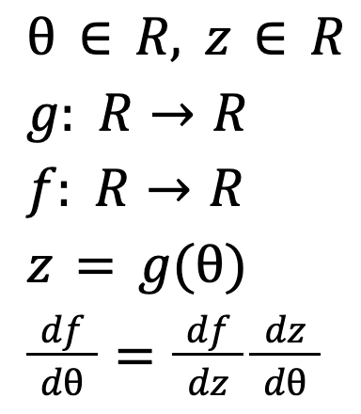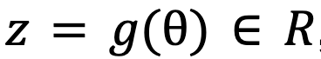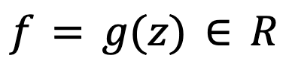

[[DRAWING]]

$\frac{df}{dθ}=\frac{df}{dz}\frac{dz}{dθ}$

Notes
$θ∈R, z=g(θ)∈R$, $g: R→R$, $f: R→R$, $z=g(θ)$, $f=g(z)∈R$

Multivariate scalar function

[[DRAWING]]

[[DRAWING]]

$f: R^{n}→R$ is a multivariate scalar function. Its partial derivatives can be arranged in its gradient.

${∇_{θ}}^{T}f=\left[\frac{∂f}{∂θ_{1}}, \frac{∂f}{∂θ_{2}}, ..., \frac{∂f}{∂θ_{n}}\right]∈R^{n}$
For each input dimension $θ_{i}$, the chain rule is applied to each intermediate dimension $z_{j}$ and the derivative is the sum over $j$.
Thus,
$\frac{∂f}{∂θ_{i}}=\sum_{j=1}^{m}{}\frac{∂f}{∂z_{j}}\frac{∂z_{j}}{∂θ_{i}}$
The expression of ${∇_{θ}}^{T}f$ above can also be expressed with:
- The Jacobian of $z$ with respect to $θ$: $\frac{∂z}{∂θ}∈R^{m × n}$
- The gradient of $f$ with respect to $z$: $∇_{z}f∈R^{m}$
$∇_{θ}f={\left(\frac{∂z}{∂θ}\right)}^{T}∇_{z}f$

Notes
$θ∈R^{n}, z=g(θ)∈R^{m}$, $z=g(θ)$, $g: R^{n}→R^{m}$, $f: R^{m}→R$

Backpropagation
The diagram below represents a simple neural network with layers $l$, $l+1$,..., $L$ and a loss function $E(\hat{y}, y)$.
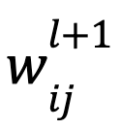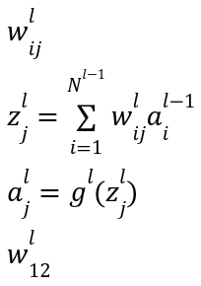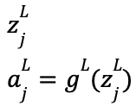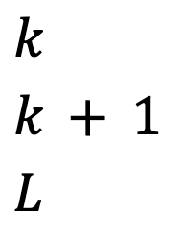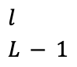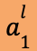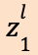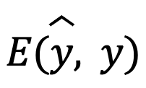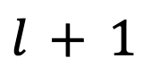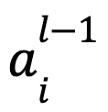

[[DRAWING]]

Generic form
The sections below explain how to compute the derivatives of $E$ with respect to:
- $a^{l}$, the activation of layer $l$
- $z^{l}$, the value of layer $l$ before the activation
- $w_{ij}^{l}$, the weight between neuron $i$ of layer $l-1$ and neuron $j$ of layer $l$

Derivative with respect to $a^{l}$
To compute the derivative of $E$ with respect to $a^{l}$, the activation of layer $l$, we express $E$ as the composition of $E(z^{l+1})$ and $z^{l+1}(a^{l},W^{l+1})$:

$E(\hat{y}, y)=E(...(z^{l+1}(a^{l},W^{l+1})))$

$E(a^{l})$ is thus a multivariate scalar function with intermediate variables $z^{l+1}$.
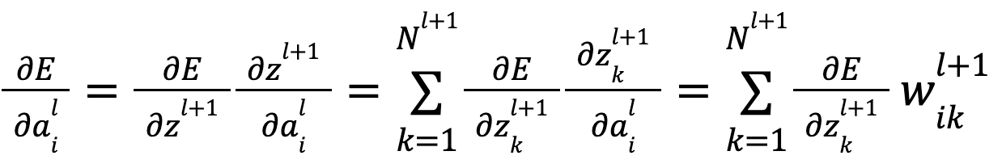

[[DRAWING]]
According to the chain rule for a multivariate scalar function, its derivative is given by its gradient:
$∇_{a^{l}} E=\left[\frac{∂E}{∂a_{i}^{l}}, ...\right]$
where $\frac{∂E}{∂a_{i}^{l}}=\frac{∂E}{∂z^{l+1}}\frac{∂z^{l+1}}{∂a_{i}^{l}}=\sum_{k=1}^{N^{l+1}}{}\frac{∂E}{∂z_{k}^{l+1}}\frac{∂z_{k}^{l+1}}{∂a_{i}^{l}}$ Multivariate chain rule
Moreover, $z_{j}^{l}=\sum_{i=1}^{N^{l-1}}{}w_{ij}^{l}a_{i}^{l-1}$, thus $\frac{∂z_{j}^{l}}{∂a_{i}^{l-1}}=w_{ij}^{l}$ and the expression above becomes:
$\frac{∂E}{∂a_{i}^{l}}=\sum_{k=1}^{N^{l+1}}{}\frac{∂E}{∂z_{k}^{l+1}}{ w}_{ik}^{l+1}$

[[DRAWING]]

Derivative with respect to $z^{l}$
Similarly, we can express $E$ as the composition of $E(a^{l})$ and $a^{l}(z^{l})$:

$E(\hat{y}, y)=E(...z^{l+1}(a^{l}(z^{l}),W^{l+1})))$

$E(z^{l})$ is thus a multivariate scalar function and its derivative is given by its gradient:
$∇_{z^{l}} E=\left[\frac{∂E}{∂z_{i}^{l}}, ...\right]$
Notice also that each function $E(z_{i}^{l})$ can be expressed as the composition of $E(a_{i}^{l})$ and $a_{i}^{l}(z_{i}^{l})$.
Thus, the chain rule for univariate scalar functions can be applied:
$\frac{∂E}{∂z_{i}^{l}}=\frac{∂E}{∂a_{i}^{l}}\frac{∂a_{i}^{l}}{∂z_{i}^{l}}$ Scalar chain rule
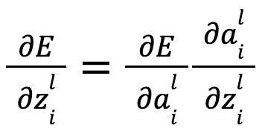

[[DRAWING]]

Derivative with respect to $w_{ij}^{l}$
Finally we can express $E$ as the composition of $E(z^{l})$ and $z^{l}(a^{l-1},W^{l})$:

$E(\hat{y}, y)=E(...z^{l}(a^{l-1},W^{l})))$

$E(W^{l})$ is thus a multivariate scalar function with intermediate variables $z^{l}$.

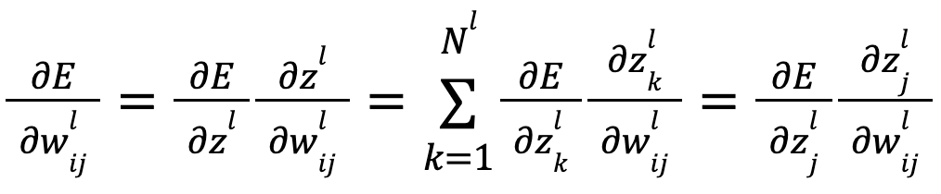

[[DRAWING]]
According to the chain rule for a multivariate scalar function, its derivative is given by its gradient:
$∇_{W^{l}} E=\left[\frac{∂E}{∂w_{ij}^{l}}, ...\right]$
where $\frac{∂E}{∂w_{ij}^{l}}=\frac{∂E}{∂z^{l}}\frac{∂z^{l}}{∂w_{ij}^{l}}=\sum_{k=1}^{N^{l}}{}\frac{∂E}{∂z_{k}^{l}}\frac{∂z_{k}^{l}}{∂w_{ij}^{l}}=\frac{∂E}{∂z_{j}^{l}}\frac{∂z_{j}^{l}}{∂w_{ij}^{l}}$ Multivariate chain rule

[[DRAWING]]
Moreover, $z_{k}^{l}=\sum_{i=1}^{N^{l-1}}{}w_{ik}^{l}a_{i}^{l-1}$
Thus $\frac{∂z_{k}^{l}}{∂w_{ij}^{l}}=0$ for $k≠j$
And the expression above becomes:
$\frac{∂E}{∂w_{ij}^{l}}=\frac{∂E}{∂z_{j}^{l}}\frac{∂z_{j}^{l}}{∂w_{ij}^{l}}$

[[DRAWING]]

Layer $L$

Derivative wrt $a^{L}$
$E(\hat{y}, y)=E(a^{L},y)$
$E$ is a multivariate real value function $E: R^{N^{L}}→R$
$N^{l}$: number of neurons in layer $l$
The derivative of $E wrt a^{L}$ is thus a gradient of dimension $R^{N^{L}}$
$∇_{a^{L}} E=\left[\frac{∂E}{∂a_{I}^{L}},\frac{∂E}{∂a_{2}^{L}}, ...,\frac{∂E}{∂a_{i}^{L}}, ...\right]$ Gradient of a multivariate function

Derivative wrt $z^{L}$
$E(\hat{y}, y)=E(a^{L}(z^{L}),y)$
$∇_{z^{L}} E=\left[\frac{∂E}{∂z_{I}^{L}},\frac{∂E}{∂z_{2}^{L}}, ...,\frac{∂E}{∂z_{i}^{L}}, ...\right]$ Gradient of a multivariate function
$a_{i}^{L}=a_{i}^{L}(z_{i}^{L})$ Scalar function
$E(\hat{y}, y)=E(a_{i}^{L}(z_{i}^{L}),y)$
$\frac{∂E}{∂z_{i}^{L}}=\frac{∂E}{∂a_{i}^{L}}\frac{∂a_{i}^{L}}{∂z_{i}^{L}}$ Scalar chain rule

Derivative wrt $w_{ij}^{L}$
$E(\hat{y}, y)=E(a^{L}(z^{L}(a^{L-1},W^{L},b^{L})))$
$∇_{W^{L}} E=\left[\frac{∂E}{∂w_{ij}^{L}}, ...\right]$ Gradient of a multivariate function
$\frac{∂E}{∂w_{ij}^{L}}=\sum_{k=1}^{N^{L}}{}\frac{∂E}{∂z_{k}^{L}}\frac{∂z_{k}^{L}}{∂w_{ij}^{L}}=\frac{∂E}{∂z_{j}^{L}}\frac{∂z_{j}^{L}}{∂w_{ij}^{L}}$ Multivariate chain rule
because $\frac{∂z_{k}^{L}}{∂w_{ij}^{L}}=0$ for $k≠j$

Layer $L-1$

Derivative wrt $a^{L-1}$
$E(\hat{y}, y)=E(a^{L}(z^{L}(a^{L-1},W^{L},b^{L})))$
$∇_{a^{L-1}} E=\left[\frac{∂E}{∂a_{i}^{L-1}}, ...\right]$
$\frac{∂E}{∂a_{i}^{L-1}}=\sum_{k=1}^{N^{L}}{}\frac{∂E}{∂z_{k}^{L}}\frac{∂z_{k}^{L}}{∂a_{i}^{L-1}}=\sum_{k=1}^{N^{L}}{}\frac{∂E}{∂z_{k}^{L}}{ w}_{ik}^{L}$ Multivariate chain rule
$z_{j}^{l}=\sum_{i=1}^{N^{l-1}}{}w_{ij}^{l}a_{i}^{l-1}$
$\frac{∂z_{j}^{l}}{∂a_{i}^{l-1}}=w_{ij}^{l}$

Derivative wrt $z^{L-1}$
$E(\hat{y}, y)=E(a^{L}(z^{L}(a^{L-1}(z^{L-1}),W^{L},b^{L})))$
$∇_{z^{L-1}} E=\left[\frac{∂E}{∂z_{i}^{L-1}}, ...\right]$
$\frac{∂E}{∂z_{i}^{L-1}}=\frac{∂E}{∂a_{i}^{L-1}}\frac{∂a_{i}^{L-1}}{∂z_{i}^{L-1}}$ Scalar chain rule

Derivative wrt $w_{ij}^{L-1}$
$E(\hat{y}, y)=E(a^{L}(z^{L}(a^{L-1}(z^{L-1}(a^{L-2},W^{L-1},b^{L-1})),W^{L},b^{L})))$
$∇_{W^{L-1}} E=\left[\frac{∂E}{∂w_{ij}^{L-1}}, ...\right]$ Gradient of a multivariate function
$\frac{∂E}{∂w_{ij}^{L-1}}=\sum_{k=1}^{N^{L-1}}{}\frac{∂E}{∂z_{k}^{L-1}}\frac{∂z_{k}^{L-1}}{∂w_{ij}^{L-1}}=\frac{∂E}{∂z_{j}^{L-1}}\frac{∂z_{j}^{L-1}}{∂w_{ij}^{L-1}}$ Multivariate chain rule
because $\frac{∂z_{k}^{L-1}}{∂w_{ij}^{L-1}}=0$ for $k≠j$

Layer $l$

Derivative wrt $a^{l}$
$E(\hat{y}, y)=E(...(z^{l+1}(a^{l},W^{l+1},b^{l+1})))$
$∇_{a^{l}} E=\left[\frac{∂E}{∂a_{i}^{l}}, ...\right]$
$\frac{∂E}{∂a_{i}^{l}}=\sum_{k=1}^{N^{l+1}}{}\frac{∂E}{∂z_{k}^{l+1}}\frac{∂z_{k}^{l+1}}{∂a_{i}^{l}}=\sum_{k=1}^{N^{l+1}}{}\frac{∂E}{∂z_{k}^{l+1}}{ w}_{ik}^{l+1}$ Multivariate chain rule
$z_{j}^{l}=\sum_{i=1}^{N^{l-1}}{}w_{ij}^{l}a_{i}^{l-1}$
$\frac{∂z_{j}^{l}}{∂a_{i}^{l-1}}=w_{ij}^{l}$

Derivative wrt $z^{l}$
$E(\hat{y}, y)=E(...z^{l+1}(a^{l}(z^{l}),W^{l},b^{l})))$
$∇_{z^{l}} E=\left[\frac{∂E}{∂z_{i}^{l}}, ...\right]$
$\frac{∂E}{∂z_{i}^{l}}=\frac{∂E}{∂a_{i}^{l}}\frac{∂a_{i}^{l}}{∂z_{i}^{l}}$ Scalar chain rule

Derivative wrt $w_{ij}^{l}$
$E(\hat{y}, y)=E(...z^{l}(a^{l-1},W^{l},b^{l})))$
$∇_{W^{l}} E=\left[\frac{∂E}{∂w_{ij}^{l}}, ...\right]$ Gradient of a multivariate function
$\frac{∂E}{∂w_{ij}^{l}}=\sum_{k=1}^{N^{l}}{}\frac{∂E}{∂z_{k}^{l}}\frac{∂z_{k}^{l}}{∂w_{ij}^{l}}=\frac{∂E}{∂z_{j}^{l}}\frac{∂z_{j}^{l}}{∂w_{ij}^{l}}$ Multivariate chain rule
because $\frac{∂z_{k}^{l}}{∂w_{ij}^{l}}=0$ for $k≠j$

Notes

$a_{i}^{l-1}$
$w_{ij}^{l}$
$z_{j}^{l}=\sum_{i=1}^{N^{l-1}}{}w_{ij}^{l}a_{i}^{l-1}$
$a_{j}^{l}=g^{l}(z_{j}^{l})$
$w_{12}^{l}$
$a_{1}^{l}$
$z_{1}^{l}$
$w_{ij}^{l+1}$
$z_{j}^{l+1}$
$a_{j}^{l+1}=g^{l+1}(z_{j}^{l+1})$
$z_{j}^{L}$
$a_{j}^{L}=g^{L}(z_{j}^{L})$
$l$
${l+1}^{}$
$L-1$
$L$

Sources
https://brilliant.org/wiki/backpropagation/

