Interpretations of correlation and inner product
As seen in the Cross-correlation, Correlation, Convolution, Inner product and Fourier coefficients blog post, the $\int_{-∞}^{∞}{}f(t)\underline{g(t)}dt$ quantity for two complex-valued functions $f$ and $g$ can be seen as:
- The correlation $(f⋆g)(0)$ between $f$ and $g$.
- The $L^{2}$ inner product $〈f,g〉$ between $f$ and $g$.
  - Which can itself be seen as the inner product between two infinite-dimensional real or complex vectors.
- $〈f,g〉=(f⋆g)(0)=\int_{-∞}^{∞}{}f(t)\underline{g(t)}dt$
This blog post explores how the above quantity $〈f,g〉=(f⋆g)(0)=\int_{-∞}^{∞}{}f(t)\underline{g(t)}dt$ can be interpreted from Correlation and Inner product point of views.

Correlation
The correlation between two complex-valued functions $f$ and $g$ is
- $〈f;g〉=(f⋆g)(0)=\int_{-∞}^{∞}{}f(t)\underline{g(t)}dt=\int_{-∞}^{∞}{}\left|f(t)\right| \left|g(t)\right| e^{i(arg(f(t))-arg(g(t)))} dt$
- It can be interpreted as the weighted sum of the pointwise similarities of $f$ and $g$ where:
  - The pointwise similarity between two points $f(t)$ and $g(t)$ is defined as the phase alignment complex vector $e^{i(arg(f(t))-arg(g(t)))}$.
  - The weights are the products of the magnitudes $\left|f(t)\right| \left|g(t)\right|$.
- The correlation is the weighted sum of the pointwise phase alignment complex vectors.
- It is a complex number.
- Its phase represents the global phase alignment between $f$ and $g$.
- Its magnitude represents how similar $f$ and $g$ are.
  - If $f$ and $g$ have almost always the same phase alignment, the phase alignment vectors $e^{i(arg(f(t))-arg(g(t)))}$ all point in a similar direction and their weighted sum has a large magnitude.
  - Otherwise they don’t sum constructively and their weighted sum has a small magnitude.
  - The magnitude tends towards $0$ if there is no correlation between the pointwise phases of $f(t)$ and $g(t)$.

Why use the conjugate?
- Because without the conjugate, instead of summing the phase alignment vectors $e^{i(arg(f(t))-arg(g(t)))}$, the correlation would sum vectors $e^{i(arg(f(t))+arg(g(t)))}$ which rotate even if $f$ and $g$ are equal.
- For example if $f$ is a rotating vector $e^{it}$, its correlation with itself would be $\int_{-∞}^{∞}{}e^{i2t}dt=0$.

Real-valued functions
- If $f$ and $g$ are real
  - $arg(f(t))$ and $arg(g(t))$ can only be 0, $π$ or undefined (if $f(t)=0$ or $g(t)=0$).
  - The phase alignment vectors $e^{i(arg(f(t))-arg(g(t)))}$ can only be 1, -1 or undefined.
  - The correlation is the weighted sum of the pointwise sign agreements between $f$ and $g$.

Inner product
The $L^{2}$ inner product between two complex-valued functions $f$ and $g$ is
- $〈f,g〉=\int_{-∞}^{∞}{}f(t)\underline{g(t)}dt$.

Cauchy-Schwarz inequality
The Cauchy-Schwarz inequality states the following 3 equivalent forms
- ${\left|〈u,v〉\right|}^{2}≤{‖u‖}^{2}{ ‖v‖}^{2}$
- ${\left|〈u,v〉\right|}^{2}≤〈u,u〉〈v,v〉$
- $\left|〈u,v〉\right|≤‖u‖ ‖v‖$
The inequalities above turn to equalities if and only if $u$ and $v$ are collinear, i.e. $u=λv$ (see When does the Cauchy-Schwarz inequality turn to equality? below).
This means that for two vectors $u$ and $v$ with constant norms, their inner product is maximal when $u$ and $v$ are collinear, i.e. $u=λv$.

Interpretations

Real-valued functions
- $〈u,v〉$ is maximal when $u$ and $v$ are equal up to a real scaling factor $λ$,
  - i.e. when they are proportional.

Complex-valued functions
- $〈u,v〉$ is maximal when $u$ and $v$ are equal up to a complex scaling factor $λ$,
  - i.e. when they are complex proportional,
  - i.e. when,
    - their point-wise magnitudes are equal up to a scaling factor,
      - $\left|u(t)\right|=\left|λ\right|\left|v(t)\right|$
    - and their point-wise phase difference is constant
      - $arg(f(t))-arg(g(t))=arg(λ)$
  - i.e. their point-wise magnitudes are scaled and their point-wise phases are shifted by a constant offset.

When does the Cauchy-Schwarz inequality turn to equality?
The proof that the Cauchy-Schwarz inequality turn into an equality if and only if $u$ and $v$ are collinear, i.e. $u=λv$ can be done in two steps.
- Proof for $u=λv⇒〈u,v〉=‖u‖ ‖v‖$
  - $\left|〈u,v〉\right|=\left|〈λv,v〉\right|=\left|λ\right|{‖v‖}^{2}=\left|λ\right|‖v‖‖v‖=‖λv‖‖v‖=‖u‖‖v‖$
- Proof for $〈u,v〉=‖u‖ ‖v‖⇒u=λv$
  - Let $w=u-\frac{〈u,v〉}{{‖v‖}^{2}}v$
${‖w‖}^{2}={‖u-\frac{〈u,v〉}{{‖v‖}^{2}}v‖}^{2}$
$=〈u-\frac{〈u,v〉}{{‖v‖}^{2}}v, u-\frac{〈u,v〉}{{‖v‖}^{2}}v〉$
$=〈u, u〉-\frac{\underline{〈u,v〉}}{{‖v‖}^{2}}〈u,v〉-\frac{〈u,v〉}{{‖v‖}^{2}}〈v, u〉+\frac{〈u,v〉\underline{〈u,v〉}}{{‖v‖}^{4}}〈v,v〉$
$={‖u‖}^{2}-\frac{{\left|〈u,v〉\right|}^{2}}{{‖v‖}^{2}}-\frac{〈u,v〉}{{‖v‖}^{2}}\underline{〈u,v〉}+\frac{{\left|〈u,v〉\right|}^{2}}{{‖v‖}^{4}}{‖v‖}^{2}$
$={‖u‖}^{2}-\frac{{\left|〈u,v〉\right|}^{2}}{{‖v‖}^{2}}-\frac{{\left|〈u,v〉\right|}^{2}}{{‖v‖}^{2}}+\frac{{\left|〈u,v〉\right|}^{2}}{{‖v‖}^{2}}$
$={‖u‖}^{2}-\frac{{\left|〈u,v〉\right|}^{2}}{{‖v‖}^{2}}$
  - And thus, because $\left|〈u,v〉\right|=‖u‖‖v‖$
${‖w‖}^{2}={‖u‖}^{2}-\frac{{\left|〈u,v〉\right|}^{2}}{{‖v‖}^{2}}={‖u‖}^{2}-\frac{{‖u‖}^{2} {‖v‖}^{2}}{{‖v‖}^{2}}=0$
  - Thus, $w=0$.
  - Thus, $u=\frac{〈u,v〉}{{‖v‖}^{2}}v$.
  - Thus, $u$ and $v$ are collinear ($u=λv$).
- Hence, $\left|〈u,v〉\right|=‖u‖ ‖v‖⇔u=λv$.

Application to the Fourier transform
The Fourier coefficients $F(ξ)=〈f,e^{i2πξτ}〉=(f∗e^{i2πξτ})(0)=\int_{-∞}^{∞}{}f(τ)e^{-i2πξτ}dτ$ is thus,
- A complex number
- Its phase represents the global phase alignment between $f$ and $e^{i2πξt}$.
- Its magnitude represents how similar $f$ and $e^{i2πξt}$ are.
However, $f$ is real thus,
- The $L^{2}$ inner product is never maximal.
- $f$ and $e^{i2πξt}$ are never collinear.
- But if $f(t)=sin(2πξt)$
  - $f$ and $e^{i2πξt}$ have similar phase alignments.
  - The phase alignment vectors don’t sum maximally but they sum constructively.
  - Their weighted sum has a large magnitude even though it is not maximal.

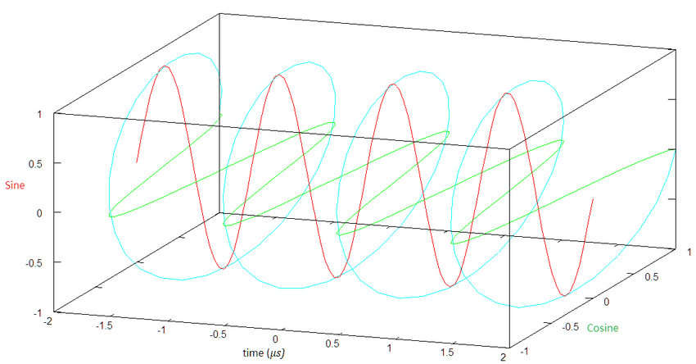

Conclusion
The $\int_{-∞}^{∞}{}f(t)\underline{g(t)}dt$ expression is equal to
- The correlation $(f⋆g)(0)$ between $f$ and $g$.
- The $L^{2}$ inner product $〈f,g〉$ between $f$ and $g$.

Correlation
From the correlation point of view, we can see that
- It is the weighted sum of the pointwise phase alignment complex vectors.
- It is a complex number.
- Its phase represents the global phase alignment between $f$ and $g$.
- Its magnitude represents how similar $f$ and $g$ are.

Real-valued functions
If $f$ and $g$ are real
- The phase alignment vectors can only be 1, -1 or undefined.
- The correlation is the weighted sum of the pointwise sign agreements between $f$ and $g$.

Inner product
From the inner product point of view, the Cauchy-Schwarz inequality tells us that $〈f,g〉$ is maximal when $f$ and $g$ are collinear, i.e. $f=λg$.

Real-valued functions
- $〈f,g〉$ is maximal when $f$ and $g$ are equal up to a real scaling factor $λ$,
  - i.e. when they are proportional.

Complex-valued functions
- $〈f,g〉$ is maximal when $f$ and $g$ are equal up to a complex scaling factor $λ$,
  - i.e. when their point-wise magnitudes are scaled and their point-wise phases are shifted by a constant offset.

Application to the Fourier transform
The Fourier coefficients $F(ξ)=〈f,e^{i2πξτ}〉=(f∗e^{i2πξτ})(0)=\int_{-∞}^{∞}{}f(τ)e^{-i2πξτ}dτ$ is thus,
- A complex number
- Its phase represents the global phase alignment between $f$ and $e^{i2πξt}$.
- Its magnitude represents how similar $f$ and $e^{i2πξt}$ are.
However, $f$ is real thus,
- The $L^{2}$ inner product is never maximal.
- $f$ and $e^{i2πξt}$ are never collinear.
- But if $f(t)=sin(2πξt)$
  - $f$ and $e^{i2πξt}$ have similar phase alignments.
  - The phase alignment vectors don’t sum maximally but they sum constructively.
  - Their weighted sum has a large magnitude even though it is not maximal.

Old
Vectors differing by a constant phase are geometrically collinear in a complex Hilbert space, not orthogonal.

