SoundStream

Introduction
The SoundStream: An End-to-End Neural Audio Codec paper proposes a Neural Audio Codec that
- Compresses audio using a neural network,
- Is an autoencoder with quantized latent vectors,
- Is trained with a perceptual loss (spectral distance).

Architecture
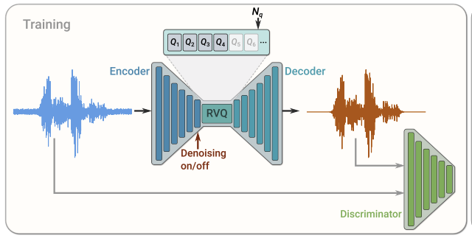
Architecture overview from the paper
- Single channel input $x ∈R^{T}$
- Encoder
  - Maps $x$ to a sequence of $S$ embeddings $e$.
- Residual vector quantizer
  - Replaces each embedding by its RQV quantization $RQV(e)$
    - Sum of the codebook vectors.
    - See Residual Vector Quantization.
- Decoder
  - Produces a lossy reconstruction of $x$ from the sequence of $S$ quantized embeddings $RQV(e)$.
- Discriminator
- The encoder, residual vector quantizer, decoder and discriminator are trained end-to-end
  - Discriminator loss
  - Generator loss
  - Perceptual reconstruction loss (spectral distance)
  - Feature matching loss
    - Features of the original and reconstructed signal in the discriminator layers.

Encoder
- Causal 1D convolutions.
- Down sampling via strided convolutions.

Residual Vector Quantizer

Training

Number $n_{q}$ of RQV levels
- RQV allows to reach the same bitrate as plain QV but with fewer codebook vectors.
  - See Residual Vector Quantization.
  - For a given number $N$ of codebook vectors in each RQV level,
    - The number $n_{q}$ of RQV levels controls the bitrate.
- During training, the number $n_{q}$ of RVQ levels is sampled uniformly in $[1; N_{q}]$ for each input sample.
  - The model learns to be robust to different bitrates.
    - i.e. the decoder learns to handle different quantities of information (in bits) per input vector $RQV(e)$.
- The dimensionality of the embeddings does not change with the bitrate.
  - The outputs of each RVQ level progressively reﬁnes the quantized embeddings $RQV(e)$ while keeping the same shape.
  - No architectural changes are needed in neither the encoder nor the decoder to accommodate different bitrates.

Codebook vectors
- The codebook vectors are learned.
- They are initialized with the centroids from a k-means algorithm run on the ﬁrst training batch.
- When a codebook vector has not been assigned any embedding for several batches, it is replaced by an embedding randomly sampled within the current batch.

Inference
- Compresses the representation to a target bitrate expressed in bits/second (bps).
  - The number $n_{q}$ of RQV levels is set according to the target bitrate.
- The indices of the selected codebook vectors are only used during inference.
  - They are produced by the encoder,
  - and transmitted to the decoder.
  - The embeddings $RQV(e)$ are reconstructed from the indices and the codebook,
  - and taken as inputs by the decoder.

Decoder
- Mirrors the encoder architecture.
- Output signal with the same resolution as the input signal.

Discriminator
- The discriminator is composed of two discriminators
  - Wave-based discriminator.
    - 3 identical 1D convolution discriminators taking as inputs the reconstructed audio signal at 3 resolution scales:
      - Original resolution.
      - 2-times downsampled.
      - 4-times downsampled.
  - STFT-based discriminator (Short-Term Fourier Transform).

Metrics
- ViSQOL metric

Ablation studies
- The output quality is more affected by the size of the decoder than by the size of the encoder.

