1. SSIS package DataFlow

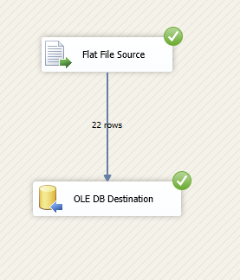

1. DataFlow MetaData showing the types and sizes of data in SSIS

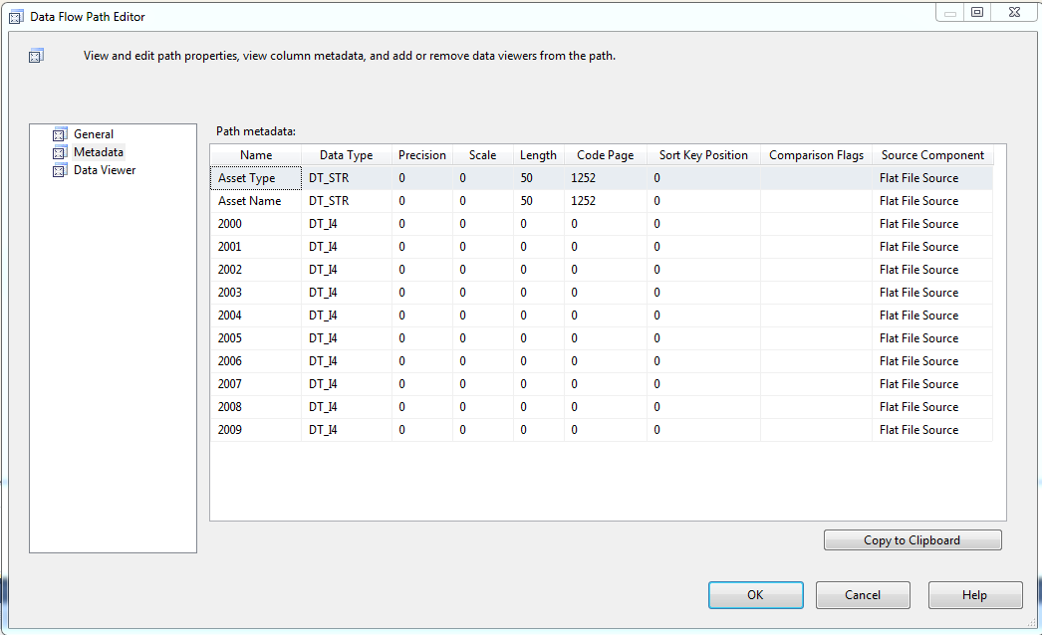

1. Table design view showing the types and sizes of columns in SQL Server

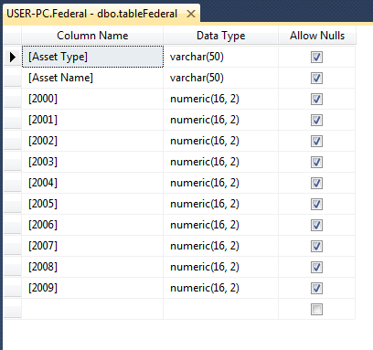

1. Result of the "Select \* from ..." query from your table after successfully running the SSIS package

