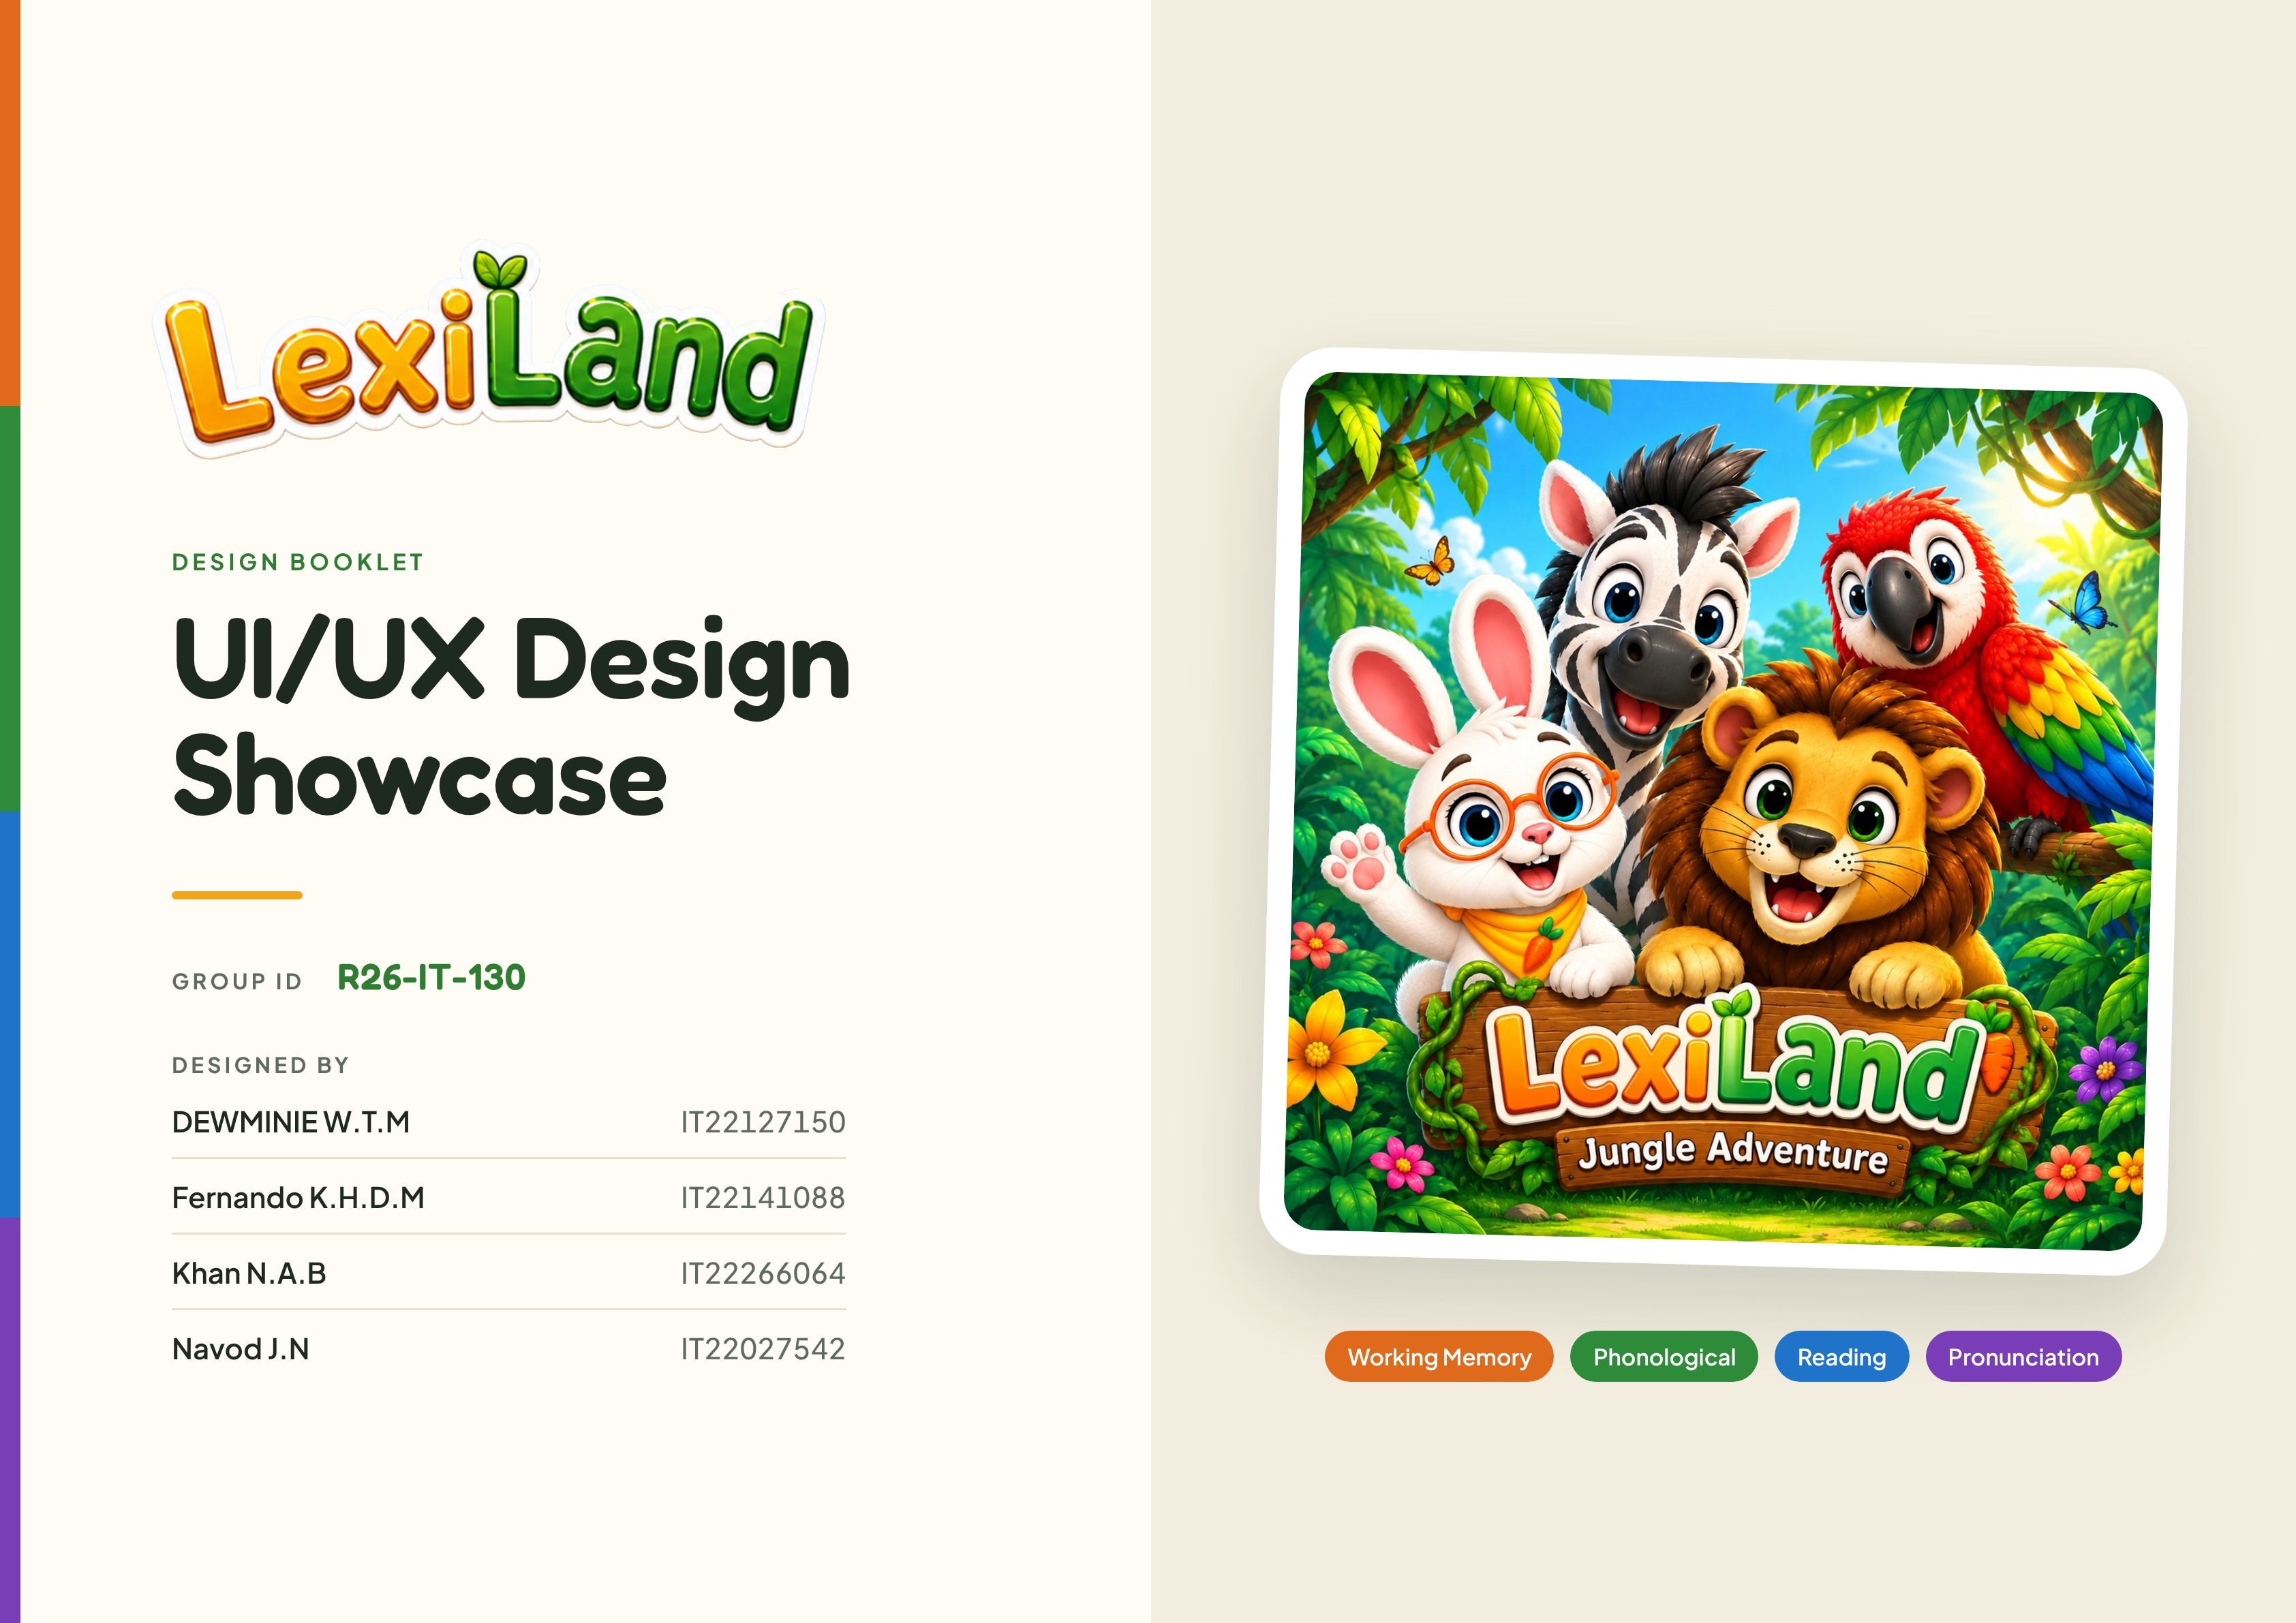

MAIN PLATFORM
Figure 01 – Sign Up Page
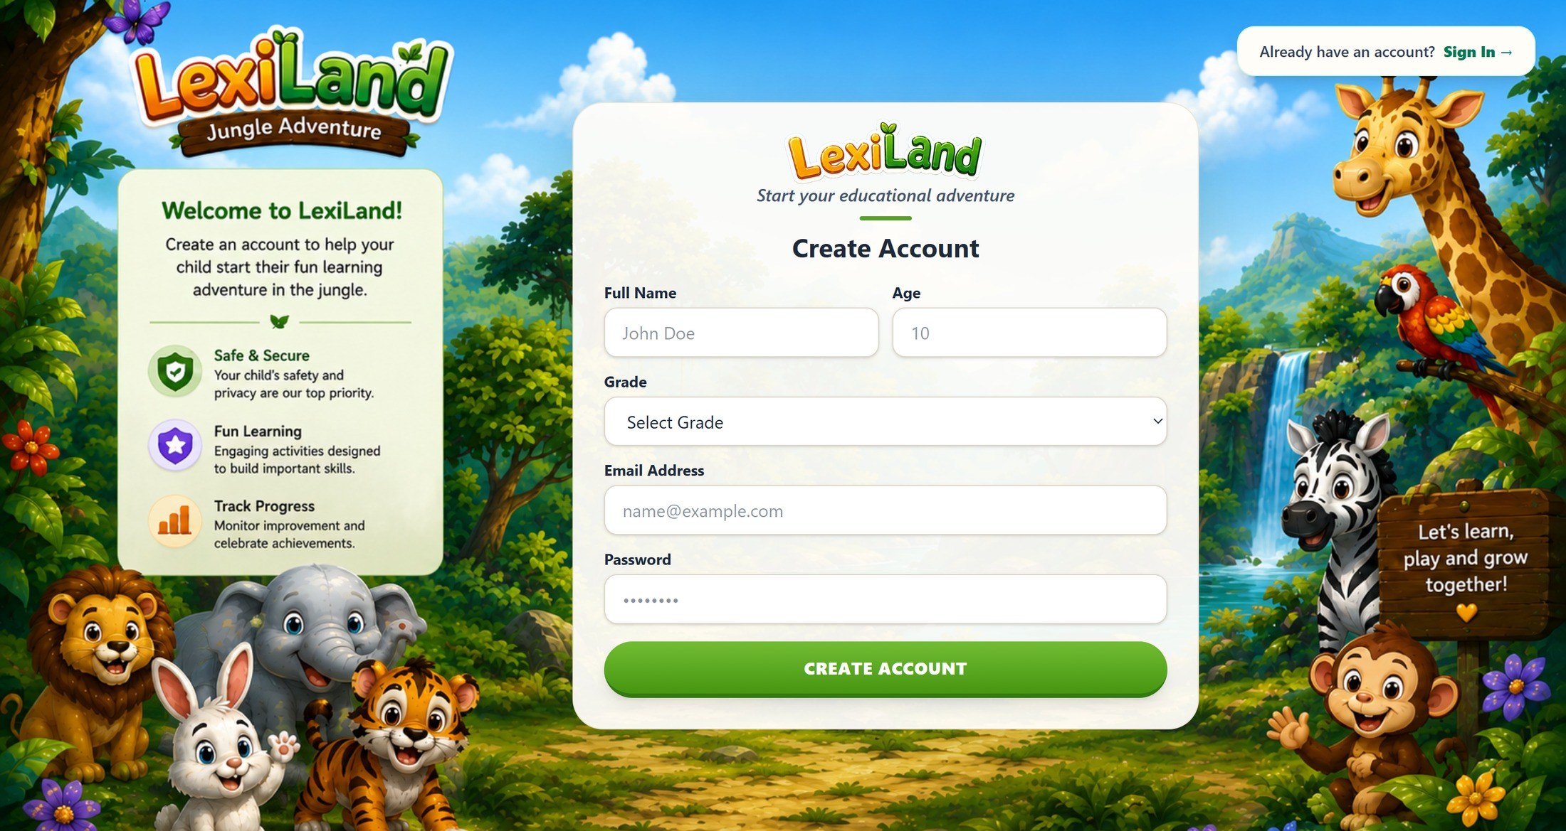

MAIN PLATFORM
Figure 02 – Sign In Page
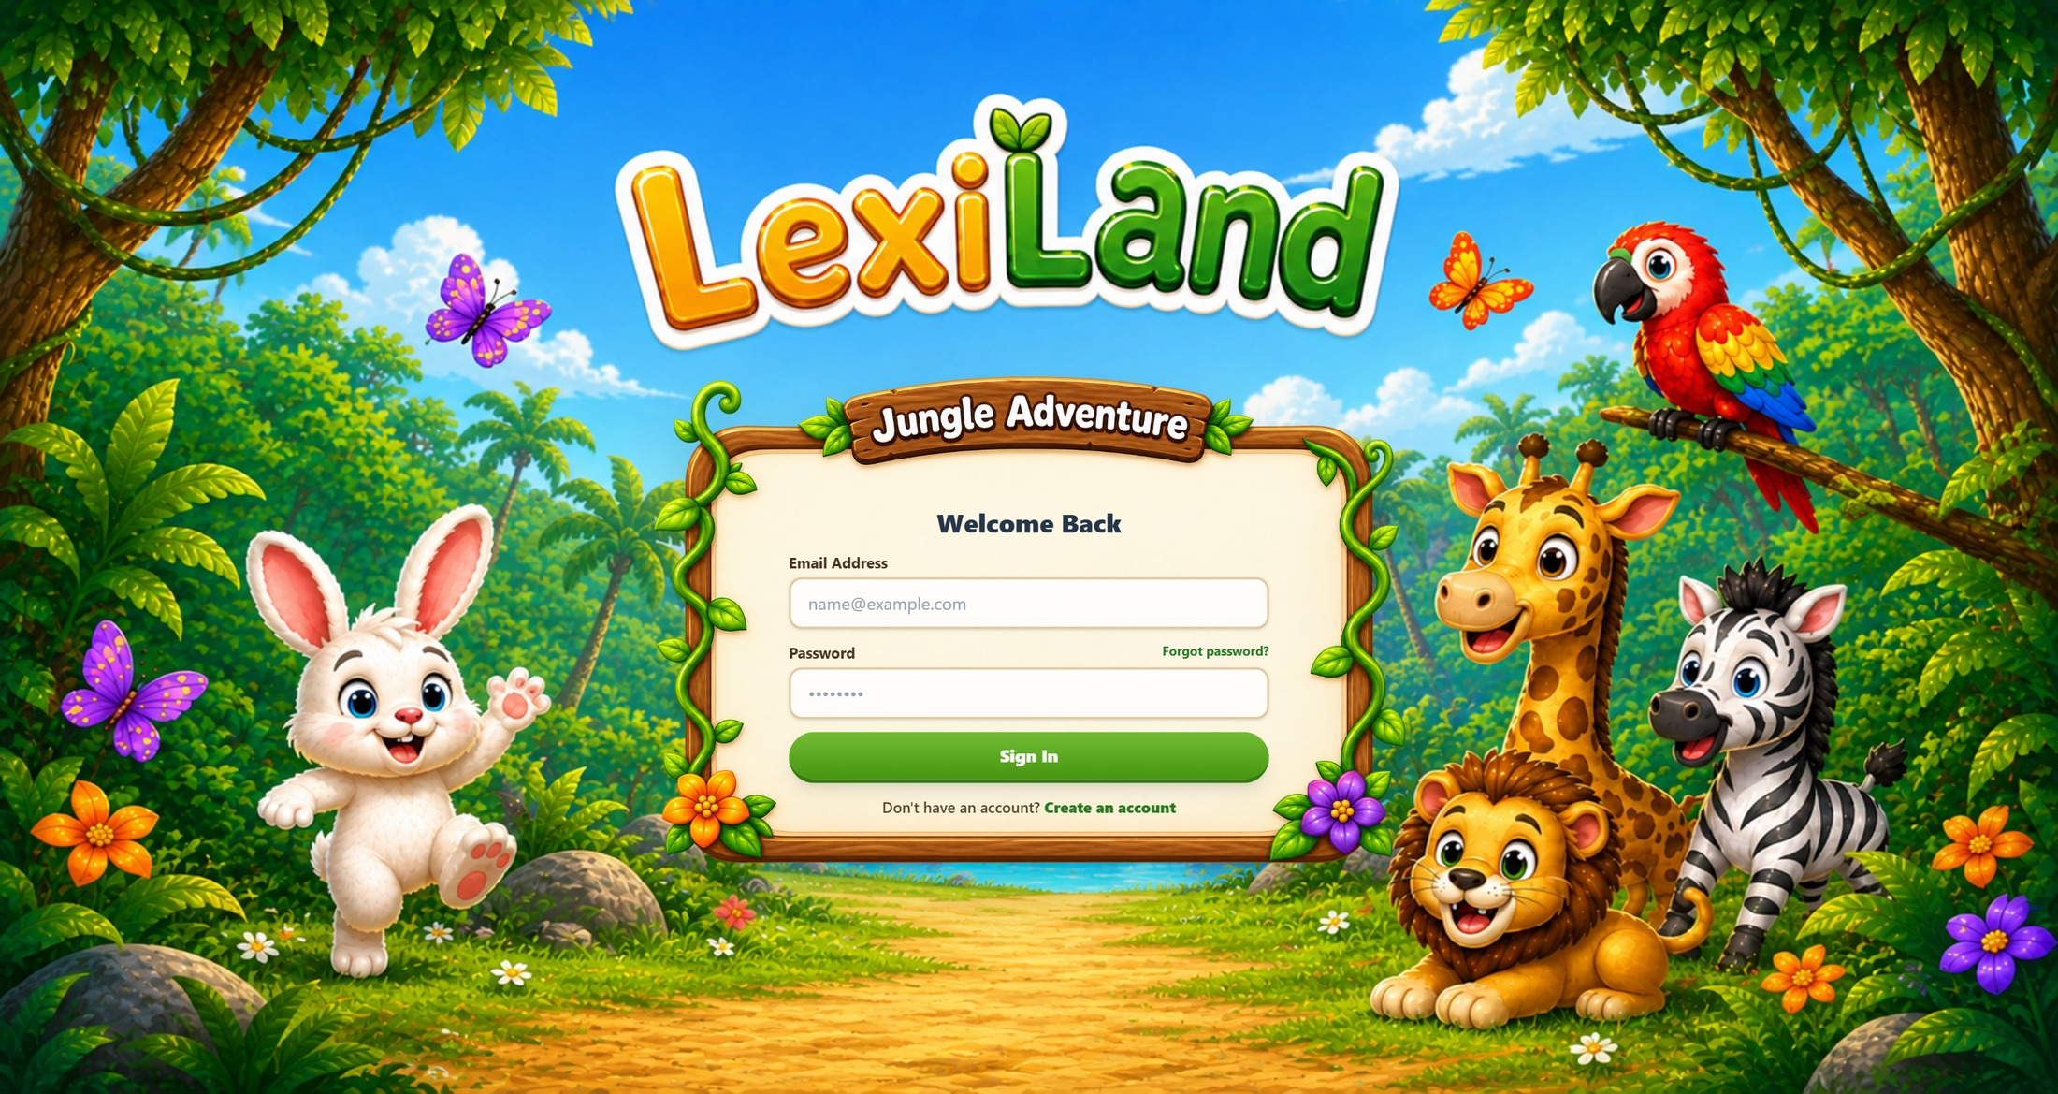

MAIN PLATFORM
Figure 03 – Student Profile Page
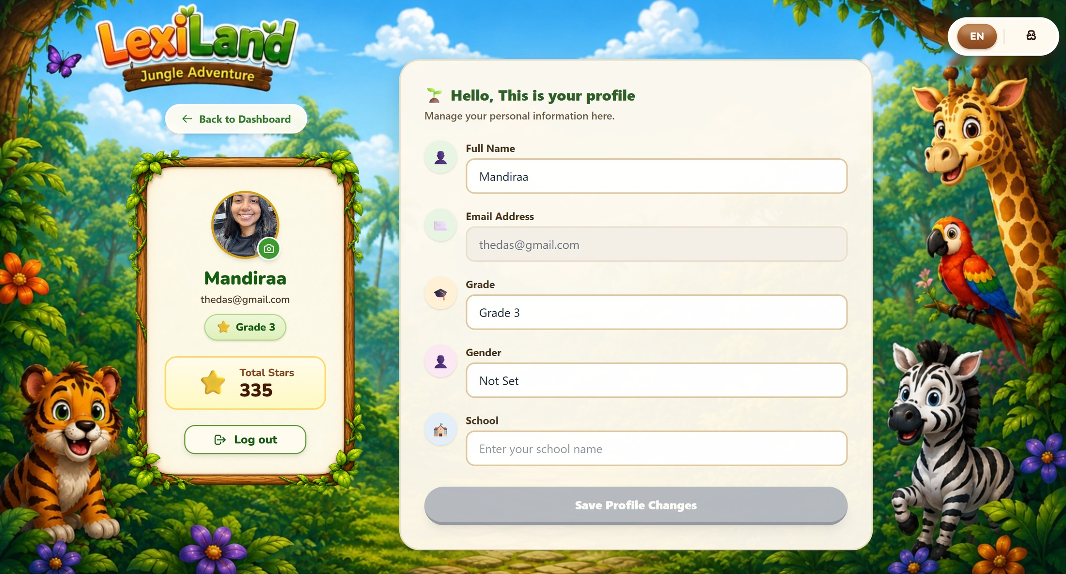

MAIN PLATFORM
Figure 04 – Learning Dashboard
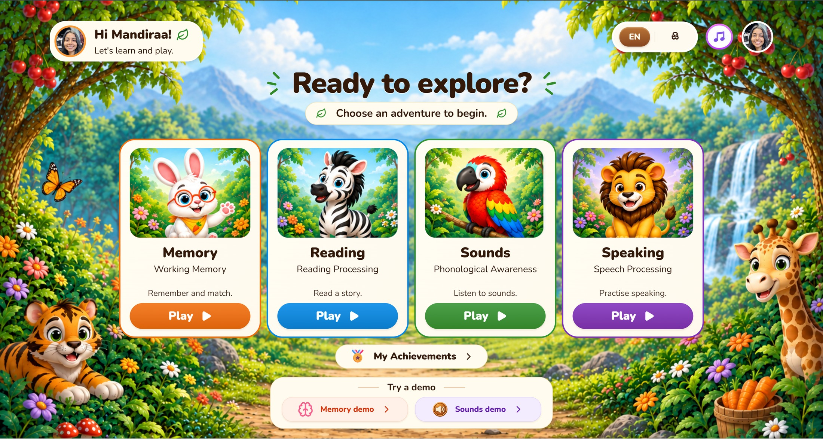

MAIN PLATFORM
Figure 05 – Learning Reports
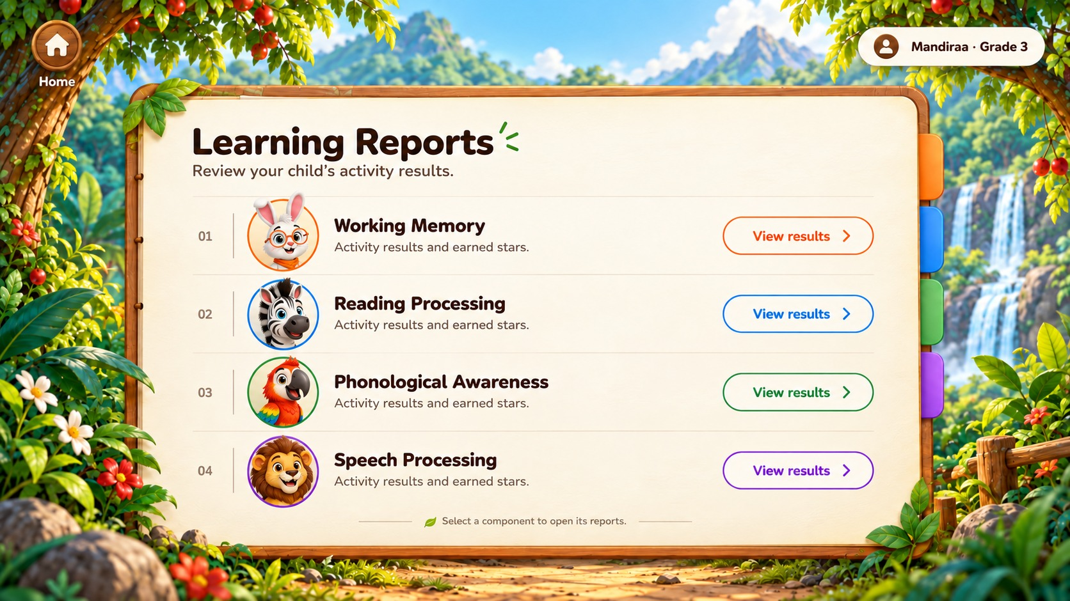

WORKING MEMORY – BUNNY
Figure 06 – Working Memory Identification – Following Instructions
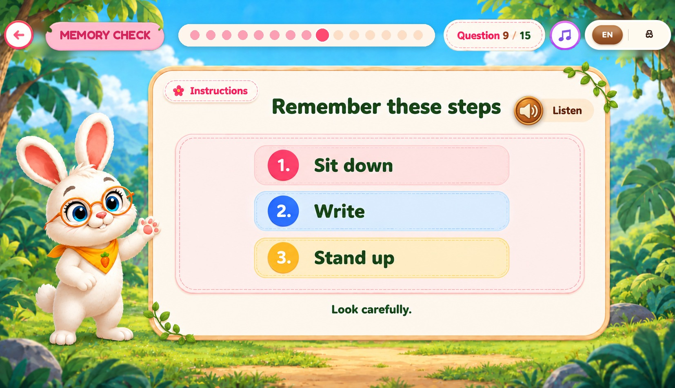

WORKING MEMORY – BUNNY
Figure 07 – Working Memory Identification – Action Choice
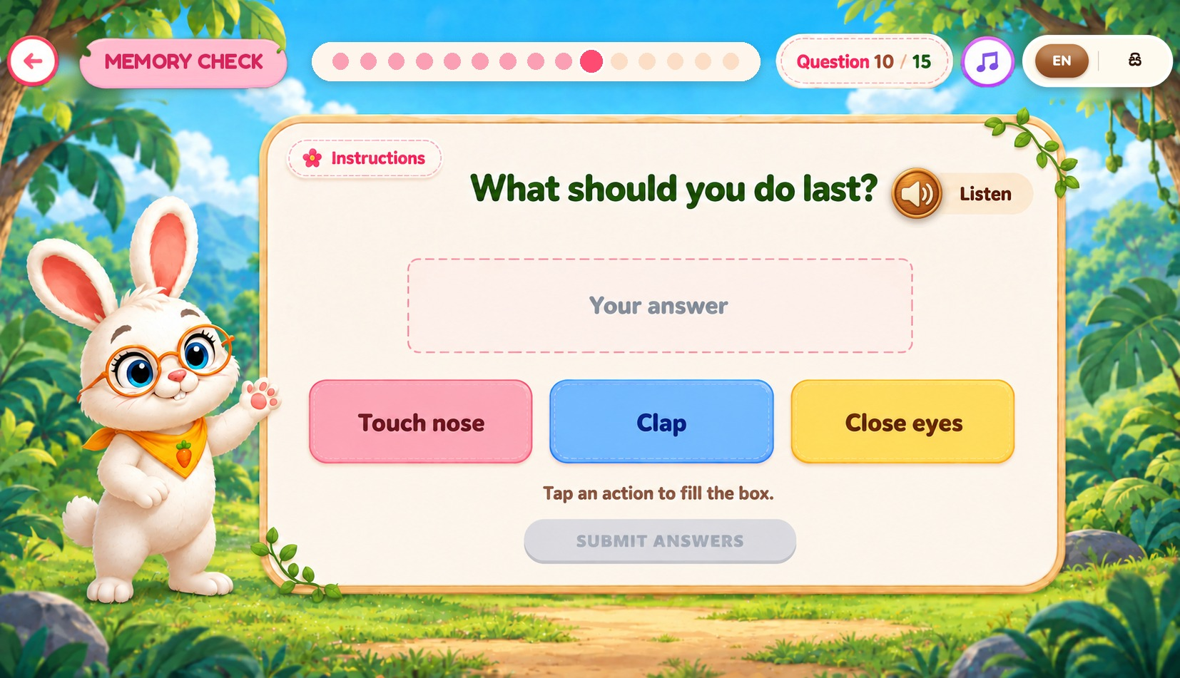

WORKING MEMORY – BUNNY
Figure 08 – Working Memory Identification – Number Memory
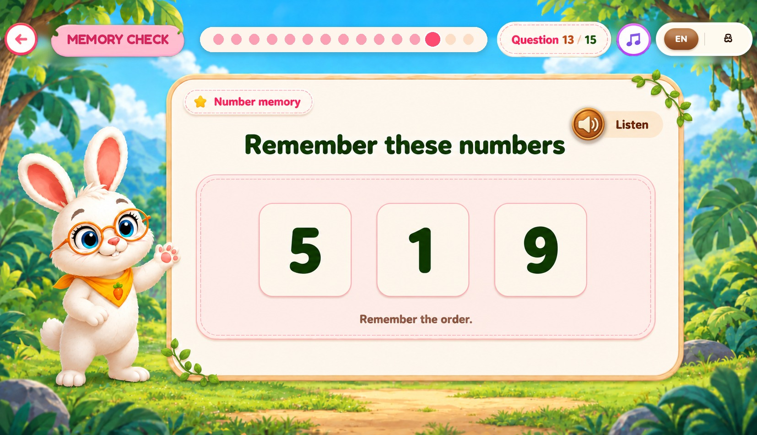

WORKING MEMORY – BUNNY
Figure 09 – Working Memory Identification – Number Order Question
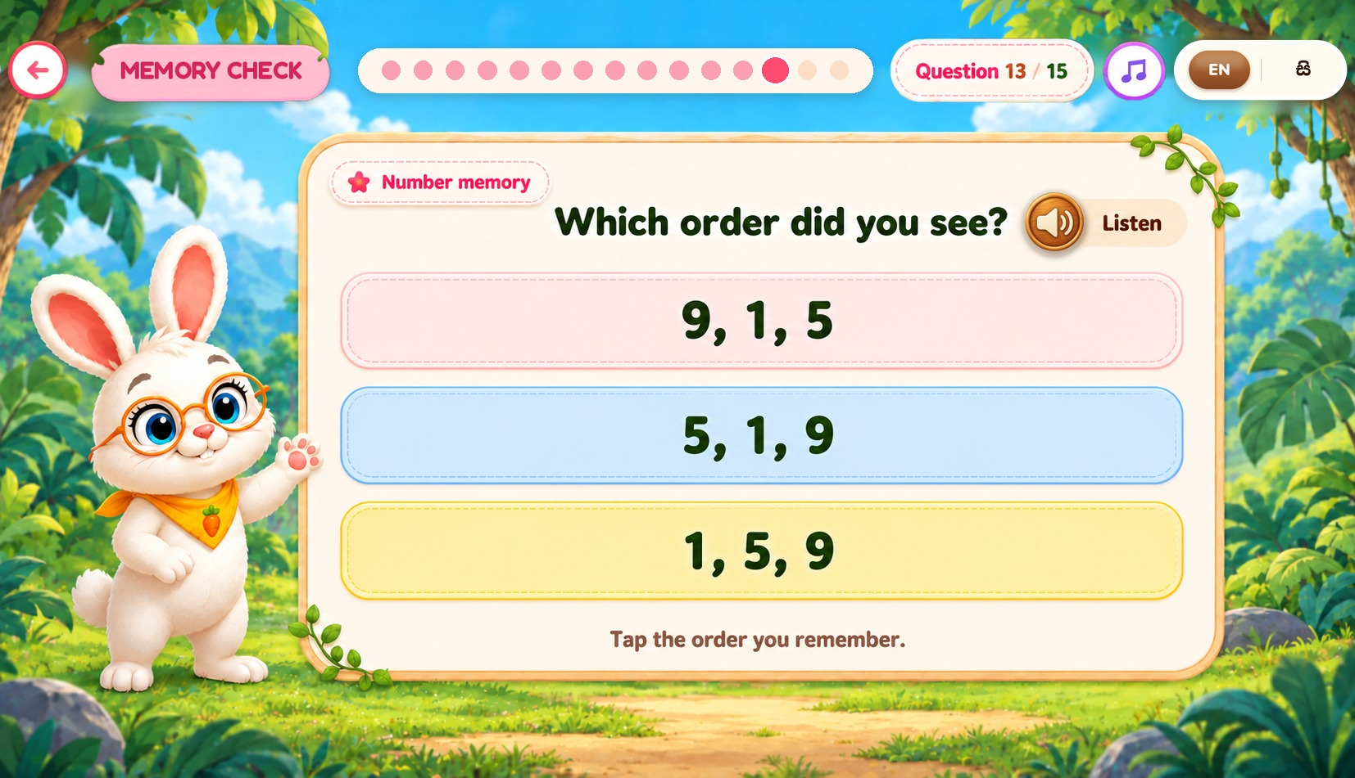

WORKING MEMORY – BUNNY
Figure 10 – Working Memory Identification – Picture Memory
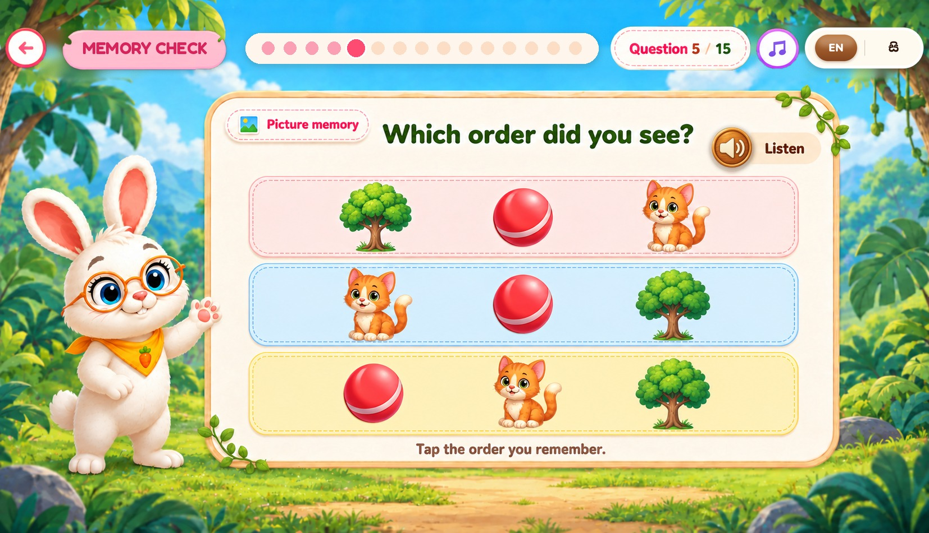

WORKING MEMORY – BUNNY
Figure 11 – Working Memory Results
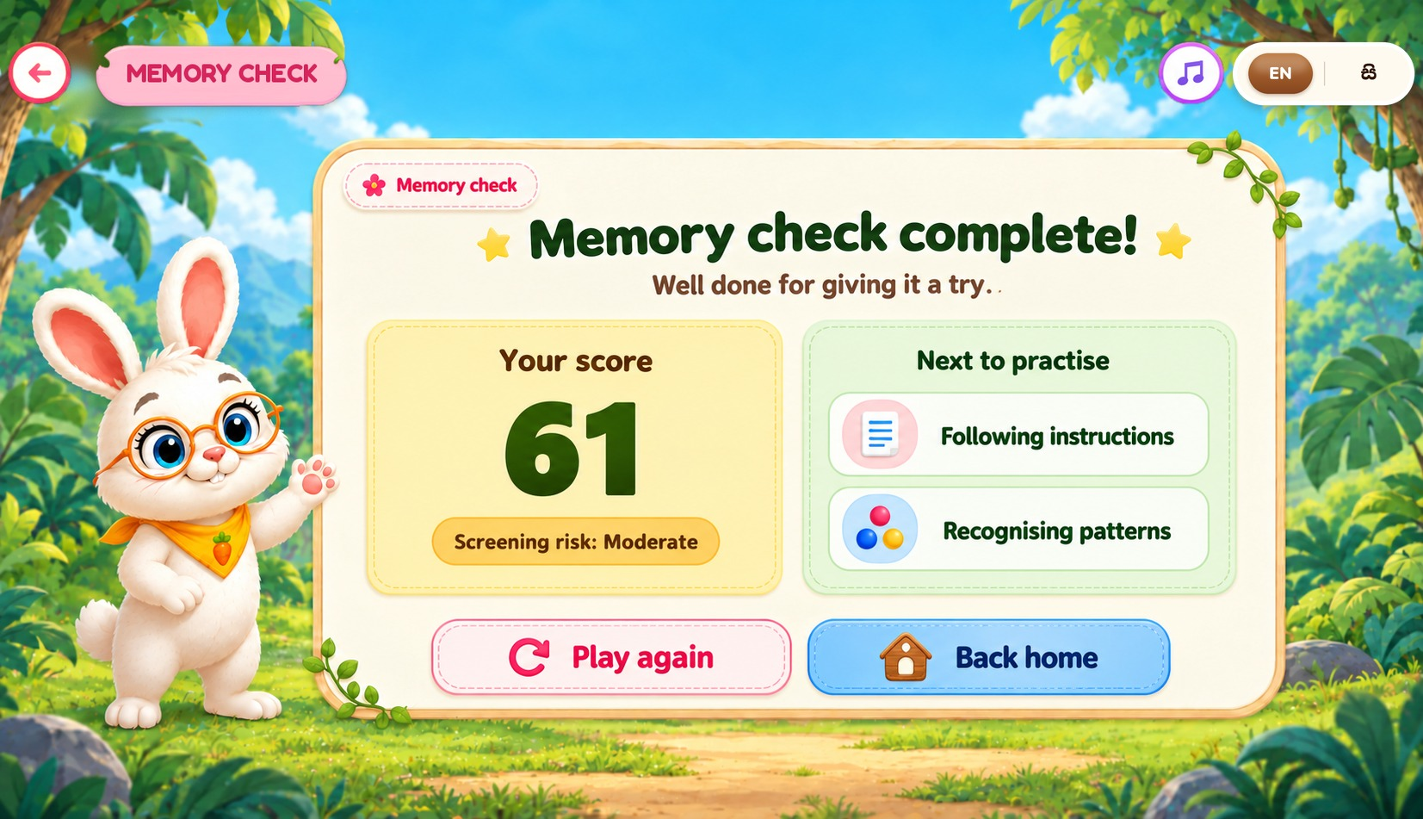

WORKING MEMORY – BUNNY
Figure 12 – Working Memory Level Map
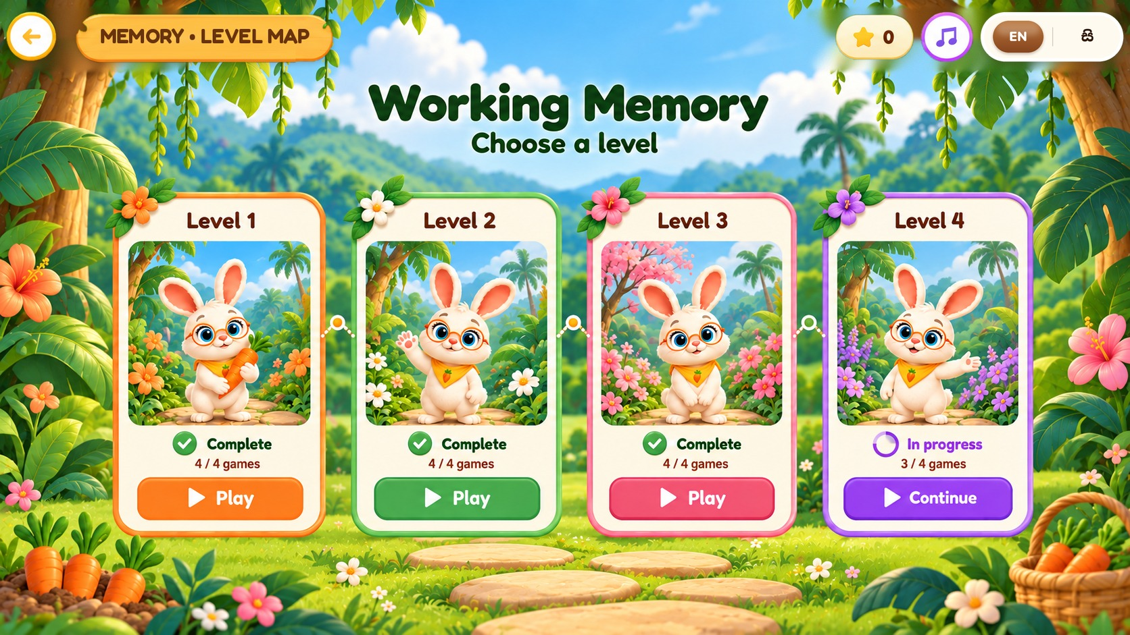

WORKING MEMORY – BUNNY
Figure 13 – Working Memory – Level 1 Game Selection
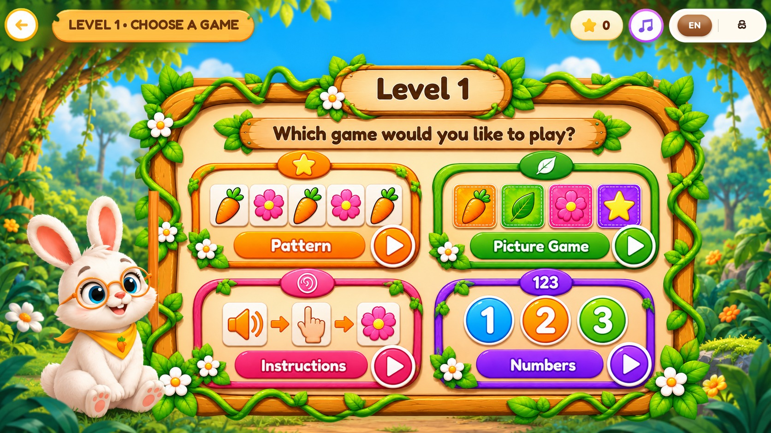

WORKING MEMORY – BUNNY
Figure 14 – Working Memory – How to Play
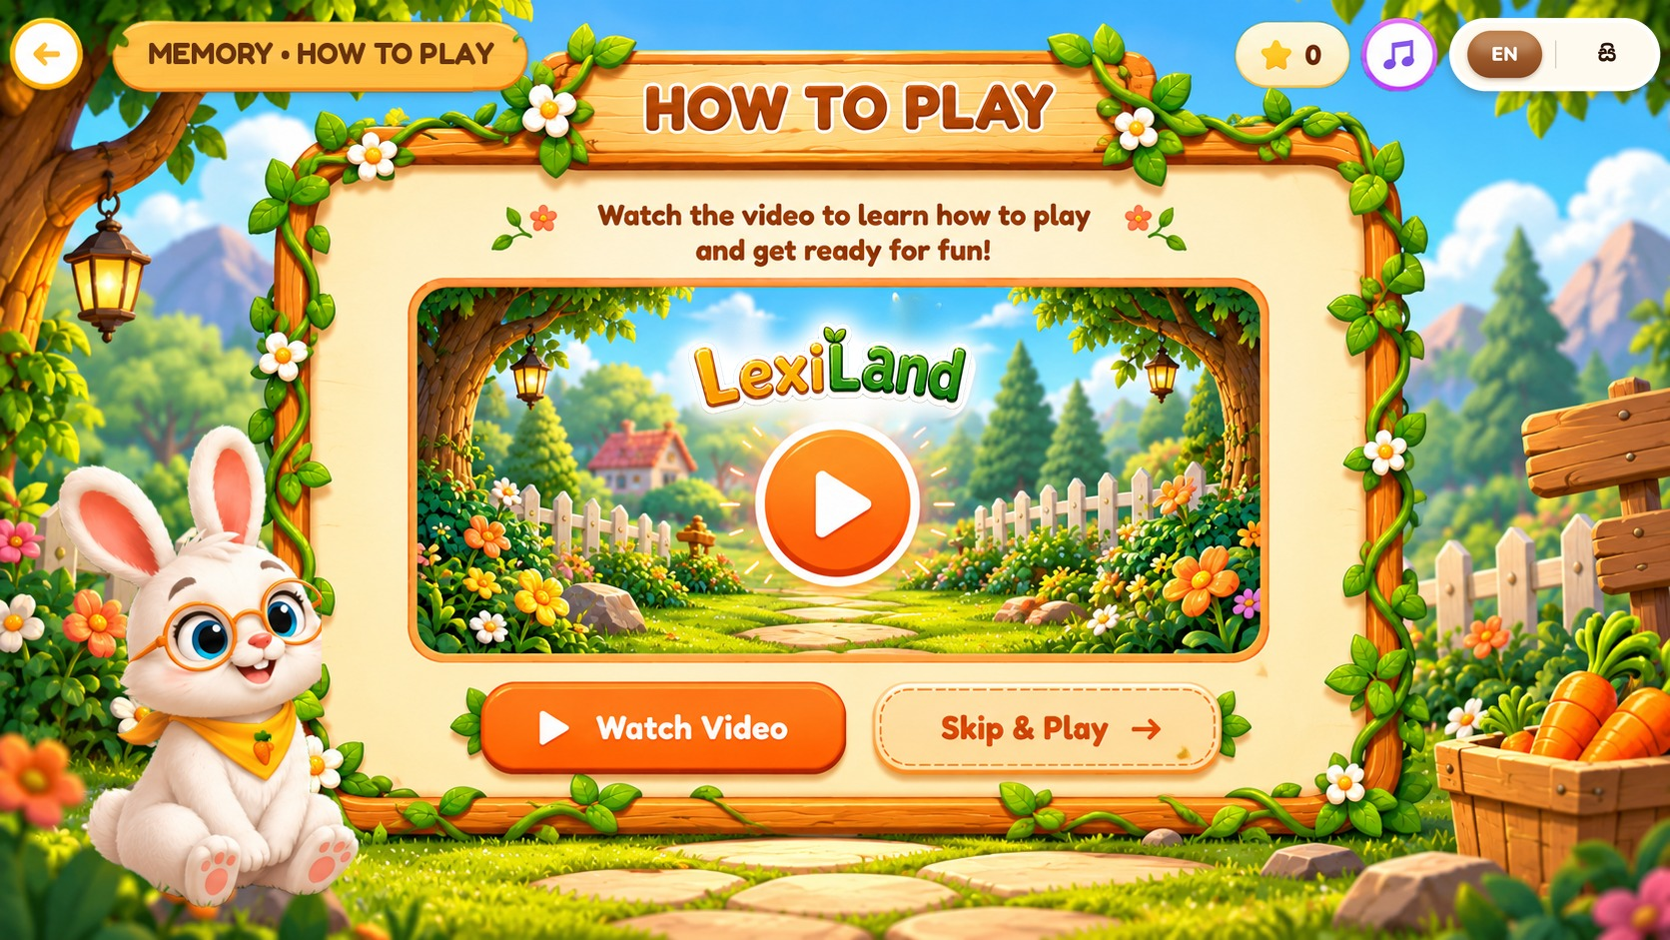

WORKING MEMORY – BUNNY
Figure 15 – Picture Memory Game – Level 1
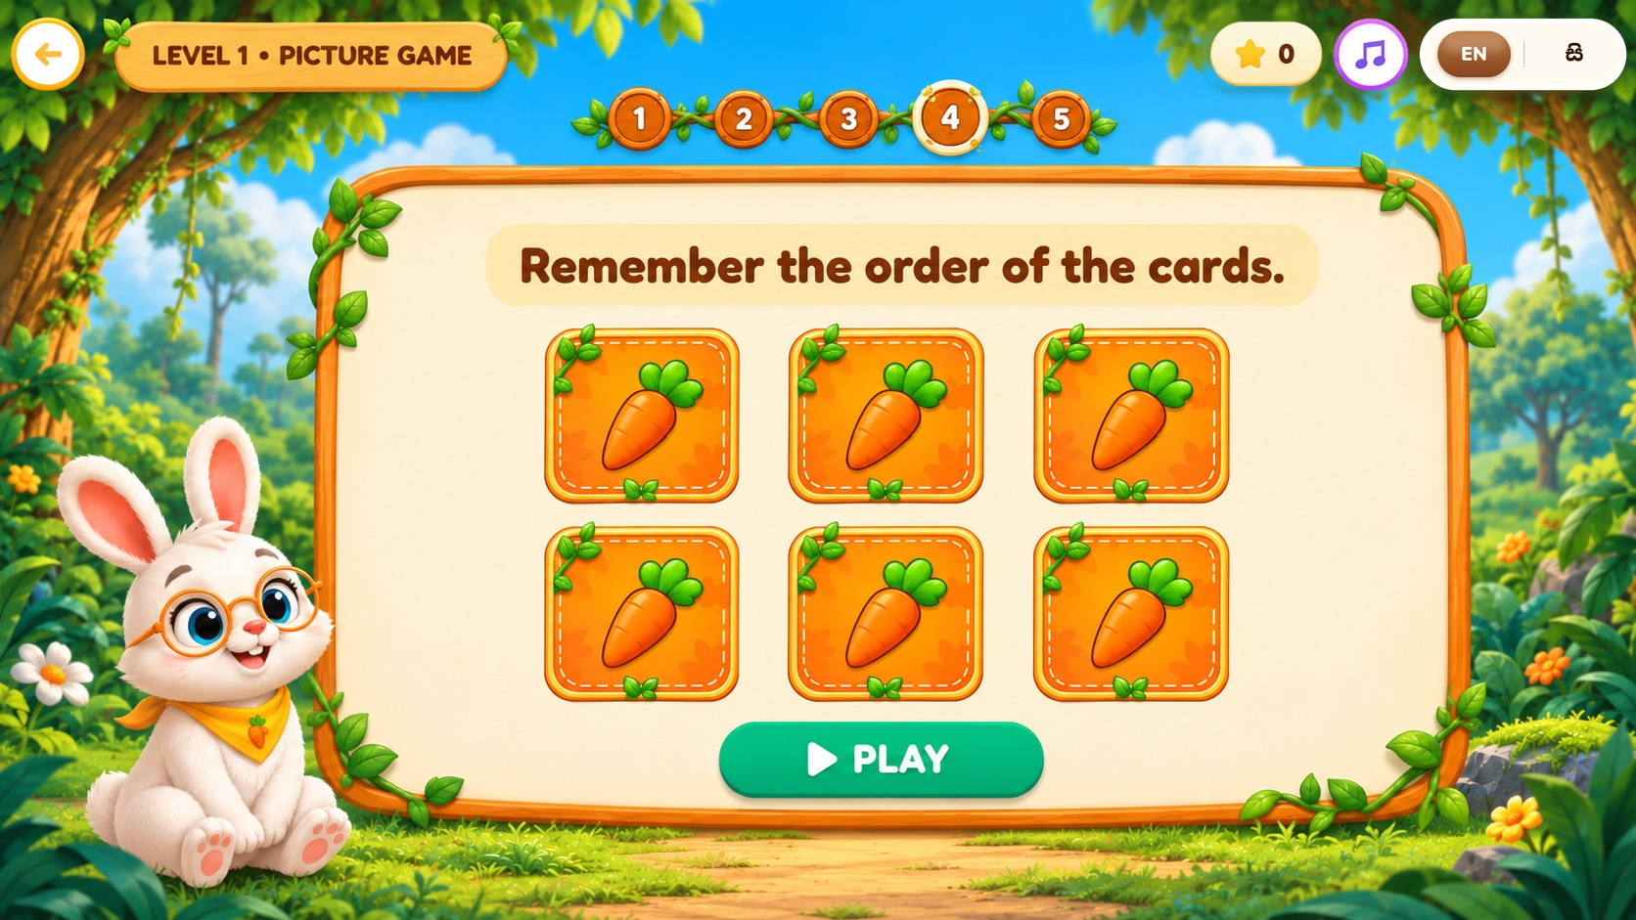

WORKING MEMORY – BUNNY
Figure 16 – Picture Memory Game – Level 2
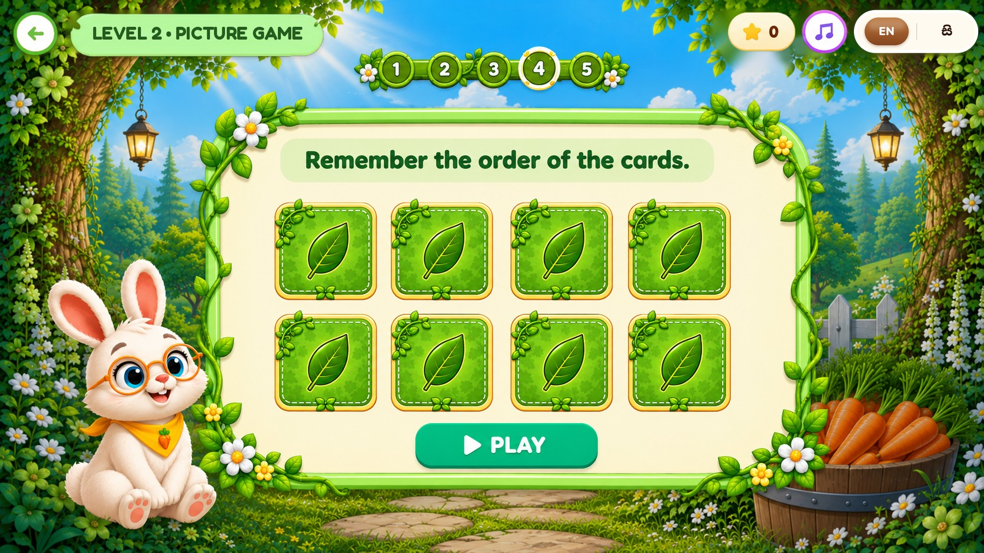

WORKING MEMORY – BUNNY
Figure 17 – Picture Memory Game – Level 3
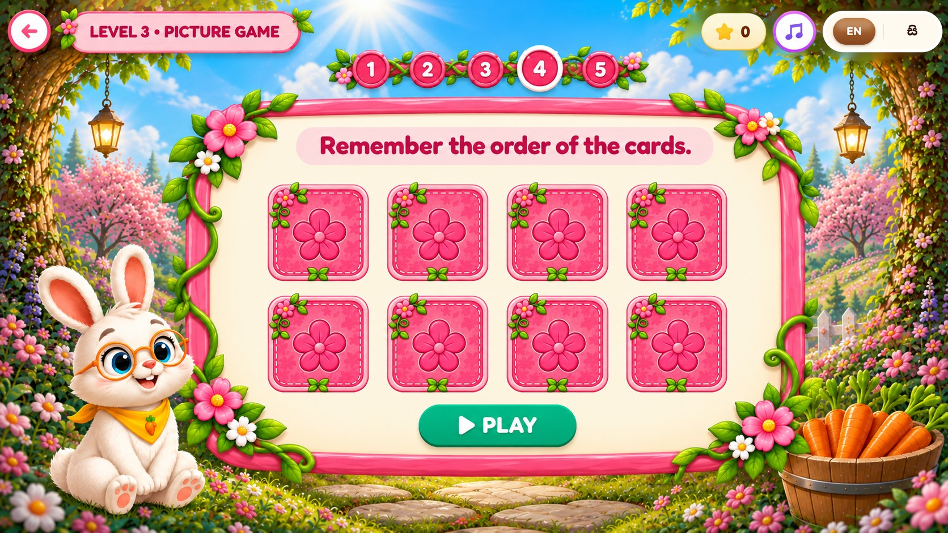

WORKING MEMORY – BUNNY
Figure 18 – Picture Memory Game – Level 4
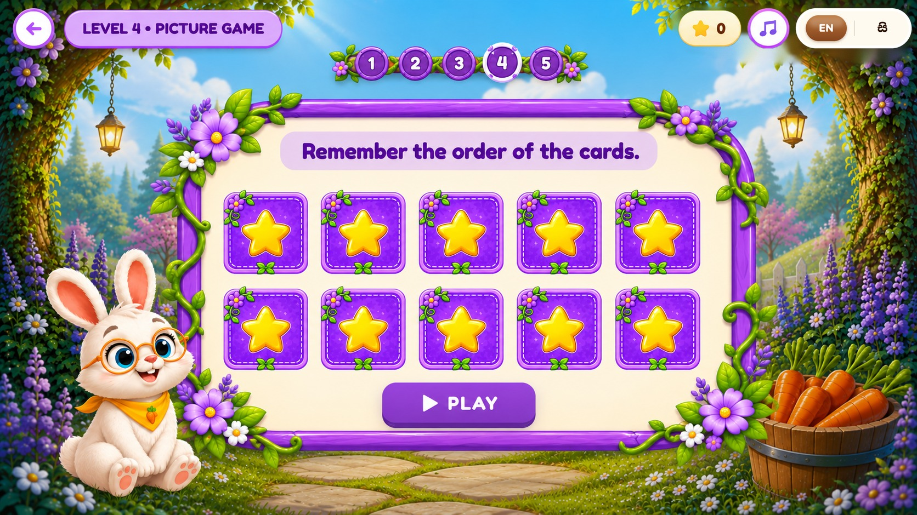

WORKING MEMORY – BUNNY
Figure 19 – Listening Game – Level 1
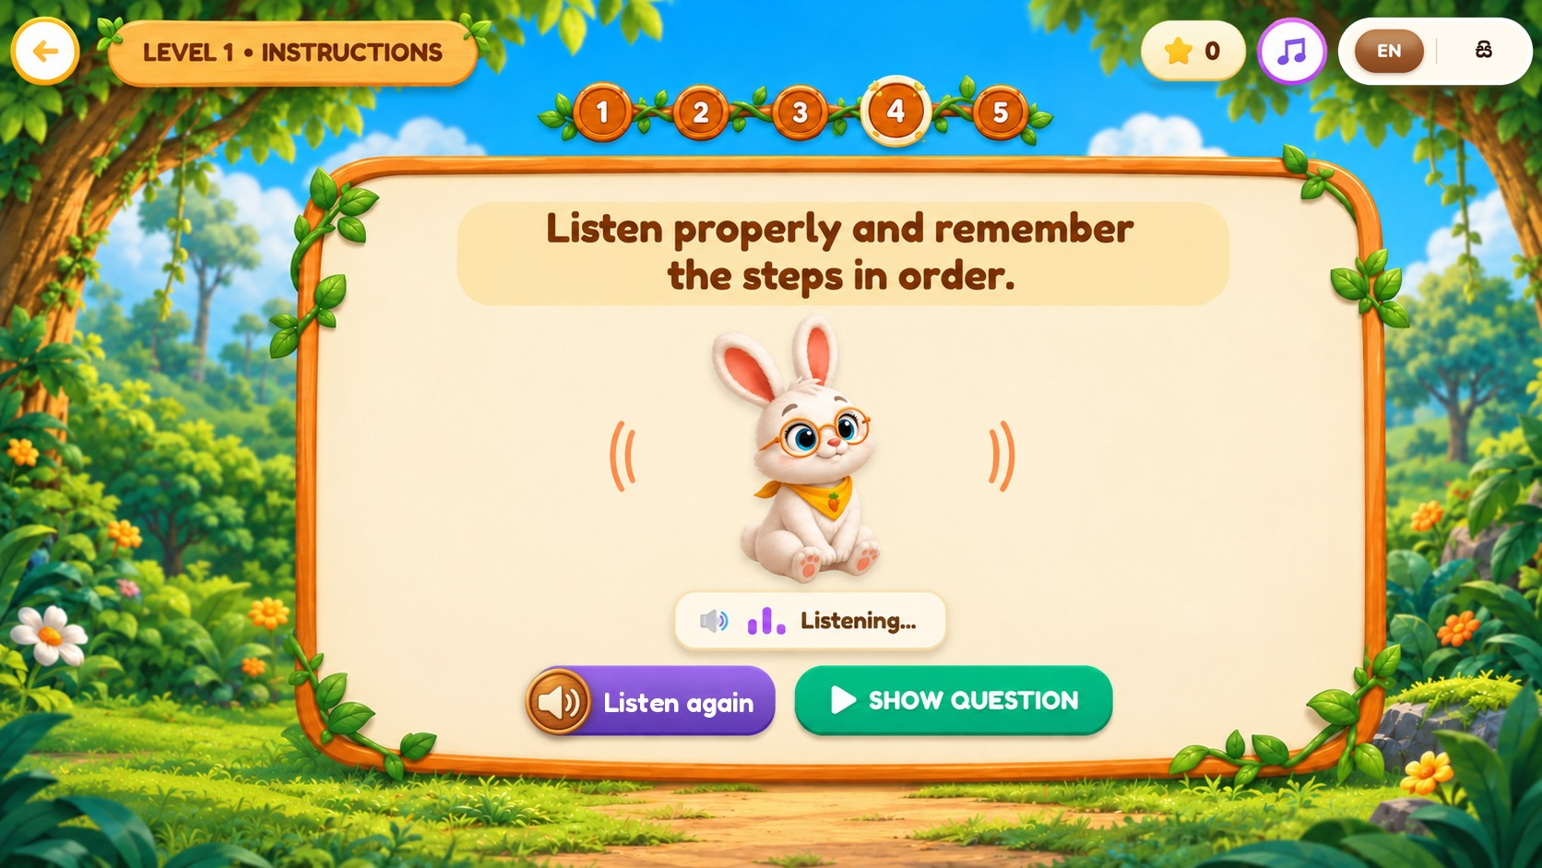

WORKING MEMORY – BUNNY
Figure 20 – Listening Game – Level 2
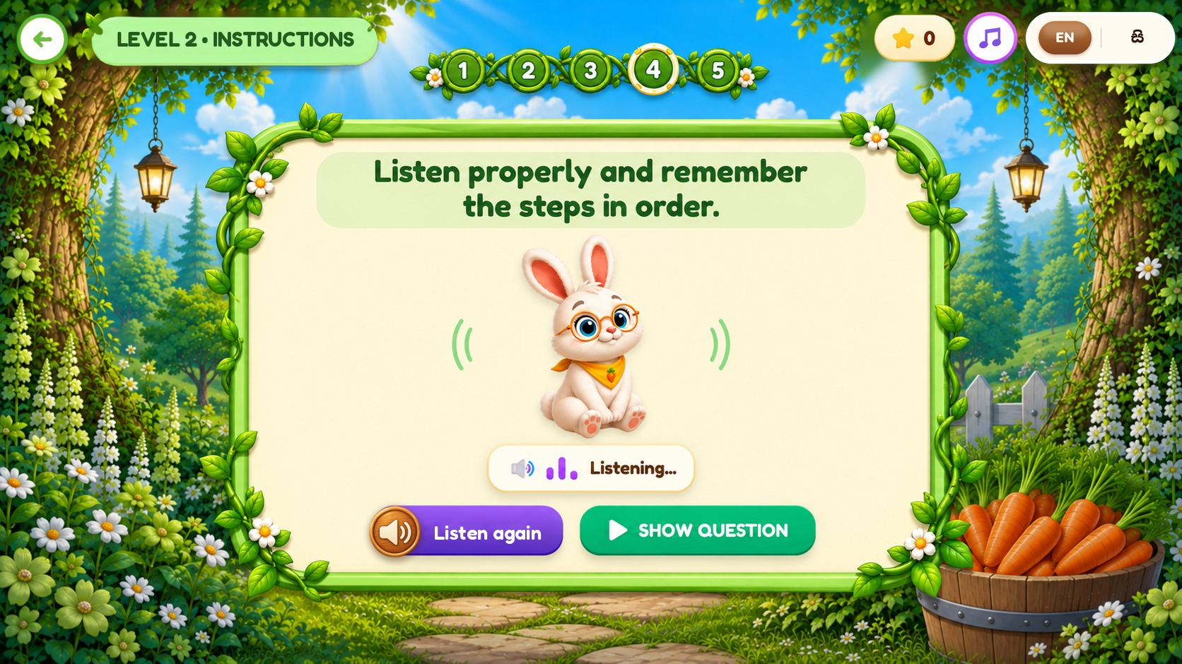

WORKING MEMORY – BUNNY
Figure 21 – Listening Game – Level 3
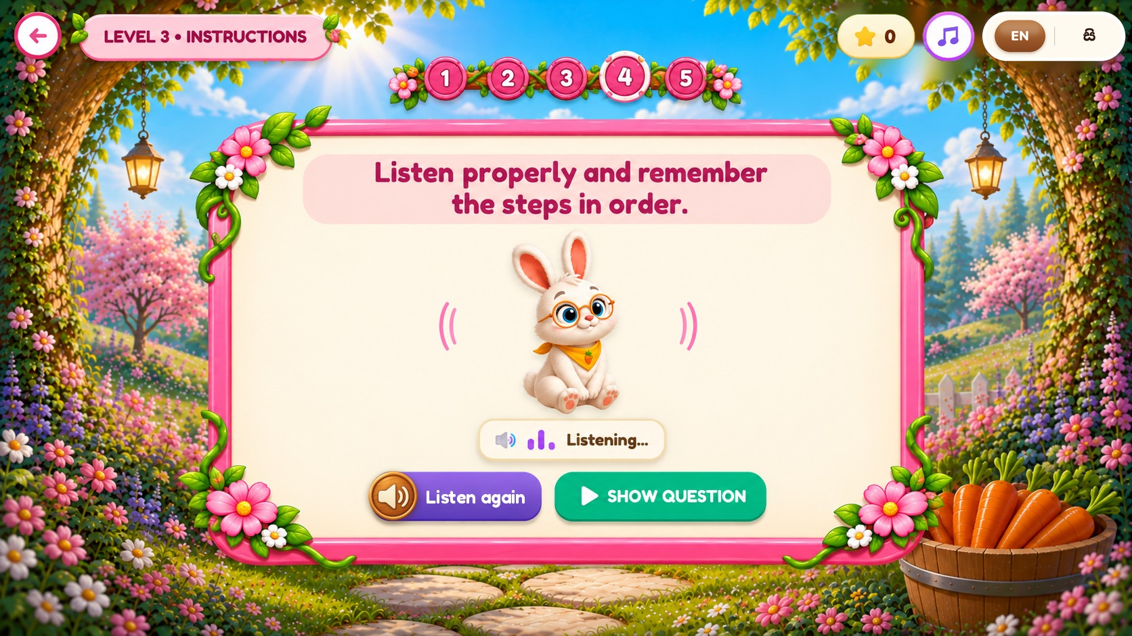

WORKING MEMORY – BUNNY
Figure 22 – Listening Game – Level 4
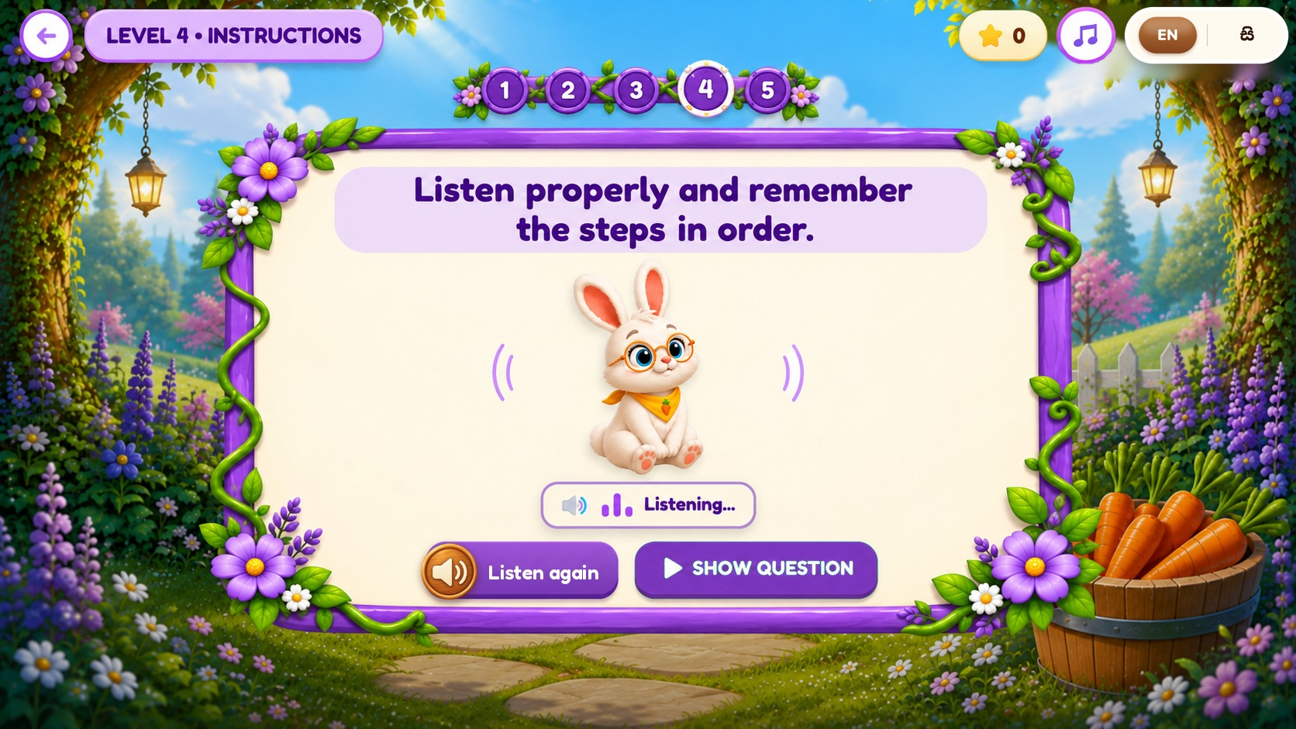

WORKING MEMORY – BUNNY
Figure 23 – Pattern Puzzle – Level 1
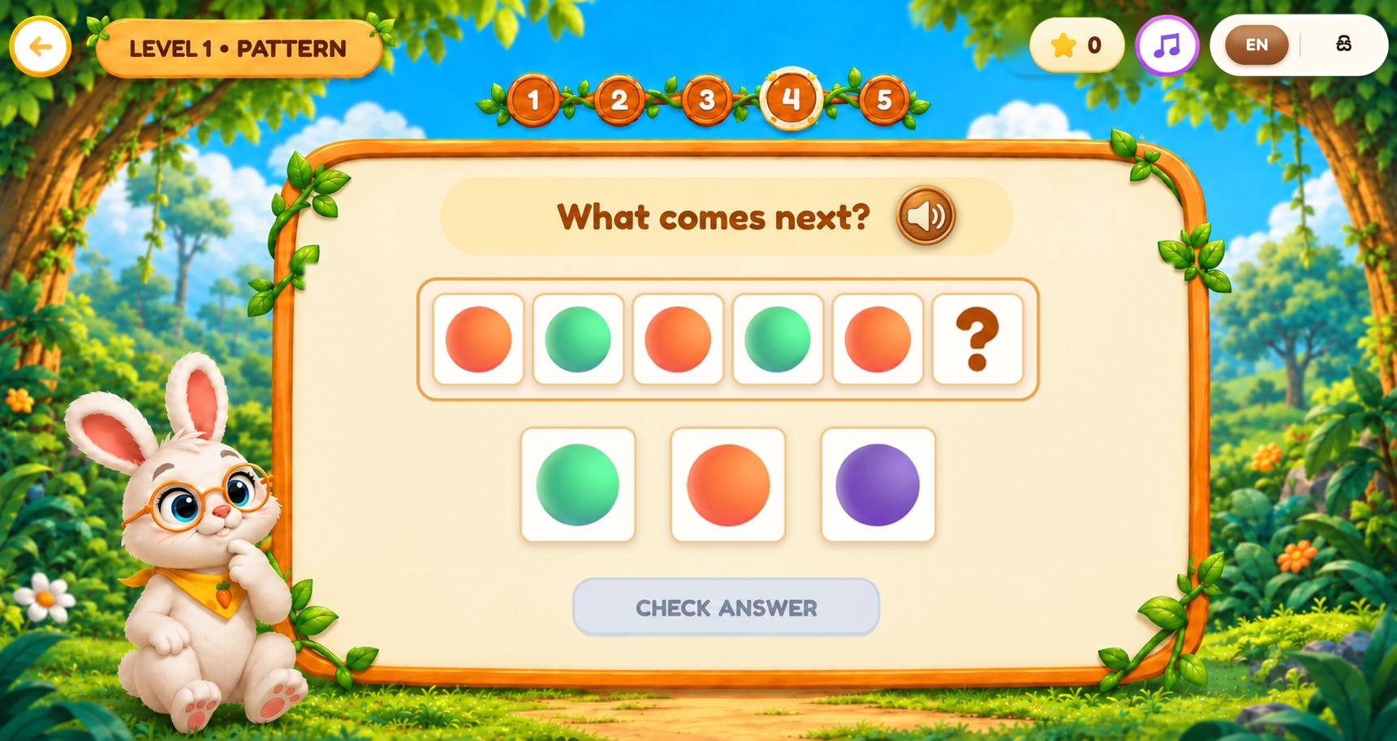

WORKING MEMORY – BUNNY
Figure 24 – Pattern Puzzle – Level 2
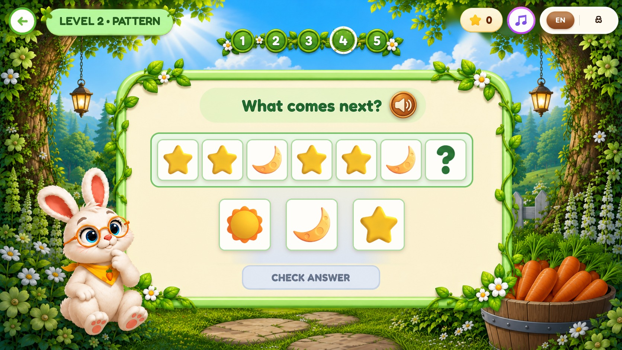

WORKING MEMORY – BUNNY
Figure 25 – Pattern Puzzle – Level 3
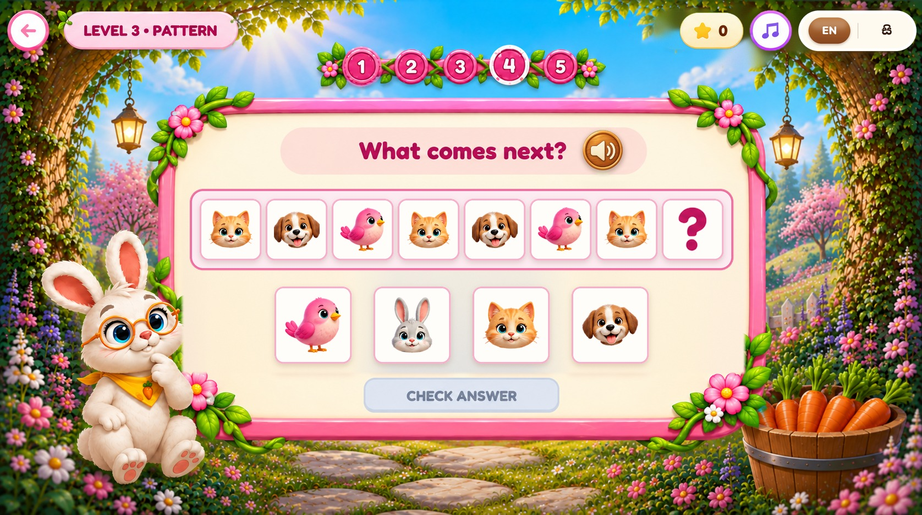

WORKING MEMORY – BUNNY
Figure 26 – Pattern Puzzle – Level 4
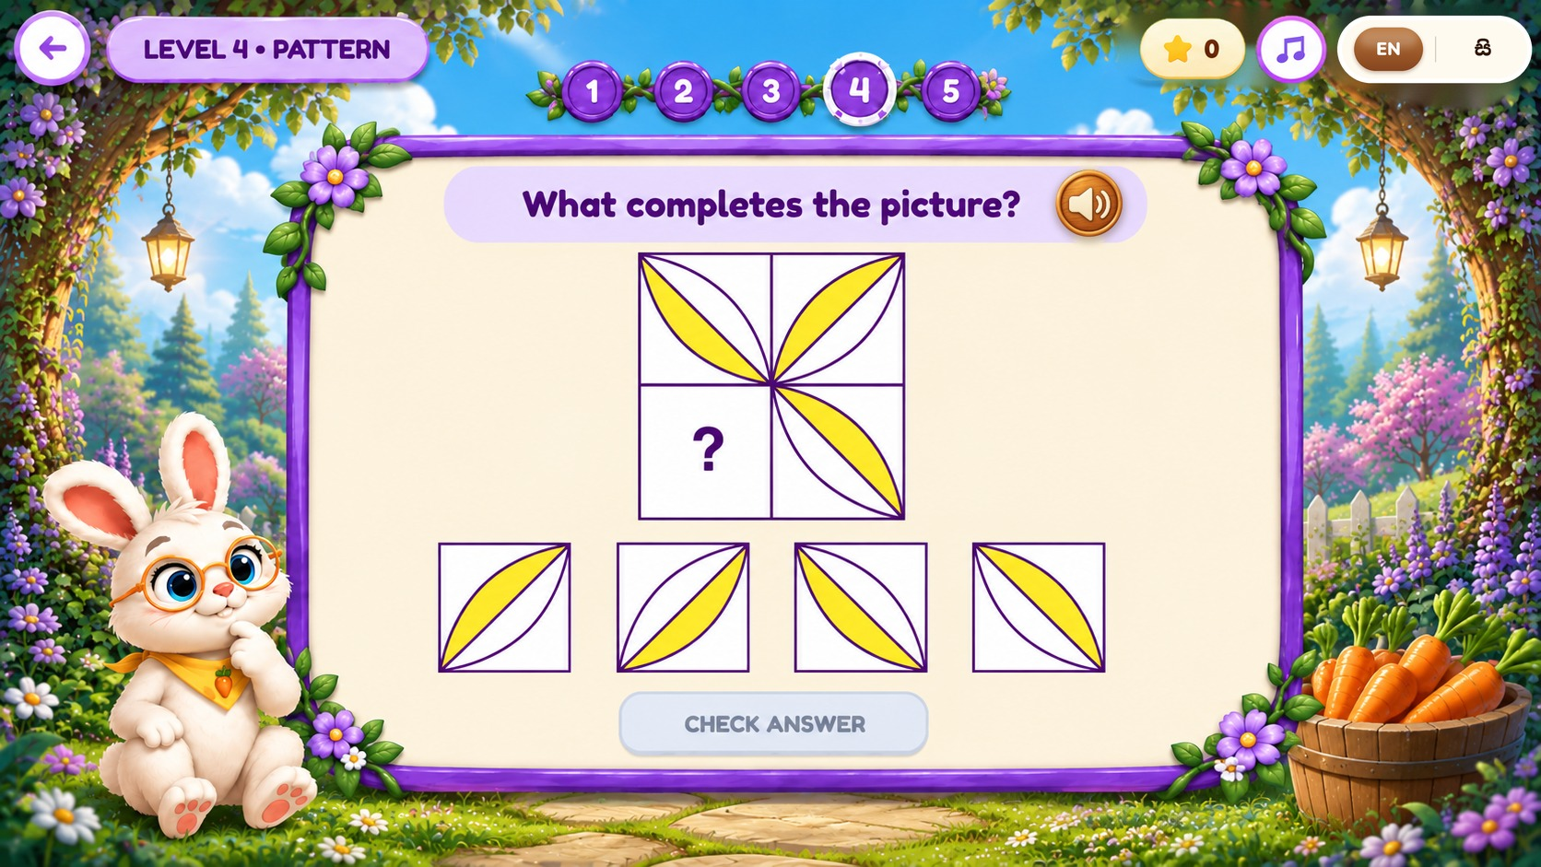

WORKING MEMORY – BUNNY
Figure 27 – Digit Span Memory – Level 1
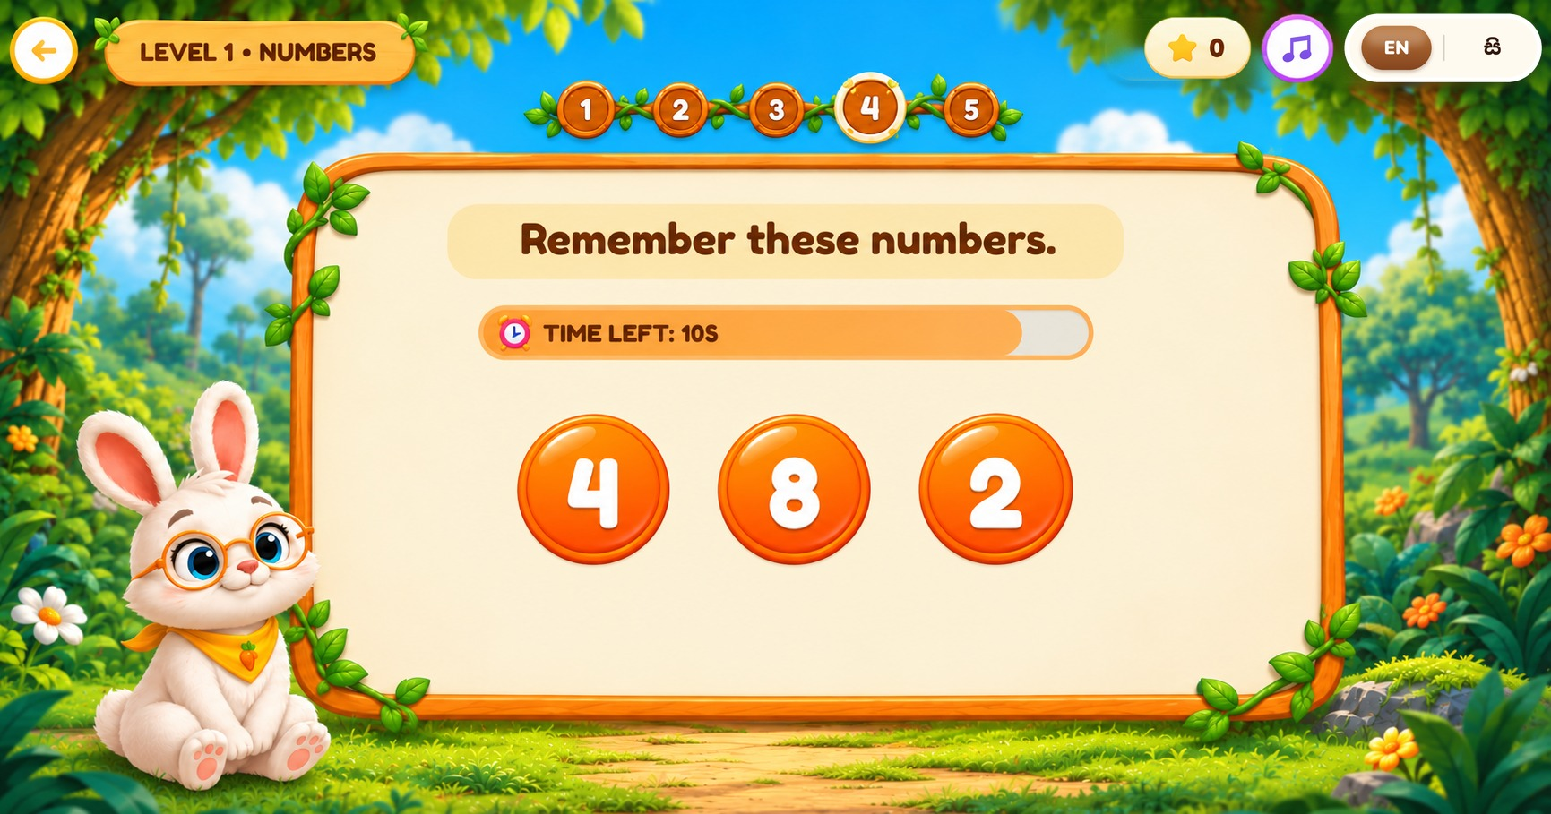

WORKING MEMORY – BUNNY
Figure 28 – Digit Span Memory – Level 2
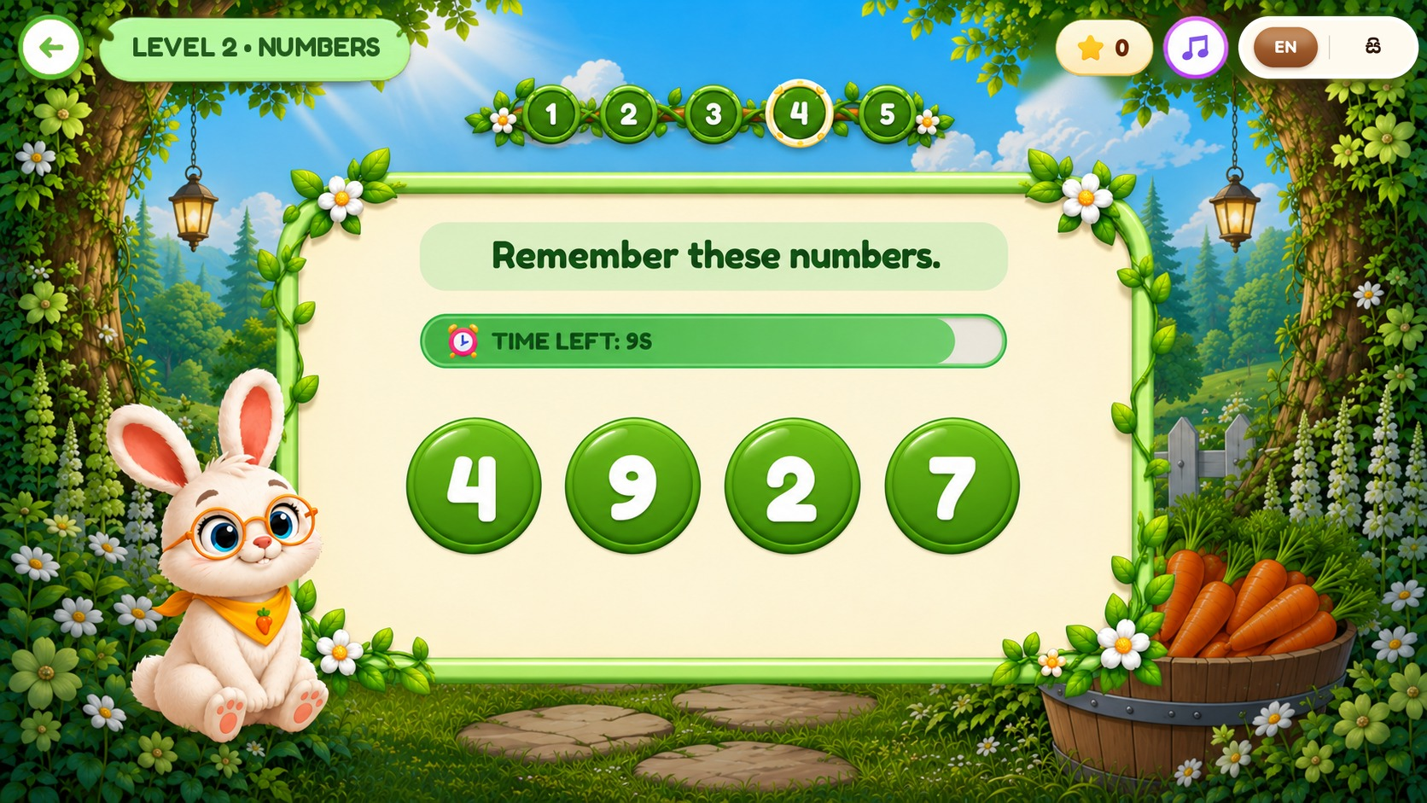

WORKING MEMORY – BUNNY
Figure 29 – Digit Span Memory – Level 3 (Backward)
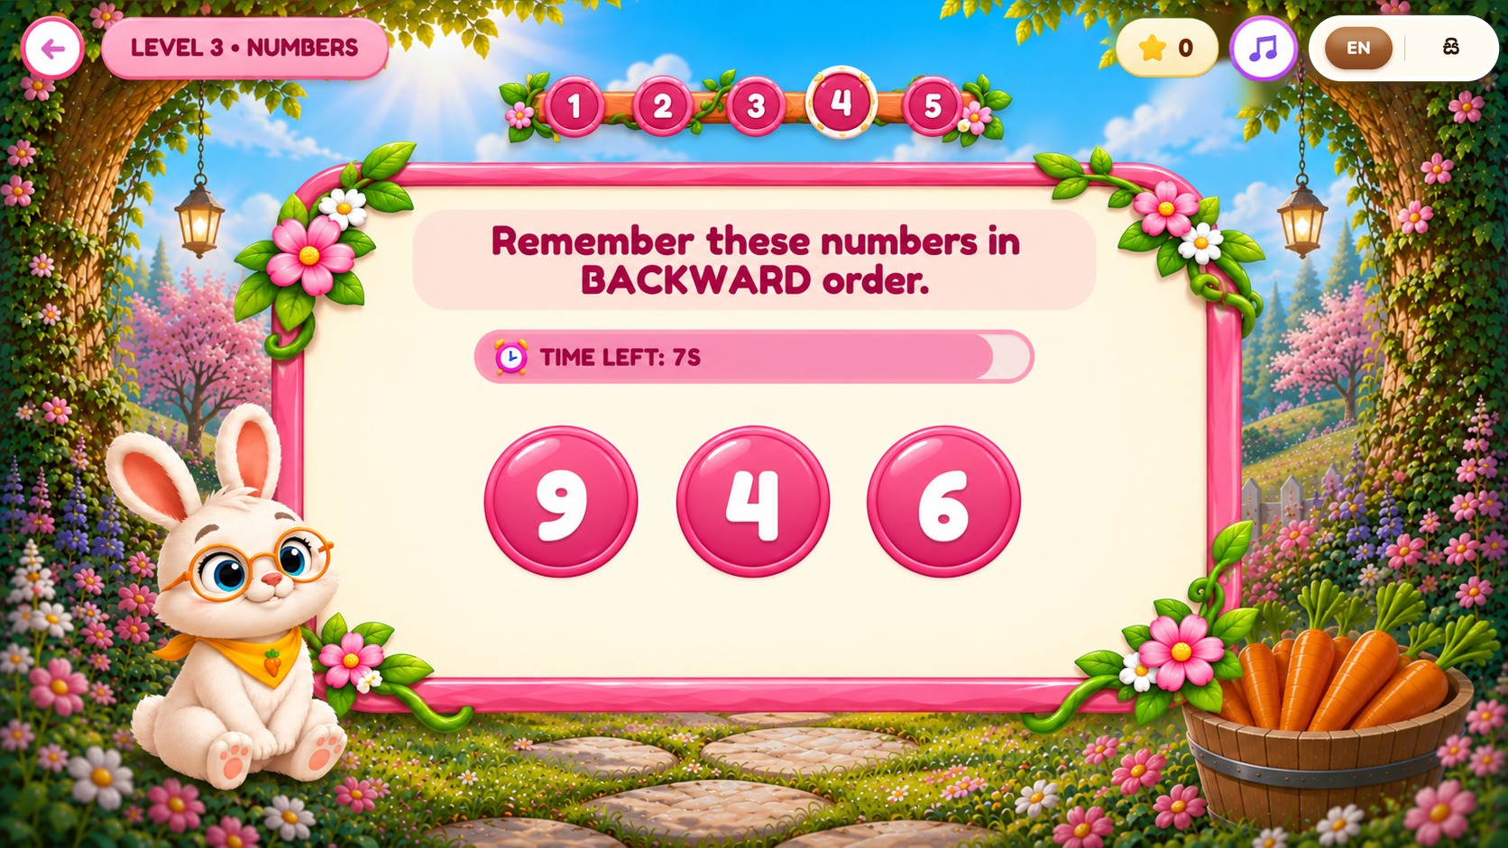

WORKING MEMORY – BUNNY
Figure 30 – Digit Span Memory – Level 4 (Backward)
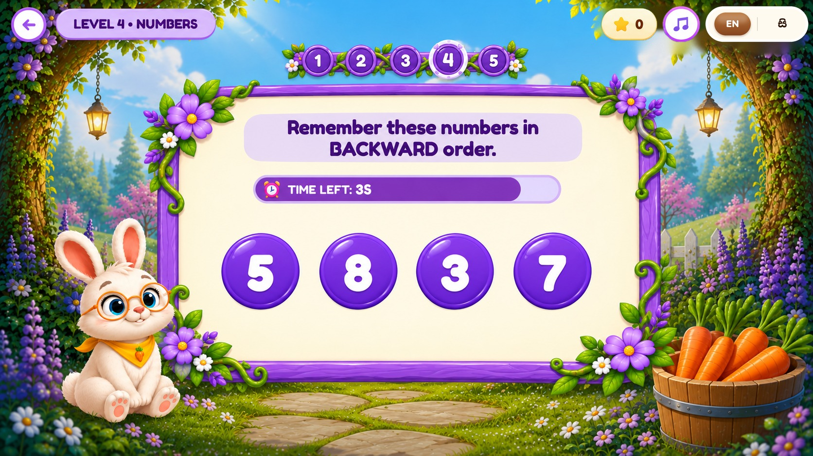

WORKING MEMORY – BUNNY
Figure 31 – Working Memory Reports
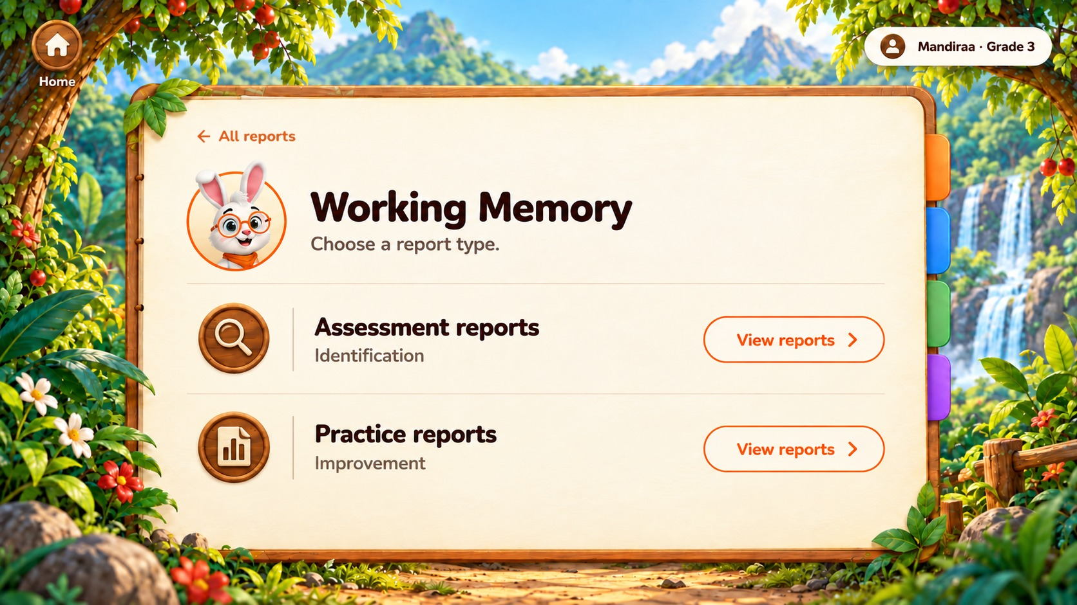

PHONOLOGICAL AWARENESS – PARROT
Figure 32 – Phonological Awareness Level Map
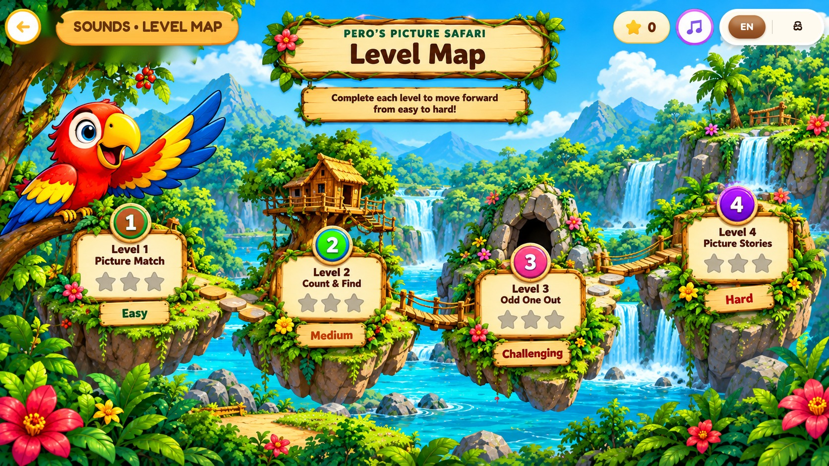

PHONOLOGICAL AWARENESS – PARROT
Figure 33 – Phonological Awareness Improvement – Sound Detective Video Lesson
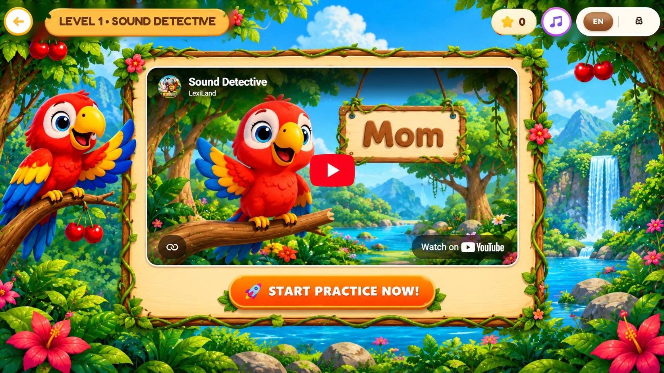

PHONOLOGICAL AWARENESS – PARROT
Figure 34 – Phonological Awareness Improvement – Sound Detective (First Letter)
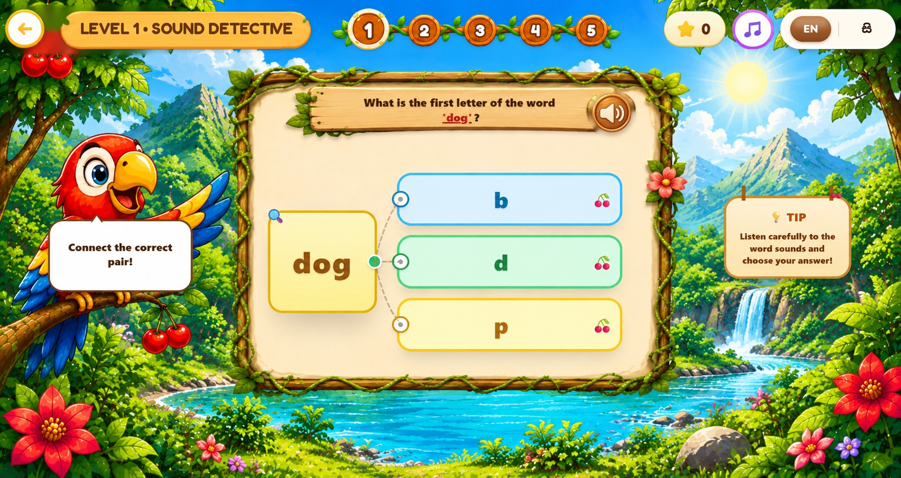

PHONOLOGICAL AWARENESS – PARROT
Figure 35 – Phonological Awareness Improvement – Picture Match (Odd Letter Out)
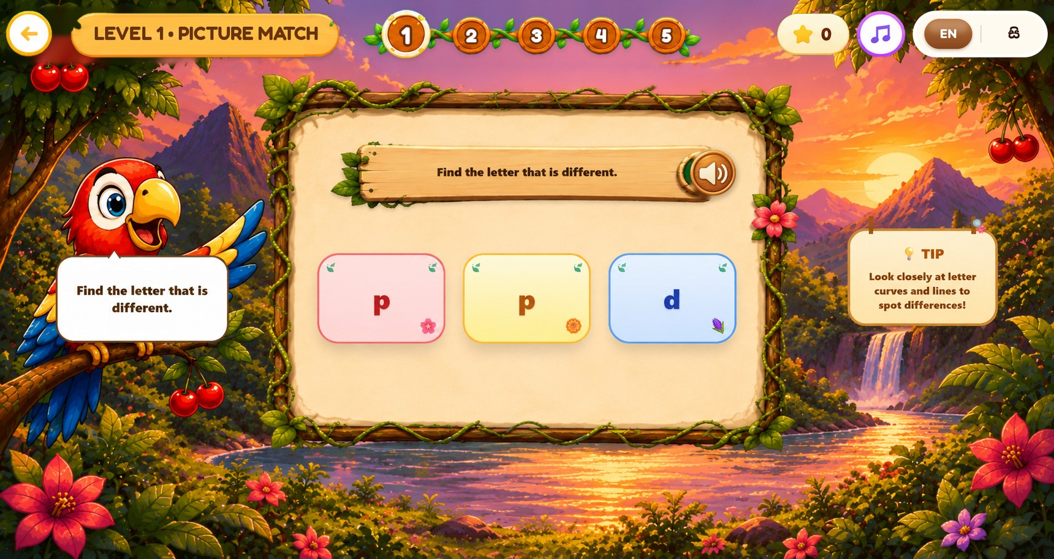

PHONOLOGICAL AWARENESS – PARROT
Figure 36 – Phonological Awareness Improvement – Count & Split (Letter Count)
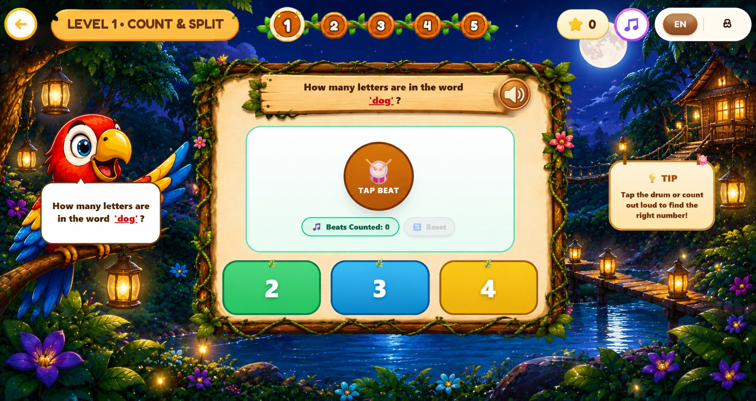

PHONOLOGICAL AWARENESS – PARROT
Figure 37 – Phonological Awareness Improvement – Word Play (Fill the Blank)
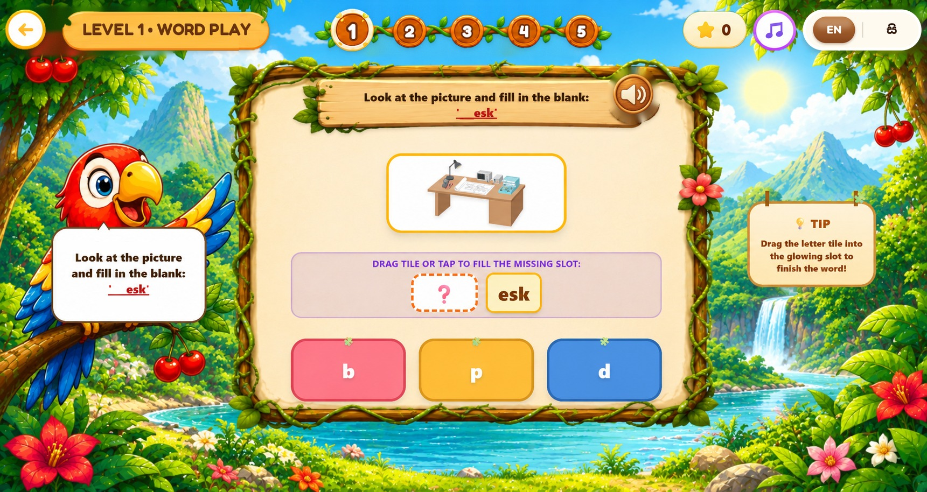

PHONOLOGICAL AWARENESS – PARROT
Figure 38 – Phonological Awareness Reports
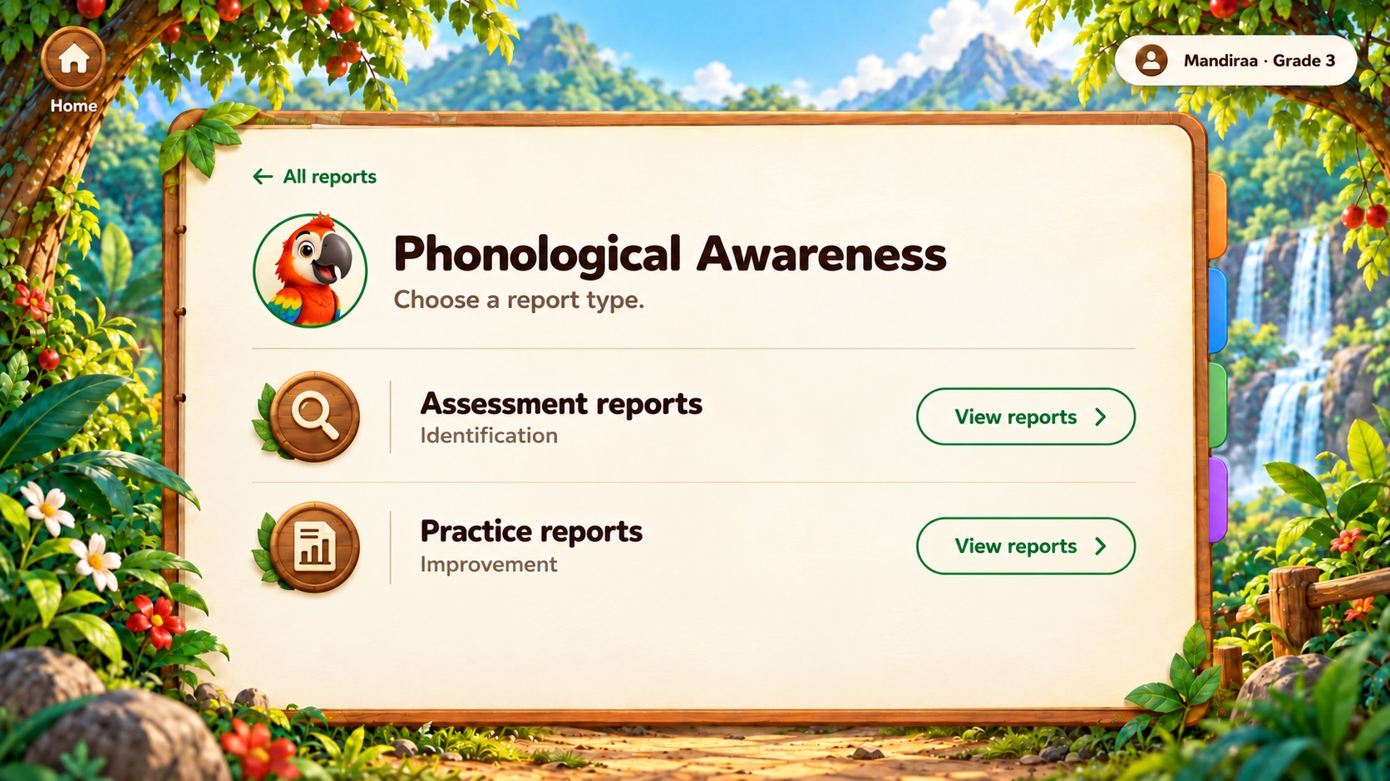

READING PROCESSING – ZEBRA
Figure 39 – Reading Identification – Camera Setup
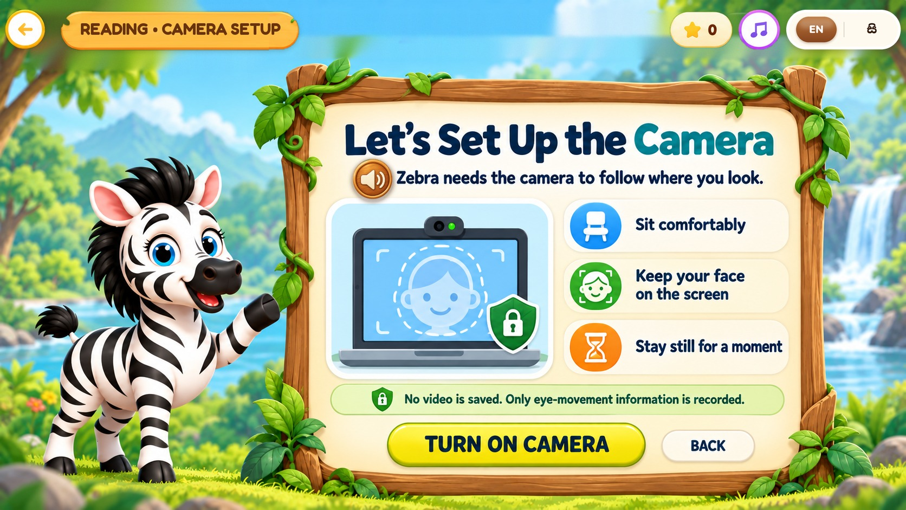

READING PROCESSING – ZEBRA
Figure 40 – Reading Identification – Follow the Firefly (Eye Calibration)
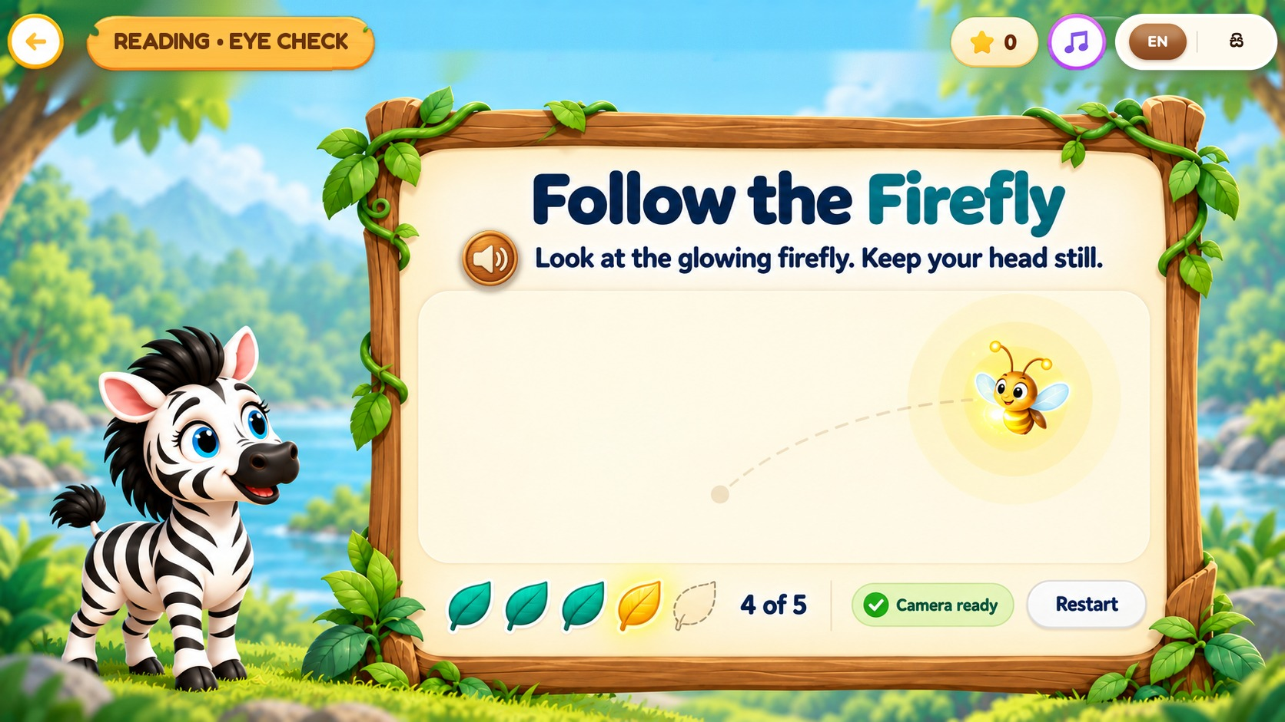

READING PROCESSING – ZEBRA
Figure 41 – Reading Identification – Shapes
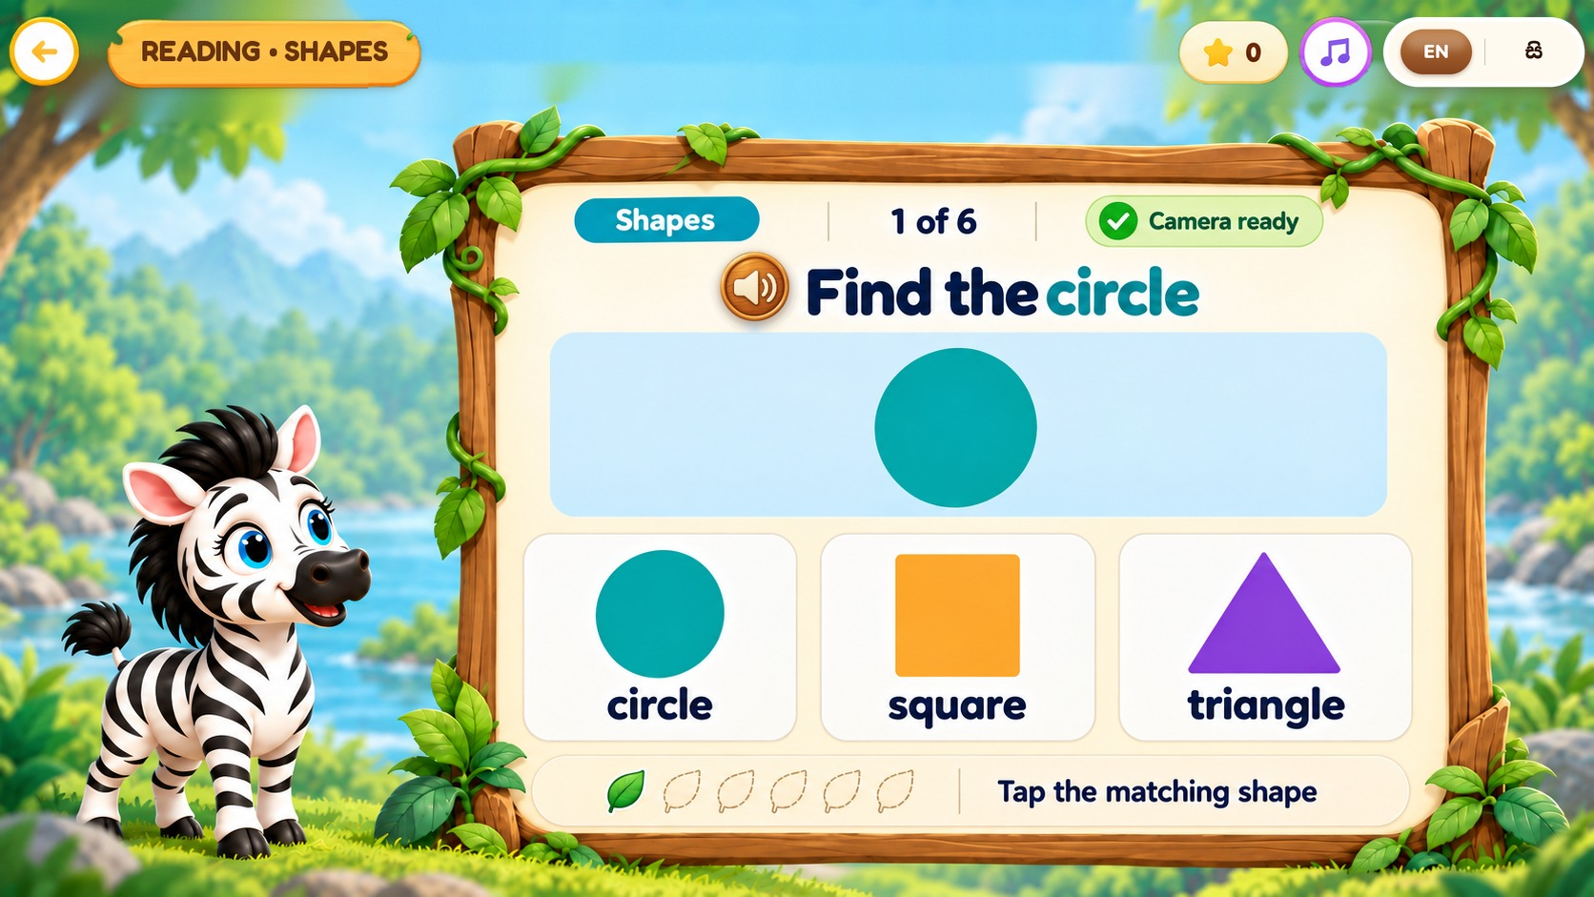

READING PROCESSING – ZEBRA
Figure 42 – Reading Identification – Sentence Safari
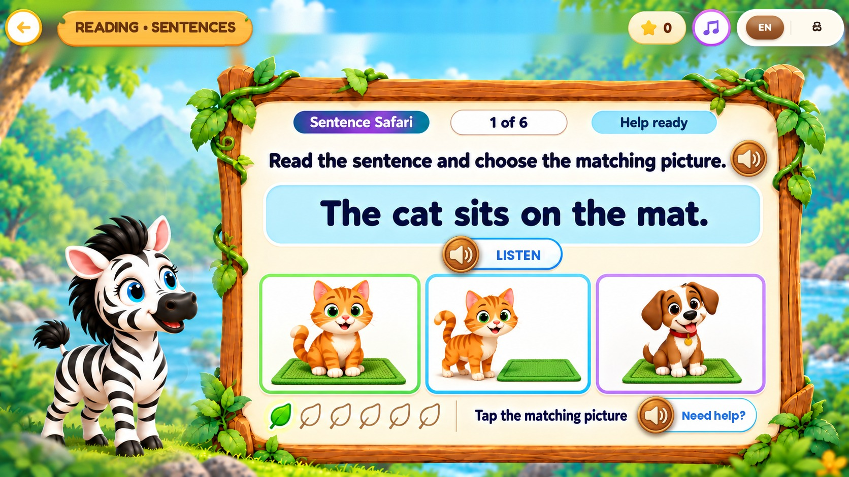

READING PROCESSING – ZEBRA
Figure 43 – Reading Results – Progress Report
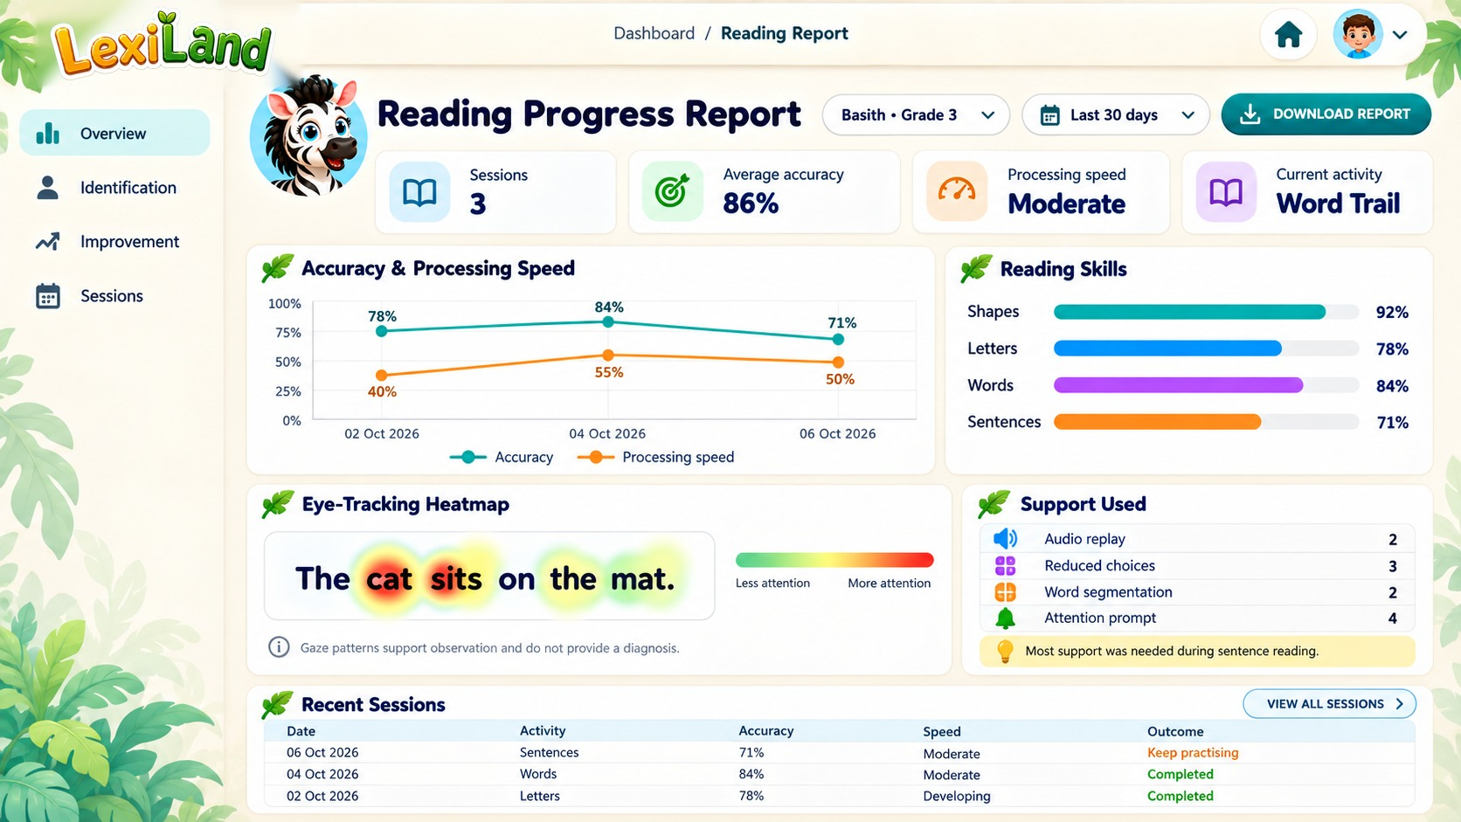

READING PROCESSING – ZEBRA
Figure 44 – Reading Improvement – Level Map
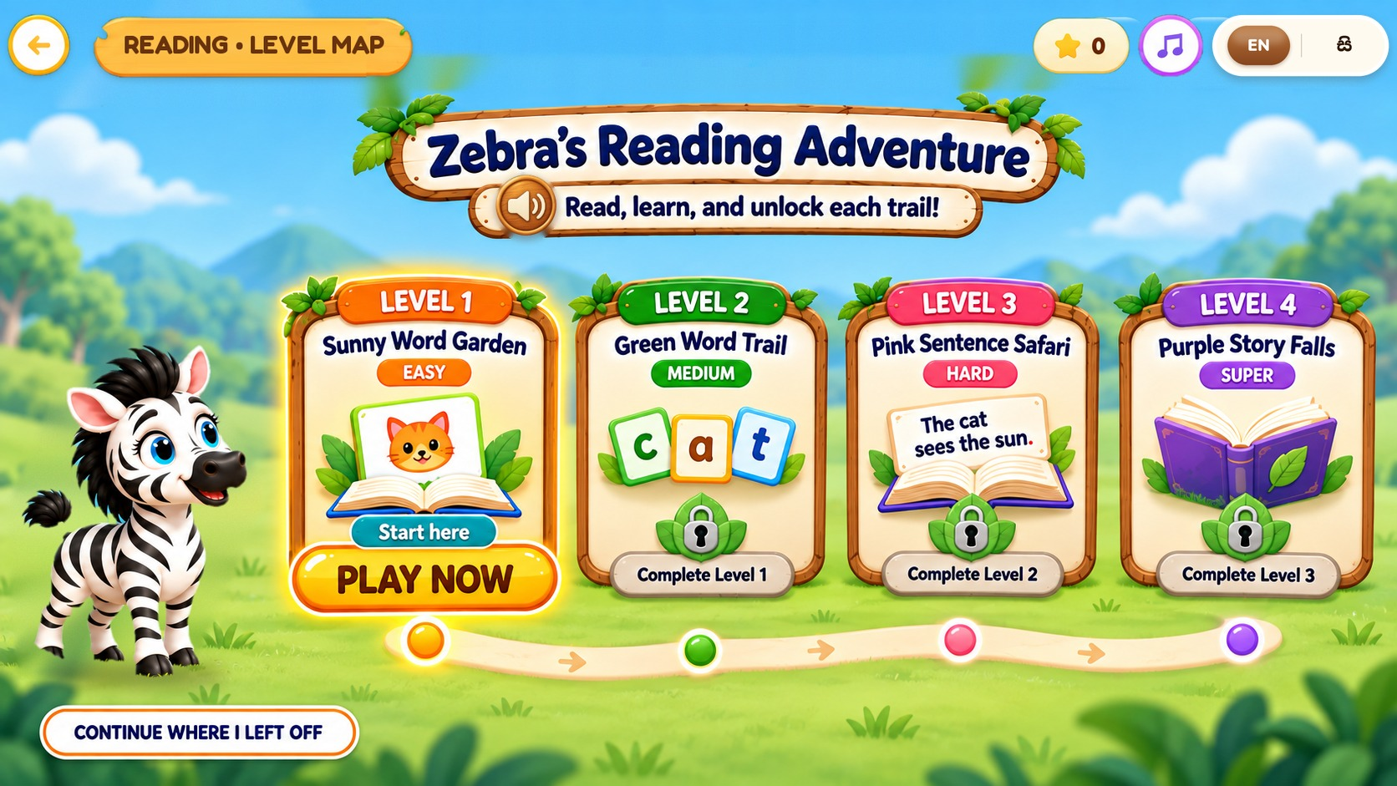

READING PROCESSING – ZEBRA
Figure 45 – Reading Improvement – Level 1 (Easy) – Word Match
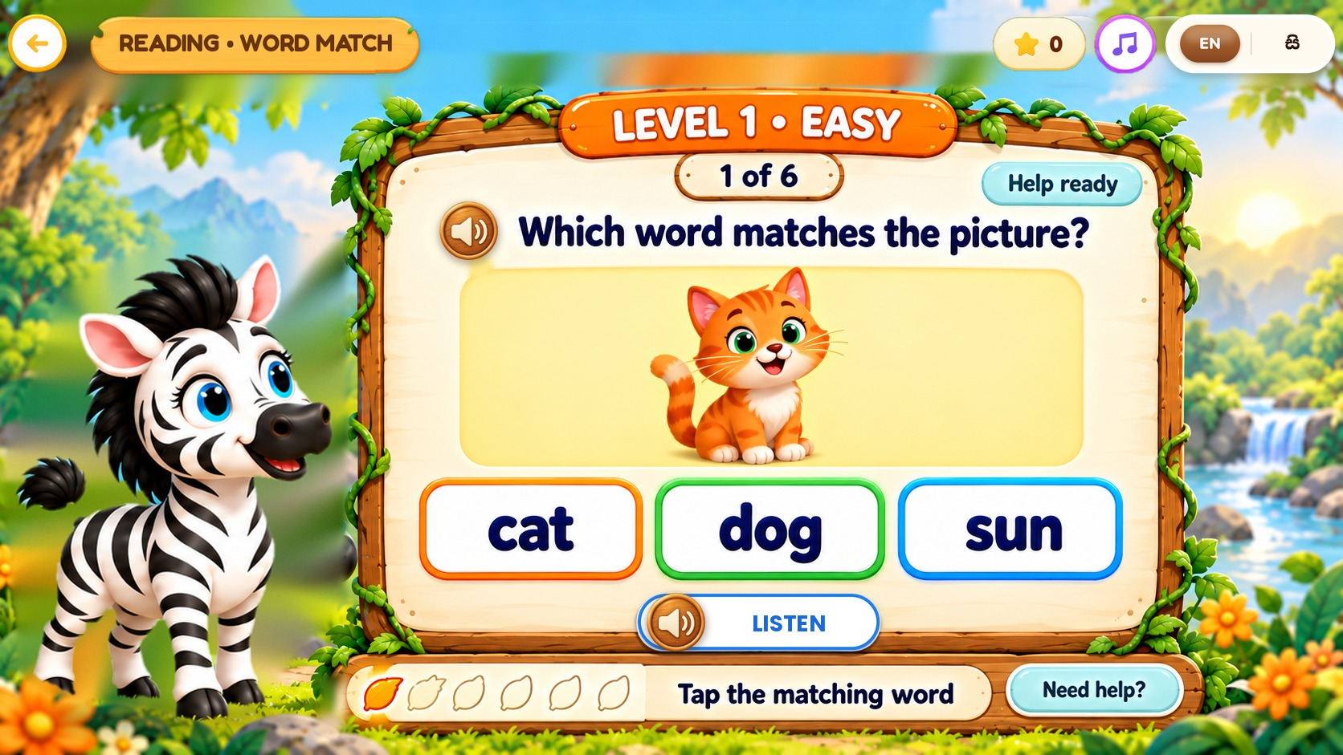

READING PROCESSING – ZEBRA
Figure 46 – Reading Improvement – Level 2 (Medium) – Build the Word
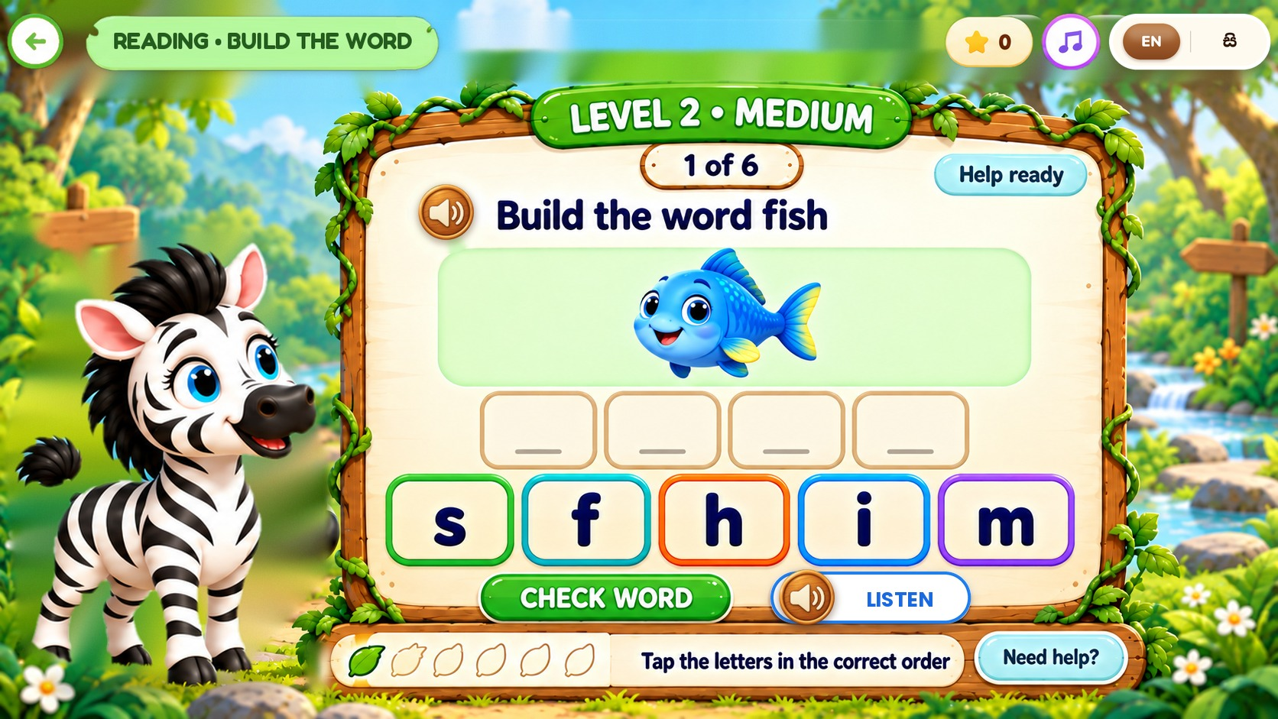

READING PROCESSING – ZEBRA
Figure 47 – Reading Improvement – Level 3 (Hard) – Sentence Order
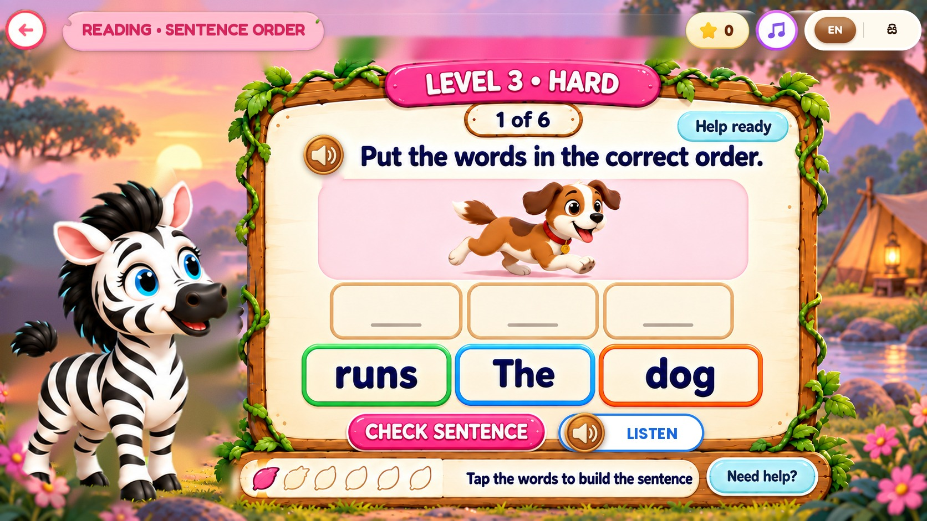

READING PROCESSING – ZEBRA
Figure 48 – Reading Improvement – Level 4 (Super) – Story Question
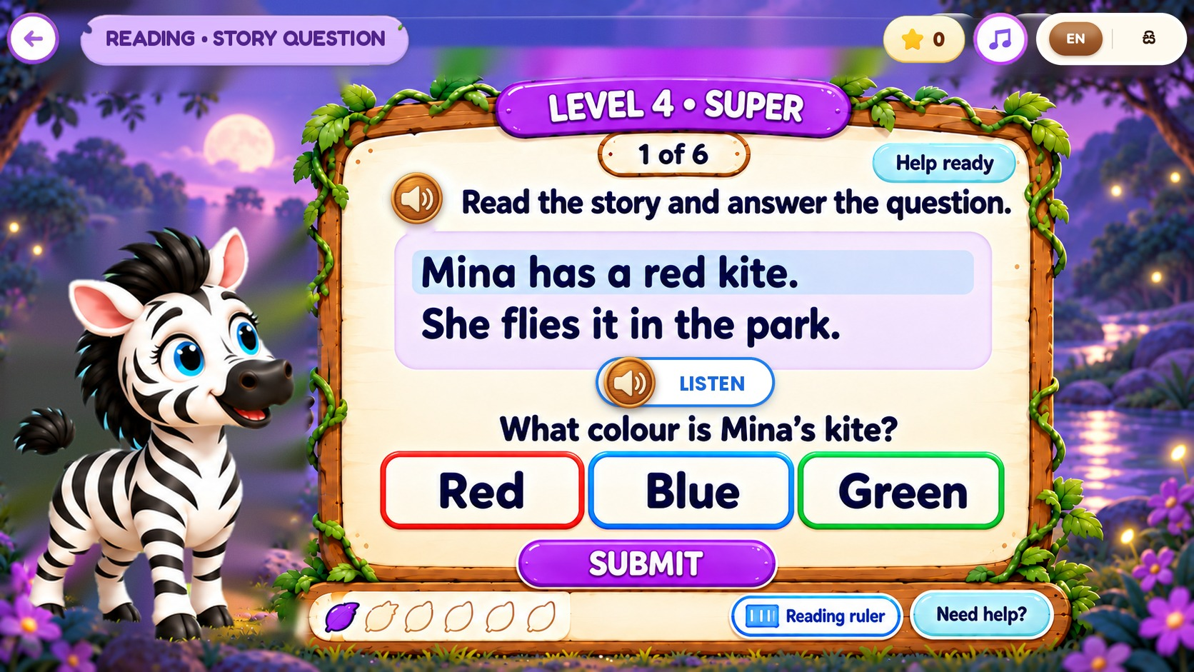

READING PROCESSING – ZEBRA
Figure 49 – Reading Processing Reports
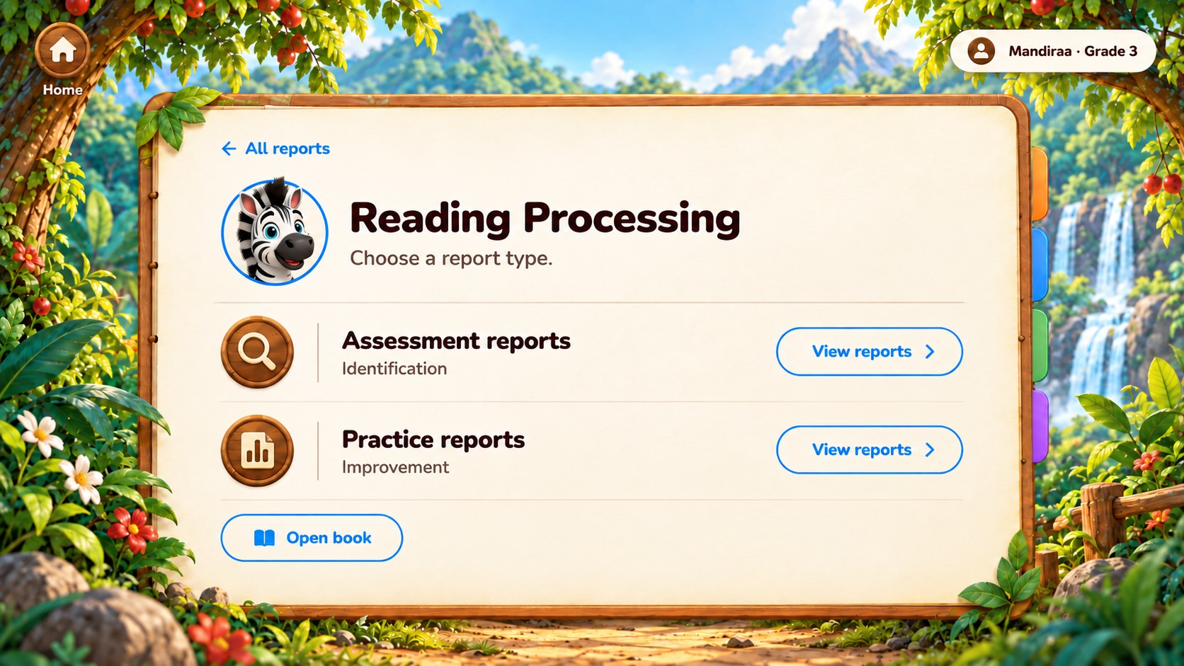

PRONUNCIATION / SPEECH PROCESSING – LION
Figure 50 – Pronunciation Component – Leo’s Sound Safari
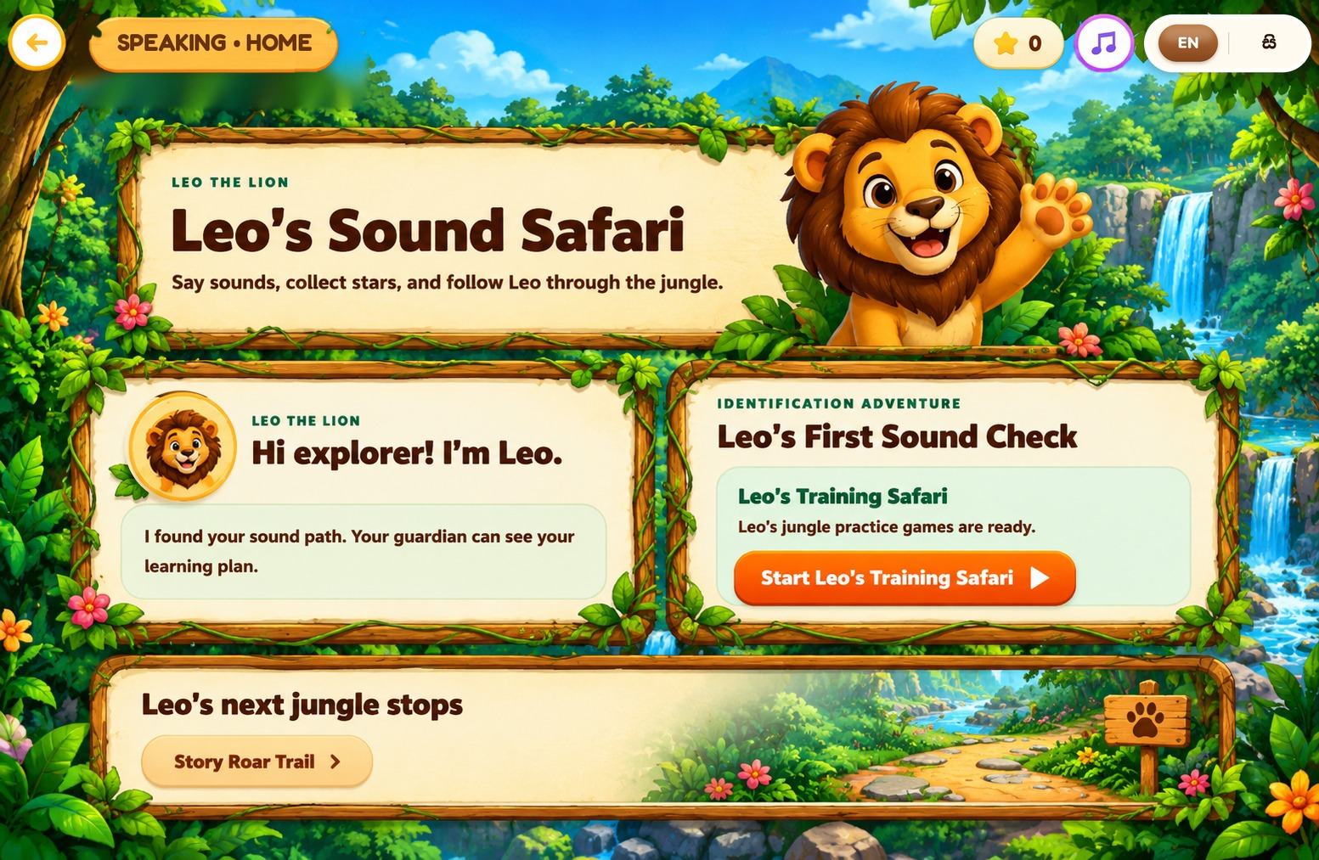

PRONUNCIATION / SPEECH PROCESSING – LION
Figure 51 – Pronunciation Level Map
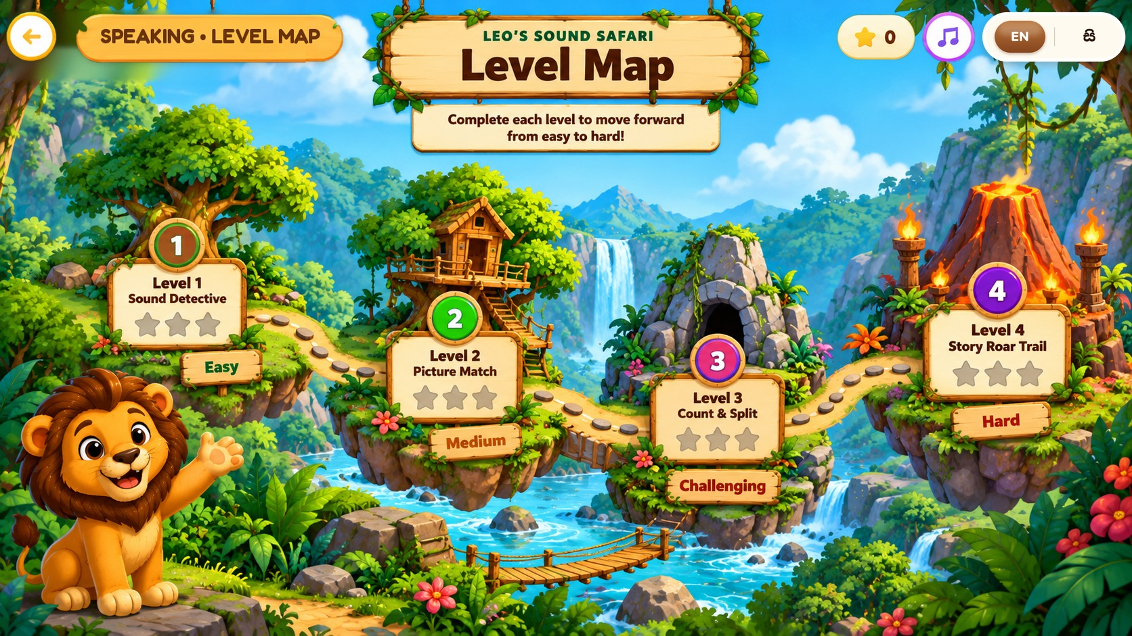

PRONUNCIATION / SPEECH PROCESSING – LION
Figure 52 – Pronunciation Improvement – Leo’s Training Safari
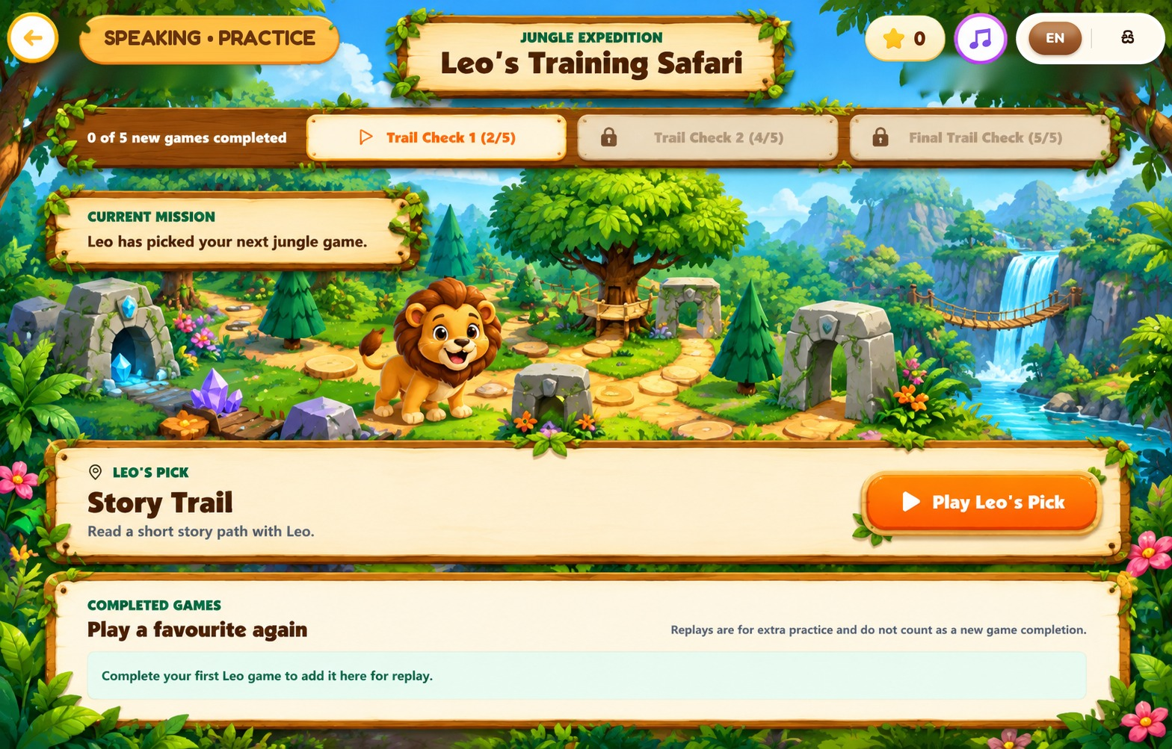

PRONUNCIATION / SPEECH PROCESSING – LION
Figure 53 – Pronunciation Improvement – Story Roar Trail
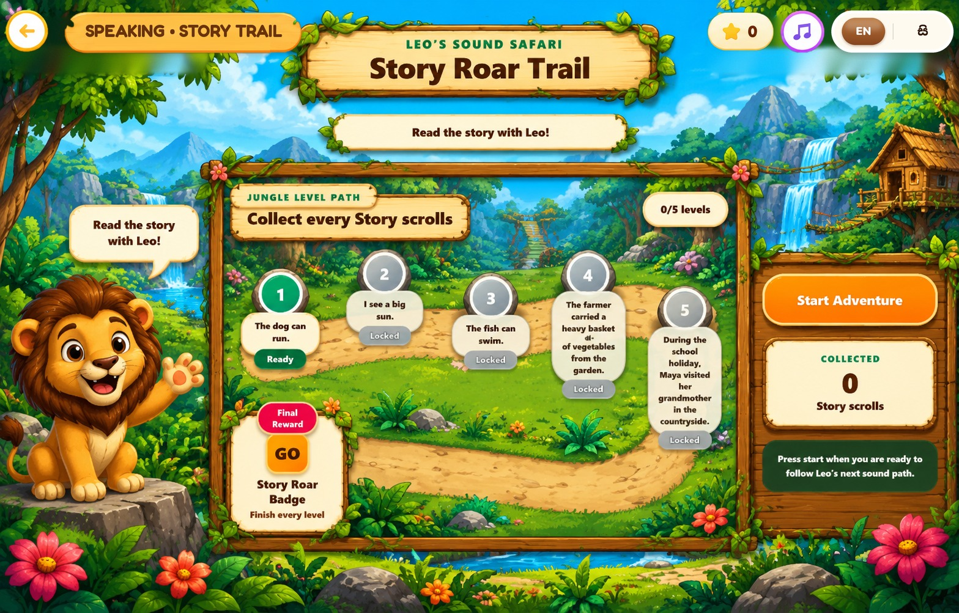

PRONUNCIATION / SPEECH PROCESSING – LION
Figure 54 – Pronunciation Improvement – Story Roar Trail Reading (Level 1)
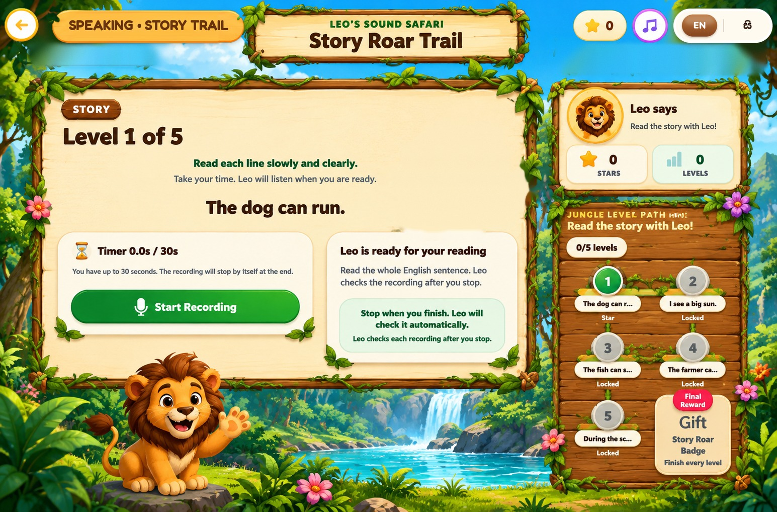

PRONUNCIATION / SPEECH PROCESSING – LION
Figure 55 – Speech Processing Reports
